RESEARCH.-

I didn't know how to write in the condition that it was greater than something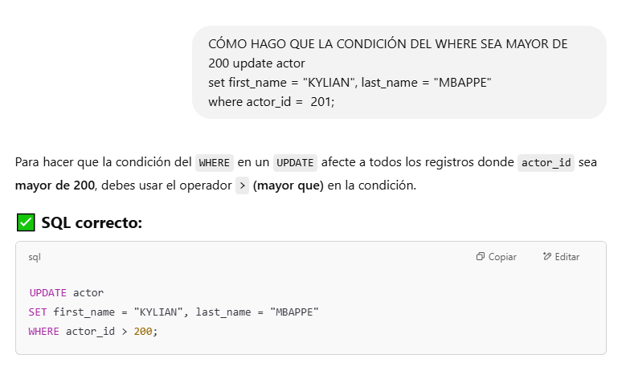I didn't know how to store a result in a new table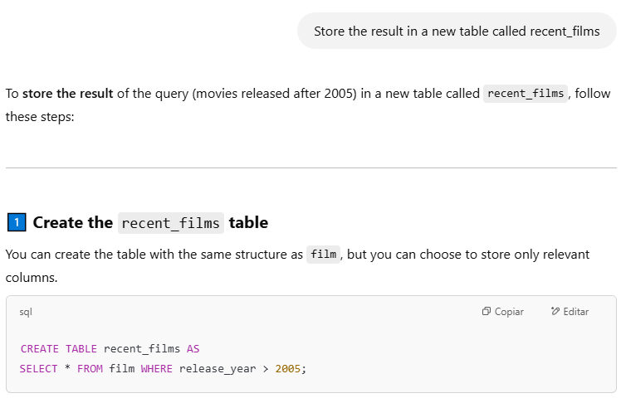

I didn't know how to do this part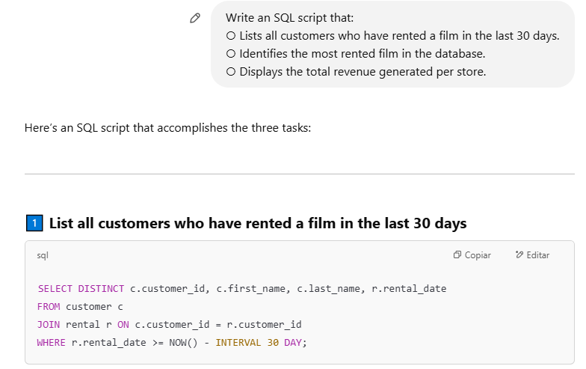

Then I tried to understand why it is called c.customer_id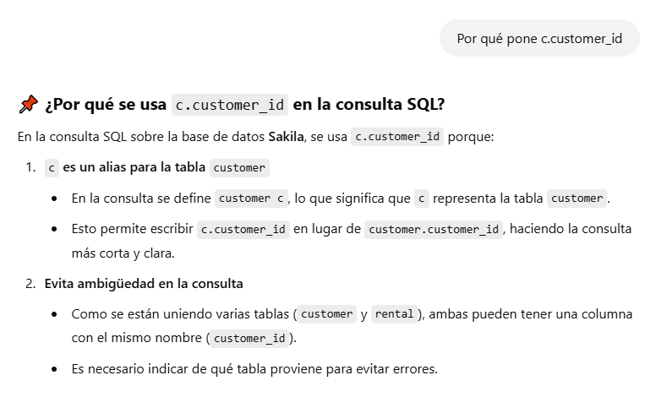

I asked about transactions and their importance, but I didn’t understand it so much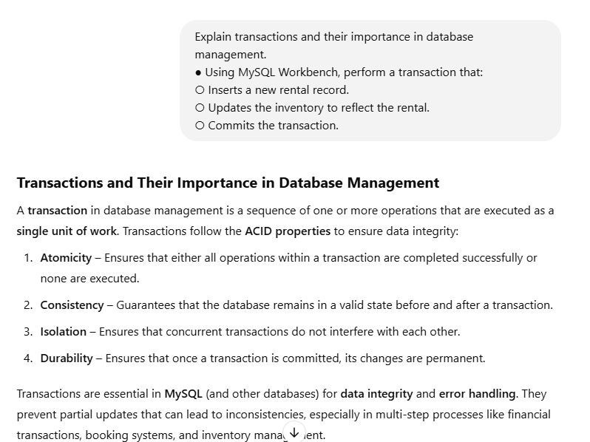

I asked about the scenario where a transaction is partially executed but later rolled back due to an error, because I did not how to start it and 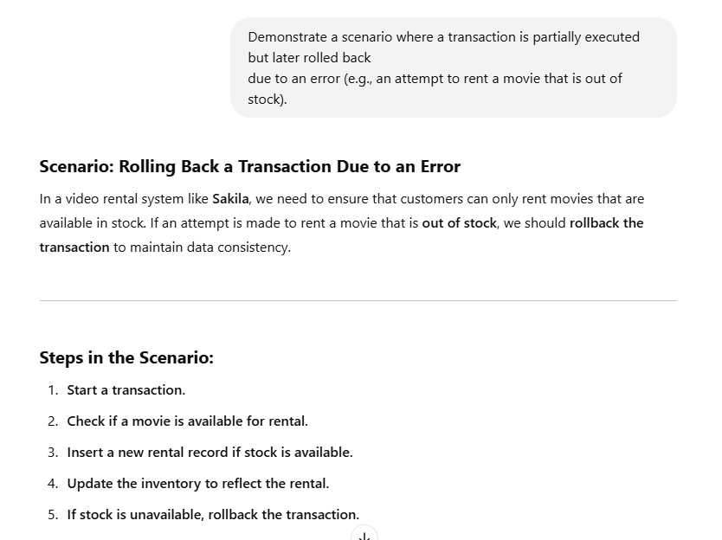

I asked about types of locking and I understood both, but I do not how to write it so I asked about it again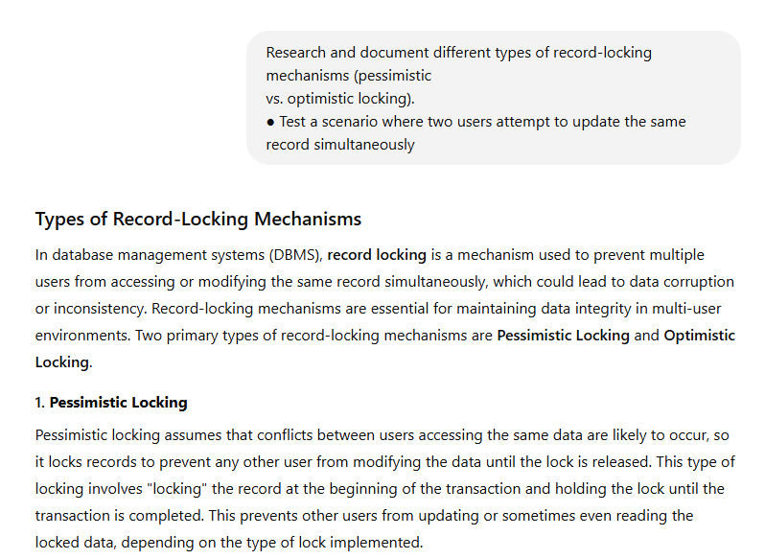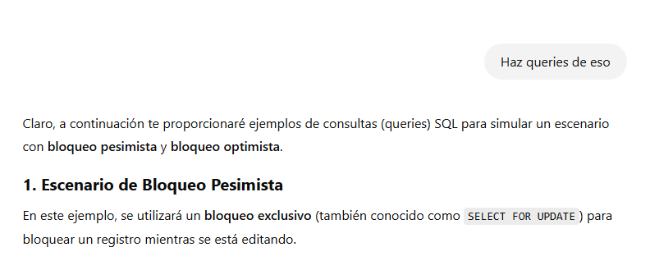

Asd

Then I asked about the scenario that task ask for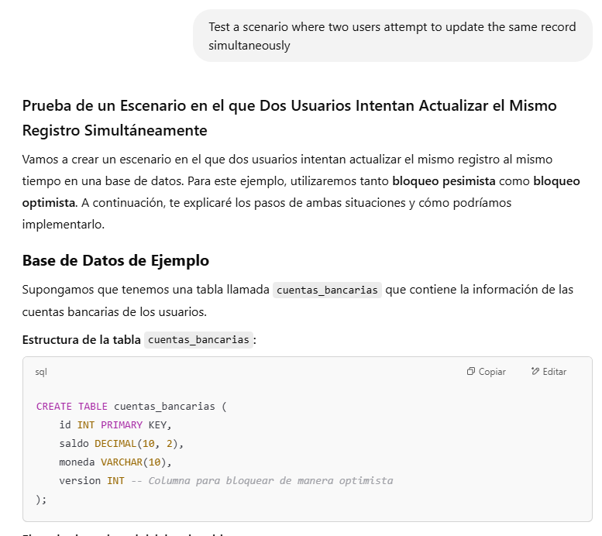

There was a problema, my information source starts queries with “begin” and it doesnt works on my queries, so I asked about another way to start transaction

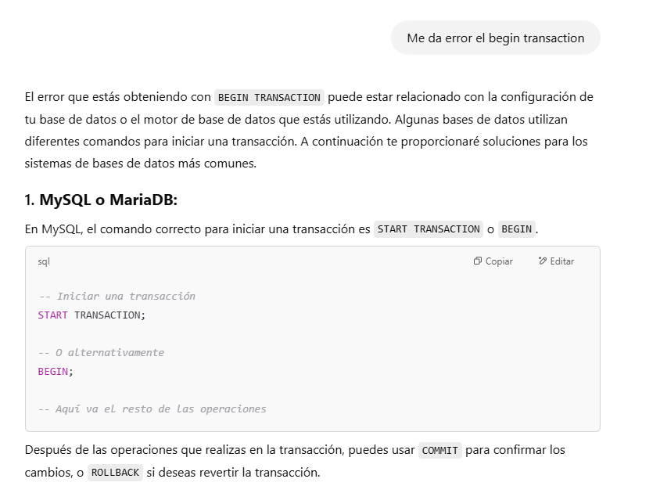

To finish, I asked about potential issues that Sakila database would have

