Dynamic Emergencies

Inspiration/Artists –

Shawn Coss – An artist I have followed for a while now and who gained more of a following in 2016 participating in “Inktober” drawing 31 depictions of mental illnesses. I have always been interested in styles with a darker tone and taken inspiration in my own works often trying to create something unsettling or creepy and wanted to incorporate that into this project.

Garth Knight – working with photo-media, computer manipulation and intricate rope bondage.  He is motivated by themes which explore rigidly held constructs of reality, often featuring structures found in nature (I,e Heart, Veins, Plants, Butterflies wings) All of these things following the same rules yet still all varying having, chaotic irregular form made me want to include something similar for the assignment.

Diana Lange – I found Diana whilst researching and trying to incorporate the inspiration from the last two artists into one and found her “Nature of Code” project creating trees and flowers using recursive functions or the Lindenmayer system.

From these three artist’s my ideas where drawn towards creating a decaying forest or tree with a night sky scene. Having trees with thing entangling branches, no leaves and little use of colour.

Development process

The first part of the development process I looked for ways I was able to generate a tree. I started by coming across the Lindenmayer system as a way to create a fractal like tree and plant structure but was unable to get the desired results with the rules I had been using. I switched to using a recursive function for my tree as it was easier for me to understand and create as well as having the effect I was looking for.

When trying to generate the rain I was unable to get it to cooperate with the code I already had for my tree, I had created a new project to see if I was coding the rain correctly, which I was with just that code. I had tried to put my tree code into a “createGraphics function” but still was unable to get it to display properly, I think due to the functions to create my tree and being unsure how to use the Graphics function properly.

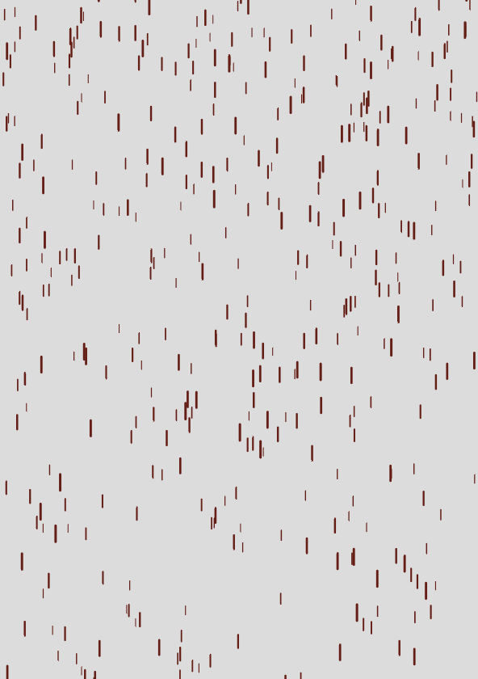 Rain functioning without tree code (also working on my github titled “rain”

In the end to get my tree and part of my rain to show I had to settle with getting my tree function to draw a new tree every frame to partially work with my rain code. Unfortunately I was unable to get the rain to position properly with generating offscreen as it seems to be linked to my tree but I could not figure out to correct it.

Future Upgrades

I would like to be able to figure out how to create my original idea, getting the tree to generate randomly and have the rain generating smoothly and correctly positioned with a bit of diagonal movement, possibly with a wind like effect that would affect the tree and rain movement.

Github page

<https://github.com/KarlsKode/GAD405/tree/master/KarlEllison-405>

References –

Shawn Coss, Inktober Illness 2016 - <http://shawn-coss.squarespace.com/#/inktoberillness/>

Garth Knight - <http://www.garthknight.com/>

Diana Lange: Nature of code - <http://www.diana-lange.de/portfolio/generative/nature_of_code/nature.html>