Interpretable Ensemble Learning for Landslide Susceptibility Mapping: A Case Study of Bhutan

Karma Sonam Rabgay¹, Mohammad Monirujjaman Khan^{1,*}
¹Department of Electrical and Computer Engineering, North South University, Dhaka, 1229, Bangladesh
*Corresponding Author: Mohammad Monirujjaman Khan. Email: monirujjaman.khan@northsouth.edu
Received: XX Month 202X; Accepted: XX Month 202X
Email: karma.radgay@northsouth.edu
Abstract: Located deep in the Himalayas, the kingdom of Bhutan faces recurrent landslides annually due to its geography. These very landslides pose an immense threat to the country’s population, economy and infrastructure. The traditional methods of assessing landslide risks manually come at the expense of time and resources. This study discusses a novel approach to landslide prediction in Bhutan using machine learning techniques using an open-source landslide dataset of topographical conditioning factors recorded in the country. Six machine learning algorithms including Logistic Regression, K-Nearest Neighbors (KNN), Decision Tree, Random Forest, Extreme Gradient Boosting (XGBoost) and Light Gradient Boosting Machine (LightGBM) were trained and tested using 10-fold cross-validation. The individual effects of the data balancing and hyperparameter optimization techniques on model performance were also evaluated. An ensemble with soft voting method of the top three models yielded the best results with accuracy of 92.14% and f1-score of 92.21%. Local Interpretable Model-agnostic Explanations (LIME) was used on the ensemble model to give clear interpretation for each prediction with the main conditioning factors.
Keywords: Landslide prediction; machine learning; hyperparameter optimization; ensemble learning; explainable artificial intelligence
1 Introduction
A landslide can be defined as the phenomenon that occurs when a large amount of rock, rubble, or soil moves down a slope [1]. It can be initiated by rainfall, snowmelt, variations in water level, stream erosion, changes in ground water, earthquakes, volcanic activity, or human disturbance [1]. The destruction this hazard brings to motor roads all over Bhutan is not uncommon to its population. Landslide hazard on roads in Bhutan has been found to be especially severe, where it has been observed that about 1,000 km of roads in Bhutan fall victim to landslide hazard every year during the monsoon period [2]. Landslides cause an average of nearly US$3 million in annual losses in the country [3]. Bhutan sits in a high rainfall zone and during the monsoon, about 70% of the country's annual precipitation arrives between June and September which is when floodings usually happen [4]. The risks of landslides to the country’s infrastructure remain undeniable but the dangers it poses to its inhabitants are considerably even larger. The global fatality landslide database records at least 64 fatalities by non-seismic landslides in Bhutan during 2004–2017 but the exact number of fatalities could be much larger because of significant under-reporting of landslides in the region [5].
The damages caused by the disaster is clear evidence that managing the risks of landslides should be a primary concern for Bhutan. In the rapidly changing digital age of artificial intelligence, the country has to upgrade its approaches towards effective disaster management through technology rather than solely relying on manual procedures. To achieve this, our work discusses the application of machine learning to predict and analyze landslide susceptibility in the country. The use of accurate prediction for future risks from landslides will ensure sustainable growth economically, protect lives of the people and help the country achieve its developmental goals.
The key contributions of this study can be stated as follows:
- An integrated approach of six machine learning algorithms was used resulting in an ensemble where the top three performers were used in combination to predict the landslides using the topographical factors.
- An Explainable AI (XAI) technique, namely LIME was used to explain the black box predictions, thus helping in understanding the spatial factors involved in landslides.
This article is structured as follows: Related works in this domain are included in Section 2. Section 3 thoroughly covers the adopted methodology. Section 4 gives an in-depth review of results obtained with discussion followed by concluding remarks in Section 5.
2 Literature Review
Several studies have explored the application of machine learning and deep learning techniques for landslide susceptibility and vulnerability mapping in Bhutan.
Sarkar et al. presented a framework for landslide susceptibility mapping in Phuentsholing through the use of individual and ensemble machine learning algorithms, including ADR, RSS, M5P, RSS-M5P, and ADR-M5P [6]. The mapping process utilized geo-environmental conditioning factors like slope, elevation, precipitation, lithology, and land use extracted from spatial data. The best performing ensemble model had an AUC of 97.1%.
Al-Najjar et al. introduced a novel methodology based on GAN and machine learning classifiers for assessing the landslide susceptibility probability [5]. In the study, GAN was utilized to synthesize more samples of landslides and then to balance the dataset before modeling. Then, the dataset was balanced by using various classifiers, including Random Forest (RF) and Support Vector Machine (SVM), using different terrain parameters such as slope, aspect, elevation, and distance-related parameters. The Random Forest model provided 94.31% accuracy and f1-score.
In a study by [7], a deep learning landslide susceptibility model was implemented for Chukha, Bhutan, which included ANN, DLNN, and CNN algorithms. In total, there were 22 physical and nine social conditioning factors in the research, such as slope, rainfall, lithology, land cover, and infrastructure. Among the models, the CNN model had the highest accuracy of 92%.
Pasang and Kubíček utilized statistical methods and logistic regression modeling for generating a landslide susceptibility map of the Asian Highway area in Bhutan [8]. For their analysis, they considered slope, aspect, lithology, drainage density, and distance from roads and rivers as the conditioning factors. The logistic regression model provided an AUC in a range of 84% - 88%.
Although existing work has focused on improving predictive performance, the importance of interpretability and explainability has been neglected to a certain extent, making it hard to figure out how each conditioning factor affects the landslide prediction. Table 1 presents an in-depth review of previous work in this area.
Table 1: A comprehensive analysis of the existing literature in landslide prediction in Bhutan
Ref. | Area | Contribution | Limitation
[6] | Phuentsholing, Bhutan | Proposed ensemble ML models for landslide susceptibility mapping (97.1% AUC). | Region-specific, limited interpretability and feature-level explanation.
[5] | Bhutan | Applied GAN-based data balancing to improve ML performance (94.31% accuracy). | Focus on performance and limited interpretability analysis.
[7] | Chukha, Bhutan | Used deep learning for landslide vulnerability mapping (92% accuracy). | Region-specific, low interpretability and limited susceptibility-focused analysis.
[8] | AH48, Bhutan | Compared statistical models for susceptibility mapping (88.3% AUC). | Limited to traditional statistical methods
3 Methodology
In this section, an overview of the methods adopted to evaluate landslide susceptibility in Bhutan is provided. It describes the entire pipeline of analysis starting from the acquisition of the data to the interpretation of the predictions obtained using those data. Fig. 1 illustrates the entire pipeline of data acquisition, preprocessing, classifiers training and fine-tuning and then evaluation of the classifier performance in terms of prediction interpretability. The process starts with collecting and processing open-source landslide dataset, where the data are prepared for further analysis and modeling via cleaning, normalization, and class balancing. Then the classifiers are trained and fine-tuned through hyperparameters optimization, where six different classifiers are trained using stratified 10-fold cross-validation strategy and the best among them are optimized for the best predictive performance. The process ends up with the evaluation on the testing data and interpretability of the predictions using XAI techniques, which means that the entire ensemble of models is evaluated not only by standard performance metrics such as accuracy, precision, recall, and f1-score, but also prediction interpretability.
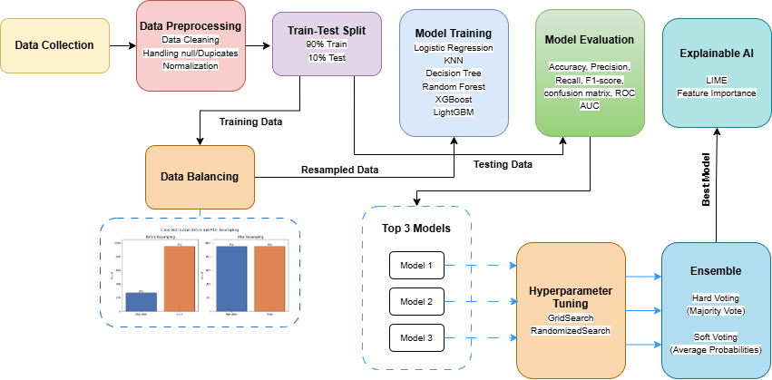
Figure 1: Workflow of the proposed landslide susceptibility assessment methodology, showing the pipeline from data acquisition and preprocessing through model training with 10-fold cross-validation, hyperparameter optimization, soft-voting ensemble construction, and final evaluation with LIME-based interpretability.
3.1 Dataset Overview
This study utilizes an open-source landslide susceptibility dataset for Bhutan [9]. Upon acquisition, all continuous geomorphological variables and categorical variables were observed to be pre-encoded as discrete integer values ranging from 1 to 10. Because the original raw metric measurements were not provided in the repository, the input features were treated as pre-discretized spatial classes for all algorithmic modeling. The main target variable is binary. Table 2 provides a brief description of the features present in the dataset.
Table 2: Description of landslide features in the dataset.
Feature | Description
Lithology | Underlying rock/soil type
Altitude | Elevation above sea level
Slope | Steepness of the terrain
Total curvature | Surface concavity/convexity of the slope
Aspect | Compass direction the slope faces
Distance to road | Proximity to nearest road
Distance to stream | Proximity to nearest stream
Slope length | Length of slope from ridge to base
TWI | Topographic Wetness Index or water accumulation potential
STI | Sediment Transport Index or erosive/sediment-transport capacity
A correlation matrix shows the collinearity between factors. Fig. 2 shows the Pearson’s correlation matrix of the dataset [9]. The matrix shows the linear relationship between the features. ‘Altitude’ shows stronger correlation with ‘lithology’, ‘distance to road’ and ‘slope length’ among all the other features. Most of the remaining pairs of features had either weak or moderate correlation coefficients. Since there were no pairs of features that had nearly perfect correlations, all ten features were kept for model training without any need for dimensionality reduction or feature elimination.
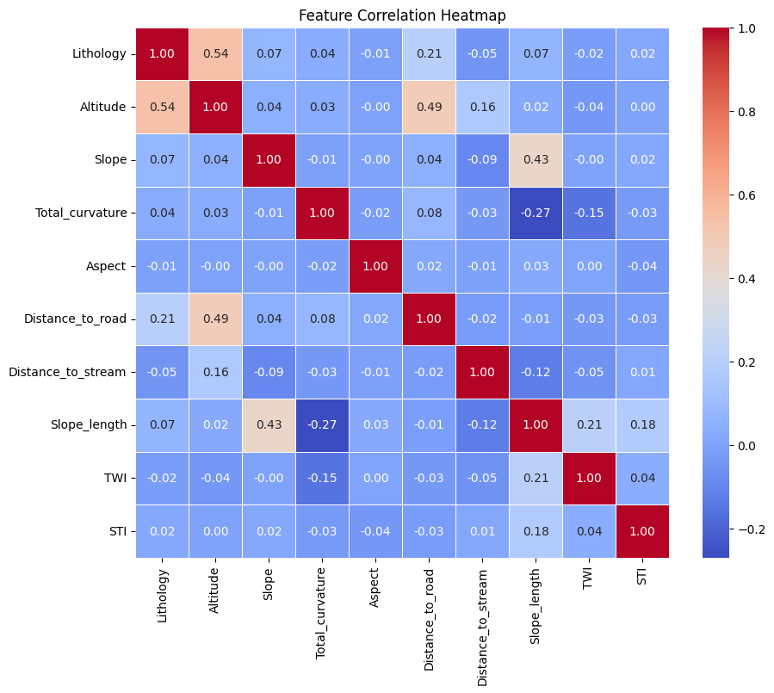
Figure 2: Pearson correlation matrix of the ten landslide conditioning factors (lithology, altitude, slope, total curvature, aspect, distance to road, distance to stream, slope length, TWI, and STI), with color intensity indicating the strength and direction of each pairwise linear relationship.
3.2 Data Preprocessing
Data preprocessing is a crucial step in machine learning before advancing to model training. Raw dataset contains messy data which can hamper the performance of the model. This process also includes removing duplicate values or dealing with empty (or null) values. There were no null or duplicate values present in the dataset. The whole set of attributes in the dataset [9] had already been preprocessed and encoded using discrete integers ranging between 1 and 10 by the authors. Continuous geomorphological attributes such as ‘altitude’ and ‘slope’ had been converted to discrete categories whereas categorical attributes like ‘lithology’ and ‘aspect’ had been used with integer encoding. Another technique involves normalizing the data into a specific range. To ensure algorithmic stability and eliminate any residual magnitude bias across the feature space, a Min-Max scaling transformation was applied. The MinMax scaler from [10] is a scaling technique which is used to rescale the features into a range of 0 to 1, as shown in Eq. (1). Scaling was primarily applied for the benefit of the distance-based and linear algorithms.
$$X_{scaled}=\frac{X-X_{min}}{X_{max}-X_{min}}$$ | (1)
The original landslide dataset [9] was heavily imbalanced. It contains 952 'slide' instances but only 269 'non-slide' instances. Class imbalance can have a severe impact on a model’s performance. To overcome this issue, resampling can be applied on either the majority or minority class. Fig. 3 shows the class distribution before and after applying resampling (specifically via SMOTE). This resampling technique uses feature-space interpolation to generate synthetic samples for the minority class [20].
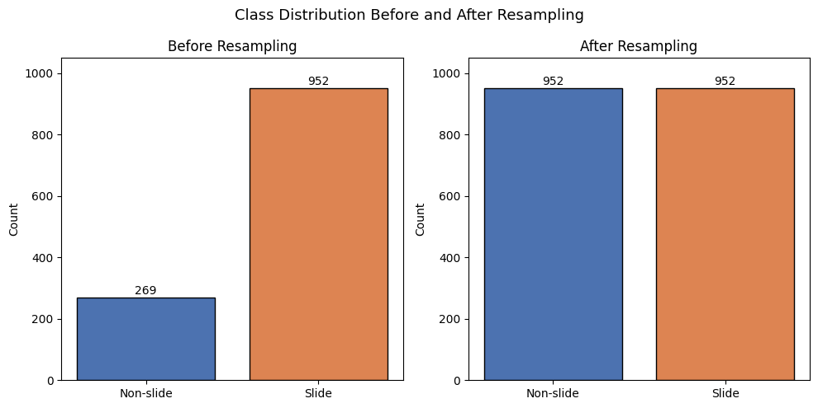
Figure 3: Class distribution of the landslide dataset before and after resampling via SMOTE, showing the original imbalance and the balanced class counts produced by synthetic minority oversampling.
3.3 Splitting the Dataset
This is a fundamental step in machine learning which involves dividing the dataset into various partitions. In this article, we used the stratified K-Fold Cross Validation technique. This approach involves dividing the dataset into $k$ equal subsets (or folds) in which $k-1$ folds are used for training and one for testing, repeatedly for $k$ times [11]. Then the results are averaged for all iterations. We used 10 folds since the dataset used was small but also for better generalization. Stratified sampling makes sure the distribution of samples in each class is representative of population as a whole [11]. It is also a useful sampling approach if there is class imbalance. 90% (or 1099 instances) are used as training set and 10% (or 122 instances) are used for testing in each iteration.
3.4 Classifiers Used
3.4.1 Logistic Regression
Despite its name, logistic regression [11] is used for classification unlike its predecessor linear regression. The algorithm passes its linear component through a function known as the sigmoid (or logistic) function $g$ which maps all real values into a range of 0 to 1. As shown in Eq. (1), $h_{θ}$ is the hypothesis that predicts the target y for input x based on threshold of 0.5. The prediction is such that y is 1 if $h_{θ}$ is greater than or equal to 0.5 and 0 if $h_{θ}$ less than 0.5. $θ^{T}$ is the linear component calculated as ($θ_{0}+θ_{1}x_{1}+θ_{2}x_{2}+…+θ_{n}x_{n}$).
$$h_{θ}\left(x\right)=g\left(θ^{T}x\right)=\frac{1}{1+e^{-θ^{T}x}}$$ |  | (2)
3.4.2 K-Nearest Neighbors
K-Nearest Neighbors is also a widely used algorithm for both classification and regression problems. KNN is a classifier that searches for the nearest k samples in the feature space and uses their class labels to perform majority voting to assign the new sample a label of the majority class [12].
3.4.3 Decision Tree
The Decision Tree [11] is a supervised tree-based learning algorithm that repeatedly splits the dataset into smaller subsets (leaf nodes) until there is homogeneity. The best split is determined by the degree of node impurity after splitting. The criterion Gini is one such measure of impurity used by the Classification and Regression Trees (CART) algorithm, as shown in Eq. (3). It constructs binary trees by selecting the optimal feature and threshold that give the highest gain at each node. Gain refers to reduction in impurity from parent node to child node after split. Entropy is another measure of impurity used in Iterative Dichotomiser 3 (ID3) algorithm, shown in Eq. (4).
$$G=1-\sum_{i=1}^{n}{p_{i}^{2}}$$ |  | (3)
$$S=-\sum_{i=1}^{n}{p_{i}\log_{2}{p_{i}}}$$ |  | (4)
Here, n is number of classes and $P_{i}$ is the probability of an instance belonging to $i$th class.
3.4.4 Random Forest
Random Forest [13] is an ensemble of decision trees. It can be used to solve a problem for classification as well as regression. In the case of classification, it selects the class by picking the one that has received the most votes from all the trees. Each tree is independent and built upon random samples and features to improve accuracy while reducing errors.
3.4.5 Extreme Gradient Boosting (XGBoost)
XGBoost [14] is an optimized gradient boosting algorithm capable of handling complex data. Decision trees are included in a sequential manner as base learners. This method known as boosting makes up for the errors prior to the next one. It consists of an objective function l and regularization term $Ω(f_{k})$, shown in Eqs. (5) and (6) respectively. The objective function measures the difference of $i$th datapoint between actual value $y_{i}$and the predicted value ${\hat{y}}_{i}$. The regularization term penalizes complex trees.
$$obj\left(θ\right)=\sum_{i=1}^{n}{l(y_{i},{\hat{y}}_{i})}+\sum_{k=1}^{k}{Ω(f_{k})}$$ | (5)
$$Ω\left(f_{k}\right)=γT+\frac{1}{2}λ\sum_{j=1}^{T}{W_{j}^{2}}$$ | (6)
Here,
- $k$ is the number of trees
- $γ$ is the regularization parameter
- $T$ is the number of leaves in a tree
- $λ$ is the parameter that penalizes the squared leaf weights $w_{j}$
3.4.6 Light Gradient Boosting Machine
LightGBM [15] is an extremely fast, lightweight machine learning framework by Microsoft that utilizes tree boosting models. Whereas conventional algorithms build decision trees from bottom to top, LightGBM builds them from top to bottom, by sequentially splitting the leaves that provide the most significant reduction in loss.
3.4.7 Voting Classifier
Voting Classifier from [10] is an ensemble technique which combines predictions made by multiple models. This way, low-performing models learn from better ones. It can either be based on hard voting or soft voting. Hard voting determines prediction using majority voting while soft voting determines the outcome using average of probabilities across all models.
3.5 Hyperparameter Optimization
Hyperparameter optimization is a technique of selecting the best values for a machine learning model’s hyperparameter. Hyperparameters are configurations defined by the user. In this work, we used Randomized Search Cross-Validation (RandomizedSearchCV) and Grid Search Cross-Validation (GridSearchCV) from [10] which are some methods for hyperparameter tuning technique. These methods were used on the top 3 performing models to further improve their performance.
Randomized search performs a random search over the defined range of parameter values whereas Grid search performs a thorough grid search over a wide range of parameter values [16]. A model, parameter grid, and scoring metric has to be defined as an input. The parameter grid is a dictionary of the parameter grid that is to be searched. The model is then evaluated using the scoring metric. We used random search to find the optimal parameter values over a parameter grid. Then we used grid search to search a local parameter grid which is centered around the initial findings of random search.
4 Result and Discussion
This section discusses the main outcomes obtained in this study. After the training phase, all trained models require evaluation. This is achieved by testing these models on unseen testing data. To precisely evaluate how the models were performing, we then used various evaluation metrics which are derived from the confusion matrix to evaluate them.
4.1 Model Evaluation
True Positive (TP), True Negative (TN), False Positive (FP), False Negative (FN) are the outcomes of the model which are used to compute the metrics. Using these outcomes, we calculate accuracy, precision, recall, and f1-score of all the models [17]. Accuracy is a fundamental metric used in evaluating machine learning models for classification. It represents a fraction that was correctly predicted from all the predictions made by the model. Precision measures the correct positive predictions. Recall tells us the total actual positive cases correctly predicted by the model. F1-score computes the harmonic mean between precision and recall. This way, the model is penalized if either metric value is low. The performance metrics used to evaluate the models are shown in Eqs. (7) through (10).
$$Accuracy=\frac{TP+TN}{TP+TN+FP+FN}$$ | (7)
$$Precision=\frac{TP}{TP+FP}$$ | (8)
$$Recall=\frac{TP}{TP+FN}$$ | (9)
$$F1score=\frac{2*Precision*Recall}{Precision+Recall}$$ | (10)

Table 3 shows the comparative performance of the base machine learning classifiers on the landslide dataset [9]. The Random Forest model outperformed the other base models with over 91% accuracy and f1-score.
Table 3: Performance comparison of machine learning classifiers.
Model | Accuracy | Precision | Recall | F1-Score | Rank (by Accuracy)
Logistic Regression | 76.91 ± 1.64 | 70.88 ± 6.27 | 76.91 ± 1.64 | 70.36 ± 1.94 | 6
Decision Tree | 89.19 ± 3.66 | 89.33 ± 3.62 | 89.19 ± 3.66 | 89.19 ± 3.64 | 4
Random Forest | 91.81 ± 3.26 | 92.21 ± 3.17 | 91.81 ± 3.26 | 91.88 ± 3.21 | 1
K-Nearest Neighbors | 83.95 ± 2.64 | 84.84 ± 2.63 | 83.95 ± 2.64 | 84.16 ± 2.44 | 5
XGBoost | 91.49 ± 3.12 | 91.72 ± 2.93 | 91.49 ± 3.12 | 91.54 ± 3.04 | 3
LightGBM | 91.65 ± 3.63 | 91.95 ± 3.49 | 91.65 ± 3.63 | 91.71 ± 3.56 | 2
4.2 Ablation Study
In order to thoroughly examine the results of each step in the proposed methodology, an ablation study has been performed. In this study, we discuss the ablation study of class imbalance handling and hyperparameter optimization.
4.2.1 Ablation Study on Class Imbalance Handling
Since there was a class imbalance issue in the dataset [9], we explored how resampling would help in improving the performance of the models. Resampling was done on the top 3 models Random Forest, XGBoost, and LightGBM. We used 3 resampling techniques which were random Undersampling, Synthetic Minority Oversampling Technique (SMOTE), and Adaptive Synthetic (ADASYN). Undersampling randomly reduces the samples of majority class, SMOTE generates synthetic minority samples through feature-space interpolation, and ADASYN adaptively synthesizes data specifically for the minority samples that are difficult to learn [20]. Contrary to expectation, no resampling technique helped in improving the performance of any of the three models. Table 4 shows the comparative performances of the models when applied different resampling techniques.
Table 4: Performance of models over different resampling techniques.
Method | Base |  | Undersampling |  | SMOTE |  | ADASYN
Model | Acc. | F1 | Acc. | F1 | Acc. | F1 | Acc. | F1
Random Forest | 91.81 ± 3.26 | 91.88 ± 3.21 | 87.23 ± 3.05 | 88.04 ± 2.77 | 90.83 ± 3.67 | 91.03 ± 3.53 | 91.65 ± 3.06 | 91.79 ± 2.92
XGBoost | 91.49 ± 3.12 | 91.54 ± 3.04 | 88.21 ± 1.70 | 88.86 ± 1.55 | 90.91 ± 3.78 | 90.99 ± 3.67 | 90.18 ± 4.38 | 90.24 ± 4.33
LightGBM | 91.65 ± 3.63 | 91.71 ± 3.56 | 87.80 ± 1.70 | 88.51 ± 1.54 | 91.00 ± 3.74 | 91.13 ± 3.61 | 91.24 ± 3.75 | 91.36 ± 3.60
Undersampling led to the greatest drop in performance among all methods, with LightGBM achieving 3.20% less f1-score, followed by Random Forest and XGBoost with loss of 3.84% and 2.68%, respectively. This can be explained by the significant reduction of training samples as a result of removal of the majority class examples from the dataset, which has become especially damaging considering the relatively small size of the dataset (1,221 examples). SMOTE and ADASYN do not remove any majority class samples, hence, they produce a smaller loss in f1-score (from 0.09% to 1.30%).
4.2.2 Ablation Study on Hyperparameter Tuning
Similarly, the top 3 performers Random Forest, XGBoost and LightGBM was also selected for hyperparameter optimization. This technique allowed us to find the optimal values for each model’s hyperparameters. Table 5 shows the comparative performance before and after optimizing the hyperparameter values for the classifiers with random search followed by grid search. Hyperparameter optimization allowed us to improve the Random Forest’s performance to 92.06% accuracy and 92.16% f1-score. But the performance for XGBoost and LightGBM did not increase even after optimizing hyperparameters.
Table 5: Performance of models before and after hyperparameter tuning (RSCV and GSCV).
Method | Base |  | RSCV |  | GSCV
Model | Accuracy | F1 | Accuracy | F1 | Accuracy | F1
Random  Forest | 91.81 ± 3.26 | 91.88 ± 3.21 | 92.06 ± 3.83 | 92.17 ± 3.72 | 92.06 ± 3.64 | 92.16 ± 3.54
XGBoost | 91.49 ± 3.12 | 91.54 ± 3.04 | 91.40 ± 4.14 | 91.53 ± 4.05 | 91.32 ± 3.75 | 91.49 ± 3.64
LightGBM | 91.65 ± 3.63 | 91.71 ± 3.56 | 91.32 ± 3.11 | 91.49 ± 3.00 | 91.32 ± 3.11 | 91.49 ± 3.00
4.3 Ensemble Model and Performance Evaluation
The ensemble was carried out using the optimized Random Forest model with XGBoost and LightGBM. A similar ensemble was used by [18] but it was for stroke prognosis. Table 6 shows the performance of the selected models and their ensemble via hard voting and soft voting. The ensemble of these models with hard voting yielded 92.14% (±3.19%) accuracy and f1-score. The ensemble based on soft voting slightly performed better with 92.14% (±3.10%) accuracy and f1-score.
Table 6: Comparative performance of base models along with their ensemble (soft voting and hard voting).
Model | Accuracy | Precision | Recall | F1-Score | Rank (by Accuracy)
Random Forest (Tuned) | 92.06 ± 3.83 | 92.54 ± 3.54 | 92.06 ± 3.83 | 92.17 ± 3.72 | 3
XGBoost | 91.49 ± 3.12 | 91.72 ± 2.93 | 91.49 ± 3.12 | 91.54 ± 3.04 | 5
LightGBM | 91.65 ± 3.63 | 91.95 ± 3.49 | 91.65 ± 3.63 | 91.71 ± 3.56 | 4
Ensemble (hard) | 92.14 ± 3.19 | 92.43 ± 3.07 | 92.14 ± 3.19 | 92.19 ± 3.13 | 2
Ensemble (soft) | 92.14 ± 3.10 | 92.44 ± 2.95 | 92.14 ± 3.10 | 92.21 ± 3.02 | 1
The Receiver Operating Characteristic (ROC) curve and Area Under Curve (AUC) are another type of metric used to evaluate classification models. The ROC graph plots True Positive Rate (TPR) versus False Positive Rate (FPR) [17]. AUC score represents the area under the ROC curve. Fig. 4 shows the ROC curve of the proposed model which is the soft-voted ensemble model. Then the AUC score of this model was 97%.
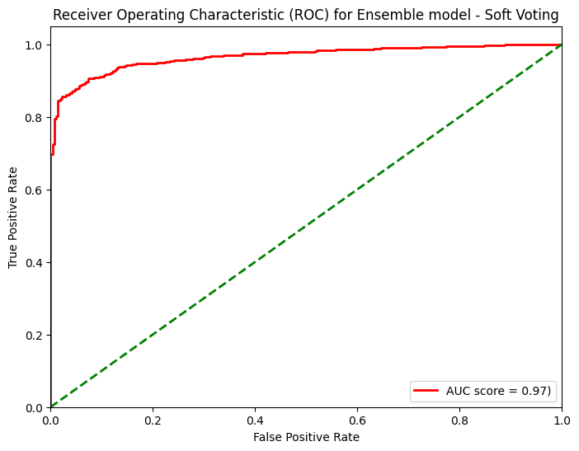
Figure 4: ROC curve of the proposed model, plotting the true positive rate against the false positive rate across classification thresholds.
The confusion matrix visually plots the TP, FP, TN, and FN outcomes of the classification model. This is especially critical in the context of disaster risk management, where the cost of overlooking a real landslide (a false negative) is usually much higher than the cost associated with precautionary measures arising from a false positive. The confusion matrix is plotted for ‘slide’ and ‘non-slide’ cases with the actual values against the predicted values. The confusion matrix of the proposed model is depicted in Fig. 5.
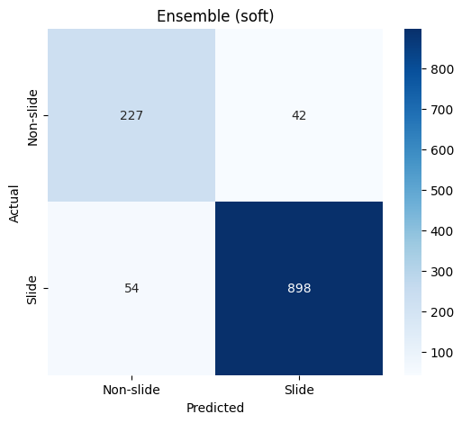
Figure 5: Confusion matrix of the proposed model on the test set, showing 898 of 952 'slide' instances and 227 of 269 'non-slide' instances correctly classified, out of 1,221 total instances (1,125 correct predictions).
Out of the 1221 total instances, the model made 1125 correct predictions. The model correctly identified 227 out of the 269 ‘non-slide’ cases and 898 out of the 952 ‘slide’ cases. Despite the landslide dataset [9] being imbalanced, the proposed model has 92.14% (±3.10%) f1-score. Fig. 6 shows the classification report of this model.
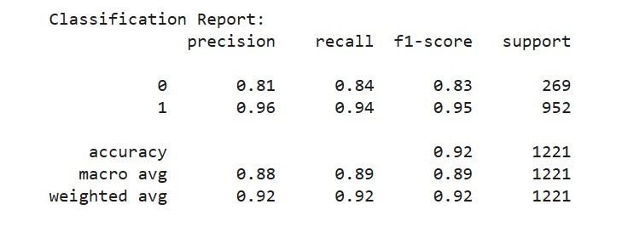
Figure 6: Classification report of the proposed model, summarizing per-class precision, recall, and f1-score for the 'slide' and 'non-slide' categories along with macro- and weighted-average metrics.
4.4 Explainable AI
An Explainable AI (XAI) can be used to overcome the “black-box” nature of a classifier and figure out what actually pushes a particular prediction. In our study, we used the Local Interpretable Model-agnostic Explanations (LIME) technique on the proposed model. LIME [19] is an XAI method that concentrates only on one particular data instance and perturbs the features of this particular data instance, and then LIME analyzes how predictions of the black box model change with these perturbations. Two separate instances of each case from the dataset were used for interpretation.
4.4.1 LIME Explanation for a 'Slide' Instance
Fig. 7 depicts the LIME explanation for the correctly predicted 'slide' case with the model assigning a probability of 0.77 to 'slide' and 0.23 to 'non-slide'. Notably, the conditions of the top three features with respect to local weights do not favor the predicted category: the smallest value of 'Distance to road' accounted for the largest local weight (0.23) but pointed toward the class of 'non-slide', just like the large value of 'Distance to stream' (0.08) and the values of 'Aspect' ranging from 6 to 8 (0.05). The features favoring the 'slide' class had considerably smaller weights, namely low value of 'STI' (0.03) and low value of 'Total curvature' (0.01), alongside negligible 'Lithology' (0.00). Minor weights of less than 0.01 from the 'Altitude', 'TWI', 'Slope length', and 'Slope' variables also supported the 'non-slide' option. From this, it is clear that the most important features for this local explanation ('Distance to road' and 'Distance to stream') have influenced the prediction against the actual output of the model, while the 'slide' decision is based on other features (in lesser amount).
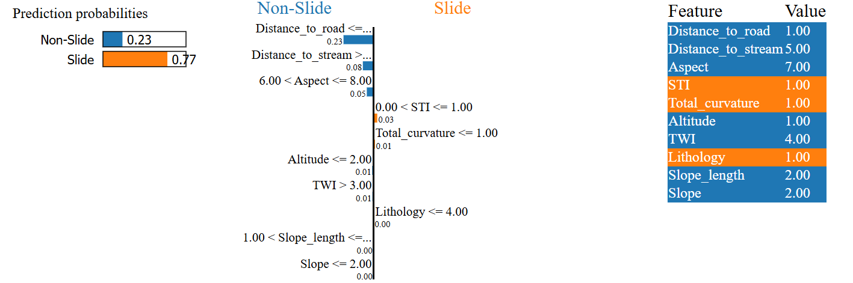
Figure 7: LIME explanation for a correctly predicted 'Slide' instance (Class 1), showing the individual feature contributions driving the prediction.
4.4.2 LIME Explanation for a 'Non-Slide' Instance
As shown in Fig. 8, the LIME interpretation of a 'non-slide' case that was accurately predicted by the model, in which the probability assigned to 'non-slide' is 0.71 whereas the probability assigned to 'slide' is 0.29. Differently from the 'slide' case, the prominent feature in this case is related to the prediction because the small value of 'Distance to road' was the most weighted (0.23) towards 'non-slide'. Besides, the large value of 'Distance to stream' (0.03) and the small value of 'TWI' (0.02) were weighted positively to the predicted class 'non-slide', together with the positive weights of 'Slope length' and 'Altitude' (0.01). On the other hand, the negative weights were the small value of 'STI' (0.03), the small value of 'Lithology' (0.01) and the small value of 'Total curvature' (0.01). The feature of 'Slope' and 'Aspect' had negligible weight (≤ 0.00). This example proves that 'Distance to road' feature is well aligned with the prediction of the model, unlike the previous case in Fig. 7 where the 'Distance to road’ worked in the opposite direction of the prediction.
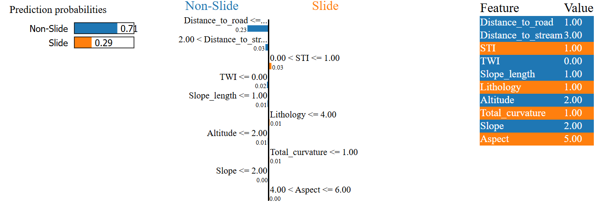
Figure 8: LIME explanation for a correctly predicted 'non-slide' instance (Class 0), showing the individual feature contributions driving the prediction.
5 Conclusion
When a landslide strikes, the losses go far beyond soil and stone. Dealing with landslides proactively is an urgent necessity. This study presents a machine learning approach to landslides susceptibility analysis in Bhutan, comparing the performance of six supervised classification algorithms using stratified 10-fold cross-validation. As a result, Random Forest, XGBoost, and LightGBM have shown themselves to be the most accurate algorithms which surpassed 91% of accuracy and f1-score. Two ablation study has been conducted to ensure the robustness of the results. One was on resampling methods (Undersampling, SMOTE, ADASYN) which did not yield any positive results. Another was on hyperparameter optimization which allowed to boost Random Forest to 92.06% of accuracy and 92.16% of f1-score but it had no effect on XGBoost and LightGBM. The best performance was reached by the soft-voting ensemble of the top 3 models, which provided the highest accuracy (92.14%), f1-score (92.21%), and AUC (97%). The issue of the black-box model has been solved with the help of LIME technique and the interpretation of individual predictions proved the greater importance of ‘Distance to road’ and ‘Distance to stream’ features for both cases. One of the major limitations was the use of pre-discretized features instead of the initial continuous data. In future, it is imperative to use high resolution topographic data and some conditioning factors such as rainfalls in the future.

References
- U.S. Geological Survey, "What is a landslide and what causes one?," U.S. Geological Survey. [Online]. Available: https://www.usgs.gov/faqs/what-a-landslide-and-what-causes-one (accessed Jun. 16, 2026).
- M. N. Khanal, S. Mool and S. R. Shrestha, "Landslide hazard and its impact on road infrastructure in the Himalayan region: Evidence from Bhutan," Natural Hazards, vol. 92, no. 3, pp. 1235–1254, 2018.
- United Nations Office for Disaster Risk Reduction (UNDRR), "This is how Bhutan is bolstering transport infrastructure against landslide risks | UNDRR (new)," YouTube, 2024. [Online]. Available: https://www.youtube.com/watch?v=ekHALKoIZCA (accessed Jun. 20, 2026).
- D. Gyelmo, "Are Bhutan's monsoon landslides becoming more deadly?," PreventionWeb, Jul. 14, 2021. [Online]. Available: https://www.preventionweb.net/news/are-bhutans-monsoon-landslides-becoming-more-deadly (accessed Jun. 17, 2026).
- H. A. H. Al-Najjar, B. Pradhan, R. Sarkar, G. Beydoun and A. Alamri, "A new integrated approach for landslide data balancing and spatial prediction based on generative adversarial networks (GAN)," Remote Sensing, vol. 13, no. 19, pp. 4011, 2021. [Online]. Available: https://doi.org/10.3390/rs13194011.
- R. Sarkar, S. Saha, J. Roy and D. Bhardwaj, "Measuring landslide susceptibility of Phuentsholling, Bhutan using novel ensemble machine learning methods," in Impact of Climate Change, Land Use and Land Cover, and Socio-economic Dynamics on Landslides. Singapore: Springer, 2022, pp. 197–220, doi: 10.1007/978-981-16-7314-6_9.
- S. Saha, R. Sarkar, J. Roy, T. K. Hembram, S. Acharya, G. Thapa and D. Drukpa, "Measuring landslide vulnerability status of Chukha, Bhutan using deep learning algorithms," Scientific Reports, vol. 11, no. 1, Art. no. 16374, 2021, doi: 10.1038/s41598-021-95978-5.
- S. Pasang and P. Kubíček, "Landslide susceptibility mapping using statistical methods along the Asian Highway, Bhutan," Geosciences, vol. 10, no. 11, Art. no. 430, 2020.
- M. Al-Zuhairi, "Bhutan data," Mendeley Data, Version 1, 2019. [Online]. Available: https://doi.org/10.17632/kr62jwy9vw.1.
- F. Pedregosa, G. Varoquaux, A. Gramfort, V. Michel, B. Thirion, O. Grisel, M. Blondel, P. Prettenhofer, R. Weiss, V. Dubourg, J. Vanderplas, A. Passos, D. Cournapeau, M. Brucher, M. Perrot and E. Duchesnay, "Scikit-learn: Machine learning in Python," Journal of Machine Learning Research, vol. 12, pp. 2825–2830, 2011. [Online]. Available: https://jmlr.csail.mit.edu/papers/v12/pedregosa11a.html.
- G. James, D. Witten, T. Hastie and R. Tibshirani, "An introduction to statistical learning," Springer Texts in Statistics, vol. 103, pp. 130–316, 2013. [Online]. Available: https://www.statlearning.com.
- J. M. Keller, M. R. Gray and J. A. Givens, "A fuzzy K-nearest neighbor algorithm," IEEE Transactions on Systems, Man, and Cybernetics, vol. SMC-15, no. 4, pp. 580–585, 1985. [Online]. Available: https://doi.org/10.1109/tsmc.1985.6313426.
- L. Breiman, "Random forests," Machine Learning, vol. 45, no. 1, pp. 5–32, 2001. [Online]. Available: https://doi.org/10.1023/A:1010933404324.
- T. Chen and C. Guestrin, "XGBoost: A scalable tree boosting system," in Proc. KDD, San Francisco, CA, USA, pp. 785–794, 2016.
- G. Ke, Q. Meng, T. Finley, T. Wang, W. Chen, W. Ma, Q. Ye and T.-Y. Liu, "LightGBM: A highly efficient gradient boosting decision tree," Advances in Neural Information Processing Systems, vol. 30, pp. 3146–3154, 2017. [Online]. Available: https://proceedings.neurips.cc/paper/2017/file/6449f44a102fde848669bdd9eb6b76fa-Paper.pdf.
- L. Yang and A. Shami, "On hyperparameter optimization of machine learning algorithms: Theory and practice," Neurocomputing, vol. 415, pp. 295–316, 2020. [Online]. Available: https://doi.org/10.1016/j.neucom.2020.07.061.
- D. M. W. Powers, "Evaluation: from precision, recall and F-measure to ROC, informedness, markedness and correlation," Journal of Machine Learning Technologies, vol. 2, no. 1, pp. 37–63, 2011. [Online]. Available: https://arxiv.org/abs/2010.16061.
- M. A. Duhayyim, S. Abbas, A. A. Hejaili, N. Kryvinska, A. Almadhor and U. G. Mohammad, "An ensemble machine learning technique for stroke prognosis," Computer Systems Science and Engineering, vol. 47, no. 1, pp. 413–429, 2023. [Online]. Available: https://doi.org/10.32604/csse.2023.037127.
- M. T. Ribeiro, S. Singh and C. Guestrin, ""Why should I trust you?": Explaining the predictions of any classifier," in Proc. SIGKDD, San Francisco, CA, USA, pp. 1135–1144, 2016. [Online]. Available: https://doi.org/10.1145/2939672.2939778.
- H. He and E. A. Garcia, "Learning from imbalanced data," IEEE Transactions on Knowledge and Data Engineering, vol. 21, no. 9, pp. 1263–1284, 2009. [Online]. Available: https://doi.org/10.1109/TKDE.2008.239.
Acknowledgement: Acknowledgement and reference heading should be left justified, bold, with the first letter capitalized but have no numbers. Text below continues as normal.
Funding Statement: The author(s) received no specific funding for this study”.
Availability of Data and Materials: The datasets analyzed during the current study are available in the Mendeley Data repository, https://doi.org/10.17632/kr62jwy9vw.1.
Conflicts of Interest: The authors declare that they have no conflicts of interest to report regarding the present study.

Appendix

