NORTH SOUTH UNIVERSITY



A Comparative Analysis of Machine Learning Classifiers for Traffic Delay Severity

Department of Electrical & Computer Engineering, North South University
CSE445: Machine Learning
Section: 1
Course Instructor: Dr. Sifat Momen
December 17, 2025
Group Members:
Name | ID
Karma Sonam Rabgay | 2233716042
Farihaa Khadija Ahmed | 2221852042
Nazia Tasmin | 2212439042
Abdus Samad Sunny | 2212047042

Abstract

Traffic accidents are unavoidable, however, the disorder they bring along could be avoided. In general, most road accidents result in traffic congestion. The loss is often very severe in terms of the economy as well as time. Thus, creating powerful predictive models to lower the risks and delays is the only way to go. The idea behind this project is to create a machine learning framework for classifying severity of traffic delays due to road accidents, specifically distinguishing between moderate and high. A total of four different classifiers: Logistic Regression, Decision Tree, Random Forest, Extreme Gradient Boosting (XGBoost) and K-Nearest Neighbors were trained and optimized through hyperparameter optimization namely GridSearchCV and RandomizedSearchCV. We have found out that the XGBoost classifier provided the best outcome, with an accuracy and a F1 score of 0.89. In addition, we also applied Local Interpretable Model-agnostic Explanations (LIME) to provide interpretability and to point out the major influence of the environmental factors like weather conditions, wind speed, and visibility on the accident frequency.

Introduction

- Background

Human reporting is not enough anymore to get a full picture of traffic delays. Every year, the World Health Organization (WHO) states that traffic accidents not only cause deaths and injuries to millions of people, but also causes countries to bear the economic burden due to loss in productivity [1]. Road accidents form a significant part of non-recurrent traffic jams and are the reason for around 25% of all the traffic delays [2] and the length of the delay caused is directly proportional to the seriousness of the accident; severe accidents need more time for their clearance because of the need for emergency response and investigation which in turn increases the traffic jams. The significance of the issue is undeniable. The shift to self-driving vehicles makes road safety a matter of computation rather than product design. Dhaka too, being the economic and administrative heartbeat of Bangladesh, has to deal with a chaotic traffic situation where accidents on the roads greatly limit movement within the city.

- Problem Statement

Despite the severity of the crisis, traffic control has typically relied on reactive actions where accidents are responded to only after they have taken place, rather than on a proactive basis. Though the latest research has already looked into the application of machine learning for analysis of road accidents, up to now predictive models are but a few; thus, the need for such models still prevails. In the absence of precise predictions, authorities have a hard time determining where to distribute their resources when an accident occurs.

- Objective

In the awakening of artificial intelligence, one has to make the most out of it to bring other critical sectors up to date. Taking this into account, our project introduces a system based on supervised machine learning algorithms, classifying the severity of traffic delay for accident trends and offering the roadmap for safer road networks.

To carry out the data analysis in the best way possible, our model was trained across five machine learning algorithms. Related works in this domain are included in Section II while Section III thoroughly covers the methodology adopted consisting of description of the entire pipeline. Section IV contains the results that gives an in-depth review of each model. Section V comprises discussion followed by concluding remarks in Section VI.

- Literature Review

Ahmed et al. [3] highlighted the necessity of interpretability in high-risk situations in their paper by combining XGBoost and Random Forest with Explainable AI (XAI) methods in their research on injury severity. The results indicated that although ensemble models yield better accuracy, it is very important to apply explainable methods in order to recognize how particular attributes are affecting the accident results directly.

Alshammari et al. [4] used DBSCAN (Density-Based Spatial Clustering of Applications with Noise) for the purpose of pinpointing high-risk zones. Their method, which was based on a combination of spatial clustering and GIS analysis, allowed the authorities to carry out the infrastructure improvements in the regions most subjected to road accidents.

Paul et al. [5] presented an elaborate investigation through local accident data. Accident severity was predicted comparing different classifiers such as Random Forest and Decision Trees. The study achieved impressive accuracy through Decision Trees, which proved the use of supervised learning for the traffic conditions of Bangladesh, which has the different characteristics.

Methodology

This work aims primarily to create a machine learning framework capable of classifying the severity of traffic delay due to accidents thus allowing the authorities to manage traffic proactively. The data used for this purpose is from the US Accidents dataset which is a large-scale national repository available through Kaggle [6].

- Proposed System
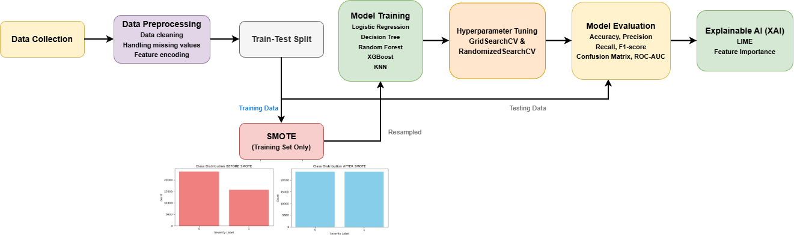

Figure 1: Flowchart of the Proposed System

The figure above illustrates the complete procedure from the data collection and preprocessing stages to the end. It shows the application of SMOTE for training data balancing, then the training of five classification models with hyperparameter optimization. The process is finished by evaluation on the unseen testing data and interpretability of the model with XAI methods.

- Data Preprocessing

Dataset: The US Accidents dataset [6] is quite large to begin with. The original dataset contains a million rows. To make computations efficient and faster, the dataset for data loading was reduced to a first 50,000 records. This smaller dataset was enough for training and assessing the models without exceeding the limits set by the hardware used.

The primary target variable being studied here is Severity, which indicates the degree to which an accident has affected traffic duration. In the original US Accidents dataset [7], this attribute is divided into four labels (1 - 4), according to the amount of traffic delay:

- Severity 1: Least impact on traffic (short delay).
- Severity 4: Significant impact on traffic (long delay).

The dataset's authors have explicitly defined the endpoints; nevertheless, this research considers intermediate classes (Severity 2 and 3) as indicating moderate and high impacts on traffic, respectively.

Severity Level | Count | Impact Description | Action Taken
Severity 1 | 58 | Short Delay | Dropped (Low Frequency)
Severity 2 | 30061 | Moderate Delay | Retained (Mapped to Class 0)
Severity 3 | 19865 | High Delay | Retained (Mapped to Class 1)
Severity 4 | 16 | Long Delay | Dropped (Low Frequency)

Figure 2: Distribution of Severity Levels in the Original Dataset

For the binary classification task, we only considered the most common labels: Severity 2 and Severity 3, while Severity labels 1 and 4 were ignored as they were statistically insignificant (low sample count), thereby causing severe class imbalance. After that, the remaining labels received new mappings; 0 (Moderate) was assigned to Severity 2 and 1 (High) to Severity 3.

Data Cleaning: Numerical features like temperature, humidity, and wind speed with missing values were filled in using the median of the corresponding column. While rows with missing values in categorical features, which are Weather_Condition and Sunrise_Sunset were removed.

Feature Engineering and Selection: Initially, there were 46 features but they were reduced to a list of 13 major features. Among the features, the Start_Time column generated the temporal features which were later on used to get time-related severity patterns (Hour, Month, Weekday) in accidents. After that, we determined a collection of features that were needed for the final dataset. The collection consisted of geometric locations (Start_Lat, Start_Lng), meteorological data (Temperature(F), Humidity(%), Pressure(in), Visibility(mi), Wind_Speed(mph), Weather_Condition), and environmental factors (Sunrise_Sunset).

Data Transformation: With the help of a ColumnTransformer, it was possible to carry out different transformations on various data types at once. The OneHotEncoder was used for converting categorical features into numerical ones while MinMaxScaler was used for scaling all numerical features to the range of [0, 1]. The transformation by MinMaxScaler is given by:

$Xscaled = \frac{X - Xmin}{Xmax - Xmin}$

Here, X is the original value of the feature, Xmin and Xmax are the minimum and maximum values of that feature, respectively [13].

Train-Test Split: The dataset that had been processed was split into sets for training and testing with an 80-20 ratio. Stratified sampling was applied to guarantee that the percentage of "Moderate" and "High" accidents was the same in both the training and testing sets.

- Synthetic Minority Oversampling Technique (SMOTE)

The training data showed a class imbalance problem, wherein there were far more impacts categorized as "Moderate" (Severity 0) than as "High" (Severity 1). To counter this, the training set was subjected to SMOTE (Synthetic Minority Over-sampling Technique). This method made synthetic samples for the minority class (Severity 1) and thus, leading to a balanced class distribution of 23,614 samples for each class prior to model training. The following figure shows class distribution before and after applying SMOTE.

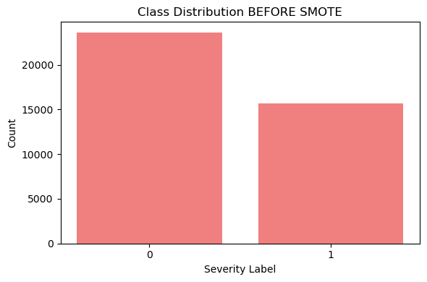
Figure 3: Class distribution before applying SMOTE

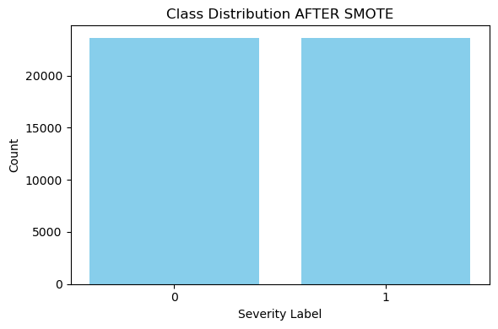
Figure 4: Class distribution after applying SMOTE

- Classifiers used

Having performed the processing of the dataset, we directly applied supervised classification algorithms to categorize the extent of traffic delays as a result of accidents into moderate and high. We used five classifiers, which included Logistic Regression, Decision Tree, Random Forest, XGBoost, and K-Nearest Neighbors. RandomizedSearchCV and GridSearchCV techniques for hyperparameter optimization were applied on Decision Tree, Random Forest, and XGBoost models but not on Logistic Regression and KNN as their baseline performance was quite poor.

- Logistic Regression

Logistic Regression [8], as compared to linear regression, whose output is a continuous value, is a statistical method that classifies the data using the sigmoid function to convert an input into a probability value of 0 to 1, thus showing the probability of the input being in a certain class. The baseline Logistic Regression model produced an 0.57 accuracy and F1 score.

- Decision Tree

The Decision Tree [9] algorithm is a supervised learning approach that repeatedly splits the data into smaller subsets until the stopping condition is satisfied. The Gini index indicates the degree of impurity among the classes within a node while the Entropy measure indicates the level of uncertainty in the dataset. At first, the Decision Tree classifier’s performance was 0.86 accuracy and F1 score, however, with the help of RandomizedSearchCV optimization, we were able to get 0.88 accuracy and F1 score and hence, the accuracy was further improved.

- Random Forest

Random Forest [10], which is an ensemble method, consists of multiple decision trees that are built together and then their outputs are averaged to produce a result that is more precise and stable. In the case of classification, it selects the class by picking the one that has received the most votes from all the trees. Using the Random Forest model, we obtained an 0.78 accuracy and F1 score, which was the same even after hyperparameter optimization.

- Extreme Gradient Boosting (XGBoost)

XGBoost [11] is a gradient boosting method which enhances the learning of decision trees. We were able to get an initial 0.87 accuracy and an 0.88 F1 score with the base XGBoost model. Hyperparameter optimization with GridSearchCV allowed us to get the best performance overall of 0.89 accuracy and F1 score.

- K-Nearest Neighbours (KNN)

KNN [12] is a classifier that searches for the nearest k samples in the feature space, uses their class labels to perform majority voting and finally assigns the new sample the label of the majority class. We were able to get 0.57 accuracy and F1 score with the base KNN model.

Result

The evaluation of the models that were trained was performed by means of accuracy, precision, recall, and F1 score, and, on top of that, by means of ROC-AUC curves. We can calculate these metrics using the following equations:

$Accuracy = \frac{TP + TN}{TP + TN + FP + FN}$

$Precision = \frac{TP}{TP + FP}$

$Recall = \frac{TP}{TP + FN}$

$F1 score = \frac{2 x Precision x Recall}{Precision + Recall}$

The following figure shows the confusion matrices for all five base classifiers (Logistic Regression, Decision Tree, Random Forest, XGBoost, KNN) and their optimized versions using GridSearchCV:

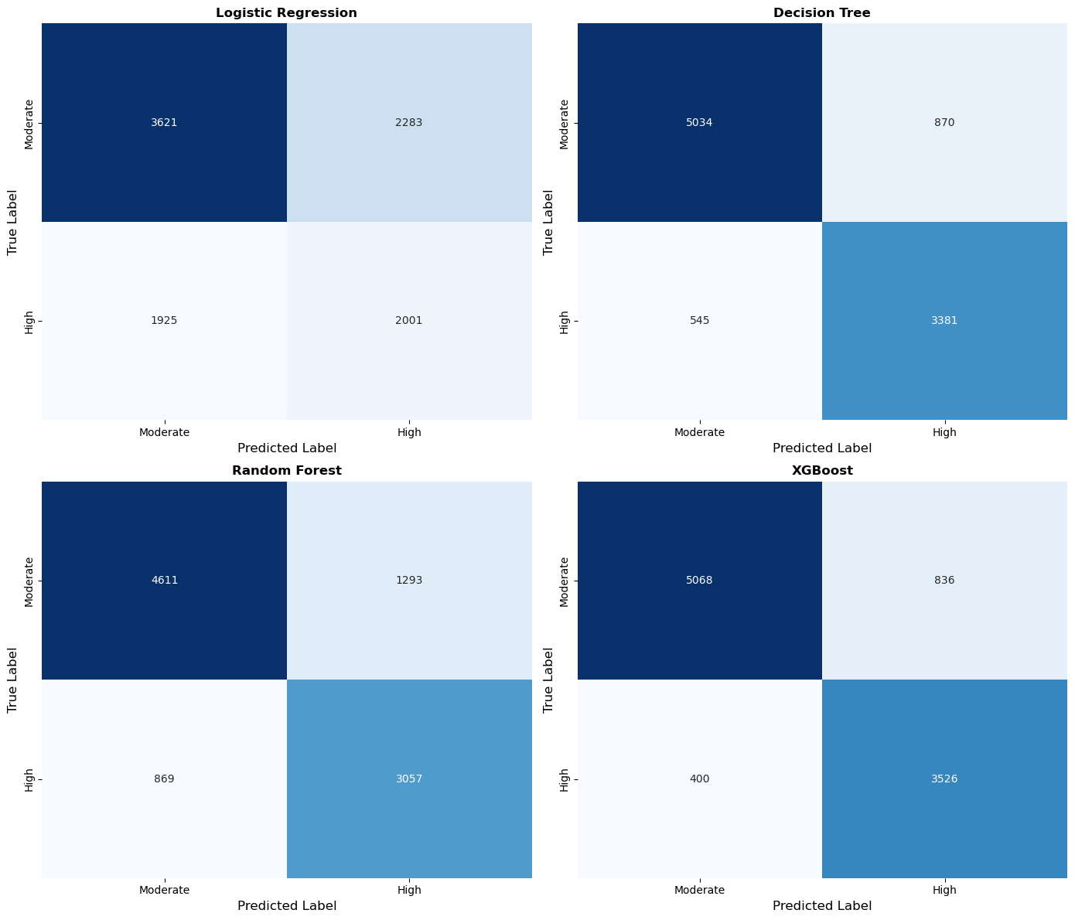
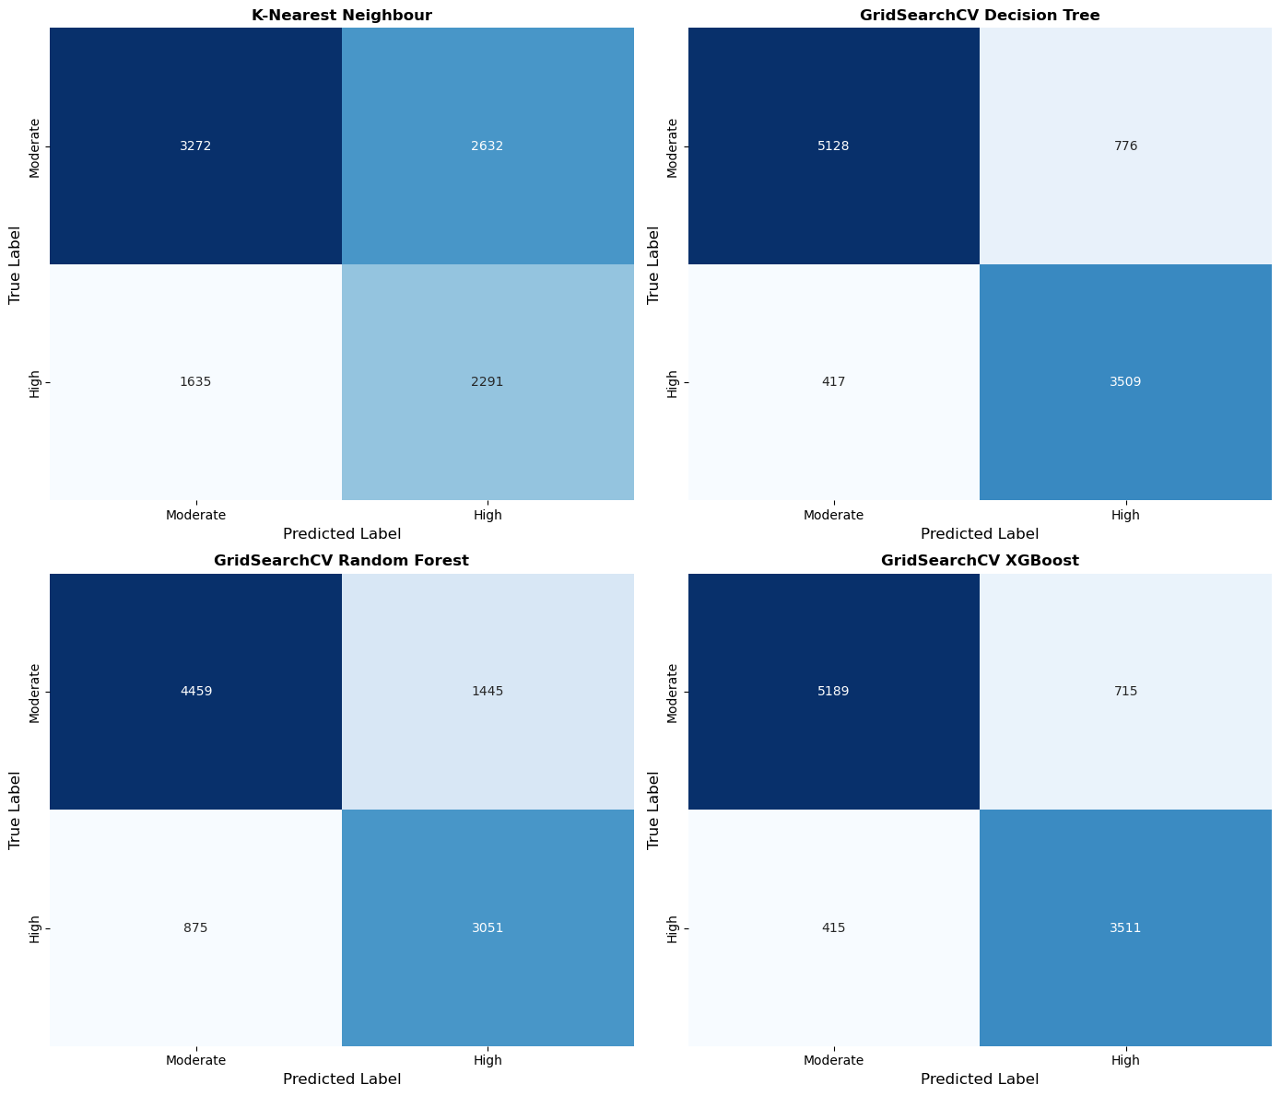
Figure 5: Confusion Matrices of Evaluated Classifiers
The following figure shows the Receiver Operating Characteristic (ROC) curves of all the models, with the True Positive Rate plotted against the False Positive Rate. Also, it shows the Area Under the Curve (AUC) score for each classifier. The XGBoost model with hyperparameter optimization reached the highest AUC score of 0.95 while the Logistic Regression model at the baseline obtained the lowest AUC score of 0.59.

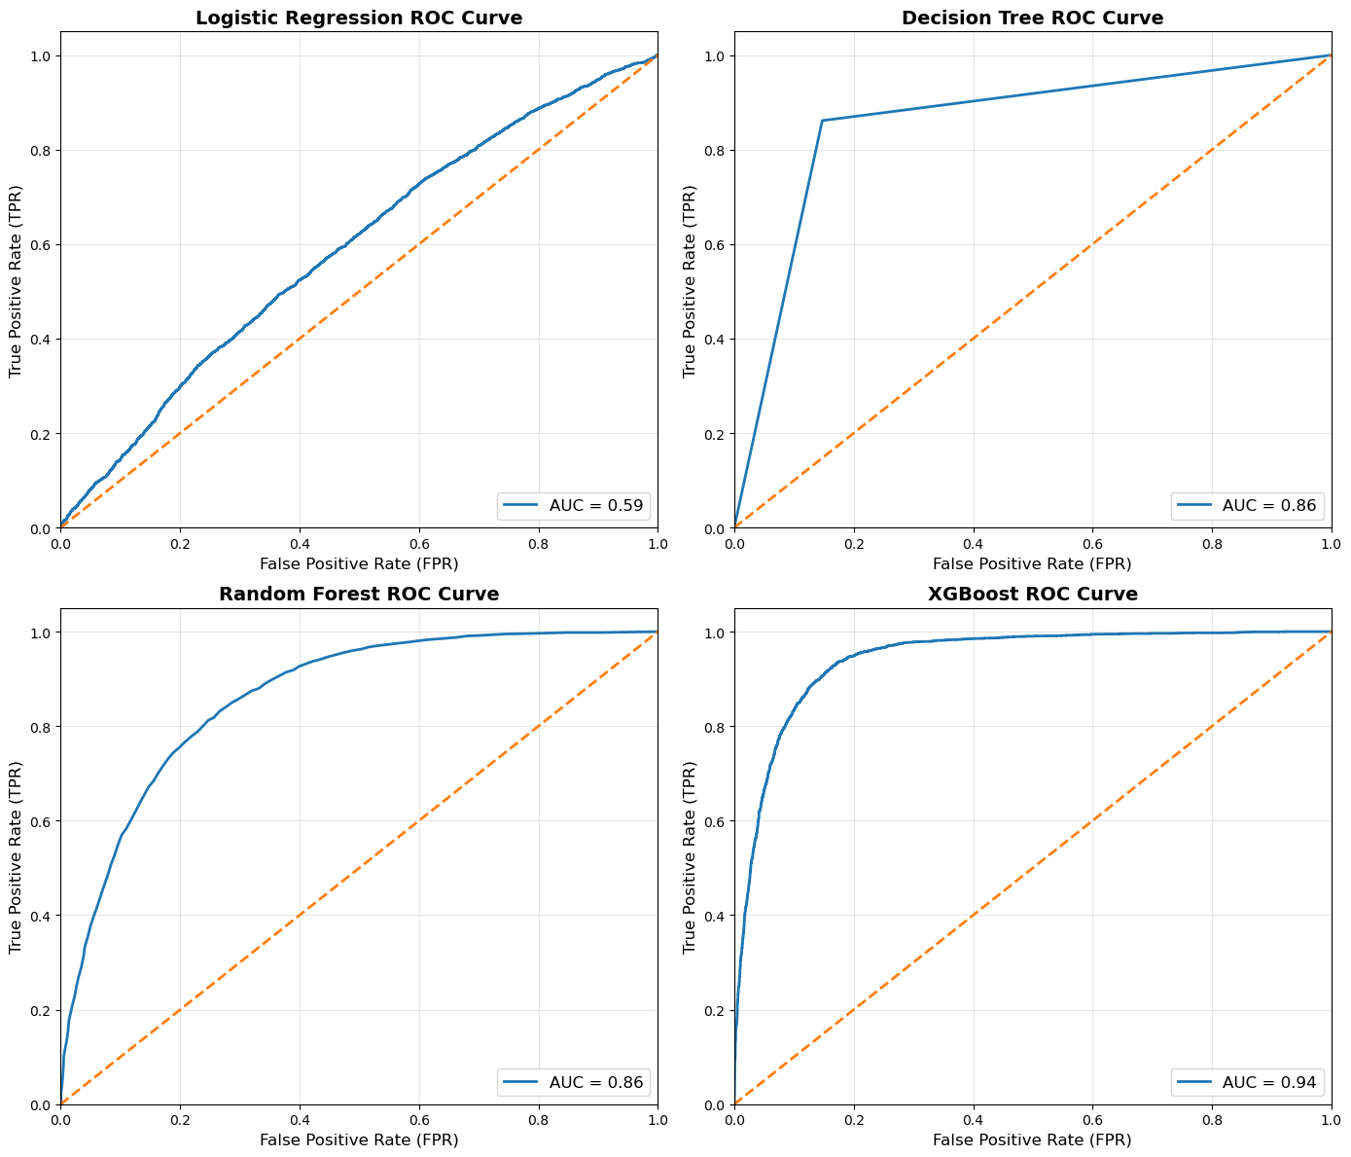
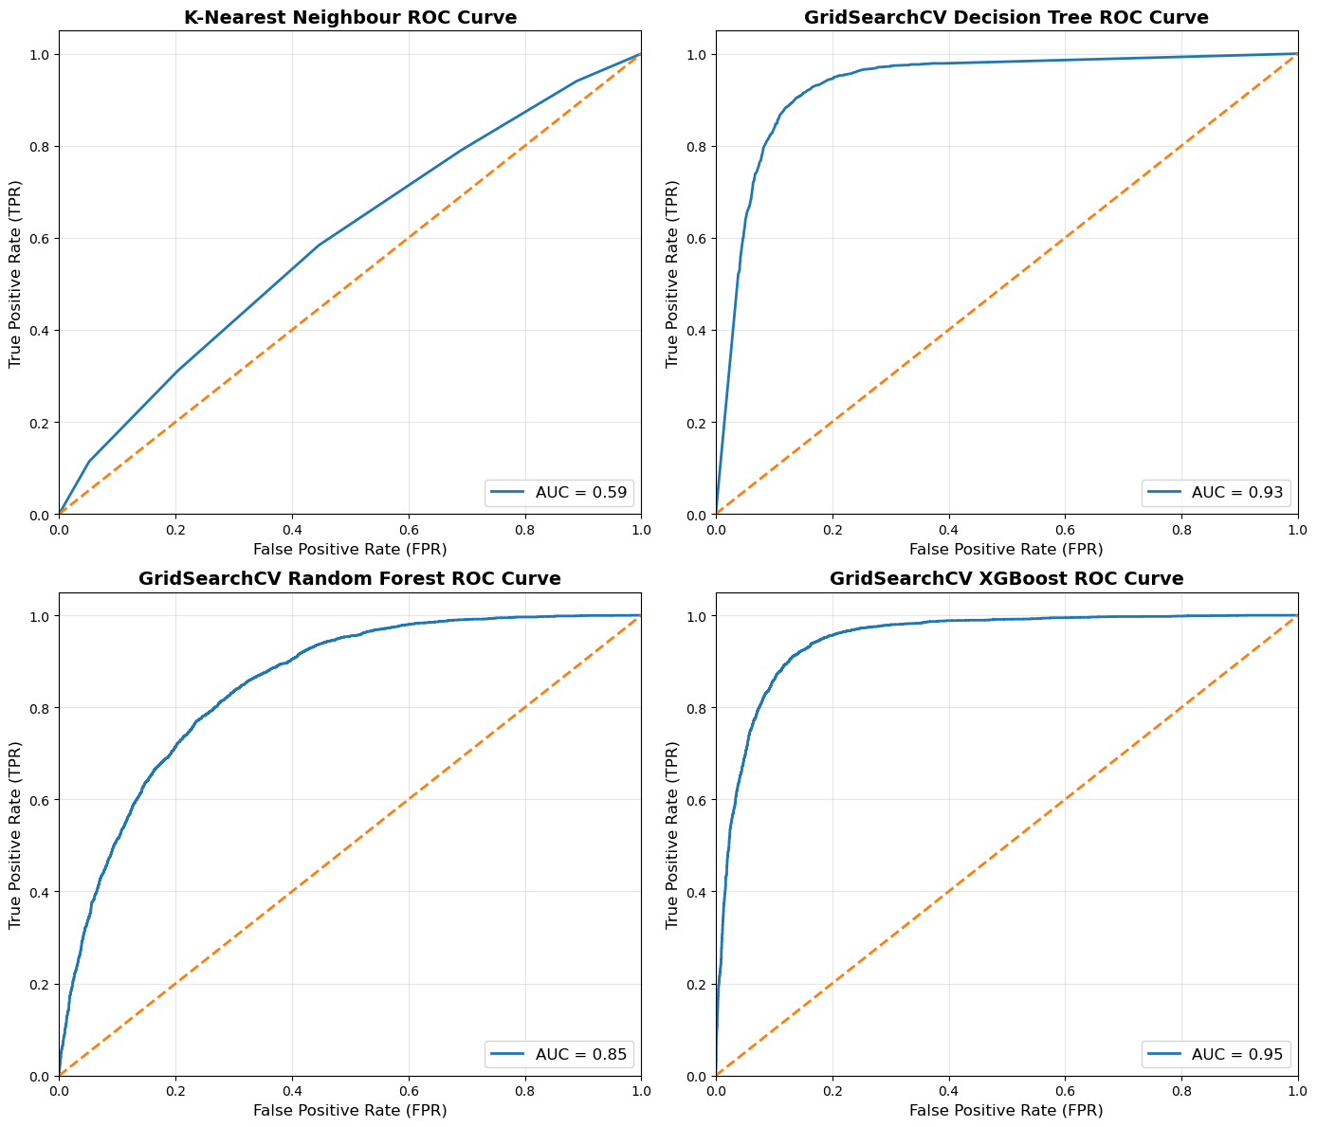
Figure 6: ROC-AUC Curves of Evaluated Classifiers

Model | Accuracy | Precision | Recall | F1-Score | ROC-AUC | Rank(by Accuracy)
Logistic Regression Model | 0.57 | 0.58 | 0.57 | 0.57 | 0.59 | 10
Decision Tree Model | 0.86 | 0.86 | 0.86 | 0.86 | 0.86 | 6
Random Forest Model | 0.78 | 0.79 | 0.78 | 0.78 | 0.86 | 7
XGBoost Model | 0.87 | 0.88 | 0.87 | 0.88 | 0.94 | 5
K-Nearest Neighbors Model | 0.57 | 0.59 | 0.57 | 0.57 | 0.59 | 11
RandomizedSearchCV Decision Tree Model | 0.88 | 0.88 | 0.88 | 0.88 | 0.93 | 4
RandomizedSearchCV Random Forest Model | 0.76 | 0.77 | 0.76 | 0.77 | 0.85 | 9
RandomizedSearchCV XGBoost Model | 0.88 | 0.89 | 0.88 | 0.88 | 0.95 | 2
GridSearchCV Decision Tree Model | 0.88 | 0.88 | 0.88 | 0.88 | 0.93 | 3
GridSearchCV Random Forest Model | 0.76 | 0.77 | 0.76 | 0.77 | 0.85 | 9
GridSearchCV XGBoost Model | 0.89 | 0.89 | 0.89 | 0.89 | 0.95 | 1

Figure 6: Comparative Performance Metrics of Used Models

The table above illustrates each classifiers' performance through the specified metrics: Accuracy, Precision, Recall, F1 Score, and ROC-AUC. The XGBoost model with GridSearchCV was the best performer with an accuracy and F1 score of 0.89 and Logistic Regression and KNN was the least performing model.

Explainable AI (XAI) Analysis

The following figure illustrates a Local Interpretable Model-agnostic Explanations (LIME) analysis for one particular accident case from the test set.

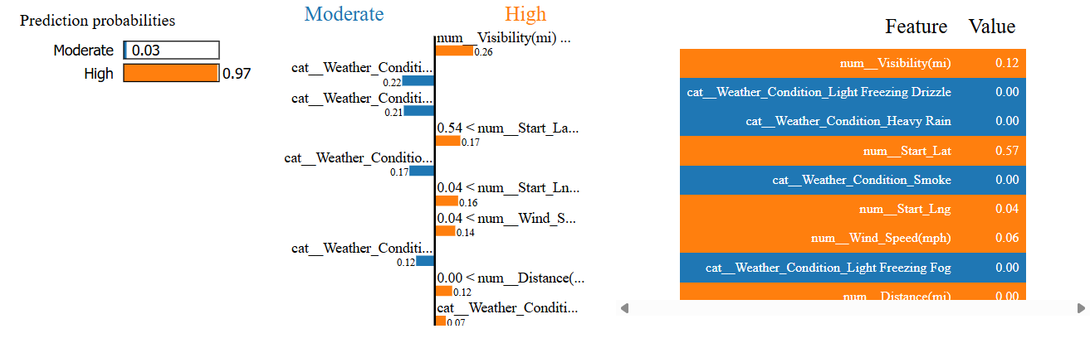
Figure 7: LIME Explanation Visualizing Feature Contributions to a High Severity Prediction

The model has a very high level of certainty regarding this classification, thus it gives a 97% probability (0.97) to the "High" class of severity and a mere 3% probability (0.03) to the "Moderate" class. Visibility is a powerful influencing factor. The value of 0.12 (on a scaled 0-1 range) indicates that low visibility was a major factor in the severity of the accident being increased. It is intuitive that poor visibility typically leads to more dangerous collisions and lengthens the clearance job. The latitude (0.57) and longitude (0.04) are also important positive factors. This means that the accident took place in a certain geographic area which could probably be a busy highway or intersection. Hence the model has recognized that area as a hotspot for severe delays. Moreover, a wind speed value of 0.06 was also in support of the "High" prediction, which means that the weather conditions were not only bad for visibility but also affecting the driving environment.

Discussion

The analysis of different models revealed that Extreme Gradient Boosting (XGBoost) was the best model for predicting the severity of traffic delays. XGBoost was able to get up to 0.89 in accuracy and F1 score and 0.95 in ROC-AUC after hyperparameter optimization through GridSearchCV. While the optimized Decision Tree model was very close to XGBoost with an accuracy of 0.88, Random Forest was stuck at 0.78. On the other hand, Logistic Regression and K-Nearest Neighbors were not helpful and were able to reach only 57% accuracy probably due to their incapacity to model non-linear relationships.

Among several factors, the use of the Synthetic Minority Over-sampling Technique (SMOTE) was one of the most significant and it helped overcome the class imbalance issue and biasing the model to the "Moderate" severity class. Furthermore, the LIME analysis verified the model's interpretability for the prediction of high-severity accidents.

Conclusion

The machine learning framework for classification of traffic delays by severity has been successfully established by this project, thus making it possible to switch traffic management strategies from reactive to proactive ones. Out of the five algorithms evaluated, the XGBoost classifier stood out as the best model with accuracy 0.89. Explainable AI (LIME) has confirmed this, proposing that such factors as weather and the location play a very important role in classifying the severity of traffic delay due to accidents. Our system will allow the authorities to find out the best way to use their resources, and which measures to take for the safety of the public, in case there is an accident.The plan for the future is to increase dataset size to more than the current 50,000, which will allow for greater model usefulness.

Reference

[1] Asian Transport Observatory, "Bangladesh Road Safety Profile 2025," Asian Transport Observatory, Sep. 2025. [Online]. Available: https://asiantransportobservatory.org/analytical-outputs/roadsafetyprofiles/bangladesh-road-safety-profile-2025/. [Accessed: Dec. 7, 2025].

[2] Wikipedia, "Traffic congestion," Wikipedia, Dec. 14, 2025. [Online]. Available: https://en.wikipedia.org/wiki/Traffic_congestion

[3] S. Ahmed et al., "A study on road accident prediction and contributing factors using explainable machine learning models: analysis and performance," Transportation Research Interdisciplinary Perspectives, vol. 19, p. 100814, 2023. [Online]. Available: https://doi.org/10.1016/j.trip.2023.100814

[4] N. Alshammari et al., "Exploring Road Traffic Accidents Hotspots Using Clustering Algorithms and GIS-Based Spatial Analysis," IEEE Access, vol. 12, 2024. [Online]. Available: https://www.researchgate.net/publication/374159015_A_GIS_Approach_for_Analysis_of_Traffic_Accident_Hotspots_in_Abha_and_Bisha_Cities_Saudi_Arabia

[5] J. Paul, R. Islam, S. C. Bakchy, and S. Das, "Prediction of Road Accident and Severity of Bangladesh Applying Machine Learning Techniques," in 2020 IEEE 8th R10 Humanitarian Technology Conference (R10-HTC), 2021, pp. 1-6. [Online]. Available: https://ieeexplore.ieee.org/document/9356987

[6] S. Moosavi, M. H. Samavatian, S. Parthasarathy, and R. Ramnath, "A Countrywide Traffic Accident Dataset," arXiv preprint arXiv:1906.05409, 2019.

[7] S. Moosavi, M. H. Samavatian, S. Parthasarathy, R. Teodorescu, and R. Ramnath, "Accident Risk Prediction based on Heterogeneous Sparse Data: New Dataset and Insights," in Proceedings of the 27th ACM SIGSPATIAL International Conference on Advances in Geographic Information Systems, Chicago, IL, USA, 2019.

[8] GeeksforGeeks, "Logistic Regression using Python," GeeksforGeeks, Jul. 11, 2025. [Online]. Available: https://www.geeksforgeeks.org/machine-learning/ml-logistic-regression-using-python/

[9] GeeksforGeeks, "Decision Tree," GeeksforGeeks, Jun. 30, 2025. [Online]. Available: https://www.geeksforgeeks.org/machine-learning/decision-tree/

[10] GeeksforGeeks, "Random Forest Classifier using Scikit-learn," GeeksforGeeks, Nov. 13, 2025. [Online]. Available: https://www.geeksforgeeks.org/dsa/random-forest-classifier-using-scikit-learn/

[11] GeeksforGeeks, "XGBoost," GeeksforGeeks, Oct. 24, 2025. [Online]. Available: https://www.geeksforgeeks.org/machine-learning/xgboost/

[12] GeeksforGeeks, "Mathematical explanation of K-Nearest Neighbour," GeeksforGeeks, Jul. 23, 2025. [Online]. Available: https://www.geeksforgeeks.org/machine-learning/mathematical-explanation-of-k-nearest-neighbour/

[13] F. Pedregosa et al., "Scikit-learn: Machine Learning in Python," Journal of Machine Learning Research, vol. 12, pp. 2825–2830, 2011.

