

**Proposal**

**For**

**Second Year Project**

**Bachelor of Science in Information Technology**

**Timing Reminder**

**Submitted by**

**Karma Choda(12190055)**

**Gyalpozhing College of Information Technology**

**Introduction**

People often forget to perform everyday tasks, and they may find it difficult to recall details related to the tasks they have already completed (Hodges et al., 2006). For example, people may fail to remember, or ‘forget’, future intentions such as buying milk or visiting the dentist. Recent technological innovations, such as smartphone-based reminder apps, can help users to remember future tasks.

Reminder apps (applications) have played an important role in my life by supporting my academic career. I mostly used app for future work. They have helped me to remember assignment deadlines, group meetings, classes and exams. In addition, they remind me of other activities, such as meetings etc. Reminder apps have a number of advantages, as people now use their smartphones and tablets to be reminded of future tasks. This study examines how and why users use reminder apps, including whether they use them for study, sport and other tasks or whether they just use it for one type. It also examines the functions and content that users need in reminder apps. The choices people have for spending time and the multiple pressures on time have increased the interest in tools for helping people to schedule and manage their tasks and remind them when tasks are due. With the ubiquity and constant proximity of personal mobile devices, many people are using electronic reminder apps to assist them. There is a proliferation of such apps with a diversity of interfaces, features and theoretical foundations. Clearly there is no one answer to fit all user needs.

## Scope:

* User scope of this project is to limited to the interested user. Therefore, this project will transform the existing manual complaint management system into an automated system.

## Scope of project is limited to interested user, so therefore service provided to user might not fulfilled.

## Functional Requirement

## User Requirement:

## Add reminder: User can add the with the tittle and description.

## Date: User can select the date which date reminder needs to reminds.

## Time: User can also set the timing for the reminders to reminds with specific AM/PM.

## Active: In the active user can the view their reminder to be reminds later with fix time and date.

## Repeated: User can set the repetition how many times the same reminder can reminds in different timing.

## History: User can view the reminders that was already reminds the important notes.

## Non-functional Requirement

## Portability: My application can run all the android smartphones users. It can be portable where ever user go. It can be treat and used my app without access of any internet connection.

## Maintainability: I will follow best practices for clean code and software modularity in order to make the application as maintainable as possible.

**Hardware Requirement**

**For Developer:**

1. Laptop 8GB ram
2. Android phone for testing purposes
3. USB for connection between Laptop and emulator

**For User:**

1. Android phone

**Use case Diagram**

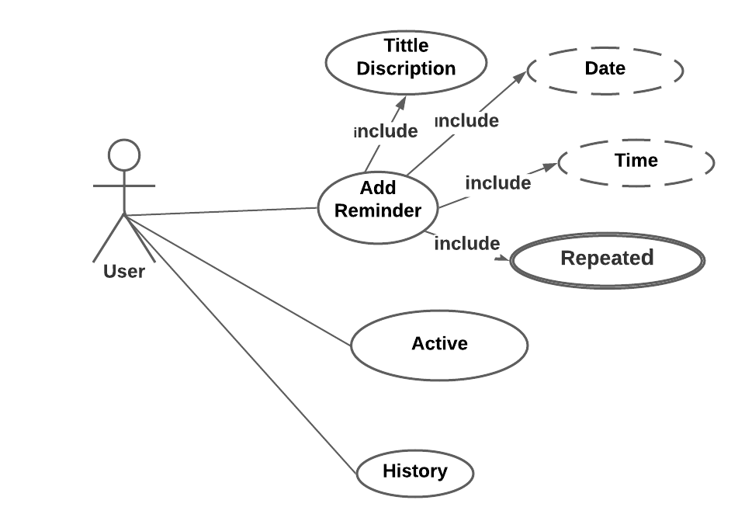

**Explanation:**

1. **Add reminder**: user can add the reminder with the following specification:

* Tittle and Description: User can add the reminder with tittle and description of the reminders.
* Date: user can select and fix the date to reminds to the user.
* Time: It is same as the date select and fix for the specific time. Date and are derived attributes because it can have derived from the system.
* Repeated: It also dropdown list where user can select after how much iteration the reminders should repeat again.

1. **Active:** user can view the reminders that are to be remind later
2. **History:** User view the events that are reminded already through this button.

**ERD Diagram**

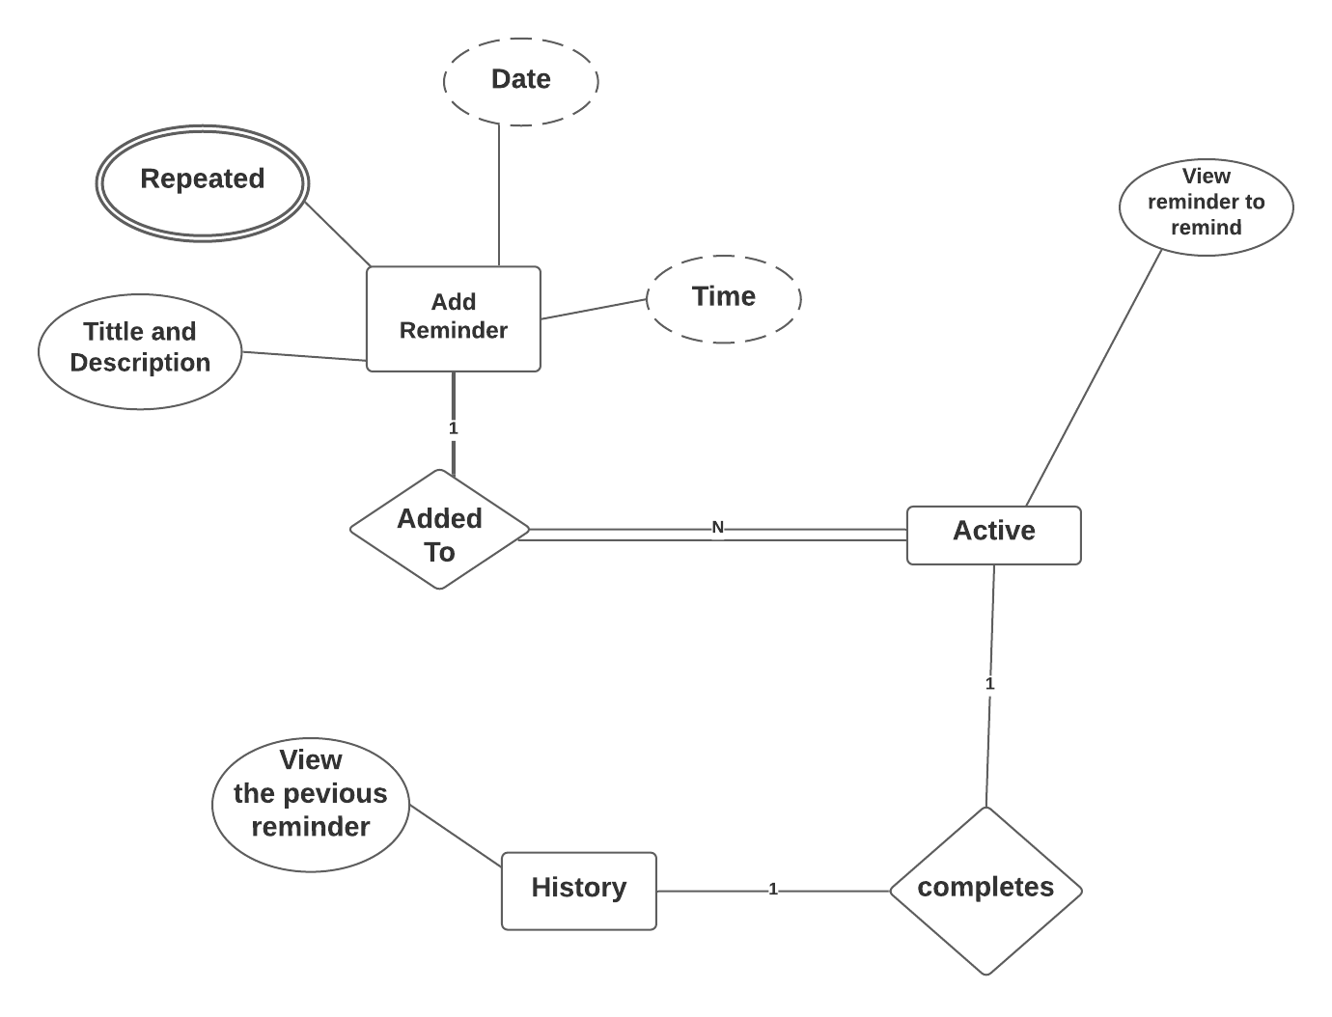

**Explanation:**

1. **Relationship:**

* Between Add reminder and Active: One to many because user can add one reminder event at different time and date, where user can view many same event at different time in active table.
* Between Active and History: One to one relationship because one the reminder was reminds for user with time and date view in the history table.

**Sequence Diagram**

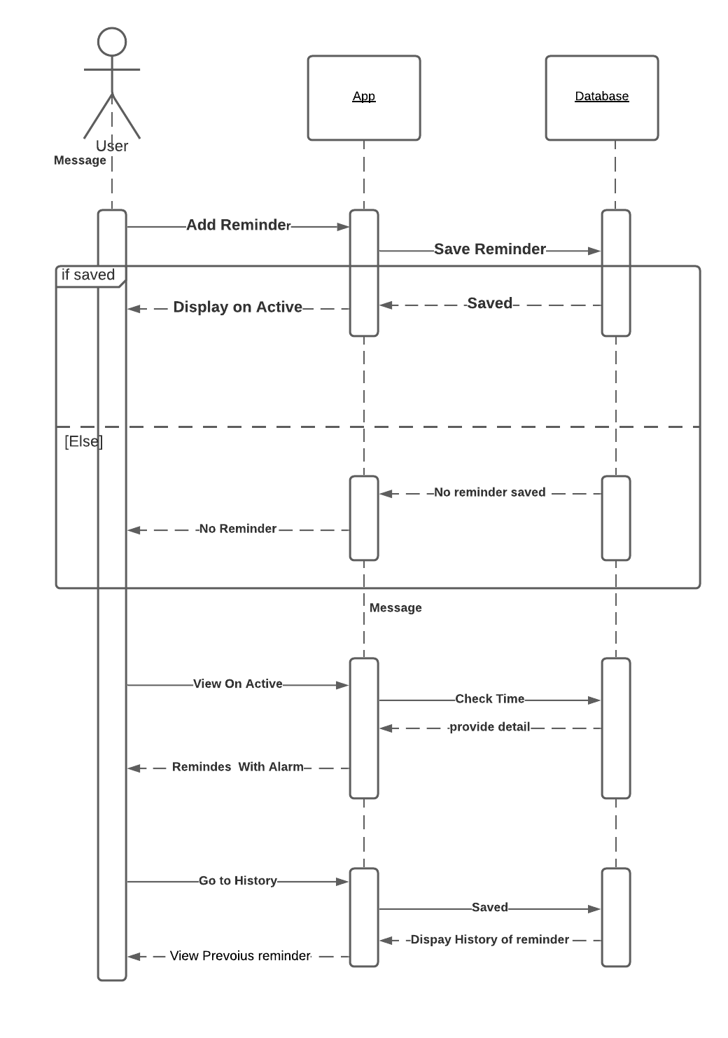

**Explanation**

**Add Reminder:** User can add Their reminder with provided time and date to application and save to the database if it is saved in the database display through app to user if data is not saved in the database the no reminder to be display.

**View On Active:**  If the reminder is not reminding to the user it will saved in the Active and after reminder reminds to the user it will save in the History.

Add reminder

|  |  |  |
| --- | --- | --- |
| Time | Date | Title and Description |

Repeated

|  |  |
| --- | --- |
| Repeated | Time |

Active

|  |  |
| --- | --- |
| View the reminder to be remind | Time |

History

|  |  |
| --- | --- |
| View the previous reminder | Time |