

NetGuard AI: Machine Learning-Based Network Intrusion Detection and Attack Classification System
Karmanya Singh (PRN 24070126079)
karmanyas06@gmail.com
[Mobile number]

Student Name Surname
Email ID
Mobile Number

Student Name Surname
Email ID
Mobile Number

Student Name Surname
Email ID
Mobile Number
GitHub Link: https://github.com/Karmanya-Singh30/NetGuard-AI
Project Deployment Link: https://netguard-ai.streamlit.app
Project Guide Name: [guide name]
Abstract—Network intrusion detection must separate malicious from benign traffic reliably, yet many machine-learning studies report near-perfect scores that do not survive realistic evaluation. This project builds NetGuard AI, a leak-free flow-classification pipeline and web application, using the public CIC-IDS2017 dataset (2,830,743 flows, 78 CICFlowMeter features, 14 attack labels). Infinite values were treated as missing, 332,638 duplicate or label-conflicting flows were removed before a stratified 80/20 split, and all imputation, feature filtering and resampling were fitted on training data inside scikit-learn pipelines. A majority baseline, logistic regression, a decision tree, a random forest and histogram gradient boosting were tuned by cross-validation and compared on 499,621 held-out flows. The selected random forest (30 features) achieved a recall of 99.77 %, a precision of 99.64 %, an F1-score of 0.997 and a false-positive rate of 0.074 %, whereas the baseline reached 83 % accuracy while detecting nothing and logistic regression produced 6 % false alarms. An attack-family model with in-fold SMOTE obtained a weighted F1 of 0.999 but a macro F1 of 0.893, exposing weak rare classes. Crucially, when trained on Monday–Thursday and tested on Friday's unseen attack types, recall fell to 10.1 %, showing that random-split scores measure recognition of known attacks rather than detection of novel ones. Permutation importance and SHAP explanations and a Streamlit interface for offline analysis complete the system.
Keywords—network intrusion detection, CIC-IDS2017, random forest, gradient boosting, data leakage, explainable AI

Introduction
Cyberattacks on networked infrastructure are frequent, diverse and costly, and security teams must triage very large volumes of traffic. Signature-based defences detect known patterns precisely but miss variants, while anomaly detection, conceptualised in Denning's intrusion-detection model [1], tends to raise many false alarms. Flow-based machine learning classifies summaries of host-to-host conversations (durations, packet and byte counts, timing and TCP-flag statistics). It scales to high traffic rates, works on encrypted traffic and never inspects payload content. The problem addressed here is to classify a network flow as benign or malicious, and to estimate its attack family, with few missed attacks and few false alarms, evaluated honestly and with explanations an analyst can inspect.
Public benchmark datasets underpin most of this research [2]. CIC-IDS2017 [3] provides five days of labelled traffic with modern attacks, and its authors report weighted F1-scores of up to 0.98 for tree classifiers. Later audits found substantial flow-construction and labelling errors in the same data [4], [5]. Broader studies of machine learning in security warn that evaluation pitfalls such as data snooping, spurious correlations and lab-only evaluation often produce unrealistic performance [6], [7].
The current challenges are therefore not only accuracy but trustworthy evaluation: duplicate flows that leak across random splits, preprocessing fitted on test data, accuracy figures that hide rare-class failures, features that encode testbed artefacts, and the gap between recognising known attack types and detecting new ones.
NetGuard AI addresses these challenges with a reproducible, leak-free pipeline. Duplicates are removed before splitting, and every learned step is fitted inside a scikit-learn pipeline on training data only. Models are selected by cross-validation, never by the test set. Evaluation uses imbalance-aware metrics with per-class error analysis, a held-out-day test for unseen attack types, and explanations. A web application exposes the model for offline analysis of flow records.
Key contributions: (i) a cleaned and profiled CIC-IDS2017 pipeline with explicit leakage controls; (ii) a comparison of five models under cross-validated tuning; (iii) an attack-family model with an in-fold comparison of imbalance strategies; (iv) a held-out-day generalisation experiment; (v) global and per-flow explanations; (vi) a seven-page Streamlit application and an automated test suite of 108 tests.
The rest of the report is organised as follows. Section II reviews related work, Section III describes the dataset and methodology, Section IV the implementation, and Section V the results and analysis. Section VI concludes.

Related Work
Table 1 summarises the studies most relevant to this project. The dataset paper [3] established strong baseline results but reported weighted averages, which are dominated by the large classes. Engelen et al. [4] showed that over a quarter of the flows are artefacts of flow construction and that per-class F1 changes drastically after correction, although overall accuracy stays at 0.99. Lanvin et al. [5] independently identified labelling flaws and their effect on detection performance. Sommer and Paxson [6] and Arp et al. [7] explain why such results may not transfer to real networks. This project therefore reports per-class and macro metrics, removes duplicates, and adds an unseen-attack evaluation.
Table 1. Related work on ML-based intrusion detection with CIC-IDS2017
Paper No | Methodology/  Algorithm/  Techonlogy Name | Dataset name, if used | Results | Limitations
[3] Sharafaldin et al., 2018 | Benign traffic profiled from 25 users; CICFlowMeter (>80 features); KNN, RF, ID3, AdaBoost, MLP, Naive Bayes, QDA | CIC-IDS2017 | Weighted F1: ID3 0.98, RF 0.97, KNN 0.96, QDA 0.92, AdaBoost 0.77, MLP 0.76, NB 0.04 | Weighted averages mask rare classes; no evaluation on unseen attack types
[4] Engelen et al., 2021 | Audit of traffic generation, flow construction and labelling; corrected dataset; RF re-evaluation | CIC-IDS2017 | >25 % of flows are artefacts; RF F1 Web-XSS 0.18→0.79, Bot 0.60→0.99 after correction, while accuracy stayed 0.99 | Correction requires reprocessing raw pcaps; still a lab testbed
[5] Lanvin et al., 2023 | Identification of packet misordering, duplication and mislabelled attacks; re-evaluation of supervised IDS | CIC-IDS2017 | Corrections significantly change measured detection performance | Single dataset; corrected labels not part of the standard ML CSVs
[6] Sommer & Paxson, 2010 | Analysis of ML for network intrusion detection | — (conceptual) | High error cost, semantic gap, traffic diversity and evaluation difficulty limit real-world use | No empirical system
[7] Arp et al., 2022 | Study of pitfalls in 30 ML-security papers (e.g. data snooping, spurious correlations, lab-only evaluation) | Various | Pitfalls are widespread and lead to unrealistic performance | Guidance, not a detection method

Methodology

Architecture/Flow Diagram
Fig. 1 shows the system. An offline training pipeline produces models, metrics and figures. The web application only reads these artifacts and never trains. Training and inference share one scikit-learn pipeline object, so inputs are treated identically in both. (The editable draw.io source is docs/architecture.drawio.)
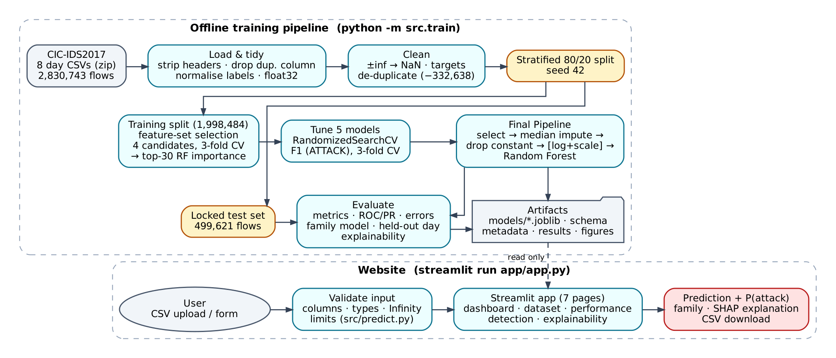
Fig. 1. NetGuard AI architecture and data flow.

Dataset/Input used
The input is the CIC-IDS2017 MachineLearningCSV release from the Canadian Institute for Cybersecurity [3] (https://www.unb.ca/cic/datasets/ids-2017.html): eight CSV files, one per capture session from 3–7 July 2017. It contains 2,830,743 flows with 78 numeric features and a Label. Benign traffic makes up 80.3 % (2,273,097 flows), and the 557,646 attack flows are spread over 14 labels, from DoS Hulk (231,073) down to Heartbleed (11). The binary target is ATTACK (the positive class) for every non-benign label. The family target groups the labels into DoS, DDoS, PortScan, BruteForce, WebAttack, Bot, Infiltration and Heartbleed. The release has no IP addresses or timestamps.
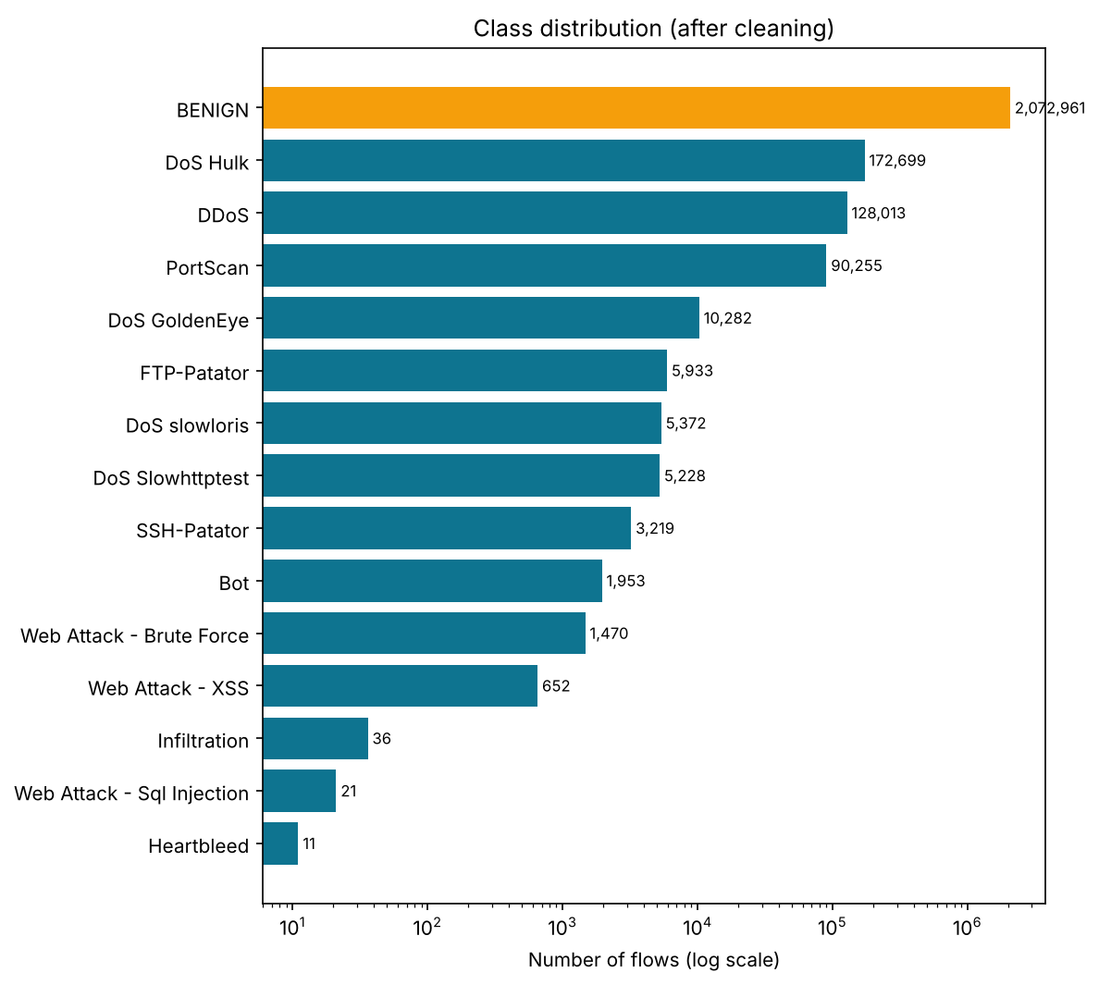
Fig. 2. Class distribution after cleaning (log scale). Three attack labels have fewer than 40 flows.
Exploratory analysis (Fig. 3) found 1,358 missing and 1,509 infinite values in Flow Bytes/s and 2,867 infinite values in Flow Packets/s, all caused by zero-duration flows. It also found eight constant columns, a duplicated Fwd Header Length column and 331,200 exact duplicate rows (11.7 %). The duplicate share reaches about 45 % for SSH-Patator and 43 % for PortScan, whose tools emit identical flows. Attack types are tied to capture days: Wednesday is DoS, and Friday is PortScan, DDoS and Bot.
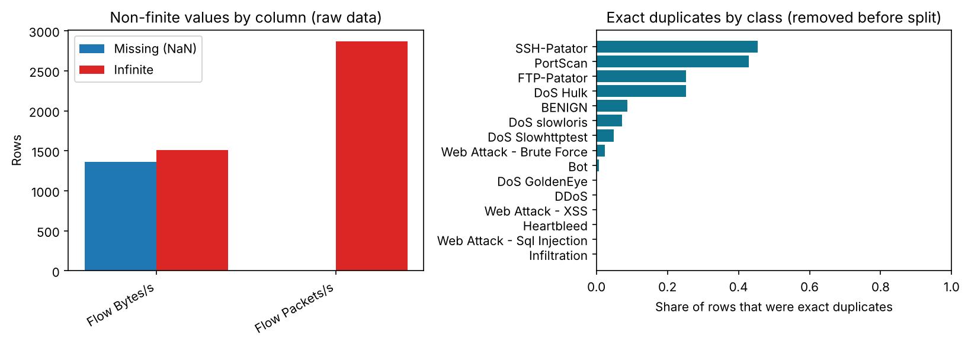
Fig. 3. Non-finite values per column (left) and share of exact duplicates per class (right).

Data preprocessing / Input preprocessing steps
• Tidy: strip header whitespace; drop the duplicated column after verifying it is identical; normalise mis-encoded web-attack labels; cast features to float32.
• Non-finite values: ±∞ → missing, then median imputation fitted on training data.
• De-duplication before the split: 331,200 exact duplicates and 1,438 flows with identical features but conflicting labels were removed (2,498,105 flows remain), so no flow can appear in both training and test data.
• Split: stratified 80/20 on the fine-grained label (seed 42): 1,998,484 training and 499,621 test flows, both 17.02 % attack. The test set was locked until final evaluation.
• Leakage controls: imputation, constant-feature removal, scaling and SMOTE live inside pipelines that cross-validation refits per fold. Destination Port was excluded as a testbed shortcut, and the capture-day file name is used only for bookkeeping.
• Feature selection (Table 2): four candidate sets were compared by 3-fold CV on a 199,995-flow training subsample. The smallest set within 0.002 F1 of the best was chosen: the top 30 features by random-forest importance.
Table 2. Feature-set comparison (training data, 3-fold CV)
Candidate feature set | Features | CV F1 | CV recall
All eligible features | 76 | 0.9937 | 0.9908
Correlation filter (|r| ≤ 0.98) | 48 | 0.9944 | 0.9920
Top 30, mutual information | 30 | 0.9930 | 0.9922
Top 30, random-forest importance (chosen) | 30 | 0.9954 | 0.9942

Algorithm/Techniques used
Five classifiers were compared. A majority-class baseline always predicts BENIGN. Logistic regression computes P(attack) = 1/(1+e^(−z)) with z = β₀ + Σβᵢxᵢ and is trained by minimising class-weighted binary cross-entropy with L2 regularisation. It uses sign(x)·log(1+|x|) and standardisation (z = (x−μ)/σ, with μ and σ from training data). A decision tree splits on the threshold that maximises impurity reduction, measured by Gini = 1−Σpᵢ² or entropy H = −Σpᵢlog₂pᵢ. A random forest [8] averages the class probabilities of 100 trees grown on bootstrap samples (at most 400,000 flows per tree on the full data) with random feature subsets. Histogram gradient boosting adds shallow trees sequentially, F_m(x) = F_{m−1}(x) + η·h_m(x), each fitted to the gradient of the log loss, with early stopping.
Hyperparameters were tuned with randomised search and stratified 3-fold CV on the training subsample, scored by F1 of the ATTACK class (Table 3). The final model is the one with the highest mean CV F1. Models within 0.001 are tie-broken by CV specificity, then prediction speed, and the test set is never consulted. For the attack-family model, no balancing, balanced class weights (w_c = N/(K·N_c)) and SMOTE [9] (x_new = x_i + λ(x_j − x_i), applied only inside training folds) were compared by CV macro-F1. Explanations use permutation importance on test data, impurity importance, and SHAP [10]. Everything is implemented with scikit-learn [11].
Table 3. Hyperparameter search spaces and selected values
Model | Search space | Selected
Logistic regression | C ∈ {0.01, 0.1, 1, 10} | C = 1
Decision tree | max_depth {10, 20, none}; min_samples_leaf {1, 5, 20}; criterion; class_weight | depth 20, leaf 1, entropy, balanced
Random forest (100 trees) | max_depth {20, 30, none}; min_samples_leaf {2, 5, 10}; max_features {√p, 0.3}; class_weight | depth none, leaf 2, √p, balanced_subsample
Hist. gradient boosting | learning_rate {0.05, 0.1, 0.2}; max_leaf_nodes {31, 63, 127}; l2 {0, 1}; class_weight | lr 0.2, 63 leaves, l2 1, none

Implementation

Software/Cloud Platform/Hardware Requirements
Software: Python 3.12, pandas 3.0, NumPy 2.5, scikit-learn 1.9, imbalanced-learn 0.14, SHAP 0.54, Matplotlib/Seaborn, Plotly and Streamlit 1.66 (exact versions are pinned in requirements.txt). The reported run executed on a Lenovo LOQ laptop (Intel Core i5, 24 GB RAM, Windows 11, Python 3.12.4); the complete pipeline took 9.7 minutes. An independent run on a Linux workspace produced an identical final model. The project runs on Python 3.11 or later. With less than 12 GB of RAM it automatically fits final models on a stratified 1-million-row subsample that keeps every rare-class row. No cloud service is required.

Front End Development and Results
The front end is a seven-page Streamlit application: Dashboard, Dataset explorer, Model performance, Intrusion detection, Explainability, Methodology and About & limitations. Every number it shows is read from the saved result files. The detection page accepts a CSV upload, a demo sample of real held-out test flows, or a single-flow form. It reports how many flows were flagged, the distribution of P(attack), an optional family estimate and a downloadable CSV. Single flows get a per-flow SHAP explanation. All pages state that the tool performs offline analysis and that predictions are model estimates (Figs. 4–5).

Fig. 4. Dashboard with test-set metrics, build information and known limits.
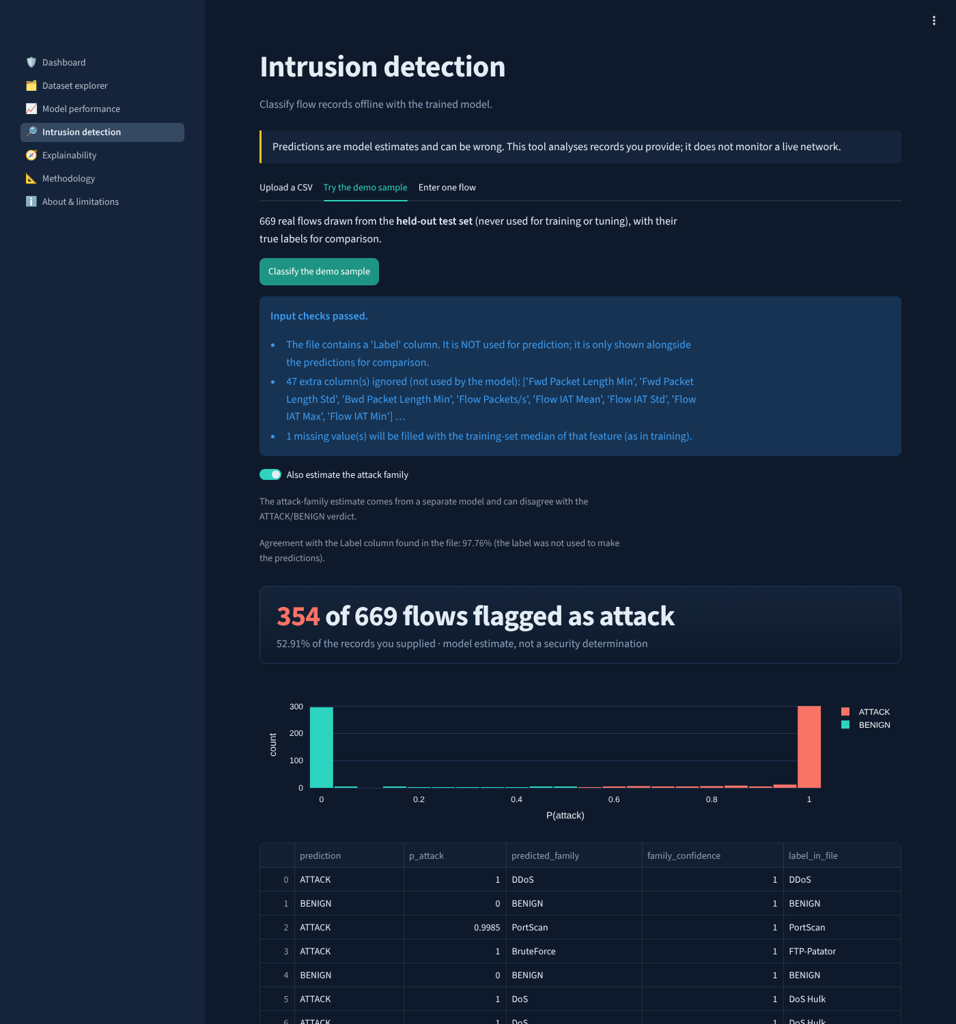
Fig. 5. Intrusion detection on 669 real held-out test flows: 354 flagged; 97.8 % agreement with the true labels (rare classes deliberately over-represented in the demo).

Back End Development and Results
The back end is a Python package (src/) with separate modules for configuration, loading, preprocessing, feature selection, training, evaluation, prediction and explainability. A single command, python -m src.train, regenerates every artifact. These are the fitted pipelines (joblib), the feature schema, metadata with library versions, JSON/CSV results and all figures. Inference validates uploads before prediction: required columns are checked by name and order-independently, non-numeric values are rejected with the offending column named, Infinity is treated as missing as in training, and there are size and row limits. An input-realism check warns when records do not resemble the training traffic: values outside the training range, such as a PSH Flag Count other than 0 or 1, or many extreme features. It flags 2 of 499,621 real test flows but 72 of 100 hand-generated rows. Uploads are parsed only as CSV and never deserialised. A pytest suite of 108 tests covers loading, cleaning, the absence of shared rows across the split, leakage guards, schema validation, save/reload, metric definitions and an end-to-end run of every web page. A rehearsal on 2.8 million synthetic rows before the real run exposed, and led to fixes for, three memory overflows and a model-serialisation fault. Reloading the saved models reproduced every test count exactly.

Result and Analysis

Test Case 1: Binary Detection on the Random Split
On the 499,621 test flows (85,029 attacks), the selected random forest detected 99.77 % of attacks (199 missed) and raised 308 false alarms on 414,592 benign flows (FPR 0.074 %), with precision 0.9964 and F1 0.9970 (Fig. 6). Detection was at least 99.2 % for DoS, DDoS, PortScan and brute force, 96.7 % for web attacks and 84.9 % for Bot. The rarest classes were missed most often: all 4 SQL-injection, 5 of 7 Infiltration and 1 of 2 Heartbleed test flows (Fig. 7). Engelen et al. [4] likewise report a random-forest F1 of 0.11 for SQL injection. Missed attacks are mostly borderline (median P(attack) 0.36) and look like near-empty flows (median average packet size 3 bytes). The false alarms are their mirror image: benign flows with a median average packet size of 3 bytes, against 78.5 for correctly passed benign traffic.
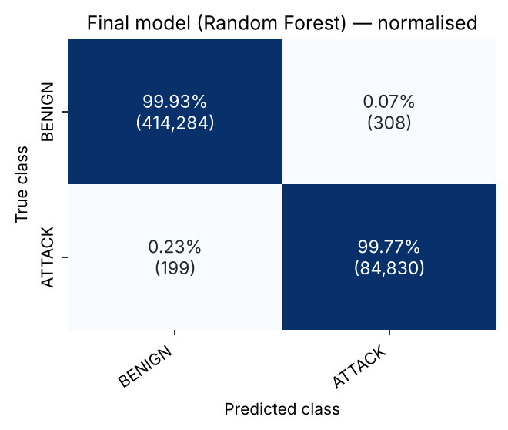
Fig. 6. Final model confusion matrix (test set).
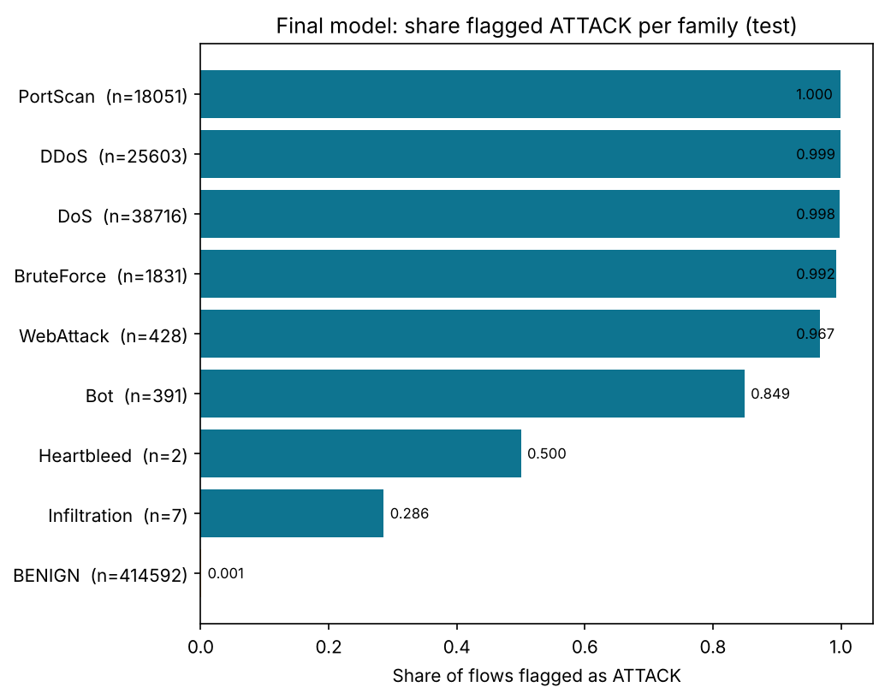
Fig. 7. Share of flows flagged as ATTACK per family (detection rate for attacks; false-alarm rate for BENIGN).

Test Case 2: Attack-Family Classification
In-fold SMOTE raised the CV macro-F1 from 0.940 (no balancing or class weights) to 0.954, so it was selected. On the test set the family model reached a weighted F1 of 0.9986 but a macro F1 of only 0.893 (Table 4, Fig. 8). The large families exceed 0.99 F1 and are confused with each other in under 0.03 % of cases. Bot recall rose to 98 %, but 356 benign flows were labelled Bot, giving a precision of 0.52. Infiltration and Heartbleed rest on 7 and 2 test flows, and 2 of 7 and 1 of 2 were labelled benign.
Table 4. Attack-family results (test set)
Family | Precision | Recall | F1 | Test flows
BENIGN | 0.9997 | 0.9985 | 0.9991 | 414,592
DoS | 0.9960 | 0.9975 | 0.9968 | 38,716
DDoS | 0.9996 | 0.9990 | 0.9993 | 25,603
PortScan | 0.9953 | 0.9996 | 0.9974 | 18,051
BruteForce | 0.9956 | 0.9967 | 0.9962 | 1,831
WebAttack | 0.9816 | 0.9953 | 0.9884 | 428
Bot | 0.5189 | 0.9821 | 0.6790 | 391
Infiltration | 0.7143 | 0.7143 | 0.7143 | 7
Heartbleed | 1.0000 | 0.5000 | 0.6667 | 2
Macro / weighted avg. | 0.911 / 0.999 | 0.909 / 0.999 | 0.893 / 0.999 | 499,621

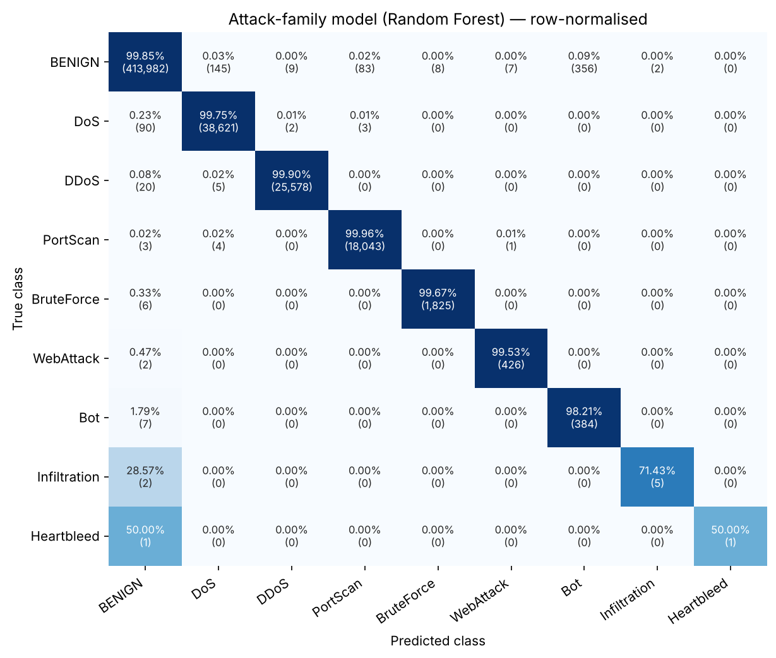
Fig. 8. Row-normalised attack-family confusion matrix.

Test Case 3: Held-Out Day (Unseen Attack Types)
To test generalisation to new attack types, the same random-forest configuration was retrained on all Monday–Thursday flows (1,882,812) and tested on all Friday flows (615,293). Friday's Bot, PortScan and DDoS never appear earlier in the week. Recall fell from 0.998 to 0.101 (Table 5, Fig. 9): DDoS was detected 17.4 % of the time, PortScan 0.07 % and Bot not at all. Precision stayed at 0.995 with an FPR of 0.03 %. The model learned what the known attack tools look like, not what malicious traffic looks like in general. This is the closed-world limitation described in [6], [7].
Table 5. Random split versus held-out day
Evaluation | Recall | Precision | FPR | F1 | ROC-AUC
Random 80/20 split | 0.9977 | 0.9964 | 0.00074 | 0.9970 | 0.99996
Held-out Friday (unseen types) | 0.1014 | 0.9951 | 0.00028 | 0.1841 | 0.7680

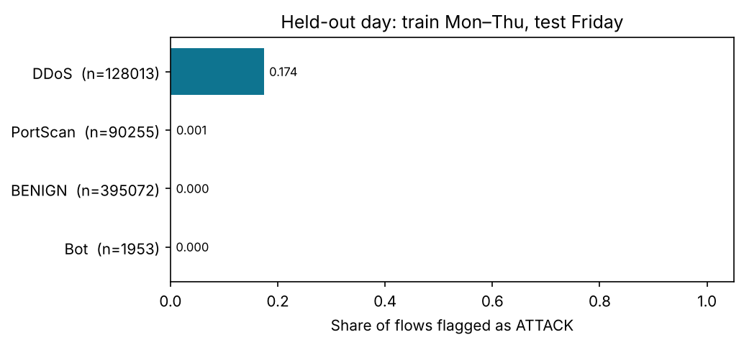
Fig. 9. Held-out day: share of Friday flows flagged per label.

Total performance analysis
Overall, the pipeline detects known attack types almost perfectly while keeping false alarms below 0.1 %. The ensemble models rank flows almost perfectly (ROC-AUC 0.99996, PR-AUC 0.99985), so the threshold can be moved with little loss: at 0.3, recall rises to 99.91 % and FPR to 0.12 %. The threshold was fixed at 0.5 in advance. Explanations agree that packet-length statistics and the TCP initial-window sizes drive the decisions (Fig. 10). Permutation importance ranks PSH Flag Count, Init_Win_bytes_forward, Flow Bytes/s and Init_Win_bytes_backward highest. The window-size features reflect the testbed machines' operating-system settings, a likely dataset-specific shortcut [4], [7]. Importance describes what the model uses, not what causes an attack.
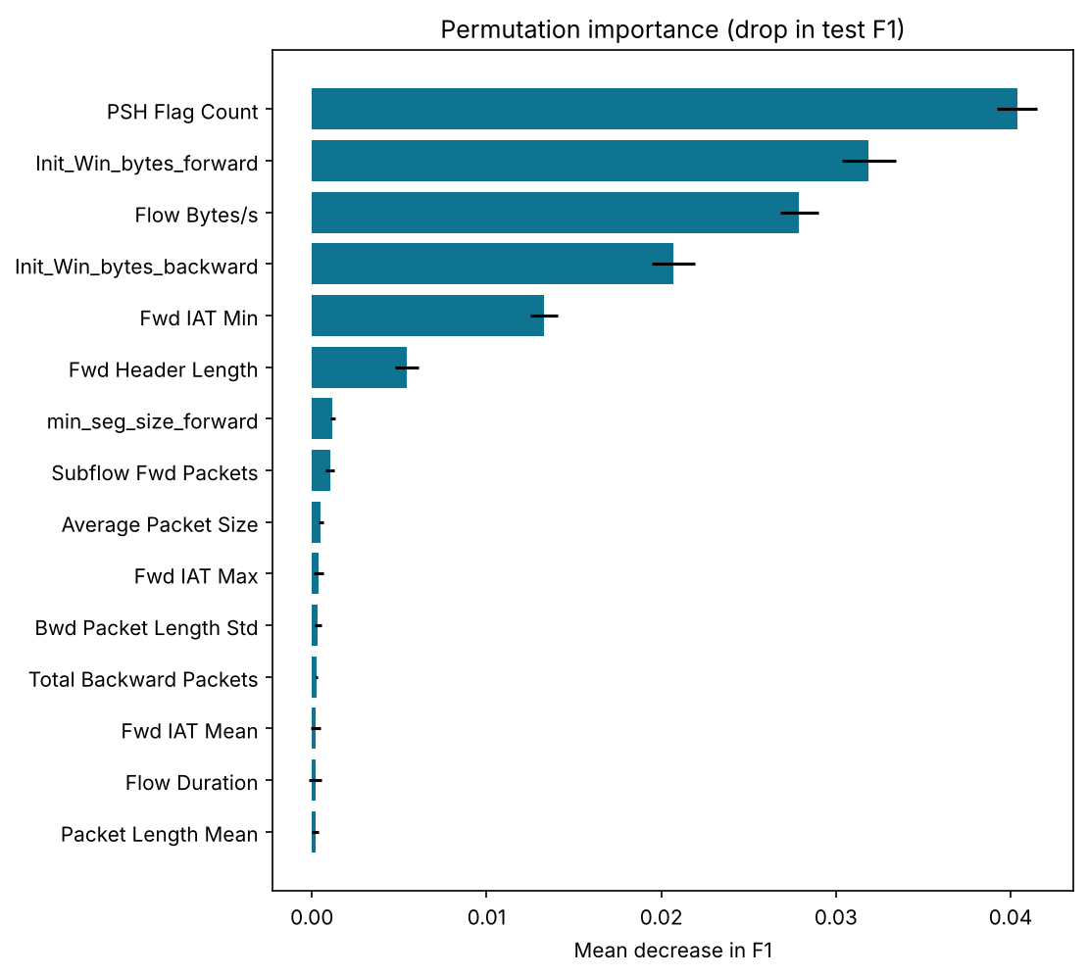
Fig. 10. Permutation importance on 20,000 test flows (drop in F1; 5 repeats).

Comparative Analysis of Model
Table 6. Binary model comparison on the held-out test set (positive class = ATTACK)
Model | CV F1 | Precision | Recall | F1 | FPR | ROC-AUC | Fit (s)
Dummy (always BENIGN) | 0.0000 | n/a | 0.0000 | 0.0000 | 0.00000 | n/a | 6.1
Logistic regression | 0.8545 | 0.7591 | 0.9542 | 0.8456 | 0.06209 | 0.9849 | 35.5
Decision tree | 0.9952 | 0.9955 | 0.9990 | 0.9972 | 0.00094 | 0.9994 | 37.4
Random forest (final) | 0.9957 | 0.9964 | 0.9977 | 0.9970 | 0.00074 | 0.99996 | 27.7
Hist. gradient boosting | 0.9963 | 0.9971 | 0.9976 | 0.9973 | 0.00059 | 0.99998 | 20.9

The baseline reaches 83.0 % accuracy while detecting nothing, which shows why accuracy cannot select an IDS model. Logistic regression ranks attacks reasonably (ROC-AUC 0.985) but raises false alarms on 6.2 % of benign traffic (25,743 flows), and its training and validation F1 are equal (0.855). Both point to underfitting a non-linear, threshold-like problem. The decision tree misses fewest attacks but raises 26 % more false alarms than the random forest and shows the largest train–validation gap (0.004). The random forest and gradient boosting were within the 0.001 CV tie margin, and the forest was chosen for its higher CV specificity. On the test set they are practically tied: boosting had 62 fewer false alarms and 7 more misses out of half a million flows. Boosting trains faster and is smaller; the forest predicts faster (0.9 vs 1.7 ms per 1,000 flows) (Fig. 11).
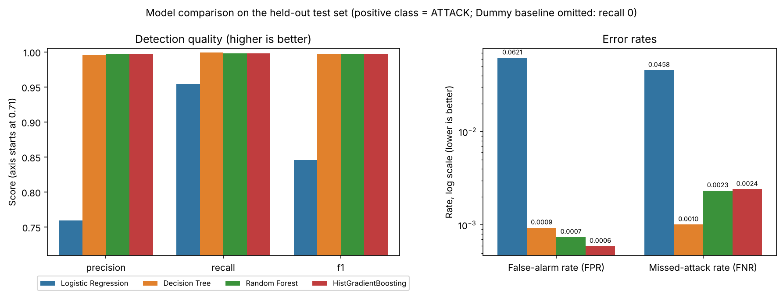
Fig. 11. Detection quality (left) and error rates on a log scale (right) for the four learned models.

Limitations of Current Work
• Laboratory traffic from 2017 with documented flow-construction and labelling errors [4], [5]; results may not transfer to real or current networks.
• Random-split scores measure recognition of known attack types; unseen types were mostly missed (10.1 % recall on the held-out day).
• The rarest classes (SQL injection, Infiltration, Heartbleed) have too few examples to learn or evaluate reliably.
• Influential features include likely testbed artefacts (TCP initial window sizes).
• Offline analysis of CICFlowMeter features only: no live capture, flow extraction or prevention.

Conclusion
This project built NetGuard AI, an end-to-end, reproducible system for classifying network flows from the CIC-IDS2017 dataset, together with a Streamlit application for offline analysis and explanation. Careful engineering removed duplicate and conflicting flows before splitting, confined all learned preprocessing and resampling to training data, and selected models by cross-validation alone. Under these controls a random forest on 30 features detected 99.77 % of attacks with a false-positive rate of 0.074 %, far ahead of a majority baseline that detected nothing at 83 % accuracy and a logistic regression with 6 % false alarms. An attack-family model reached a weighted F1 of 0.999, but its macro F1 of 0.893 exposed unreliable rare classes. The most important finding is negative: on a held-out day containing unseen attack types, recall fell to 10.1 %. The model recognises the attacks it was trained on rather than malicious behaviour in general, and influential features include testbed artefacts. Random-split results on this dataset should therefore not be read as evidence of protection against new attacks. Future work should evaluate on newer and corrected datasets and across datasets, add live flow extraction, choose thresholds from analyst costs, and combine supervised detection with anomaly detection for unseen threats.

References
- D. E. Denning, “An intrusion-detection model,” IEEE Trans. Softw. Eng., vol. SE-13, no. 2, pp. 222–232, 1987.
- M. Ring, S. Wunderlich, D. Scheuring, D. Landes, and A. Hotho, “A survey of network-based intrusion detection data sets,” Computers & Security, vol. 86, pp. 147–167, 2019.
- I. Sharafaldin, A. H. Lashkari, and A. A. Ghorbani, “Toward generating a new intrusion detection dataset and intrusion traffic characterization,” in Proc. 4th Int. Conf. Inf. Syst. Secur. Privacy (ICISSP), 2018, pp. 108–116, doi: 10.5220/0006639801080116.
- G. Engelen, V. Rimmer, and W. Joosen, “Troubleshooting an intrusion detection dataset: the CICIDS2017 case study,” in Proc. IEEE Secur. Privacy Workshops (SPW), 2021, doi: 10.1109/SPW53761.2021.00009.
- M. Lanvin, P.-F. Gimenez, Y. Han, F. Majorczyk, L. Mé, and É. Totel, “Errors in the CICIDS2017 dataset and the significant differences in detection performances it makes,” in Risks and Security of Internet and Systems (CRiSIS 2022), LNCS vol. 13857, Springer, 2023, pp. 18–33, doi: 10.1007/978-3-031-31108-6_2.
- R. Sommer and V. Paxson, “Outside the closed world: On using machine learning for network intrusion detection,” in Proc. IEEE Symp. Secur. Privacy, 2010, pp. 305–316.
- D. Arp et al., “Dos and don'ts of machine learning in computer security,” in Proc. 31st USENIX Secur. Symp., 2022.
- L. Breiman, “Random forests,” Mach. Learn., vol. 45, no. 1, pp. 5–32, 2001.
- N. V. Chawla, K. W. Bowyer, L. O. Hall, and W. P. Kegelmeyer, “SMOTE: Synthetic minority over-sampling technique,” J. Artif. Intell. Res., vol. 16, pp. 321–357, 2002.
- S. M. Lundberg and S.-I. Lee, “A unified approach to interpreting model predictions,” in Adv. Neural Inf. Process. Syst. (NeurIPS), 2017.
- F. Pedregosa et al., “Scikit-learn: Machine learning in Python,” J. Mach. Learn. Res., vol. 12, pp. 2825–2830, 2011.

