STOCKPILOT AI
Multi-Agent Inventory Intelligence
and Replenishment System
PROJECT REPORT
Submitted by
Karmanya Singh
Department of Artificial Intelligence and Machine Learning
Symbiosis Institute of Technology, Pune
CA-3 • Agentic AI Proof of Concept

Abstract
StockPilot AI is a prototype for inventory decision support that brings inventory analysis, replenishment planning, purchase-cost estimation, and budget validation into one interactive application. It uses a synthetic retail inventory dataset and a Streamlit dashboard to demonstrate how a coordinated set of software modules can break a business task into smaller, inspectable stages.
The workflow begins with product and sales information, including current stock, units sold over a defined period, supplier lead time, safety stock, and unit cost. The Inventory Analyst calculates demand-related indicators and stock risk; the Replenishment Agent prepares candidate order quantities; and the Critic / Validator checks quantity rules, cost arithmetic, and the purchasing budget. A Planner Agent coordinates the sequence, while the dashboard presents the resulting inventory views, proposed plan, validation status, and execution trace.
In the demonstrated run, the dashboard displayed 25 products across five categories, 2,192 units on hand, and a purchasing budget of ₹10,000. The proposed approved cost was ₹9,972.10, leaving ₹27.90. Validation reported two passed checks, two warnings, and zero errors. The warnings concerned products P001 and P006, whose approved quantities were below their suggested quantities. These results describe the shown synthetic-data run only; they do not establish real-world forecasting accuracy or business savings.

1. Introduction
Inventory decisions involve a balance between availability and cost. Holding too much stock can tie up working capital, while holding too little can lead to stockouts and missed sales. Decisions also depend on supplier lead times, safety stock, demand patterns, and the budget available for purchasing.
In a small or disconnected workflow, a person may need to review spreadsheets, calculate reorder quantities, estimate costs, and check the total against a budget. StockPilot AI explores how these tasks can be arranged into a consistent software workflow. Rather than claiming to replace a human inventory manager, the prototype provides structured calculations and visible validation results that a user can review before acting.

1.1 Problem Statement
How can inventory data be analyzed systematically to recommend replenishment quantities while considering stock requirements and financial constraints?

1.2 Project Objectives
- Monitor inventory levels and identify potential stockout risks.
- Estimate replenishment requirements using demand and supplier lead-time information.
- Generate purchase recommendations based on configurable target stock levels.
- Validate proposed purchases against a user-defined budget.
- Present inventory insights, recommendations, validation status, and workflow activity through an interactive dashboard.

2. System Overview and Architecture
StockPilot AI is organized into four logical layers. Each layer has a clear role, making the application easier to explain, test, and extend.
Layer | Purpose
Data layer | Provides synthetic inventory records containing product, stock, sales, lead-time, safety-stock, and unit-cost fields.
Agent layer | Separates planning, inventory analysis, replenishment calculations, and validation into specialized software modules.
Orchestration layer | Coordinates execution order, passes results between stages, and records workflow events and validation outcomes.
Presentation layer | Uses Streamlit to show inventory indicators, category charts, product tables, replenishment results, and agent activity.

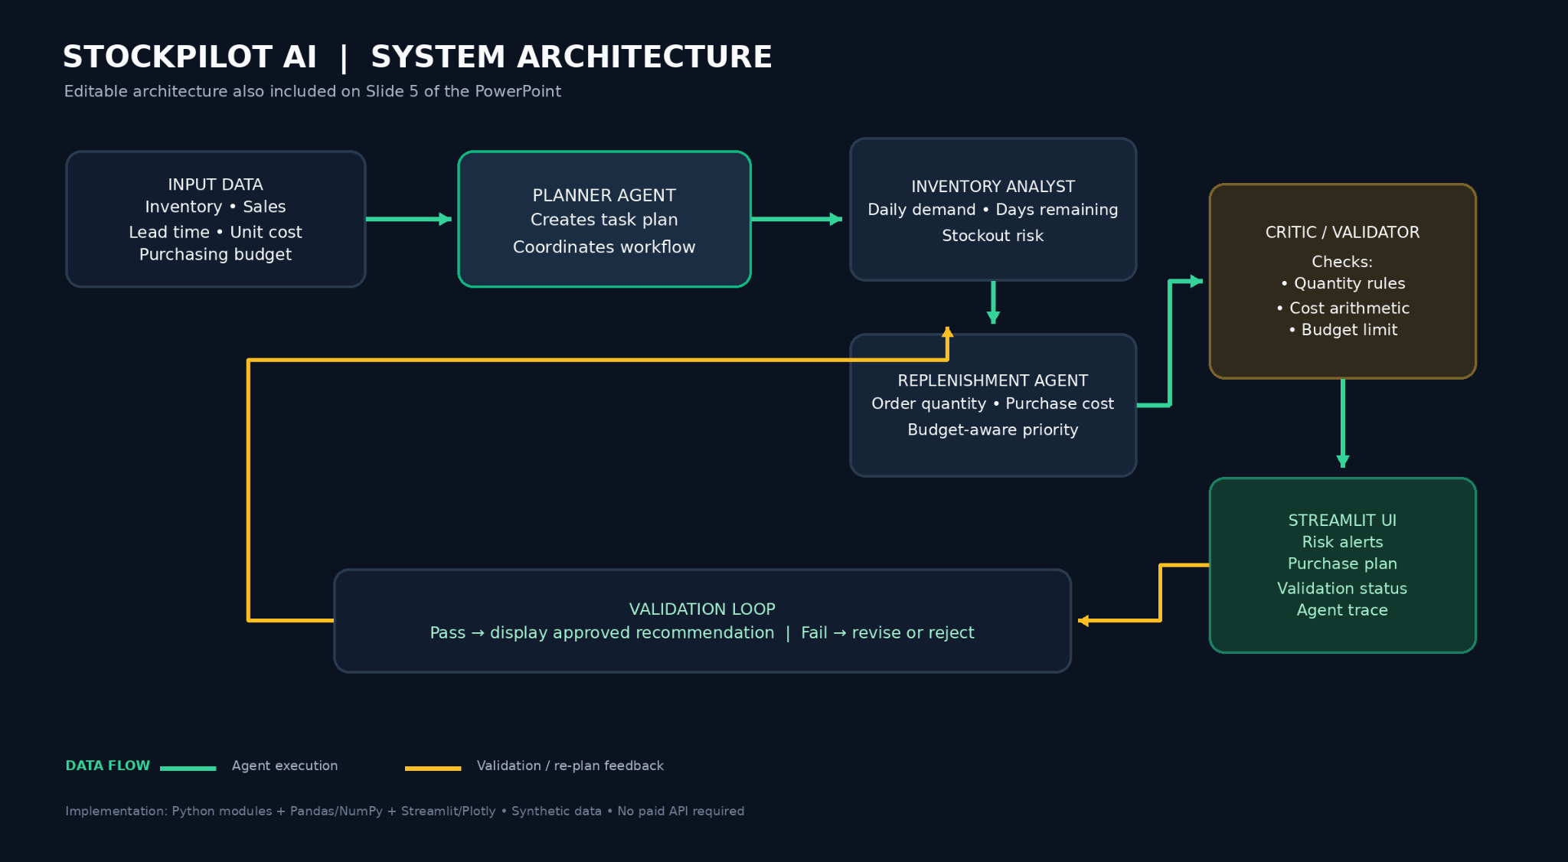
Figure 1. StockPilot AI system architecture supplied with the project materials.
The agents are software modules in a coordinated workflow. Their names describe responsibilities; they should not be interpreted as evidence that each module is an independently trained machine-learning model or an autonomous external service.

2.1 Agent Responsibilities
Module | Responsibility
Planner Agent | Creates the execution plan and coordinates the sequence of tasks.
Inventory Analyst Agent | Calculates daily demand, stock coverage, reorder points, and risk classifications.
Replenishment Agent | Builds candidate purchase quantities, estimates costs, and considers the available budget.
Critic / Validator Agent | Rechecks quantities, cost arithmetic, product-ID uniqueness, and the budget constraint.
Input Validator | Checks the input schema and numeric values before the main workflow proceeds.

2.2 Workflow
- Load the synthetic inventory dataset and set the available purchasing budget.
- Validate the input schema and numeric fields.
- Ask the Planner Agent to create an ordered execution plan.
- Analyze demand, stock coverage, reorder points, and risk.
- Generate a replenishment plan and estimate its purchasing cost.
- Run independent validation checks and record warnings or errors.
- Display the inventory analysis, purchase plan, validation status, and execution trace in the dashboard.
The validation loop is intended to flag a plan that fails a rule so that it can be revised or rejected. The demonstrated run had zero revision attempts and finished with a validation status of WARNING, so it should not be described as a completely warning-free result.

3. Technical Design
Area | Technology / approach | Role in the prototype
User interface | Python and Streamlit | Interactive controls, KPI cards, tables, and workspace navigation.
Data handling | Pandas and NumPy | Synthetic dataset handling and numeric inventory calculations.
Visualisation | Plotly | Stock-risk and category-level charts.
Agent workflow | Python modules | Planning, analysis, replenishment, and critique/validation responsibilities.
Validation | Rules and assertions | Quantity checks, cost arithmetic, and budget checks.

The core workflow is designed to run without a paid external model API. Model-assisted interpretation or a graph orchestration framework such as Ollama or LangGraph is an optional extension, not a required part of the demonstrated core system.

4. Inventory Logic and Methodology

4.1 Average Daily Demand
Average daily demand is estimated from recorded sales over a known sales period:
Average Daily Demand = Units Sold ÷ Sales Period in Days
The sales period must be greater than zero. This average is a simple rule-based estimate; it does not model seasonality, promotions, or sudden changes in customer demand.

4.2 Reorder Point
Reorder Point = (Average Daily Demand × Lead Time) + Safety Stock
The reorder point estimates the stock level at which a replenishment decision should be considered. It combines expected demand during supplier lead time with a safety-stock allowance.

4.3 Target Stock and Suggested Order Quantity
Target Stock = Average Daily Demand × (Lead Time + Additional Coverage Days)
Suggested Order Quantity = max(0, Target Stock − Current Stock)
The additional coverage period is configurable in the dataset. The maximum with zero prevents the suggested order quantity from becoming negative. The target-stock formula is the rule documented for this prototype and is not a learned prediction.

4.4 Purchase Cost and Budget Check
Line Cost = Suggested Order Quantity × Unit Cost
The total proposed cost is obtained by summing the purchase costs for the proposed line items. The Validator compares the plan total with the available budget and reports whether the budget rule is satisfied. If the plan has warnings, the user should review the affected items instead of assuming that the plan is fully approved for operational use.

5. Worked Example: Packaged Milk (P001)
The project presentation includes a worked example for product P001, Packaged Milk. The values below are the example inputs and calculations shown in the project materials.
Input / result | Value | Calculation / meaning
Current stock | 30 units | Quantity currently on hand.
Units sold | 280 in 14 days | Sales observed over the selected period.
Average daily demand | 20 units/day | 280 ÷ 14.
Supplier lead time | 2 days | Assumed replenishment lead time.
Safety stock | 10 units | Additional stock allowance.
Coverage days | 1.5 days | Additional target coverage.
Reorder point | 50 units | (20 × 2) + 10.
Target stock | 70 units | 20 × (2 + 1.5), as shown in the presentation.
Suggested order | 40 units | 70 − 30.
Purchase cost | ₹1,200 | 40 × ₹30 unit cost.

During the displayed budget-constrained run, the Critic flagged P001 because its approved quantity was lower than the suggested quantity after applying the ₹10,000 budget. The example illustrates why a recommendation and a budget-adjusted approved quantity may differ.

6. Dashboard and Demonstration Results
The dashboard is divided into four workspaces: Command Center, Inventory Explorer, Replenishment, and Agent Activity. Together, these views show the input dataset, product-level information, proposed purchase plan, validation feedback, and the recorded execution trace.

6.1 Command Center
The Command Center provides a high-level view of the synthetic inventory. In the supplied screenshot, the dashboard shows 25 tracked products, 2,192 units on hand, five categories, an inventory value of ₹252,850.23, and a purchase budget of ₹10,000. The stock-health chart classifies the 25 analyzed products by risk, while a category chart compares current units on hand.

6.2 Inventory Explorer
The Inventory Explorer provides search and category filtering for the product dataset. The displayed view includes product identifiers, names, categories, current stock, units sold, sales-period length, unit cost, supplier lead time, safety stock, and target coverage. The interface is intended to make it easier to inspect the records behind the summary indicators.

6.3 Replenishment Workspace
The supplied demonstration shows a planning budget of ₹10,000.00, a proposed approved cost of ₹9,972.10, and a remaining budget of ₹27.90. The dashboard reports that the workflow produced a plan within the budget, while asking the user to review each line before acting.

6.4 Independent Validation
The Critic / Validator view reports two passed checks, two warnings, and zero errors. The passed checks are that product IDs are unique and the plan total of ₹9,972.10 does not exceed the ₹10,000.00 budget. The warnings identify P001 and P006 because their approved quantities are lower than their suggested quantities.

6.5 Agent Activity
The Agent Activity workspace displays a workflow state of VALIDATED with validation status WARNING, zero revision attempts, ten logged events, and zero failed or rejected events. The execution trace includes input validation, planning, inventory analysis, replenishment, Critic validation, and workflow finalisation. A downloadable execution log is shown in the interface.
These figures describe the captured demonstration only. They should not be interpreted as benchmark results or as evidence of real-world inventory savings.

6.6 Evidence from the Dashboard
Screenshots supplied with the project materials document the dashboard's visible states. The report uses them as implementation evidence rather than claiming additional features or measurements that are not shown.
Note: The dashboard screenshots were provided in the conversation, but separate image files were not available to embed in this document. The architecture image is included above; dashboard evidence is described from the supplied screenshots.

7. Scope and Limitations
- Synthetic data. The demonstration dataset may not represent actual retail demand, seasonality, promotions, supplier delays, or operational exceptions.
- Rule-based logic. The documented calculations use configured formulas and do not establish that a trained forecasting model is present.
- No live enterprise integration. The supplied materials do not demonstrate a live connection to an ERP, point-of-sale platform, warehouse system, or supplier service.
- Human review required. StockPilot AI provides recommendations; it does not place real supplier orders.
- Limited evaluation. The demonstration does not provide a baseline comparison, forecast-accuracy metric, or measured reduction in stockouts or inventory cost.

8. Future Enhancements
- Connect the dashboard to a relational database and live inventory or sales feeds.
- Add historical-data-based demand forecasting and evaluate it against simple baselines.
- Represent uncertainty in demand and supplier lead times.
- Make stockout-risk scoring more explainable to users.
- Support supplier selection, minimum order quantities, and purchase-order constraints.
- Introduce human approval, audit trails, and role-based access controls.
- Test edge cases and compare inventory outcomes using documented metrics such as stockout frequency, holding cost, excess inventory, and budget utilisation.

9. Conclusion
StockPilot AI demonstrates a structured, agent-oriented approach to inventory decision support. By separating input validation, planning, inventory analysis, replenishment calculations, and independent checking, the prototype makes the stages of a purchasing recommendation easier to inspect. Its Streamlit dashboard combines summary indicators, product-level data, budget information, validation feedback, and workflow events in one interface.
The supplied demonstration shows how the system can create a budget-aware purchase plan and flag cases where approved quantities differ from suggested quantities. At the same time, the use of synthetic data and rule-based calculations places clear limits on what can be concluded. Before use in a real retail environment, the system would need live data integration, stronger testing, human approval controls, and evaluation against historical inventory outcomes.

References
- Python Software Foundation. Python Documentation. https://docs.python.org/3/
- Streamlit. Streamlit Documentation. https://docs.streamlit.io/
- StockPilot AI project presentation, CA-3: Agentic AI Proof of Concept, supplied project materials.
- StockPilot AI working-dashboard screenshots supplied with the project materials.

