# REST API – PHP Demo

Developed by:

Mariano Luna [mluna@jaspersoft.com](mailto:mluna@jaspersoft.com)

Published by:

Date: January 15, 2012

About REST API Sample  
The sample currently provides following functionality of Jaspersoft through REST API:

* Authenticate to JasperServer
* Browse JasperServer repository
* Run JasperServer reports (HTML, PDF and XLS). Only some input control rendering is included in this this version (single select query, multi-select query, single value & Boolean).
* Additionally includes tab that uses the embed theme and IFRAME integration to show adHoc and other features using the simple iframe HTTP integration to include JasperServer content. It uses the JSESSION ID cookie to authenticate the iframe so there is no exposure of the login credentials in the HTML source code, for this to work properly the application and JRS must be in the same top level domain.

REST API upon successful authentication sends a cookie with the JS SESSION ID for use in subsequent REST calls.

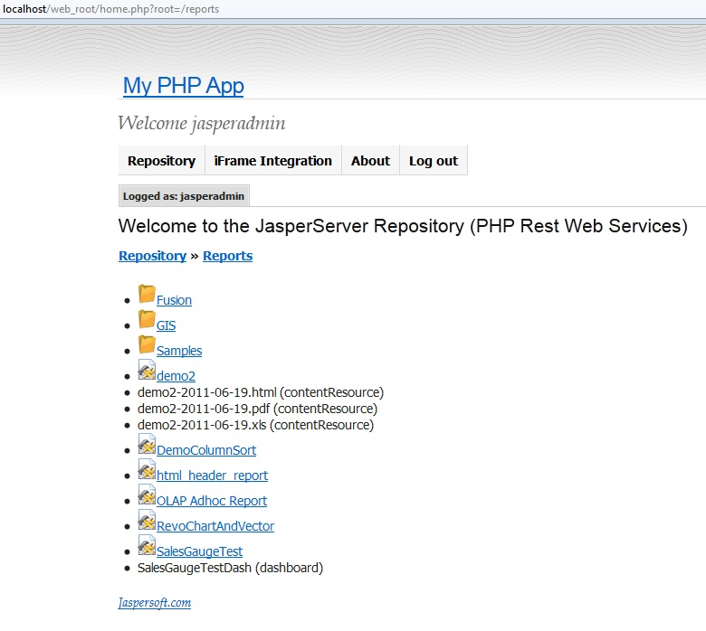

If you have your application running in the same domain as JS (e.g. myexample.com ) you can successfully set that cookie in the right path and you do not need to add the authentication (j_username & j_password) to the iframe URL (see the screen shot below).

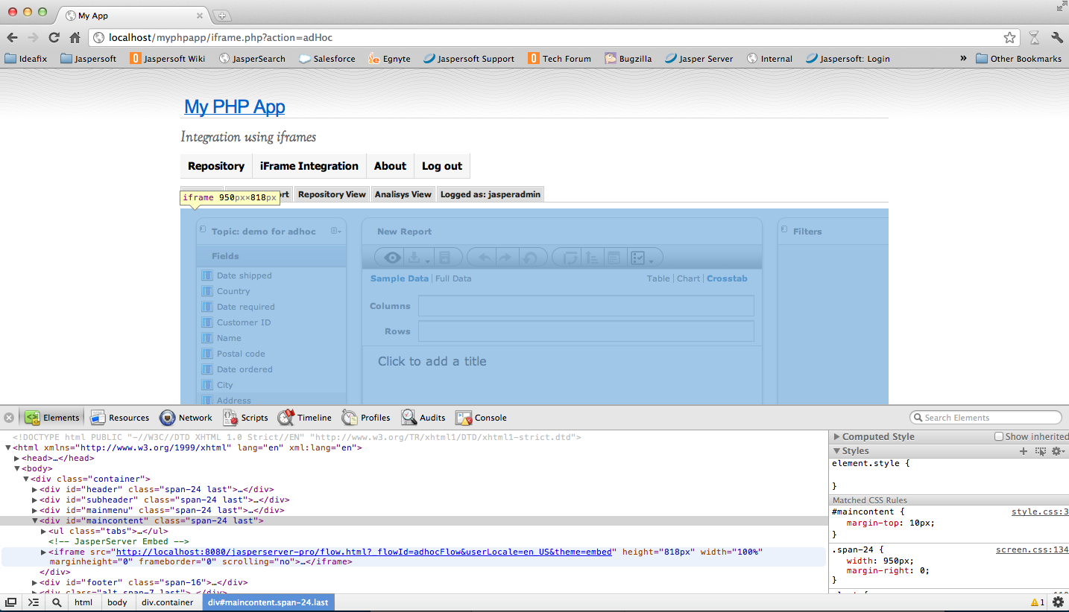

## Installation

Unzip the REST API Sample file in your file system and save that path. For the purpose of this document we will call this path {SAMPEL_INSTALL_PATH}, and we will assume:  
  
***C:\PHP-Sample\***

Inside that folder you will find two folders as follows:

1. **./resources**  
   This folder contains the included libraries and classes and the main configuration file “***config.php***”
2. **./web-root**  
   This folder contains the application logic and should be set as your webserver document root.

Apache Configuration

1) If you placed web_root folder outside of \htdocs folder, you need to register the folder in the Apache configuration file \conf\httpd.conf. Add Directory reference and alias:  
---  
# Alias for PHP APP demo  
Alias /web_root "c:\php-sample-app\web_root\"  
<Directory "c:\php-sample-app\web_root\">  
    Options Indexes  FollowSymLinks MultiViews ExecCGI  
    AllowOverride All  
    Order allow,deny  
    Allow from all  
</Directory>  
2) If you web_root folder inside \htdocs, you need to change default AllowOverride behavior to allow setting to be picked up from .htaccess file.

    AllowOverride All  
  
web_root Folder Configurations  
3) Modify the .htaccess file in web-root  
- Edit the file called htaccess-sample that is in web-root. There is only one line in this file should look like this:  
  
php_value include_path "C:/Program Files (x86)/Apache Software Foundation/Apache2.2/htdocs/resources"

You might need to activate PEAR, if it’s not configured on the Apache config level. Check your php.ini file

php_value include_path "C:/Program Files (x86)/Apache Software Foundation/Apache2.2/htdocs/resources; C:/php/PEAR;."  
  
**SAVE this file as ".htaccess" note the . (dot) at the beginning. (IMPORTANT)**  
  
4) change the paths inside ./web_root/iframe.php  
Line 33:

$iFrameServerURI = "http://localhost:8080/jasperserver_pro/";

5) restart Apache server

resources Folder Configurations  
  
6) change the paths inside ./resources/config.php  
Line 34:

define('WWW_ROOT', '/web_root/'); //

define('SITE_PATH', 'C:\\Program Files (x86)\\Apache Software Foundation\\Apache2.2\\htdocs\\');

Line 57:

define('JS_WS_URL', 'http://localhost:8080/jasperserver-pro/rest/');  // if needed

Start REST API Demo

7) go to: <http://localhost/web_root/home.php> and Voila!  
  
Most of the logic of the API is embed in the following scripts:  
- login.php (authentication)  
- home.php (repository browser)  
- viewReport.php and executeReport.php (request and execute a report)