This task uses the same movement rules as Task 7, but this time Robbie has multiple keyboard configurations to choose from and will choose the one that requires the fewest moves.

**Task Description**

Write a program that asks the user to input a string, then choose a keyboard, then plans the actions of Robbie the robot so that it can type this string on a keyboard. For a given input string,

• If there is a single keyboard on which in can be typed, then Robbie picks that one.

• If it can be typed on multiple keyboards, Robbie picks a single keyboard as follows:

* The one that requires the fewest moves, or, if there is a tie,
* The first best keyboard configuration (in the order we give them).

Finally, there may not be a keyboard that can type that string.

The keyboards have the configurations below.

**Configuration 0**

abcdefghijklm

nopqrstuvwxyz

**Configuration 1**

789

456

123

0.-

**Configuration 2**

chunk

vibex

gymps

fjord

waltz

**Configuration 3**

bemix

vozhd

grypt

clunk

waqfs

**Robbie starts at the top left position of the chosen keyboard.**

**Input and Output Examples**

User inputs are in **bold font** below.

**Example 1**

**Example 2**

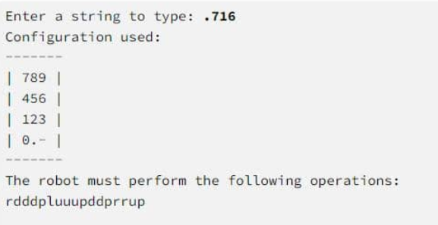

**Console Example:**

