Jenkins Task

Task :6

Launch jenkins and explore creating projects and users.

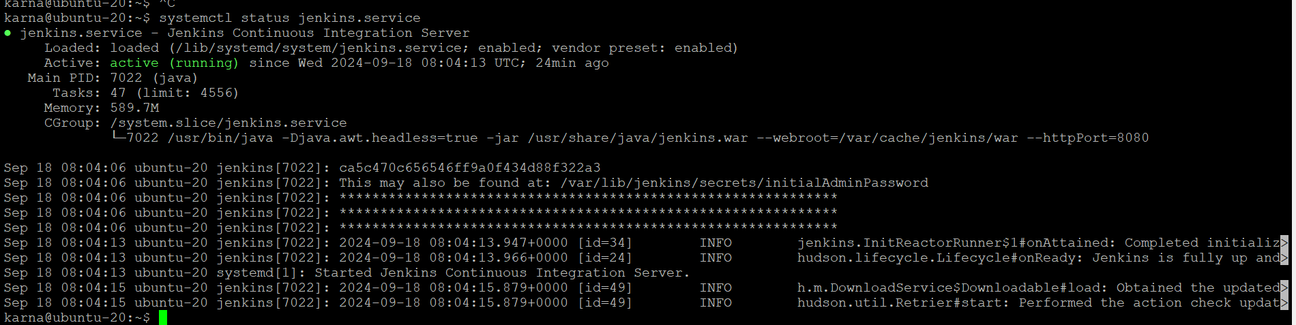

Creating explore projects

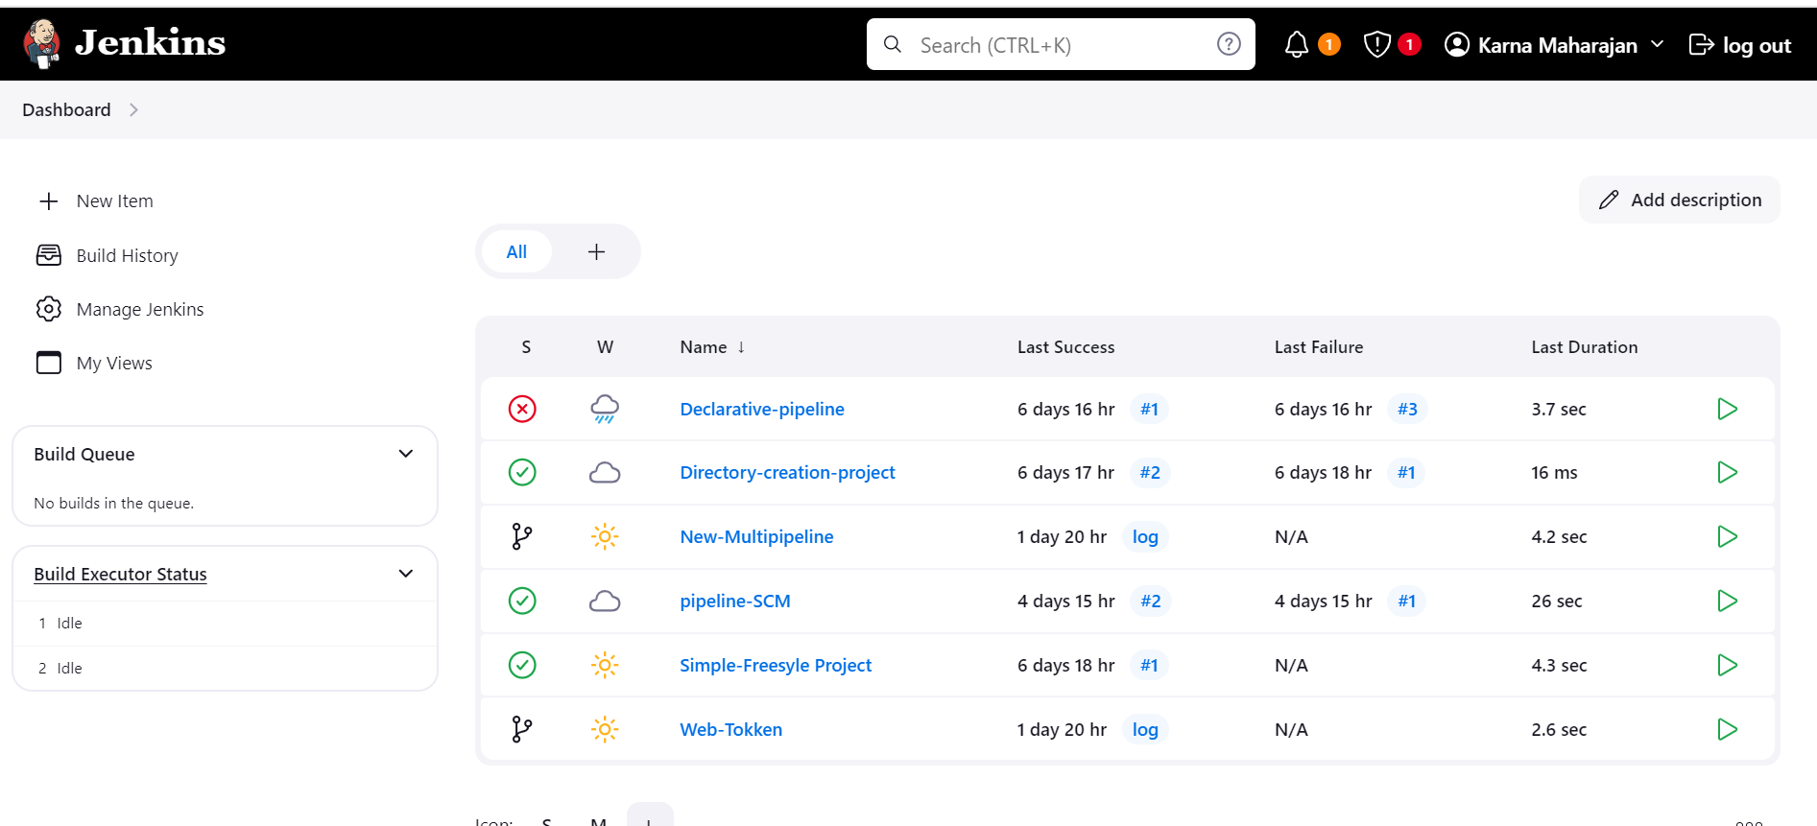

Creating explore Users

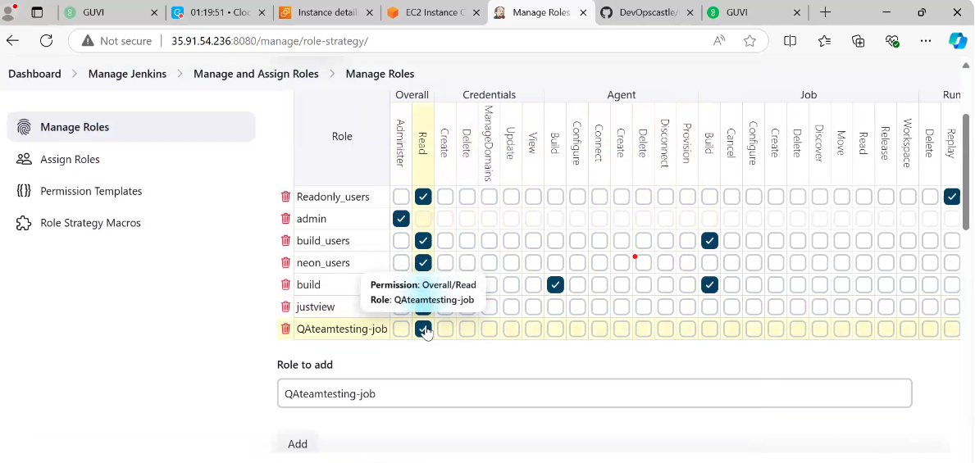

Assigning the years to roles



                                    

