JENKINS-2

Task :7

Create a simple script file and push it to repo. Create a project in Jenkins connected to your GitHub repository. When a commit is made to your repo, automatically build must get triggered from Jenkins and the output must be shared to me via email.

Create a simple script file and push it to repo.
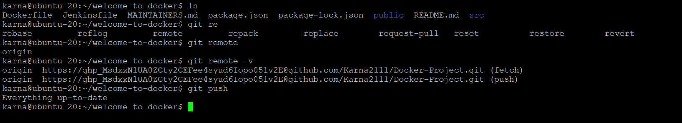

Installing Plugins for automatic trigger

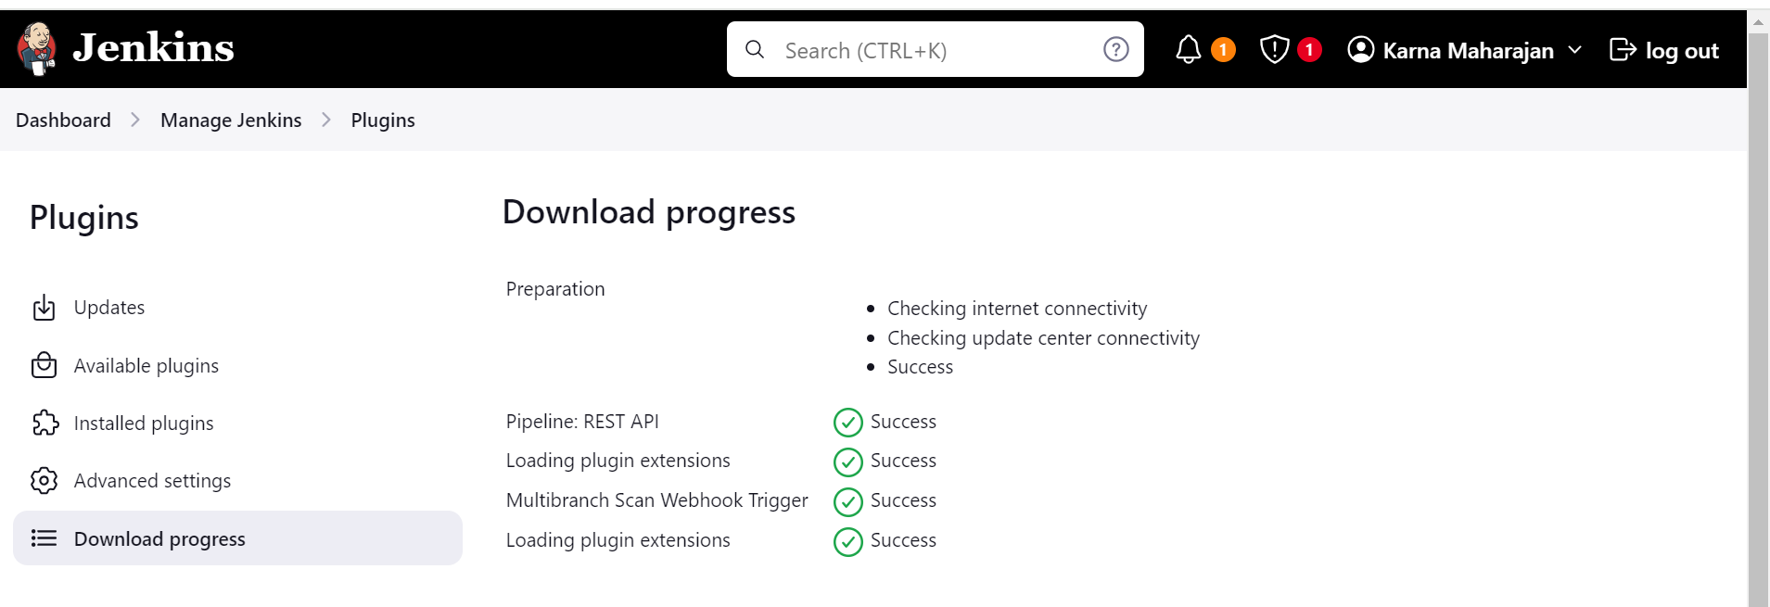

Adding the Webhook and creating the Token to integrate the Github

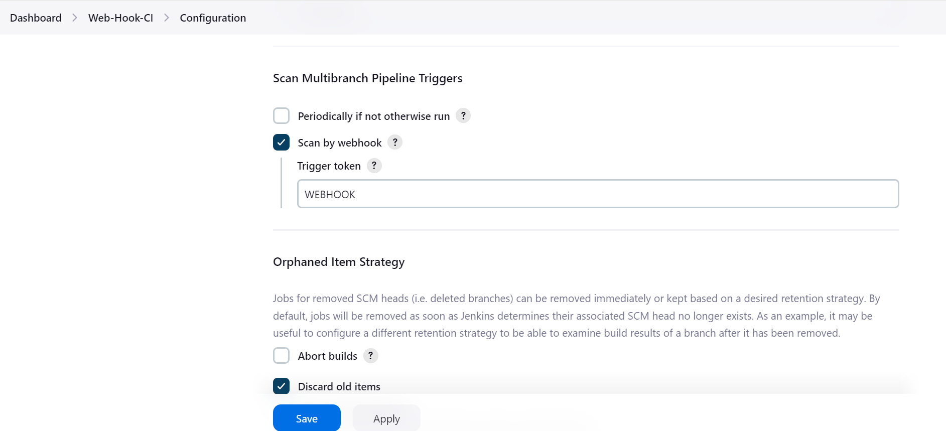
Integrate the token in github

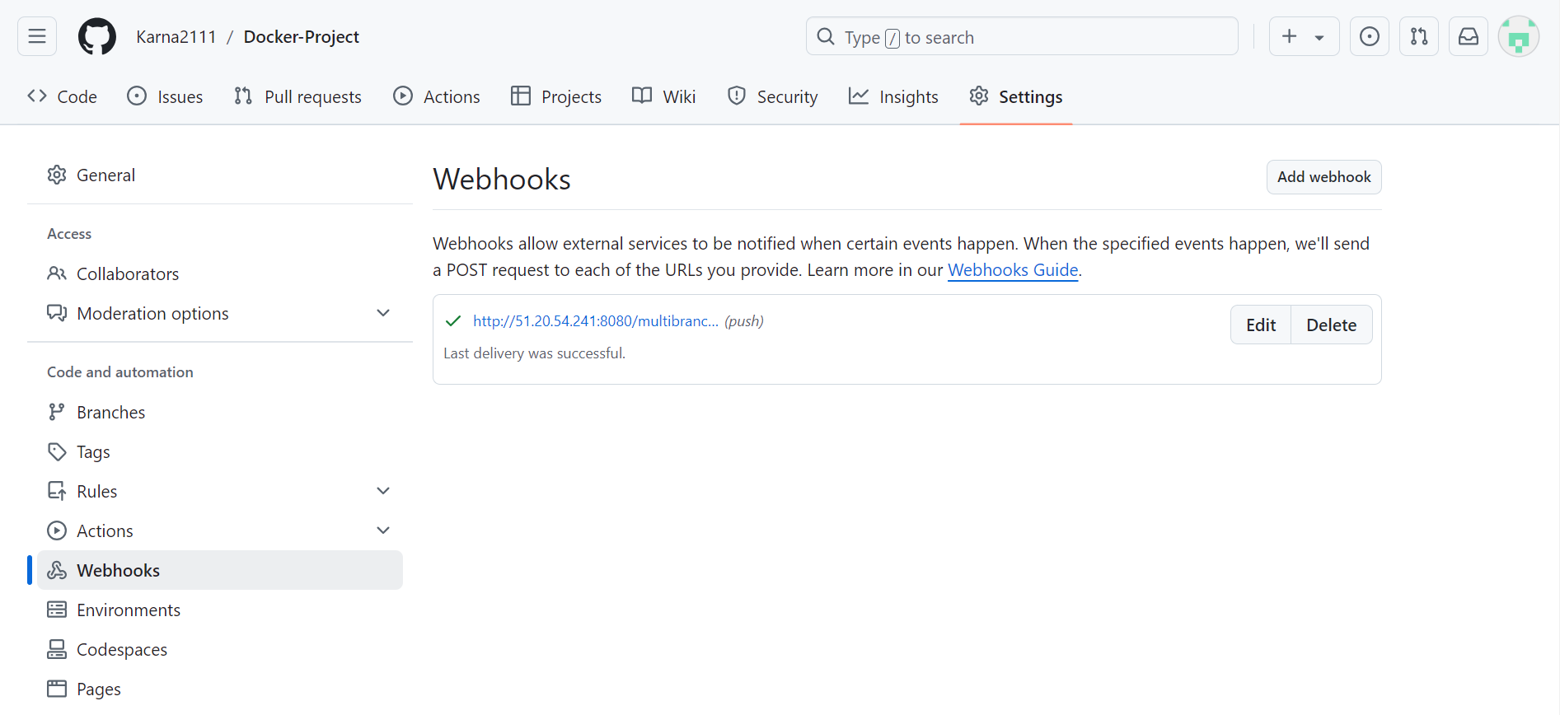

Building the pipeline
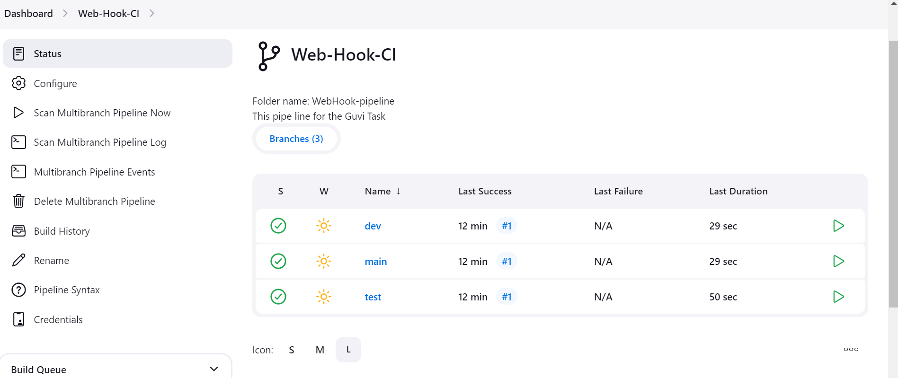

Change the code in github for the automatic build

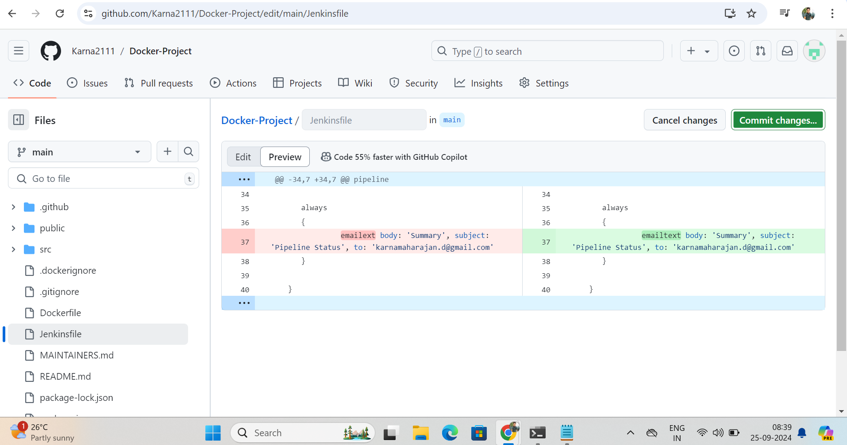

Here the main is triggered and started built automatically.

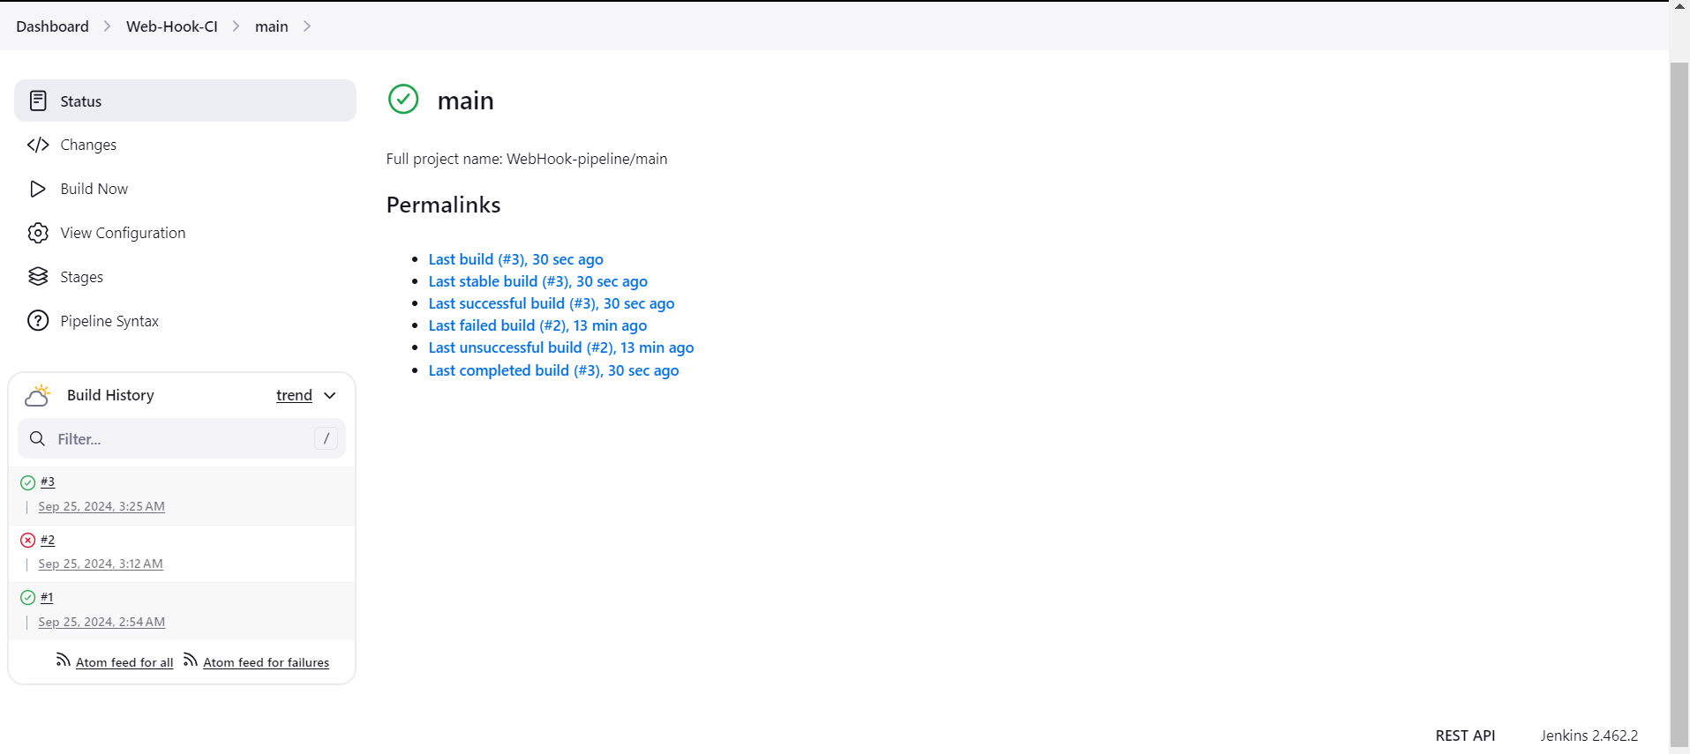

Output for automatic trigger


                                    

