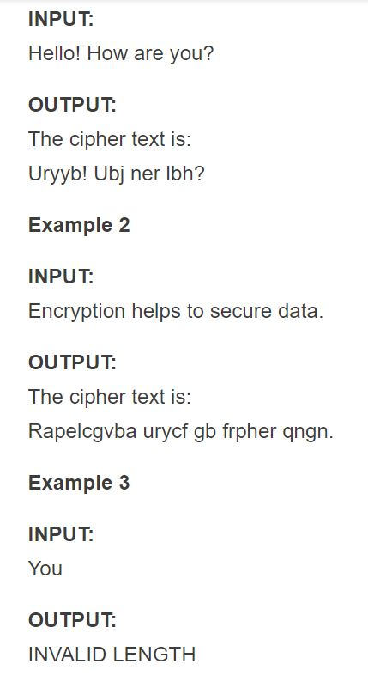

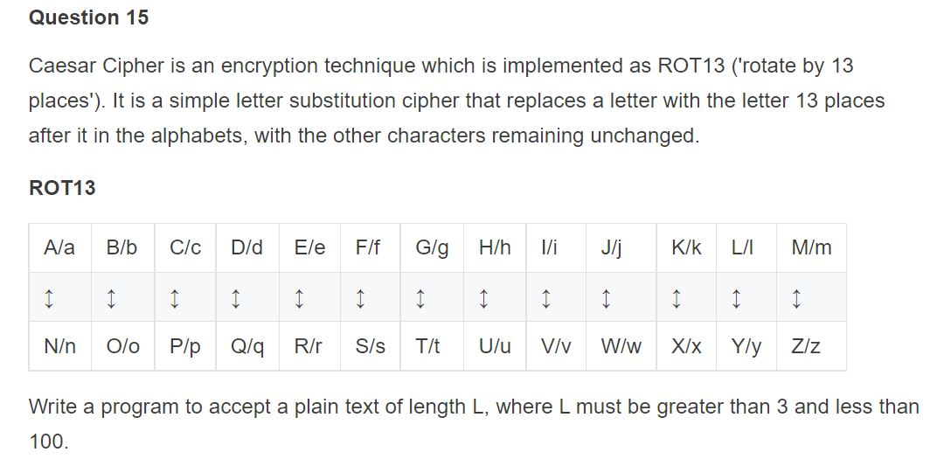**Problem Statement 2**

Take an input string and print the vowels first and then consonant

Input> HELLO

Output> EOHLL

Input> BIMALENDU

Output> IAEUBMLND

**Problem Statement 3**

Word wise reverse String

Input> I love India

Output> India Love I