An enum can, just like a class, have attributes and methods. The only difference is that enum constants are public, static and final (unchangeable - cannot be overridden).

An enum cannot be used to create objects, and it cannot extend other classes (but it can implement interfaces).

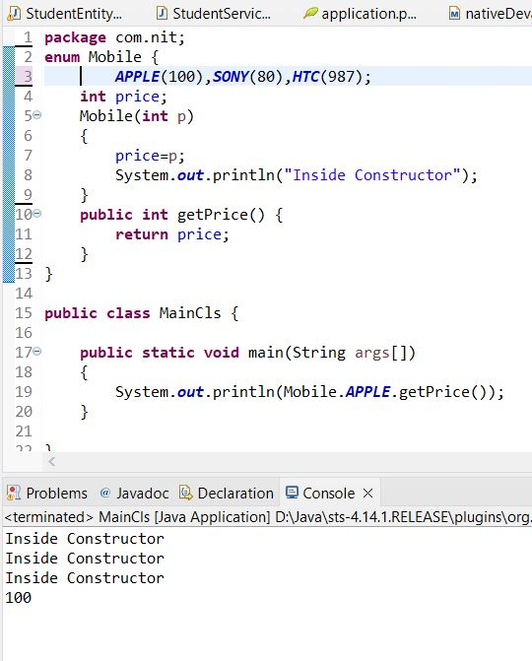

Here the variables inside the enum are treated as objects. Since they are special types of class behind the scene.

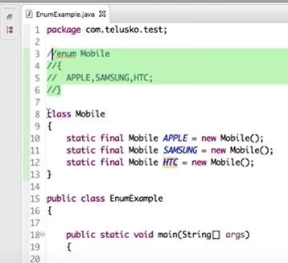

**The number of variables inside a enum, that many numbers of objects are created.**

