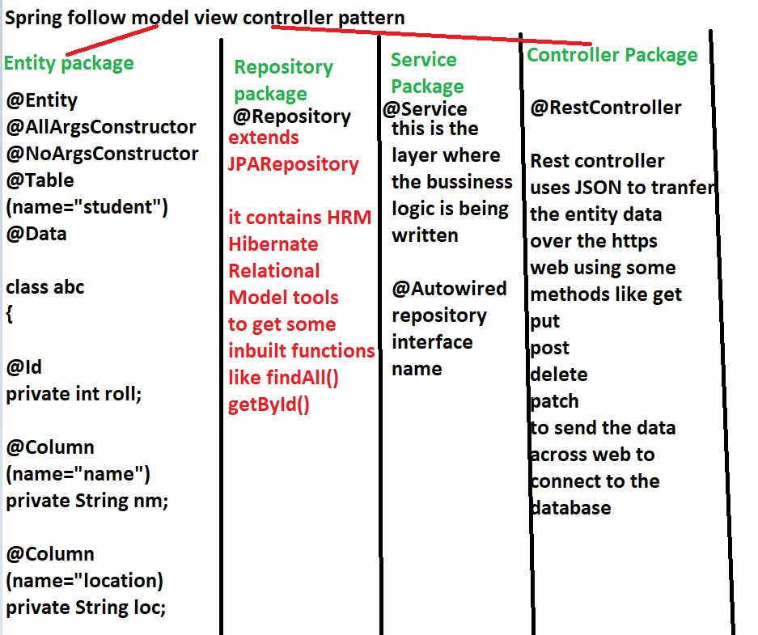

here in the databse the column name would be roll, but in case of second column it would be name and not nm. We are explicitly marking the field name as name while the attribute name inside the class that would be mapped to mysql is nm.

@Controller

Then over the apis we need to write the request methods by which the https call is being made

**@RequestMapping(value = "/show", method = RequestMethod.GET)**

**/show is the name of the https: path where the api would get fired**

**@RestController was introduced in spring 4.0 and is a combination of @Controller and @ResponseBody**

**@ResponseBody is the JSON data format that is being parsed over the web.**

REST controller uses JSON to parse the data over the web

While SOAP api uses XML to parse the data.

