**Cloud Application Development**

**Image Recognition with IBM Cloud Visual Recognition**

**Phase-4**

* Continue building the image recognition system by integrating IBM Cloud Visual Recognition and AI-generated captions.
* Implement the image classification process using the IBM Cloud Visual Recognition API.
* Use natural language generation to create captions for the recognized images.

Login to the IBM account with IBMid.

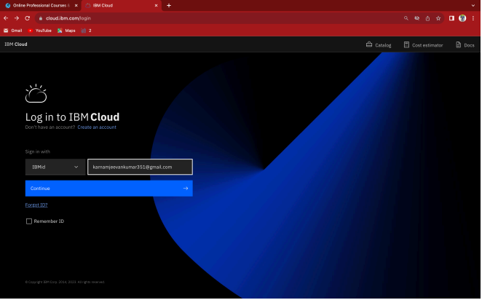

Enter password to login.

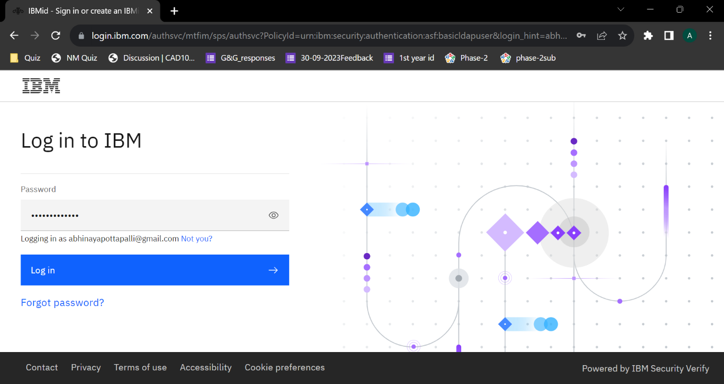

Home page of the IBM account.

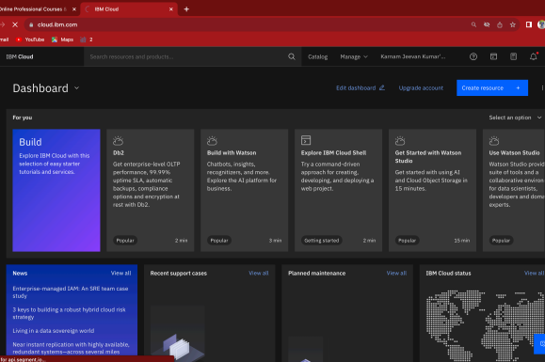

Click on the help icon and then click on Docs in the drop-down menu.

Then click the search icon.

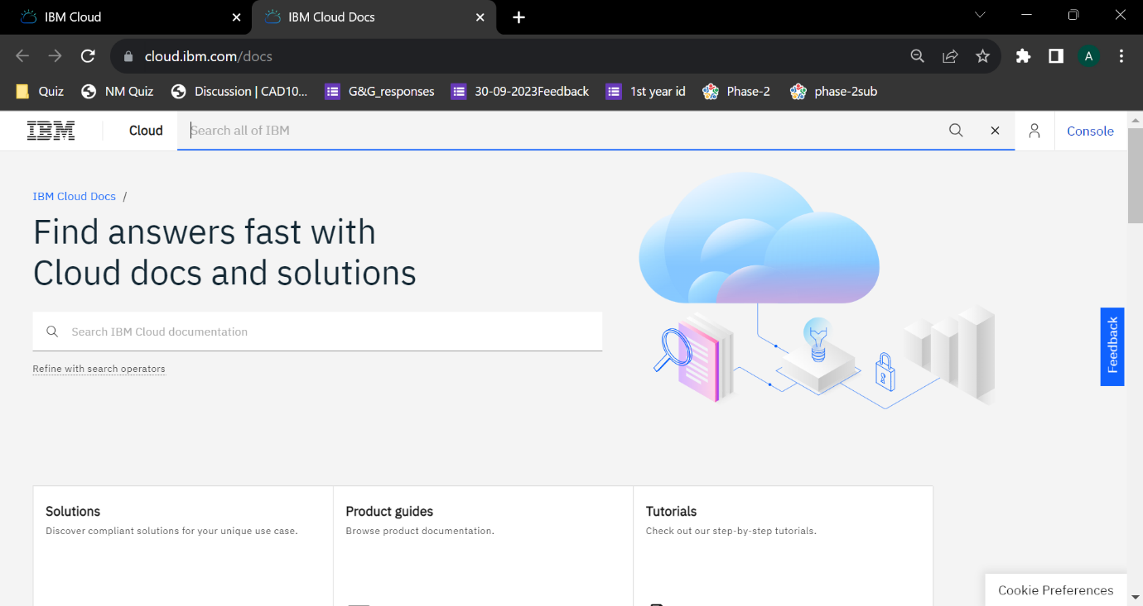

Then search for Visual Recignition.

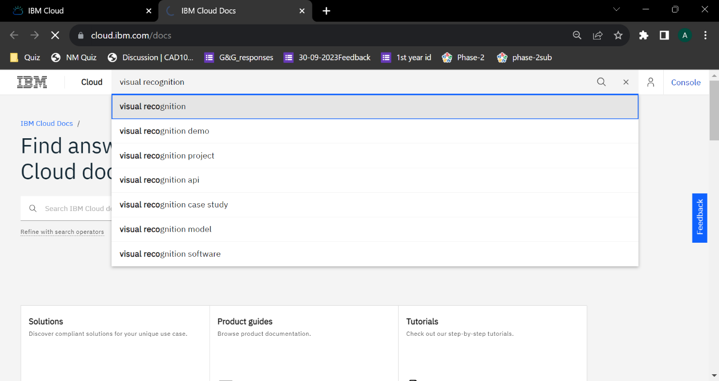

Then open the DocumentAnalytics.VisualRecognitionClassifier actions.

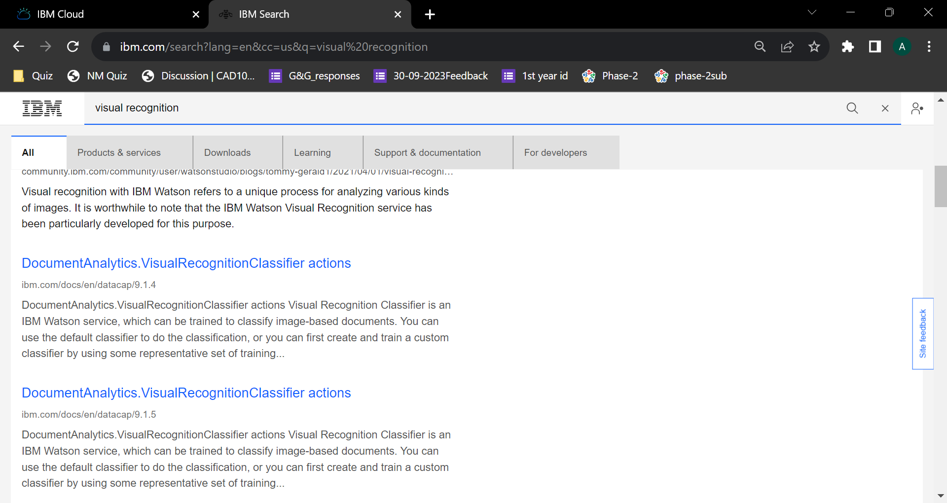

DocumentAnalytics.VisualRecognitionClassifier actions.

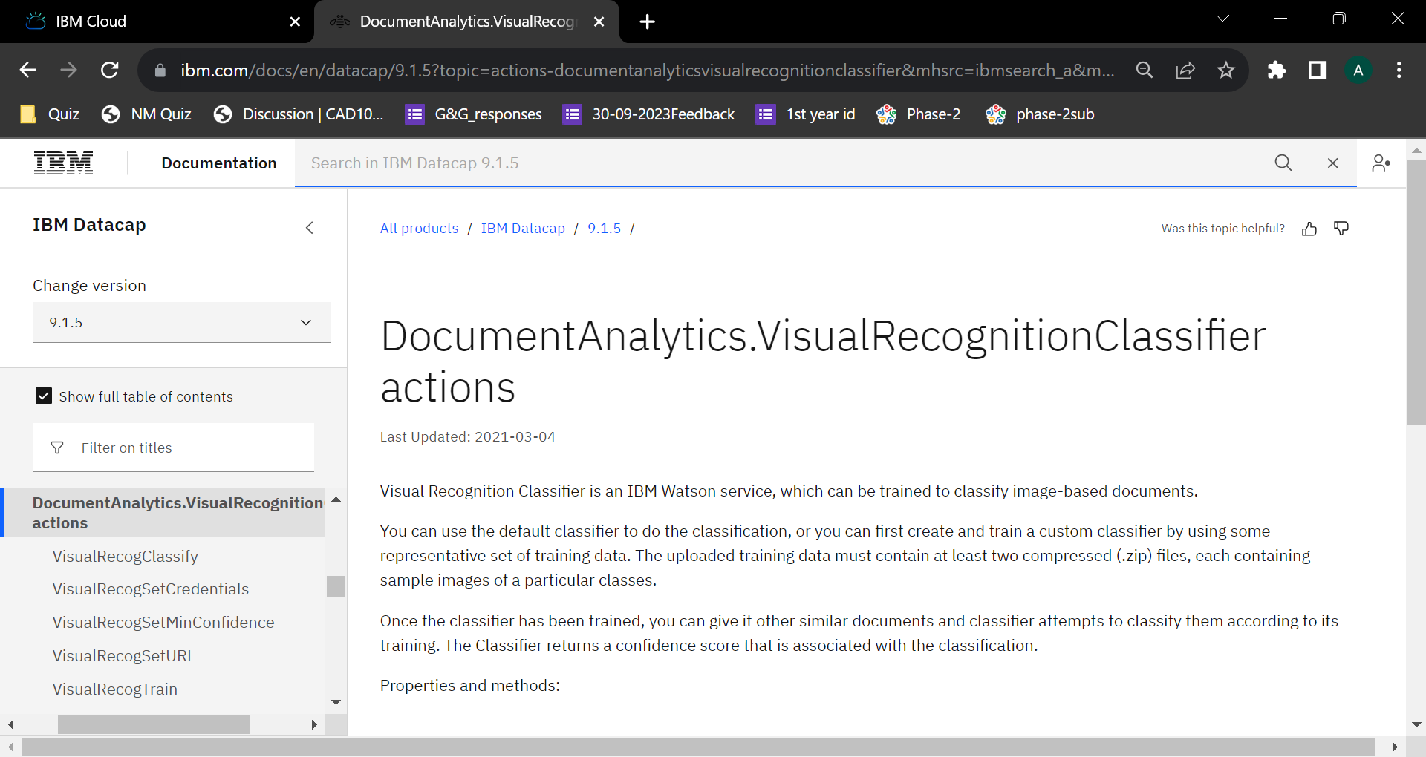

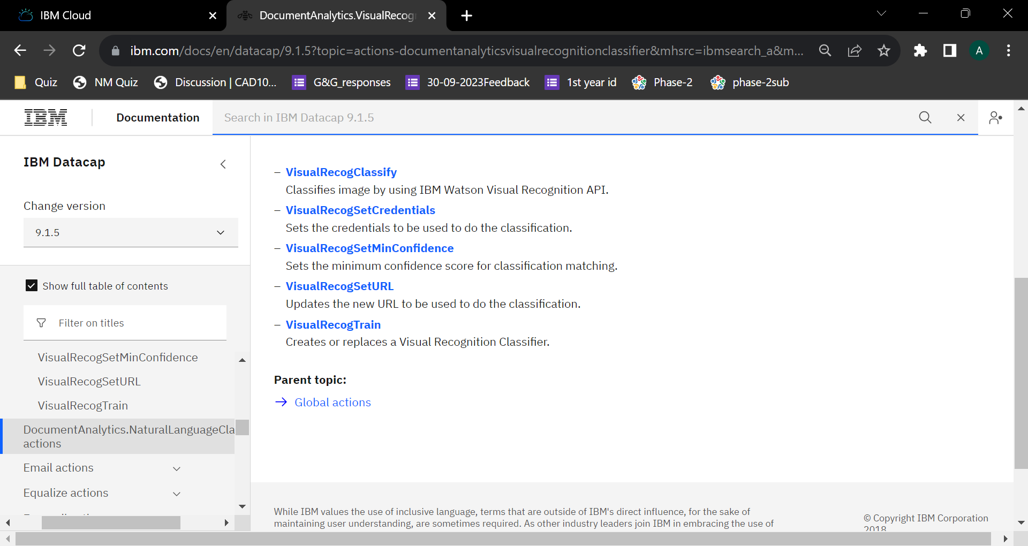

DocumentAnalytics.NaturalLanguageClassifier actions

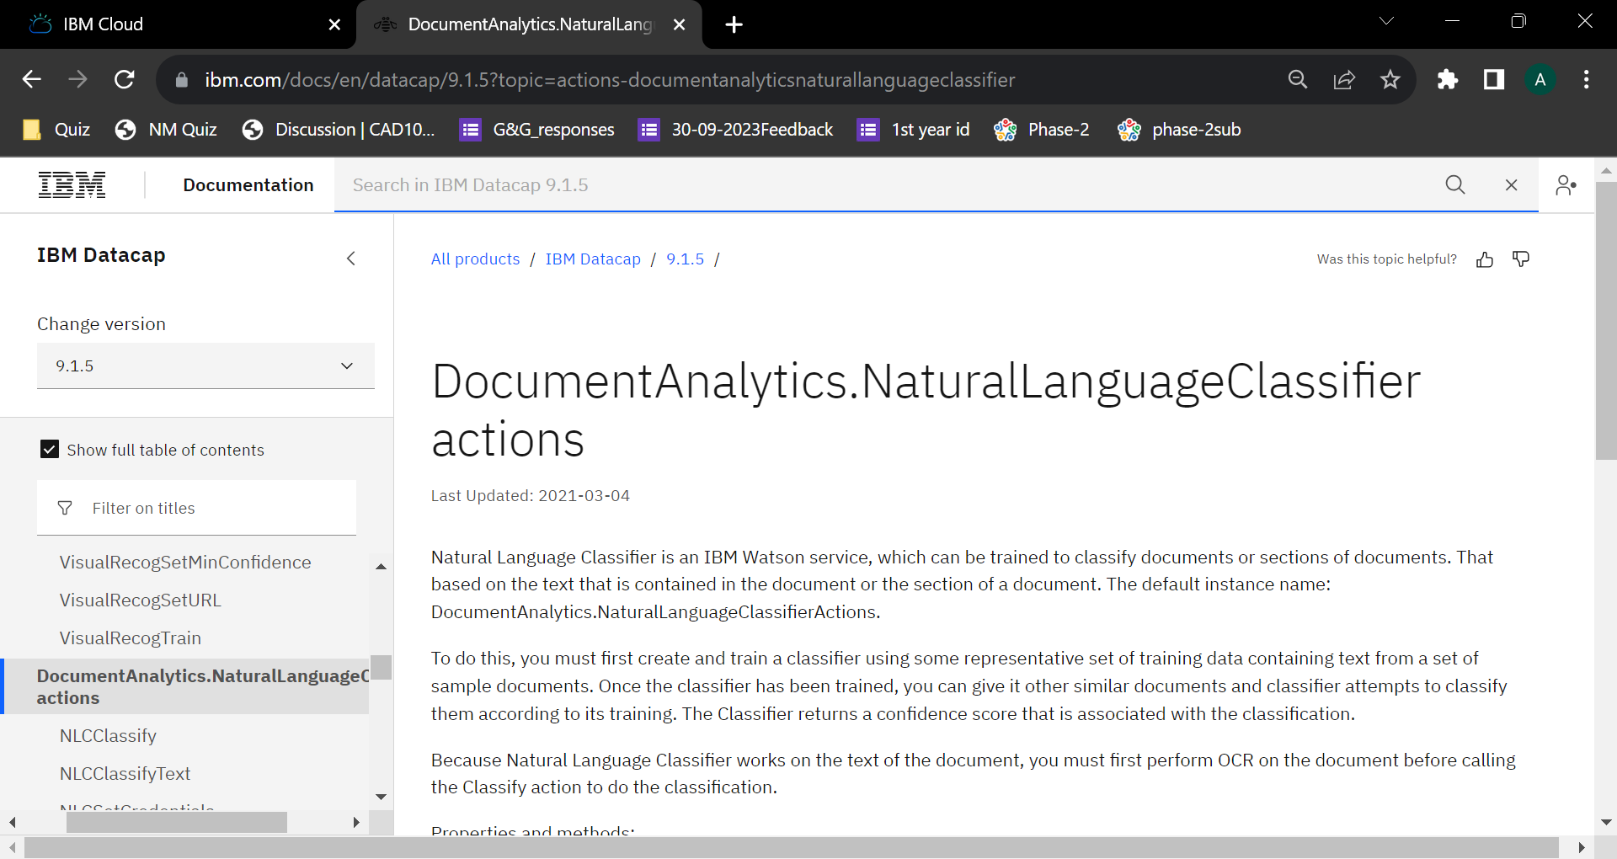

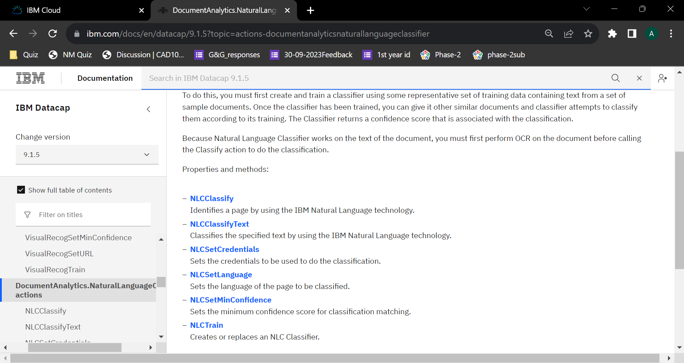

[**NLCClassify**](https://www.ibm.com/docs/en/SSZRWV_9.1.5/com.ibm.dc.reference.doc/dcaca918.htm)  
Identifies a page by using the IBM Natural Language technology.

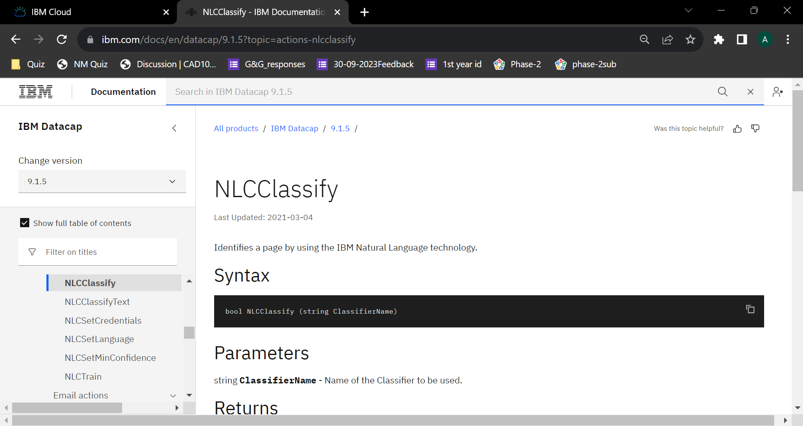

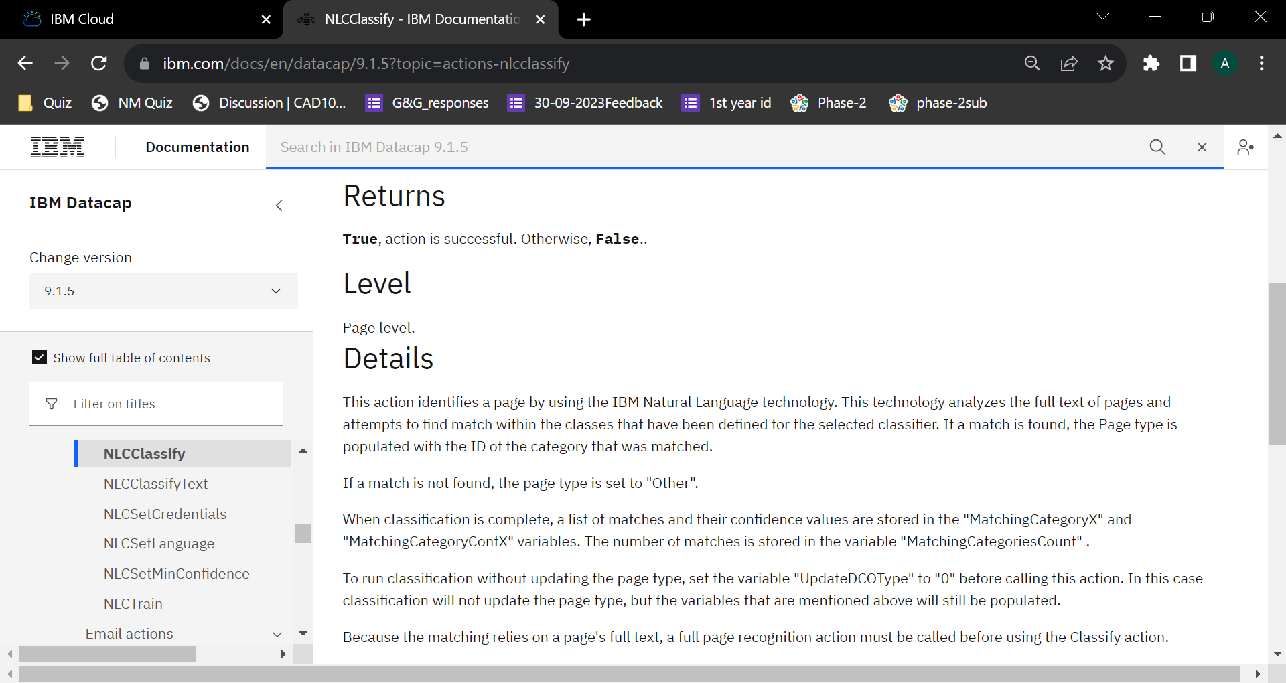

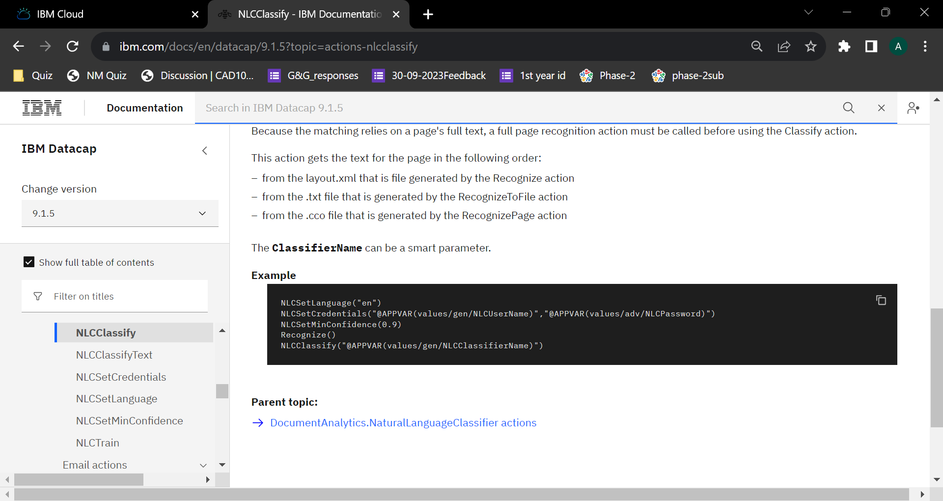

[**NLCClassifyText**](https://www.ibm.com/docs/en/SSZRWV_9.1.5/com.ibm.dc.reference.doc/dcaca919.htm)  
Classifies the specified text by using the IBM Natural Language technology.

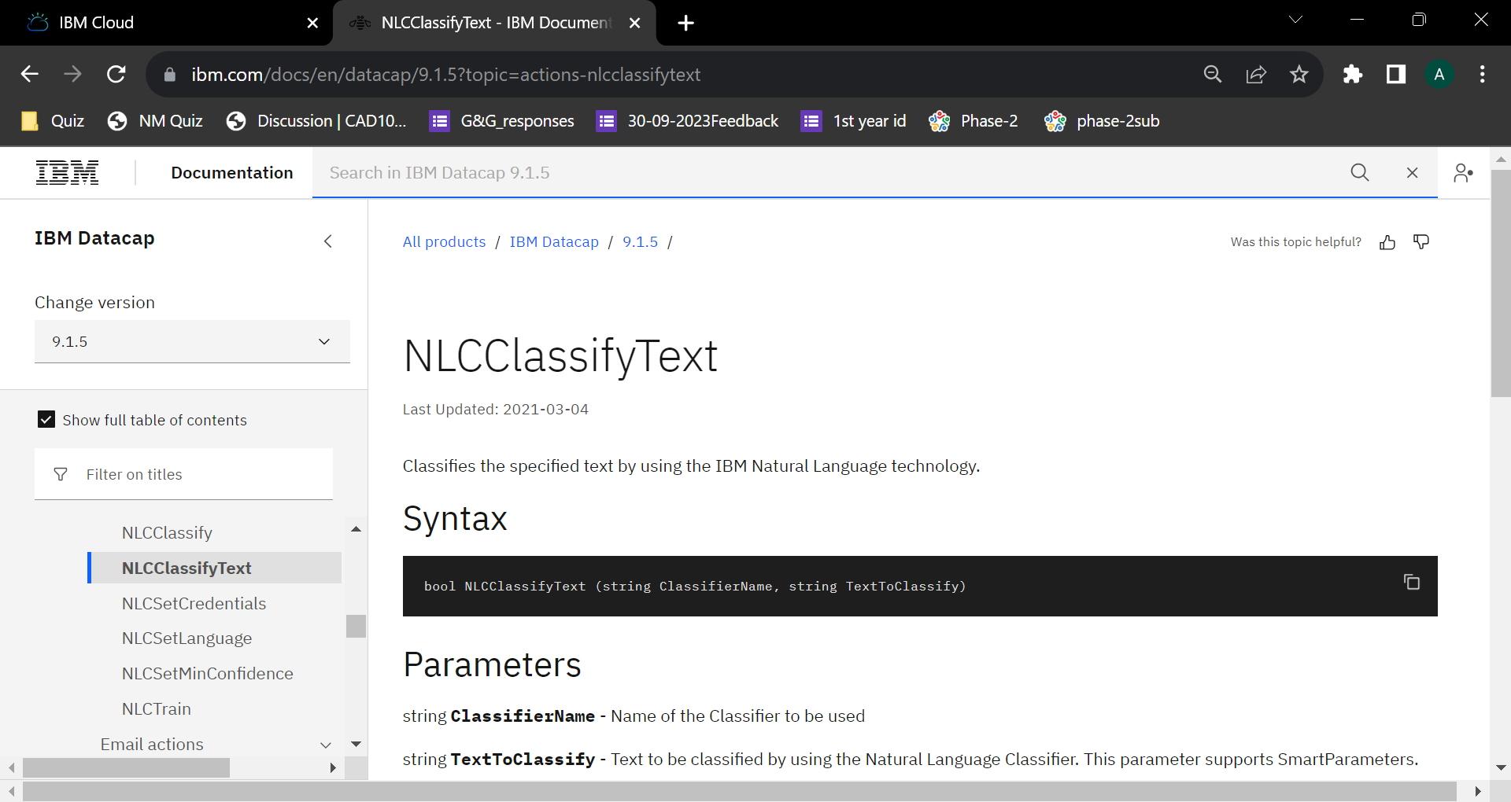

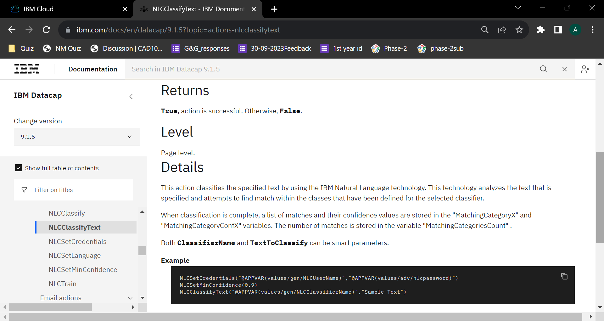

[**NLCSetCredentials**](https://www.ibm.com/docs/en/SSZRWV_9.1.5/com.ibm.dc.reference.doc/dcaca920.htm)  
Sets the credentials to be used to do the classification.

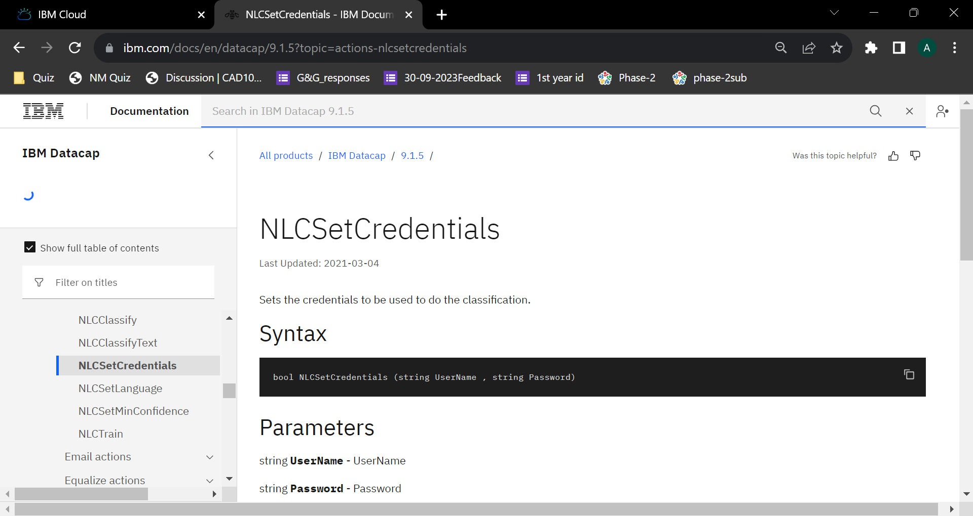

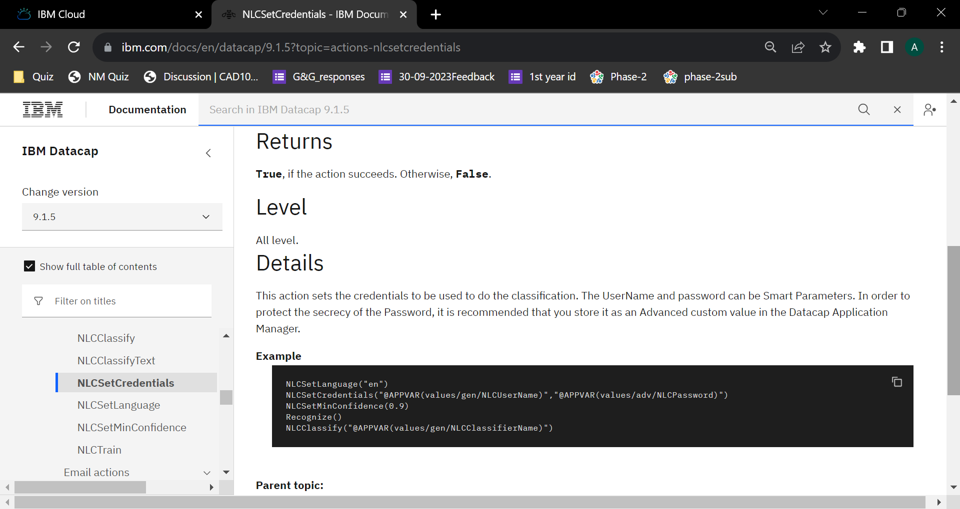

[**NLCSetLanguage**](https://www.ibm.com/docs/en/SSZRWV_9.1.5/com.ibm.dc.reference.doc/dcaca921.htm)  
Sets the language of the page to be classified.

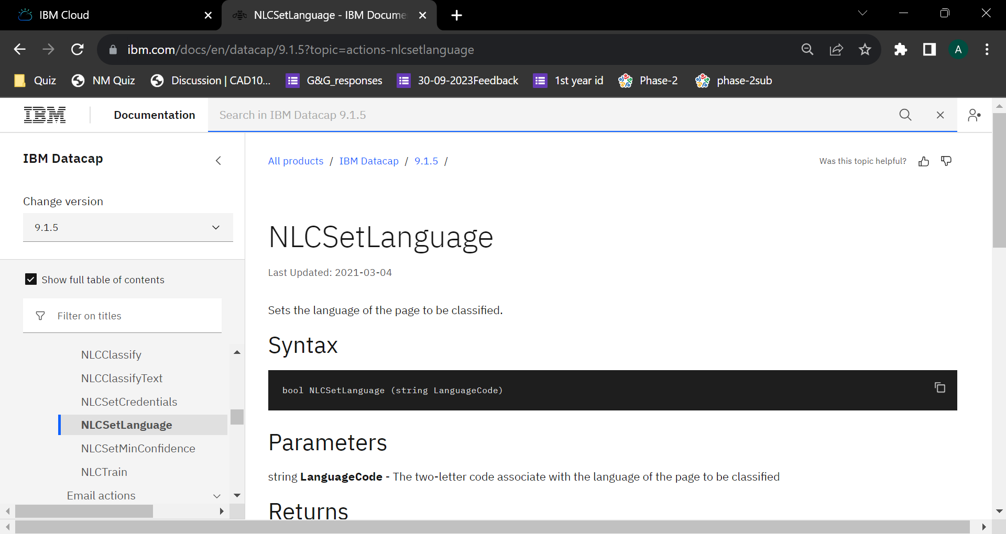

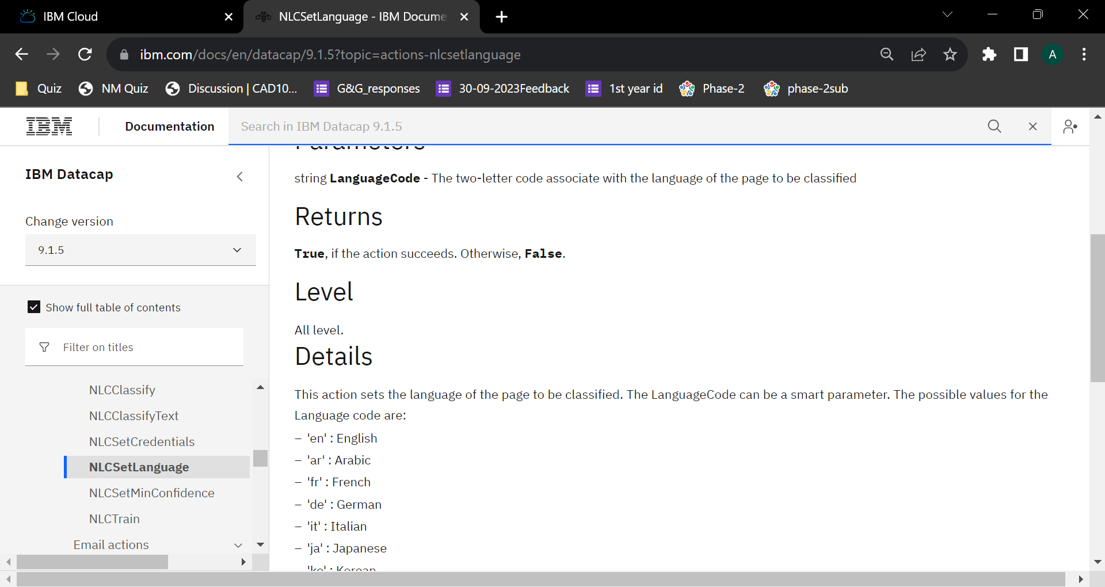

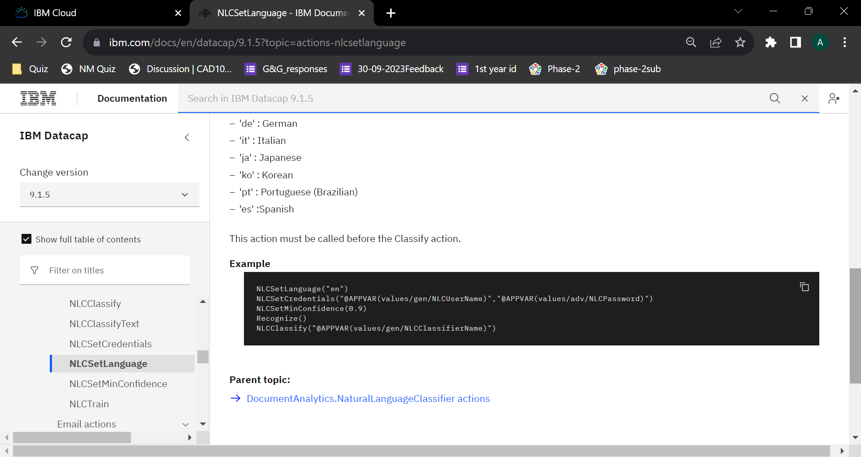

[**NLCSetMinConfidence**](https://www.ibm.com/docs/en/SSZRWV_9.1.5/com.ibm.dc.reference.doc/dcaca922.htm)  
Sets the minimum confidence score for classification matching.

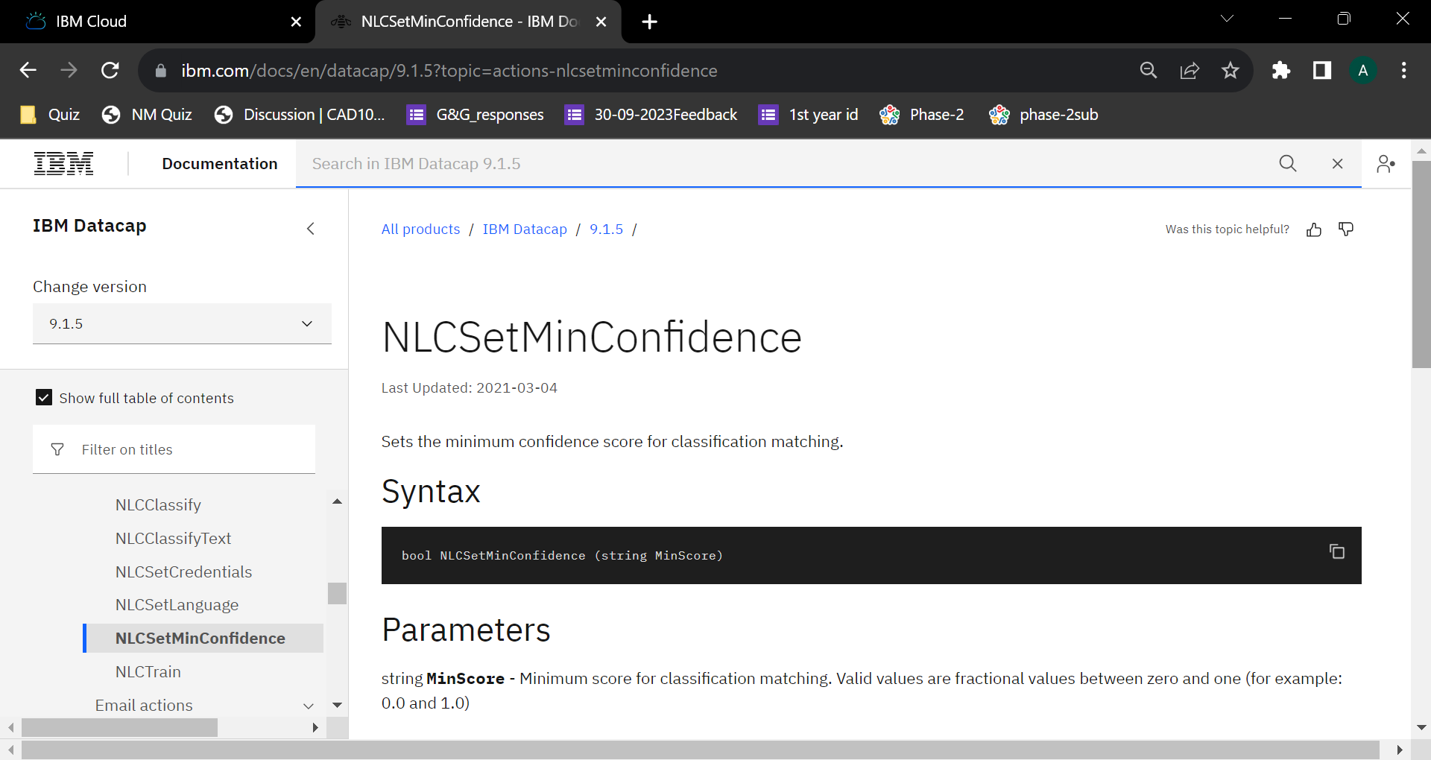

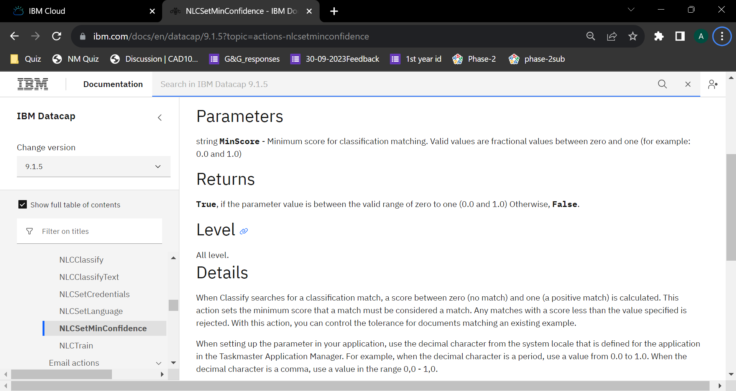

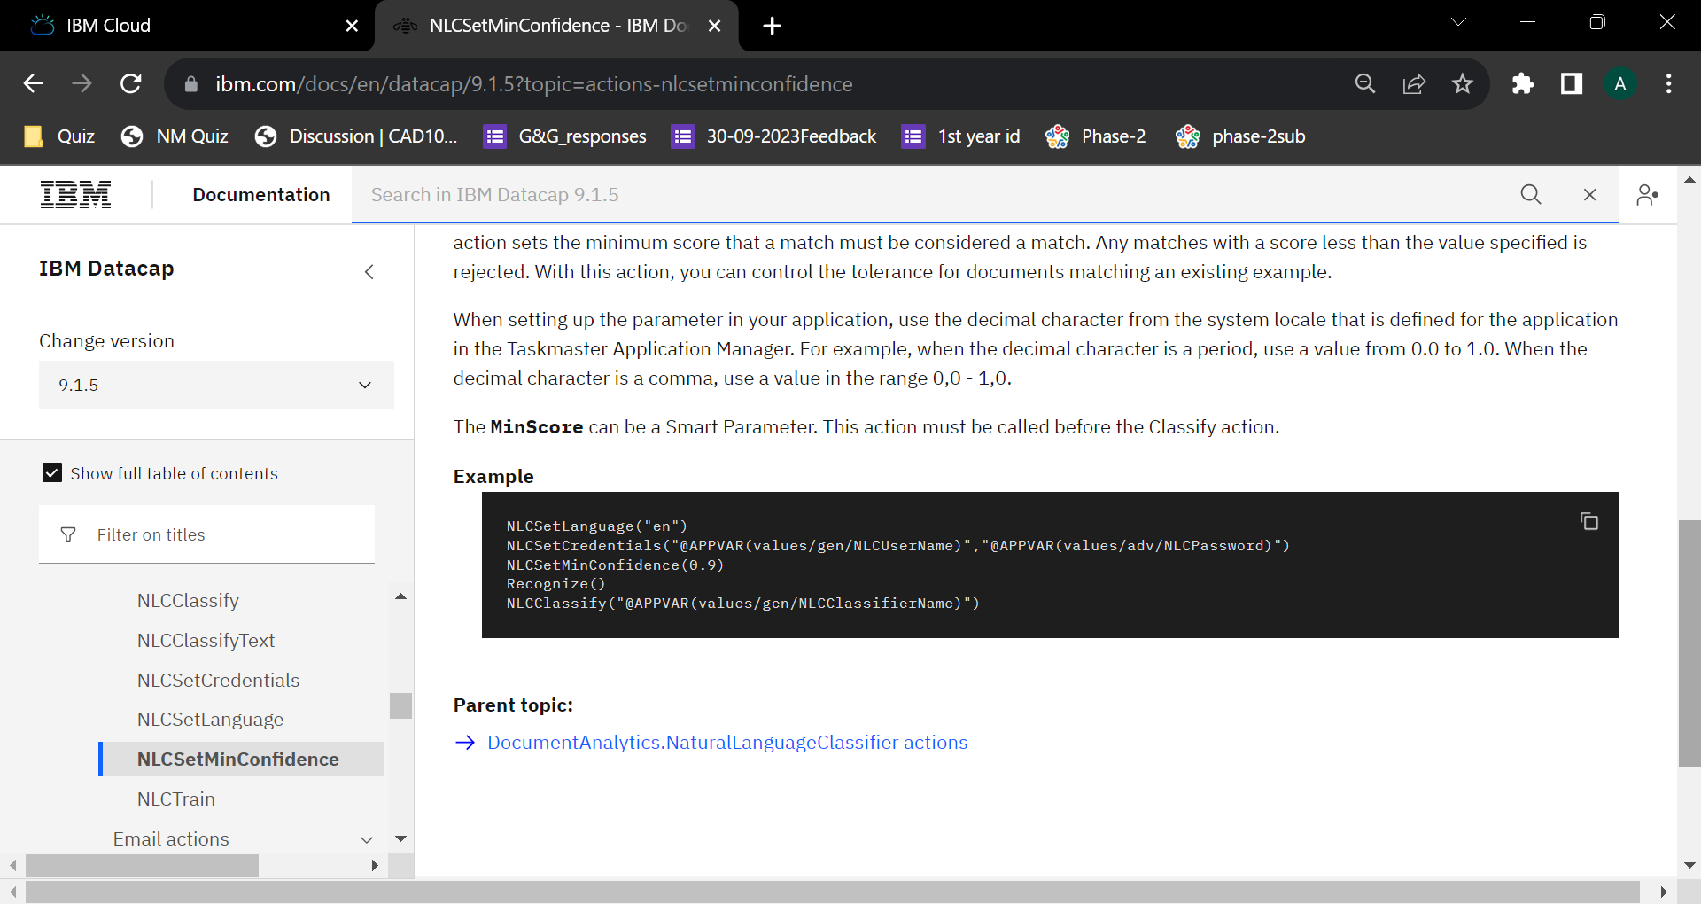

[**NLCTrain**](https://www.ibm.com/docs/en/SSZRWV_9.1.5/com.ibm.dc.reference.doc/dcaca923.htm)  
Creates or replaces an NLC Classifier.

