2.Create a simple cloud software application for Flight Reservation System using any Cloud Service Provider to demonstrate SaaS

STEP1: GOTO ZOHO.COM

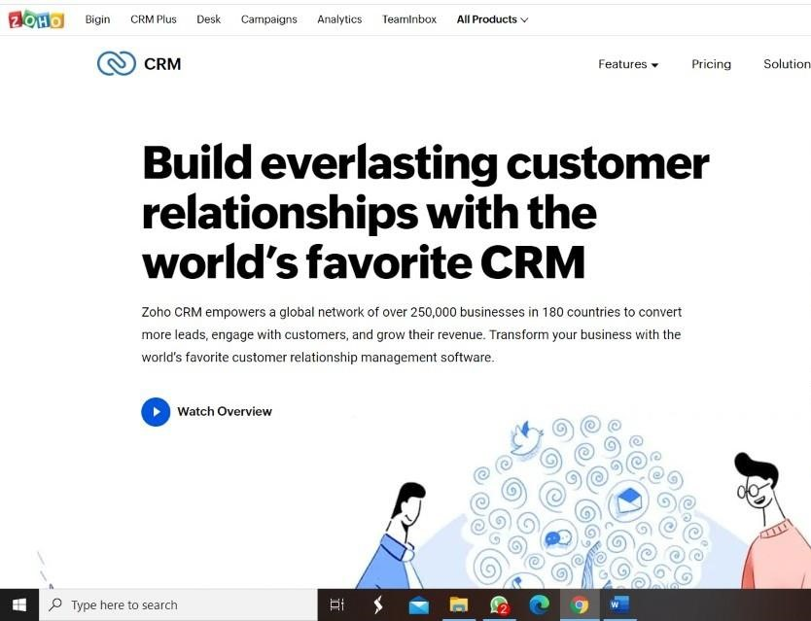

STEP 2: LOGIN TO THE ZOHO.COM

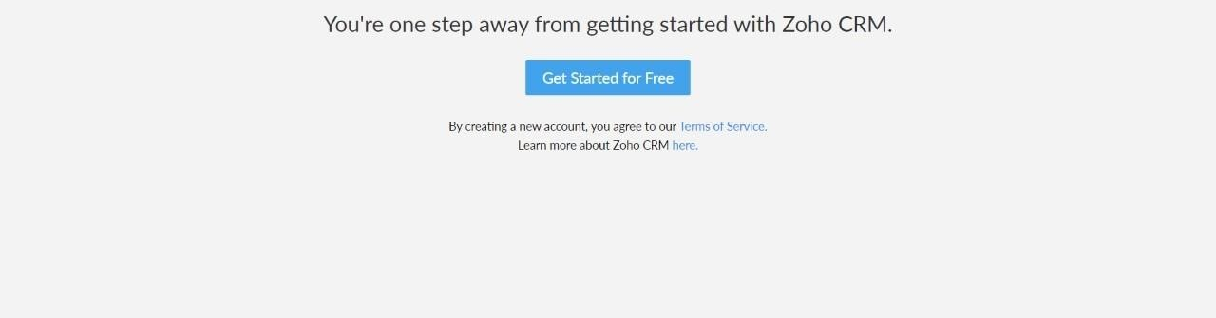

**step4:** Enter application name as flight reservation system.

