**3: CREATE A SIMPLE CLOUD SOFTWARE APPLICATION FOR PROPERTY BUYING & RENTAL PROCESS (IN CHENNAI CITY) USING ANY CLOUD SERVICE PROVIDER TO DEMONSTRATE SAAS.**

**STEP1: GOTO ZOHO.COM**

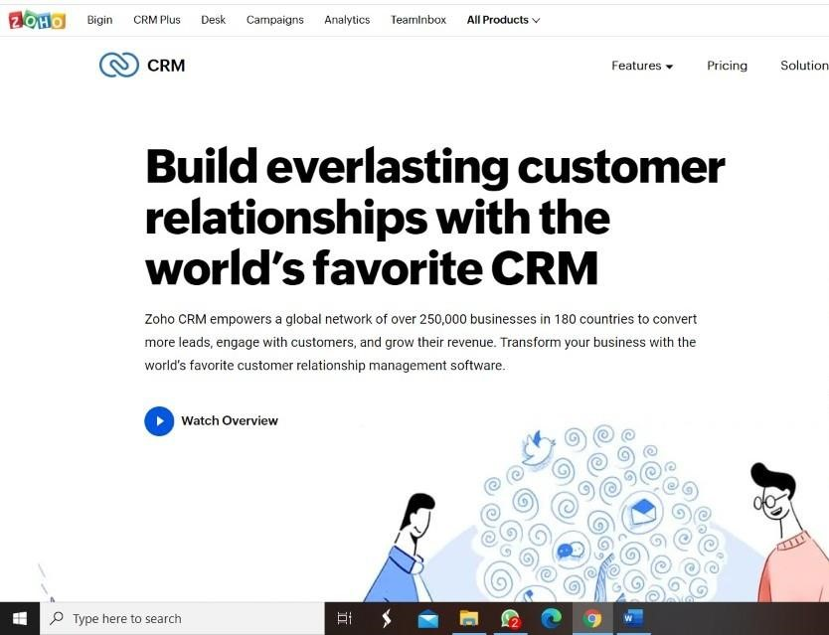

#### STEP 2: LOGINTOTHE ZOHO.COM



#### STEP 3: SELECT ONE APPLICATION

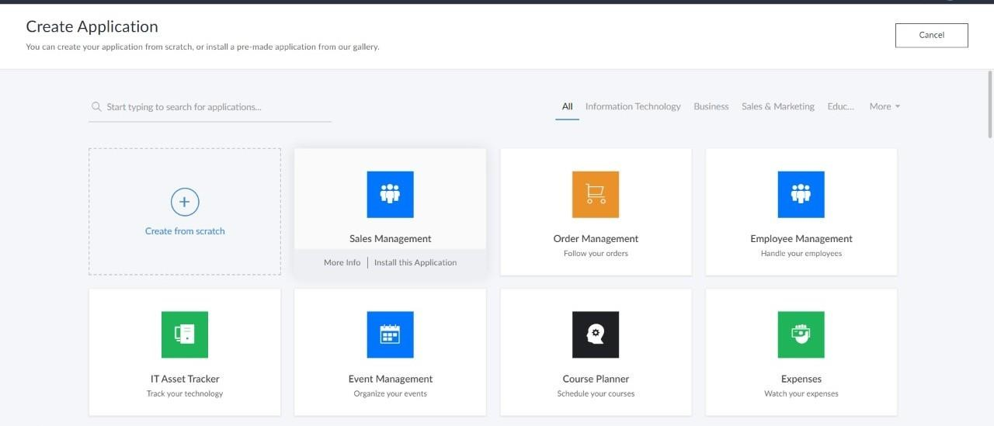

**step4:** Enter application name as property buying & rental.

