SWE645 - ASSIGNMENT 3
Team Members:
- Neeraj Reddy Karnati (G01502689) – Worked on containerizing the frontend and backend using Docker, deploying the application on Kubernetes using Rancher, configuring services, setting up persistent storage, and preparing technical documentation.
- Abhinav Reddy Telkala (G01504068) – Implemented and configured the CI/CD pipeline using Jenkins, integrated GitHub and DockerHub, performed testing and debugging, and ensured smooth deployment and application functionality.
Overview:
The objective of Homework Assignment 3 was to design and implement a complete full-stack Student Survey application using modern cloud-native technologies, focusing on scalable architecture, microservices, containerization, persistent storage, and CI/CD automation. The assignment required building both the frontend and backend from scratch, containerizing each component, and deploying them as independent microservices on a Rancher-managed Kubernetes cluster.
To meet these requirements, the project was divided into several major components:
1. Full-Stack Application Development
- The frontend was developed using React.js (Vite) to implement an interactive Student Survey form and views for listing, editing, and deleting surveys.
- The backend was built using FastAPI, with SQLModel providing the ORM layer to perform full CRUD operations.
- A SQLite database was used for persistent storage, with a Kubernetes PersistentVolume (PV) and PersistentVolumeClaim (PVC) ensuring data durability across pod restarts.
2. Containerization Using Docker
Both the frontend and backend were packaged into separate Docker images:
- The frontend image includes a Vite build served using Nginx, configured for Single Page Application (SPA) routing.
- The backend image runs FastAPI via Uvicorn.
These images were pushed to DockerHub to enable automated deployment.
3. Kubernetes Deployment on Rancher Cluster
The application was deployed to a Rancher-managed Kubernetes cluster hosted on AWS EC2.
Kubernetes manifests were created for:
- Frontend Deployment (3 replicas)
- Backend Deployment (3 replicas)
- NodePort Services for external access
- Persistent storage using PV/PVC for SQLite database
- This architecture ensures high availability, scalability, and persistent data management.
4. CI/CD Pipeline with Jenkins & GitHub
A fully automated CI/CD pipeline was built using Jenkins, enabling continuous integration and deployment:
- Checkout: Pull source code from GitHub
- Build: Build Docker images for frontend & backend
- Push: Upload images to DockerHub
- Deploy: Apply Kubernetes manifests and restart deployments on the Rancher cluster
- This ensures rapid, automated, and error-free application updates.
5. Deliverables Provided
- Frontend Dockerfile
- Backend Dockerfile
- Kubernetes Deployment Manifests (frontend, backend, PVC, services)
- Jenkinsfile for CI/CD automation
- Full React source code (Survey form, list view, edit view)
- FastAPI backend source code
- Database persistence validation (SQLite + PVC)
- Application URLs and demonstration video
Tools and Technologies Used:
- AWS EC2 – Hosting environment for Jenkins and Rancher-managed Kubernetes.
- Rancher – Cluster management for Kubernetes.
- Docker – Containerization of the student survey application.
- DockerHub – Registry to push and store Docker images.
- Kubernetes – Orchestrating application deployment with multiple replicas.
- Jenkins – Automating CI/CD pipeline for build and deployment.
- GitHub – Source code repository and integration with Jenkins.
- NodePort / LoadBalancer Services – Exposing the application externally.
System Architecture:
The Student Survey application follows a modern, cloud-native microservice architecture. The workflow of the system is as follows:
Developer Workflow:
- A developer updates code in the React frontend, FastAPI backend, or Kubernetes manifests.
- Changes are pushed to the GitHub repository, which serves as the central version control system.
Jenkins CI/CD Pipeline:
Once code is pushed to GitHub, the Jenkins pipeline executes automatically:
- Build Stage: Jenkins pulls the latest code and builds two Docker images:
- swe645-frontend – React + Vite build served by Nginx
- swe645-backend – FastAPI application running on Uvicorn
- Push Stage:
The newly built images are pushed to DockerHub under the team’s repository.
- Deploy Stage:
Using Rancher’s kubeconfig, Jenkins applies updated Kubernetes manifests:
- Frontend Deployment
- Backend Deployment
- NodePort Services
- PVC (Persistent Volume Claim)
- Restart Stage:
Jenkins forces a rolling restart of Kubernetes deployments to ensure the latest Docker images are running.
Kubernetes Cluster (Rancher):
- Deployments:
Kubernetes runs:
- 3 frontend pods for UI availability
- 3 backend pods for API scalability
- These pods auto-restart and self-heal if failures occur.
- Persistent Storage:
A PersistentVolume (PV) and PersistentVolumeClaim (PVC) store the SQLite database file at /data/survey.db.
This guarantees that backend data survives:
- pod restarts
- node rescheduling
- rolling updates
- Services:
Two NodePort services expose the microservices:
- Frontend: NodePort 31000
- Backend: NodePort 30080
- End-User Access
Users access the running application via the EC2 Elastic IP, such as:
- Frontend: http://<EC2-IP>:31000
- Backend API: http://<EC2-IP>:30080/surveys/
- The frontend interacts with the backend REST APIs directly through these exposed services.

Implementation Steps:
  - Push Full-Stack Application to GitHub: All source code:
  - React frontend (Vite project)
  - FastAPI backend application
  - Dockerfiles for frontend and backend
  - Kubernetes manifests:
  - backend-deployment.yaml
  - frontend-deployment.yaml
  - backend-service.yaml
  - frontend-service.yaml
  - survey-pvc.yaml
  - Jenkinsfile (complete CI/CD pipeline)were uploaded to a GitHub repository.
  - This ensures that Jenkins can automatically retrieve the latest code.

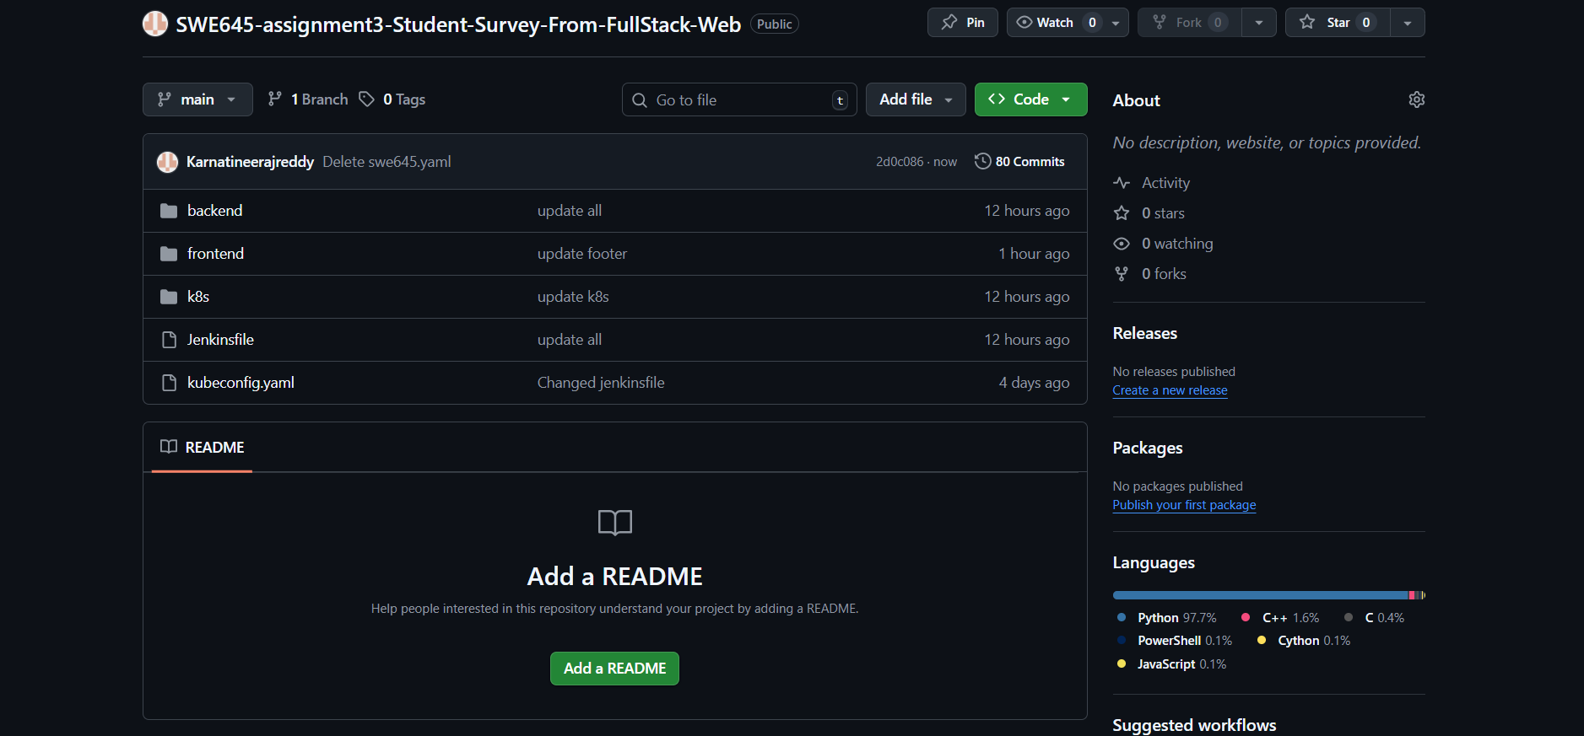
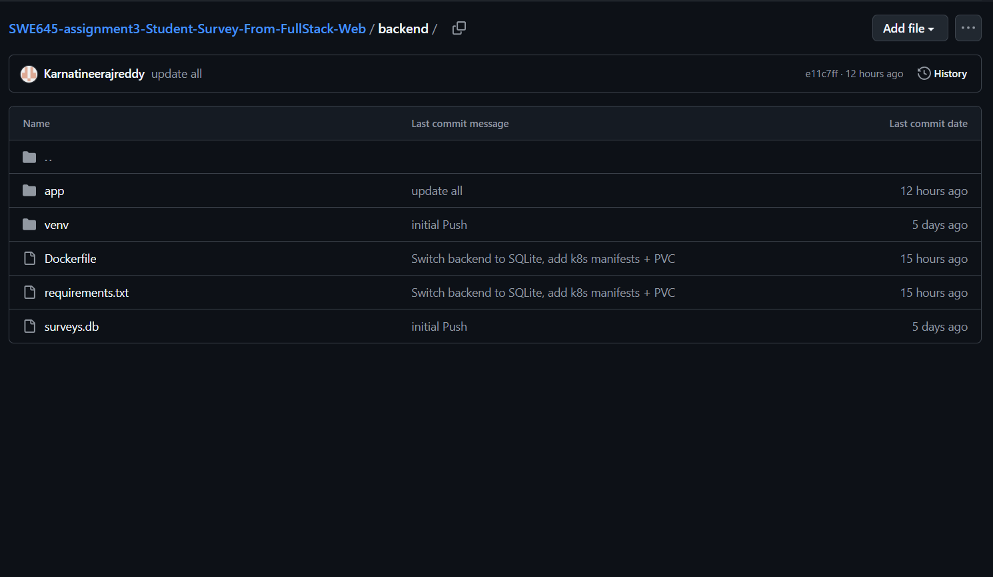
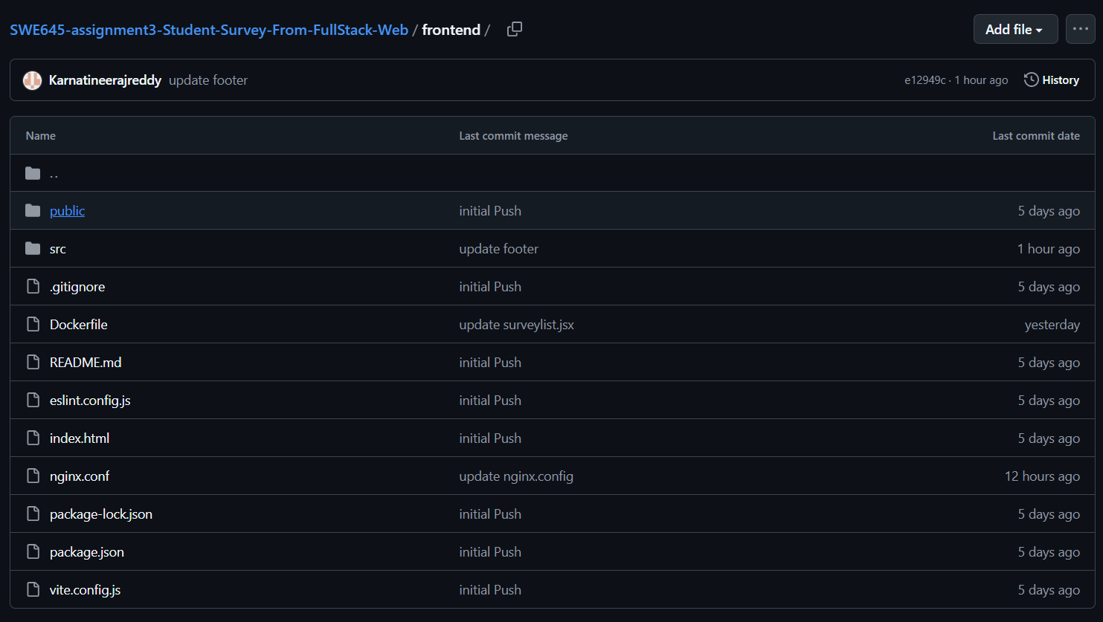
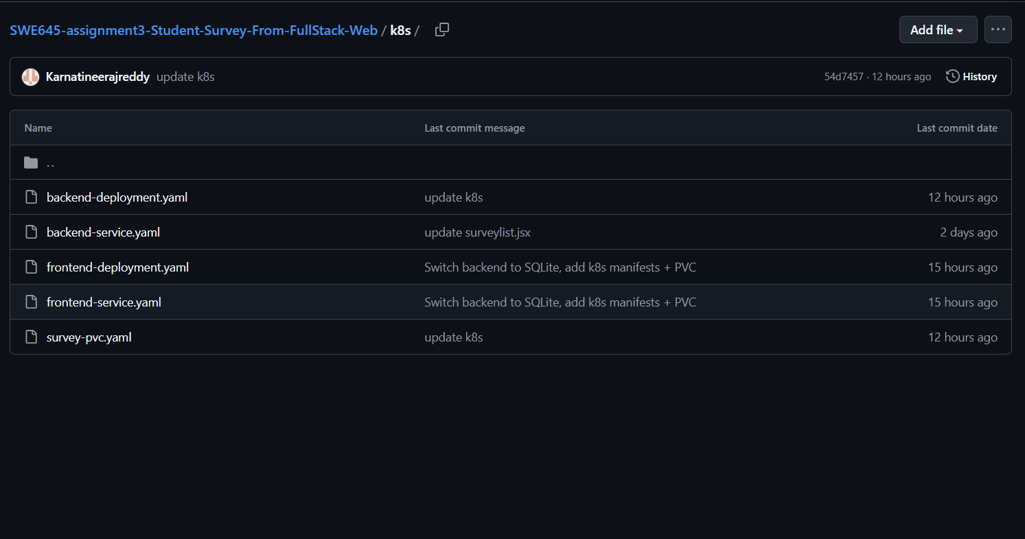

  - Build and Push Docker Images:
    - In Assignment 3, the project consists of two separate microservices, each of which must be packaged as its own Docker image:
    - Frontend Docker Image
    - Backend Docker Image
    - Both images are built on Jenkins automatically and pushed to DockerHub, where they become available for the Kubernetes cluster.
  - Backend Dockerfile (FastAPI + Uvicorn):
      - The backend Dockerfile is responsible for packaging the FastAPI application into a lightweight Python container.
      - Backend Dockerfile Code:
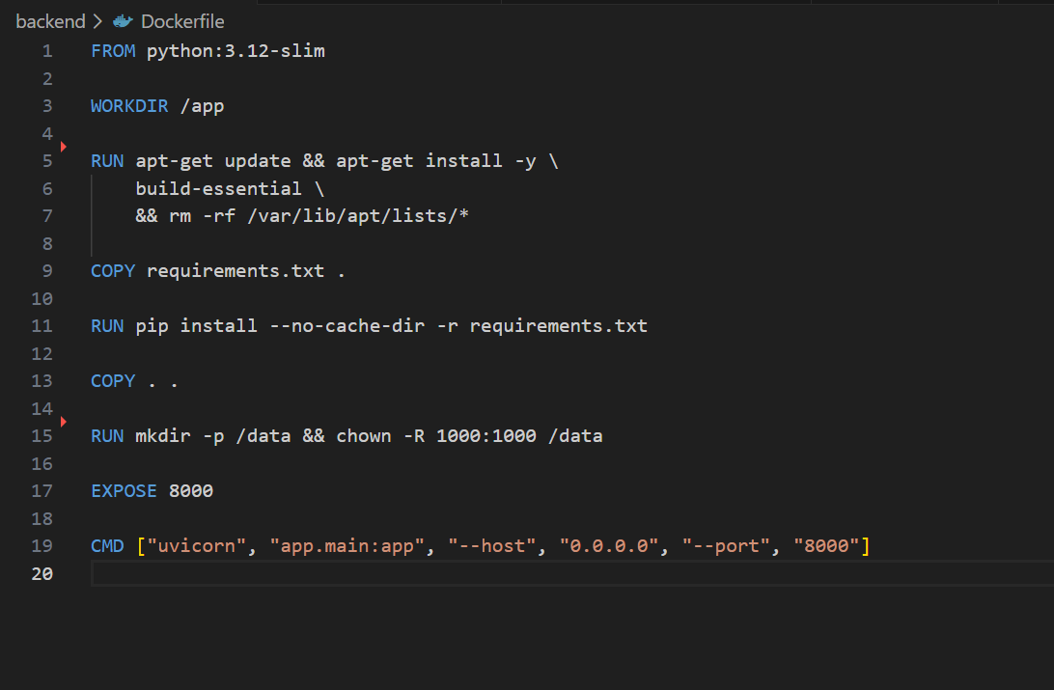
    - Backend Image Build & Push Commands: These steps are automated in Jenkins, but can be run manually during development.)
      - docker build -t neerajreddy22/swe645-backend:latest ./backend
      - docker login
      - docker push neerajreddy22/swe645-backend:latest

  - Frontend Dockerfile (React + Vite + Nginx):
      - The frontend uses React.js built via Vite. The production build is served using Nginx for performance and stability.
      - Frontend Dockerfile Code:
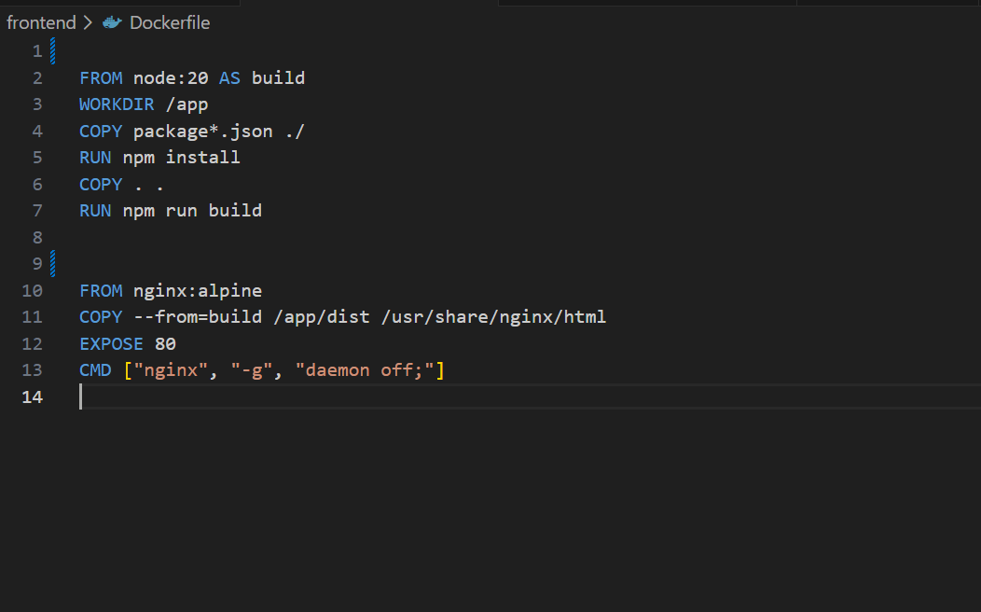

Frontend Image Build & Push Commands:
1. docker build -t neerajreddy22/swe645-frontend:latest ./frontend
2. docker login
3. docker push neerajreddy22/swe645-frontend:latest2

Summary of Docker Images Created:
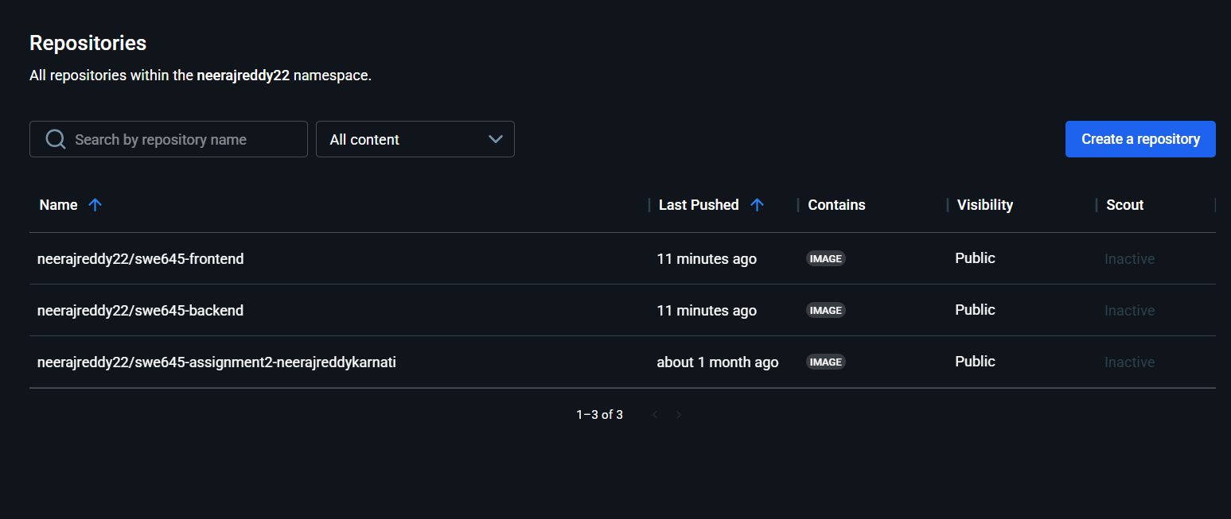

3. Kubernetes Deployment:
This section describes how the full-stack Student Survey application was deployed onto a Rancher-managed Kubernetes cluster running on AWS EC2 instances. The deployment consists of:
- Frontend (React + Nginx) Deployment
- Backend (FastAPI) Deployment
- NodePort Services
- Persistent Volume (SQLite Database)
- CI/CD integration with Jenkins
3.1 Setting Up AWS EC2 Instances for Rancher & Worker Node:
Two EC2 instances were provisioned:
- Instance 1 – Rancher Server (manages Kubernetes cluster)
- Instance 2 – Kubernetes Worker Node
Steps:
- Navigate to AWS EC2 → Launch Instance.
- Create two instances with the following configuration:
  - AMI: Ubuntu 22.04 LTS
  - Instance Type: t3.medium (required by Rancher)
  - Storage: 30 GiB
- Under Network / Security Group, add inbound rules:
  - HTTP (80) → 0.0.0.0/0
  - HTTPS (443) → 0.0.0.0/0
  - Custom TCP (8080) → 0.0.0.0/0
- Launch both instances.
- Allocate Elastic IPs and associate them with both EC2 instances.
These EC2 machines serve as the control-plane and worker node of the cluster.

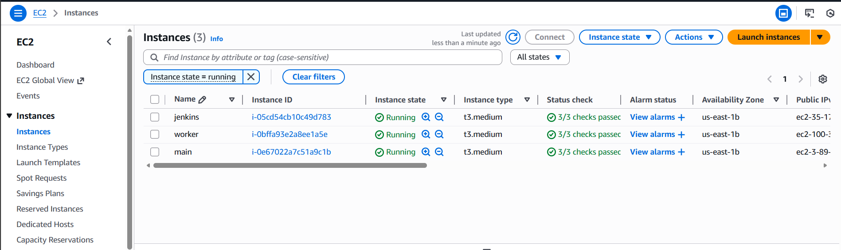
3.2 Installing Docker on Both EC2 Instances:
Rancher and Kubernetes agents require Docker. The following commands were run on both instances:
sudo apt update
sudo apt install -y ca-certificates curl gnupg lsb-release

sudo mkdir -p /etc/apt/keyrings
curl -fsSL https://download.docker.com/linux/ubuntu/gpg | sudo gpg --dearmor -o /etc/apt/keyrings/docker.gpg

echo \
"deb [arch=$(dpkg --print-architecture) signed-by=/etc/apt/keyrings/docker.gpg] \
https://download.docker.com/linux/ubuntu \
$(lsb_release -cs) stable" | \
sudo tee /etc/apt/sources.list.d/docker.list > /dev/null

sudo apt update
sudo apt install -y docker-ce docker-ce-cli containerd.io docker-compose-plugin
sudo systemctl enable docker
sudo systemctl start docker

docker --version
sudo systemctl status docker

3.3 Installing Rancher on EC2 Instance 1:
Rancher was deployed as a Docker container on the first instance.
Steps:
- Ensure Docker is running:
sudo systemctl status docker
- Deploy Rancher Server:
sudo docker run -d --restart=unless-stopped \
--privileged \
-p 80:80 -p 443:443 \
--name rancher \
rancher/rancher:latest
- Wait 2–3 minutes until Rancher starts fully.
- Access Rancher Dashboard in browser:
https://<EC2-PUBLIC-IP>
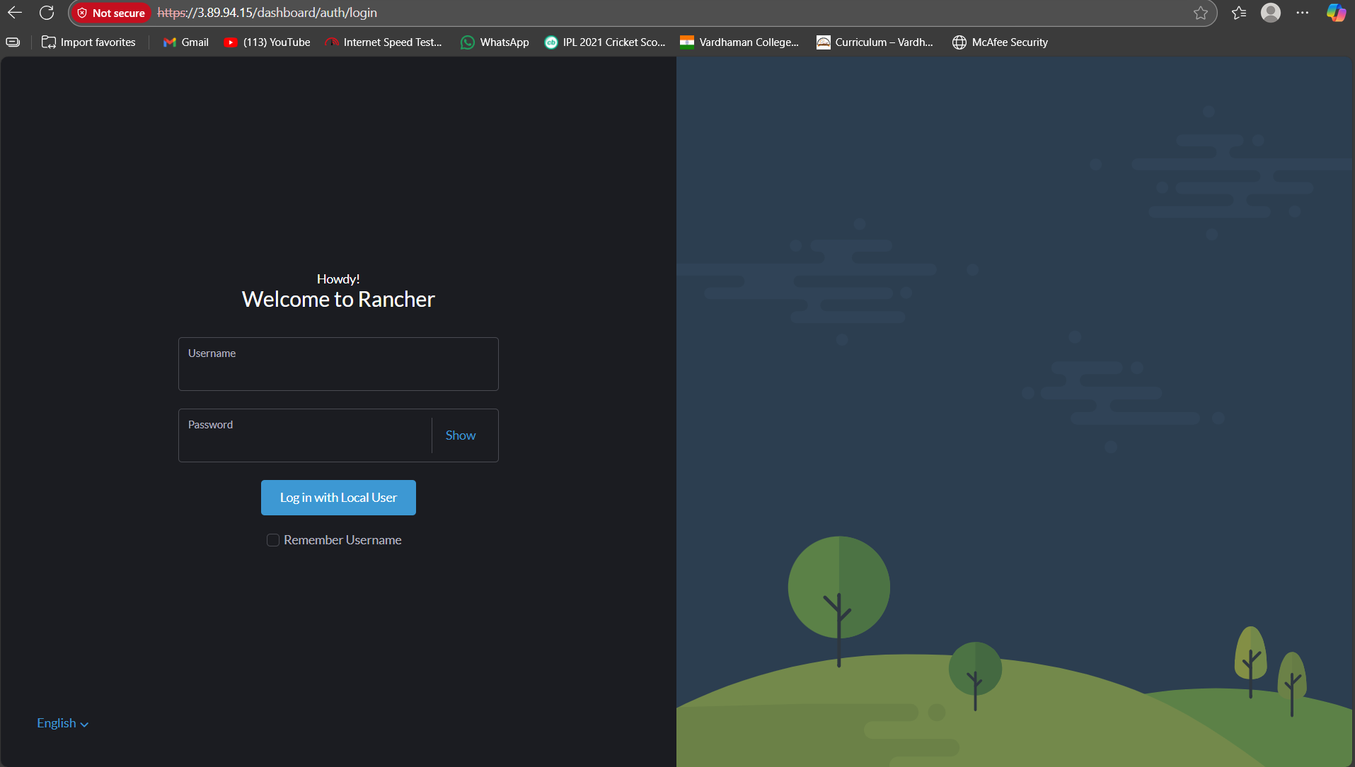
To access my rancher my url was: https://3.89.94.15
- Accept HTTPS security warnings.
- Set up:
  - Admin password
  - Rancher server URL
- If needed, retrieve password:
sudo docker logs rancher 2>&1 | grep "Bootstrap Password"
At this point, Rancher UI is fully ready for cluster creation.

3.4 Creating a Kubernetes Cluster in Rancher:
Steps:
- Log in to Rancher:
- Navigate to:
Cluster Management → Create → Custom Cluster
- Name the cluster (example: swe645).
- Select etcd + controlplane + worker roles.
- Rancher displays a Node Registration Command.
Example registration command:
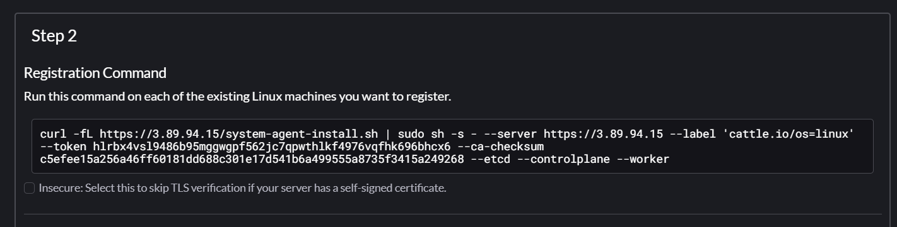
- SSH into EC2 Instance 2 (worker node) and run the command.
- Wait for the node to appear as Active in Rancher.
The Kubernetes cluster is now ready for workloads.
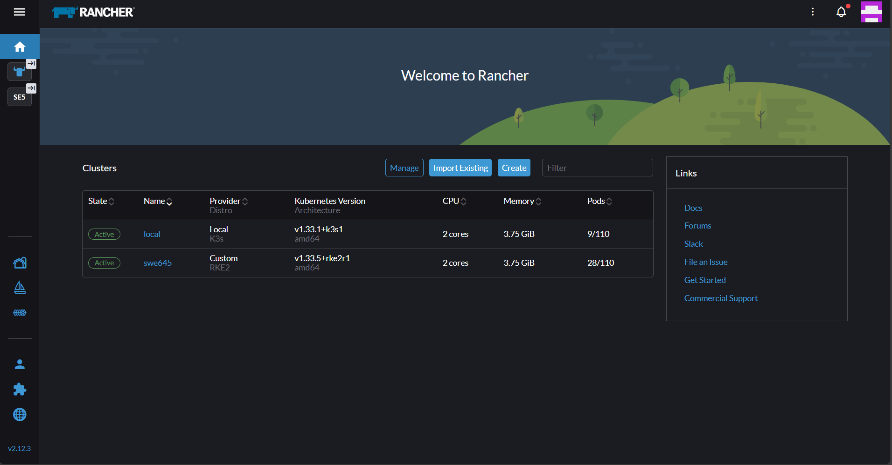

3.5 Deploying the Full-Stack Application to Kubernetes
All Kubernetes manifests are stored in the GitHub k8s/ directory and deployed automatically via Jenkins.
Kubernetes Components:
- frontend-deployment.yaml – React UI
- backend-deployment.yaml – FastAPI server
- frontend-service.yaml – NodePort 31000
- backend-service.yaml – NodePort 30080
- survey-pvc.yaml – Persistent Storage
Manual deployment commands:
kubectl apply -f k8s/survey-pvc.yaml
kubectl apply -f k8s/backend-deployment.yaml
kubectl apply -f k8s/backend-service.yaml
kubectl apply -f k8s/frontend-deployment.yaml
kubectl apply -f k8s/frontend-service.yaml
Verify deployments:
kubectl get pods -o wide
kubectl get svc
kubectl get pvc
kubectl get pv
All pods must be in Running state before production access.
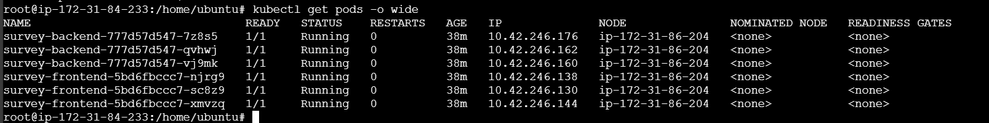

3.6 Verifying Cluster and Application Access:
1. Verify in Rancher UI
- Navigate to Workloads → Deployments
- You should see:
  - survey-backend with 3 pods
  - survey-frontend with 3 pods
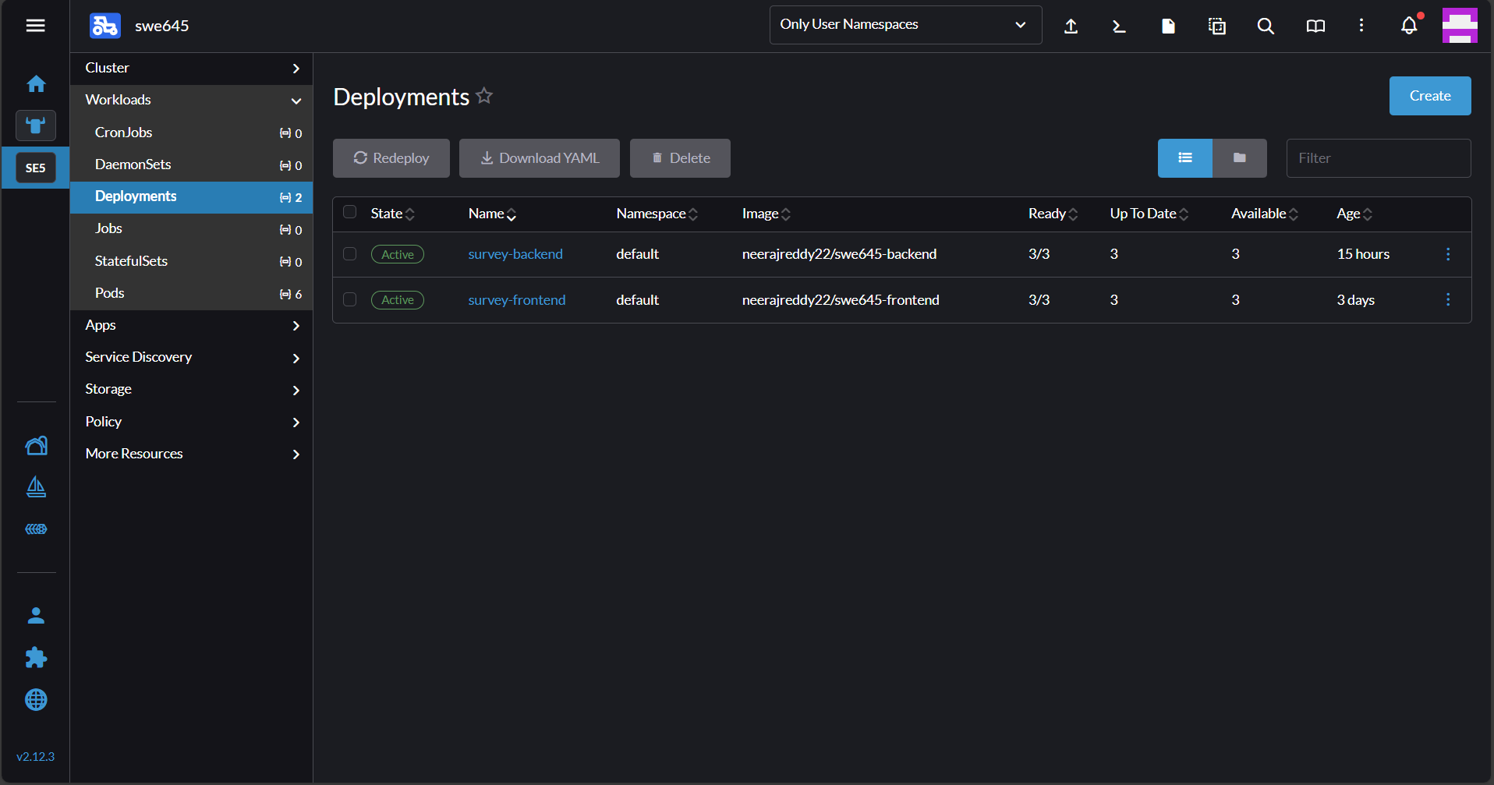
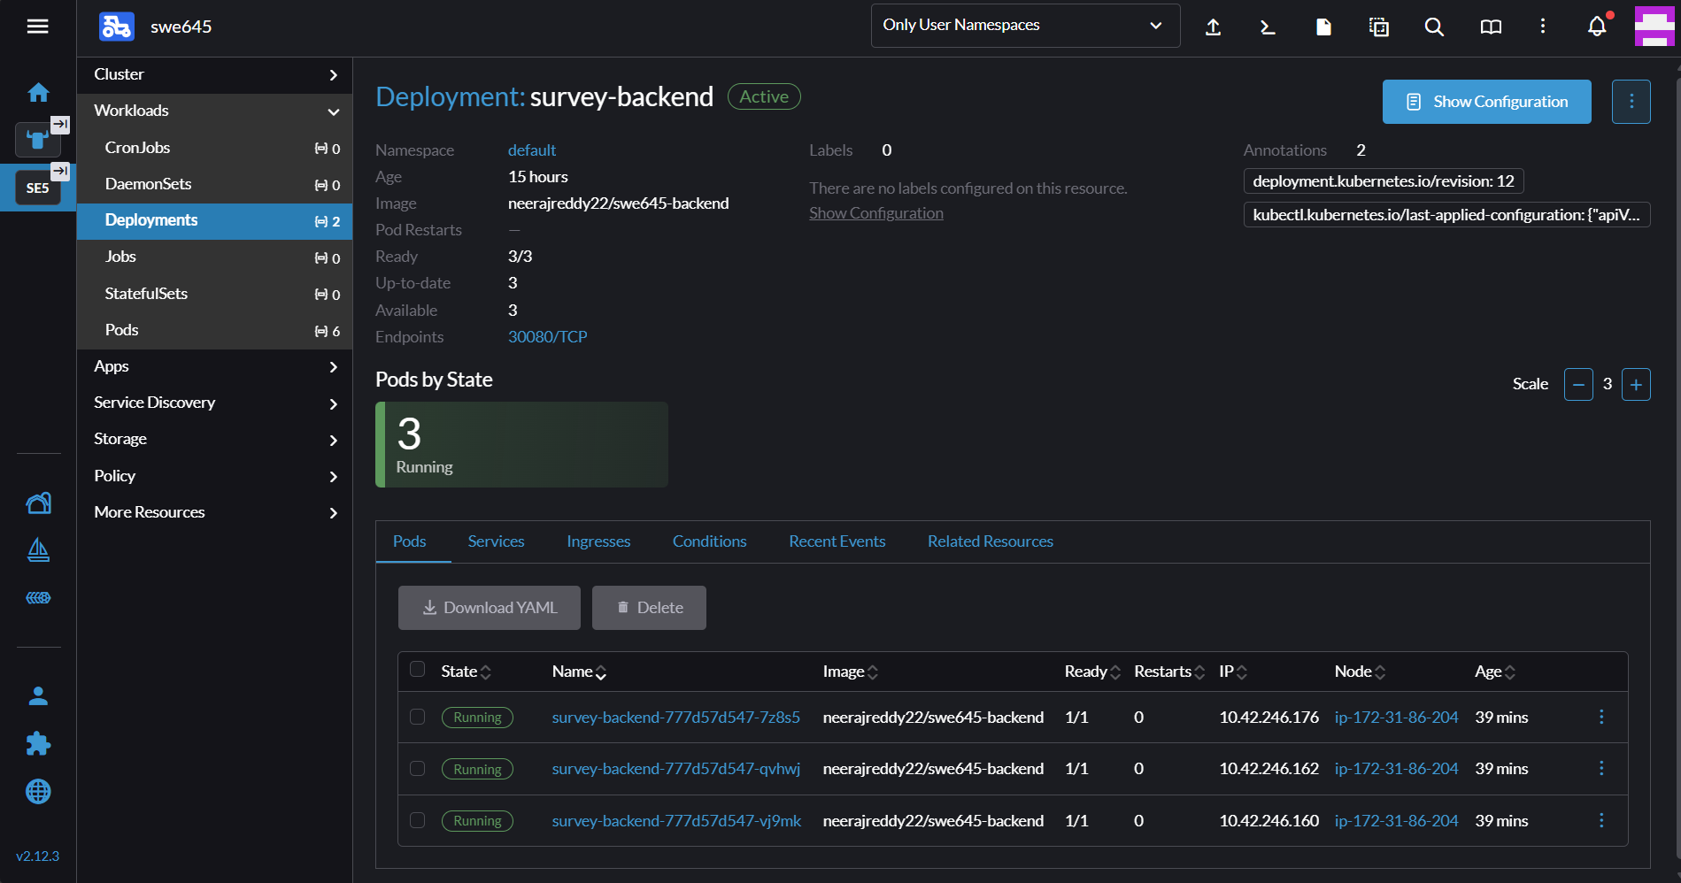
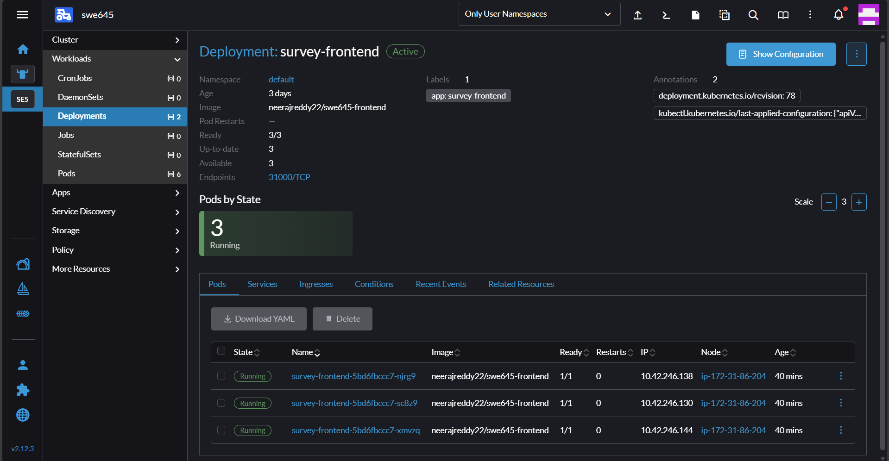
2. Test Application in Browser
- Frontend:
- http://<EC2-IP>:31000
- My website: http://100.30.1.131:31000/
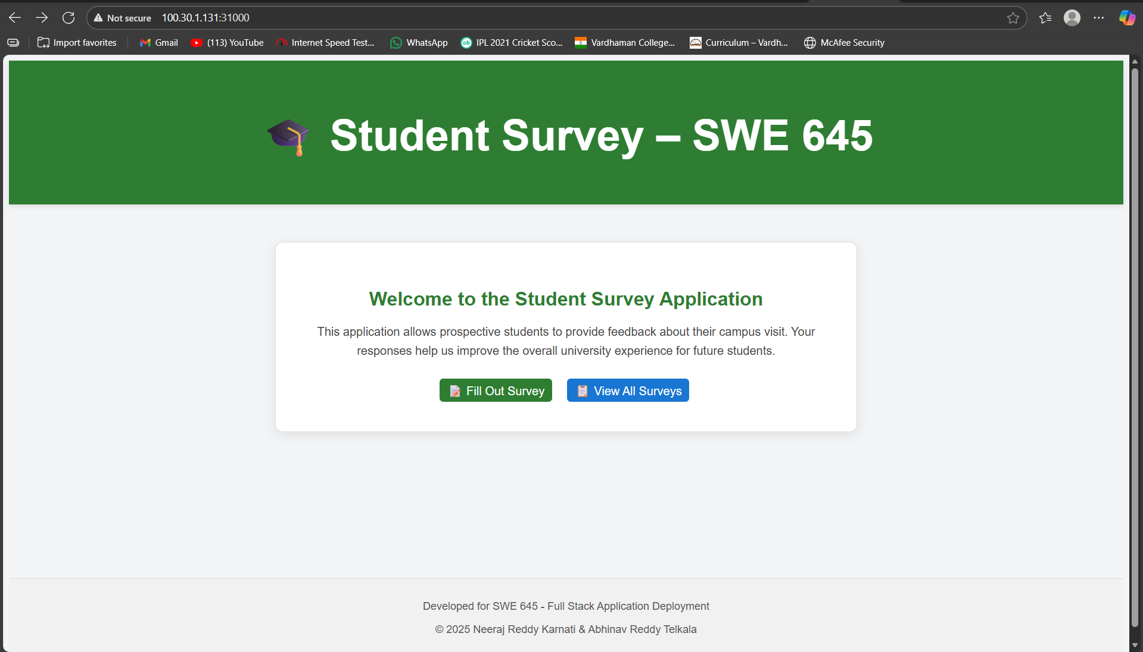
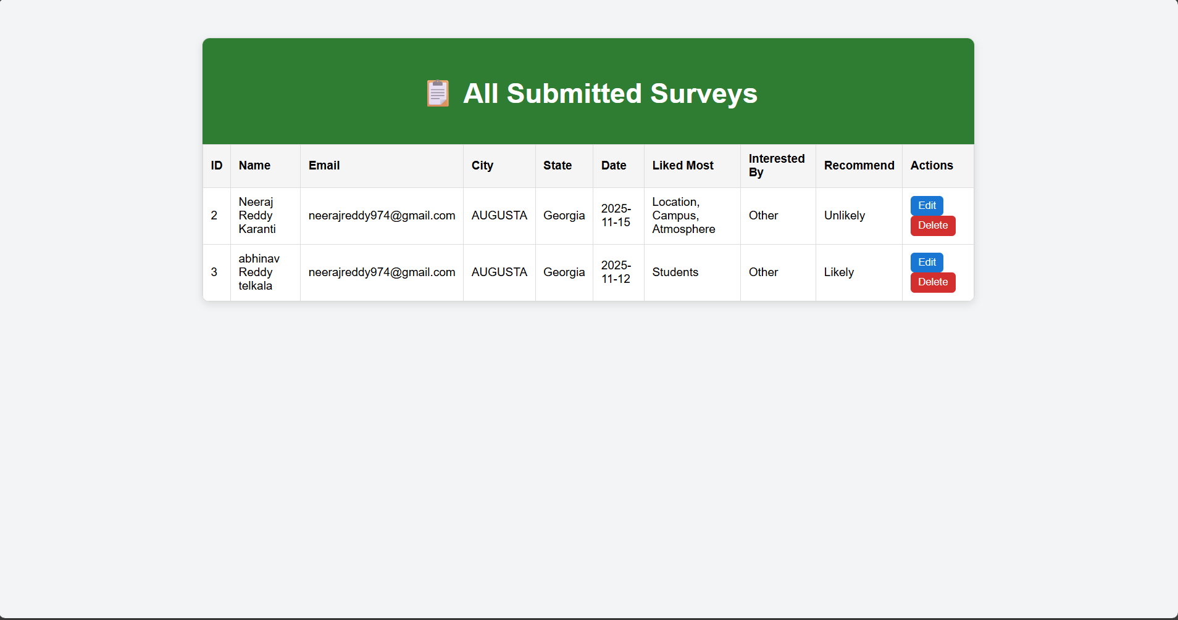

- Backend API:
- http://<EC2-IP>:30080/surveys/
- My website: http://100.30.1.131:30080/
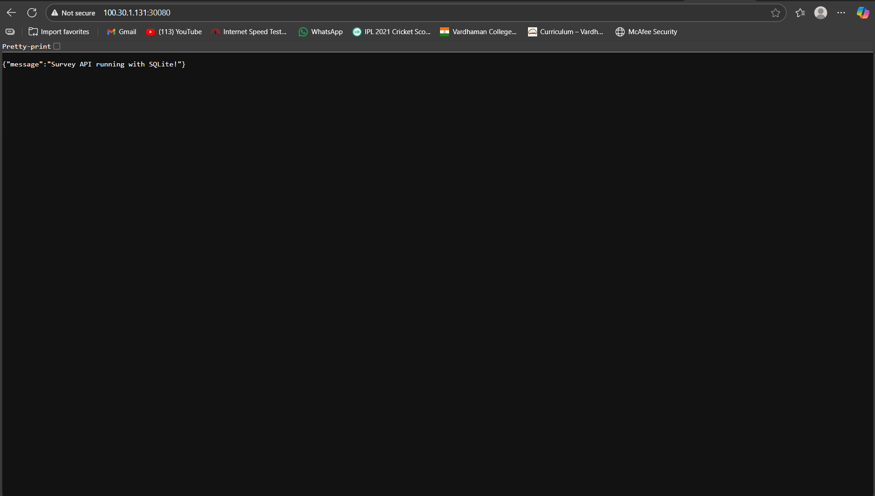
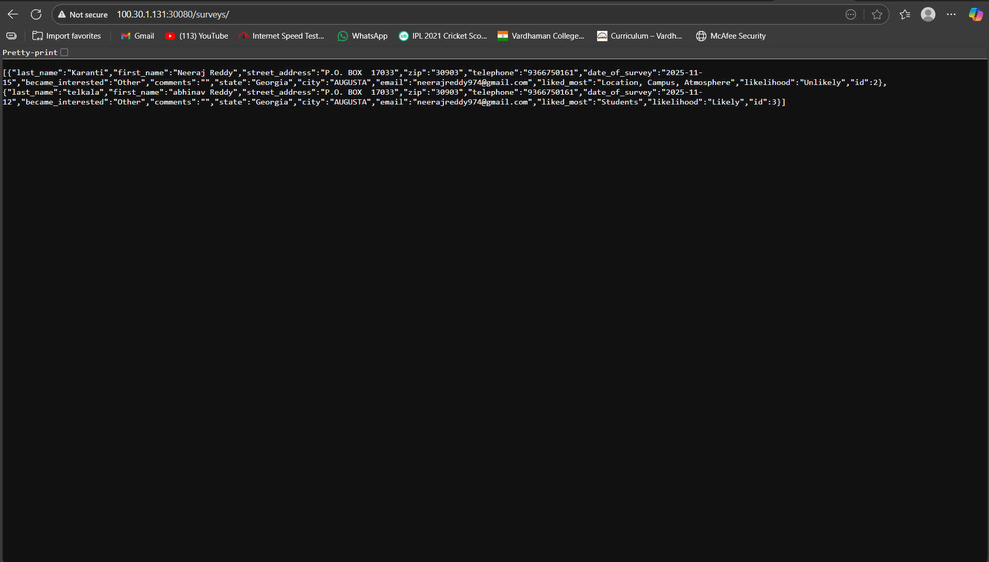
3. Validate Database Persistence
List DB inside PVC:
kubectl exec -it <backend-pod> -- ls /data
Download DB:
kubectl cp <backend-pod>:/data/survey.db survey.db
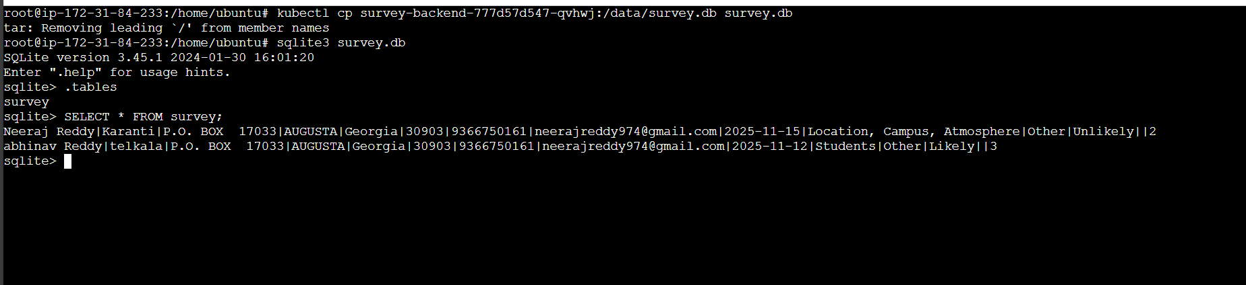
Commands to access data from database:
1. kubectl cp survey-backend-777d57d547-qvhwj:/data/survey.db survey.db
2. sqlite3 survey.db
3. .tables
4. SELECT * FROM survey;

4. CI/CD Pipeline Setup with Jenkins: The CI/CD pipeline plays a crucial role in automating the integration, containerization, and deployment of both the React frontend and FastAPI backend. Jenkins ensures that any change pushed to GitHub automatically triggers a full build and redeployment to the Rancher-managed Kubernetes cluster.
4.1 Installing Jenkins on AWS EC2:
- A separate EC2 instance was provisioned to serve as the Jenkins automation server. The installation steps executed on the Jenkins EC2 instance were:
Code:
sudo apt update -y
sudo apt install openjdk-11-jdk -y
wget -q -O - https://pkg.jenkins.io/debian-stable/jenkins.io.key | sudo apt-key add -
sudo sh -c 'echo deb http://pkg.jenkins.io/debian-stable binary/ > /etc/apt/sources.list.d/jenkins.list'
sudo apt update -y
sudo apt install jenkins -y
sudo systemctl enable jenkins
sudo systemctl start Jenkins

- To verify Jenkins status:
Code: sudo systemctl status Jenkins

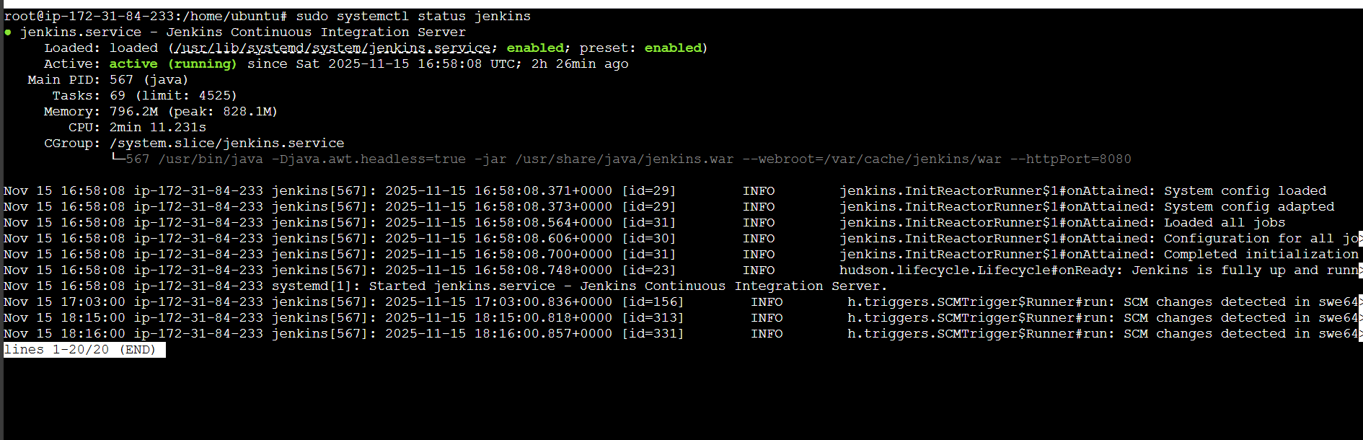

4.2 Accessing Jenkins UI: To access the Jenkins web dashboard:
http://<Jenkins-EC2-Public-IP>:8080
Example in our project:
http:// 35.174.79.122 :8080
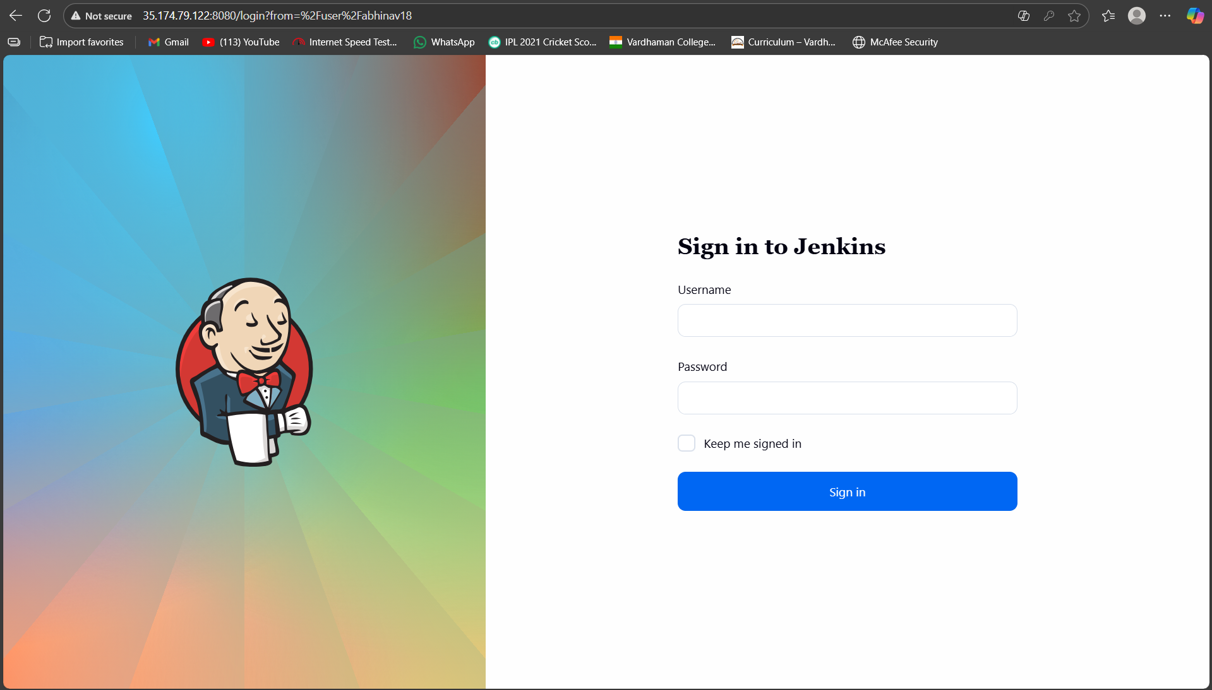

Initial Setup:
- Retrieve admin password:
- sudo cat /var/lib/jenkins/secrets/initialAdminPassword
- Log in and install the Suggested Plugins.
- Create an admin user and complete the setup.

4.3 Configuring Jenkins Credentials:
1. Navigate to:
Manage Jenkins → Credentials → System → Global Credentials
Three credentials were added:
1. GitHub Credentials
Used for Jenkins to pull code.
2. DockerHub Credentials
Allows Jenkins to push Docker images:
docker login
3. Kubernetes kubeconfig (Secret File)
Required so Jenkins can deploy to the Rancher Kubernetes cluster.
This kubeconfig file was downloaded from Rancher and uploaded into Jenkins.

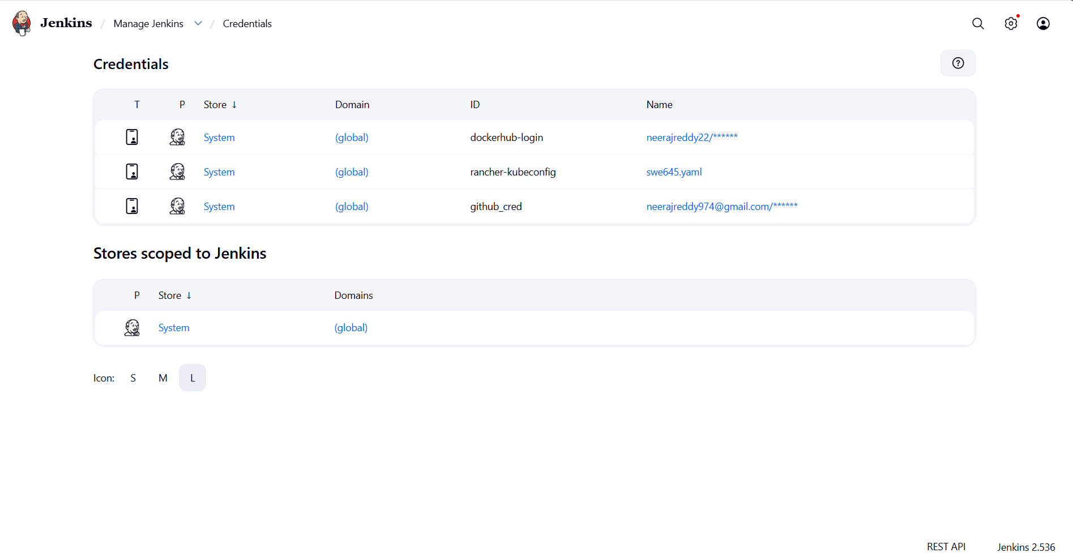

4.4 Creating a Jenkins Pipeline Job:
- Go to New Item
- Enter project name:
- In my case: swe645x
- Select Pipeline
- Click OK
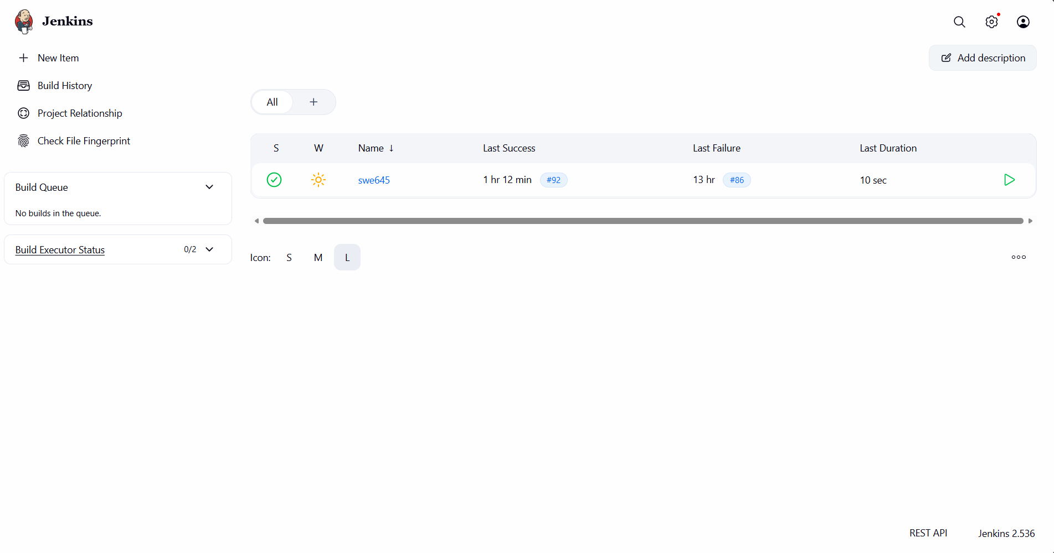

4.5 Configuring Pipeline with GitHub Integration:
Inside the pipeline settings:
General
- Check: GitHub project
- Add your GitHub repository URL
Build Triggers
To automatically detect changes:
Poll SCM: * * * * *
(This checks GitHub every minute.)
Pipeline Definition
- Script from SCM
- SCM: Git
- Repository URL: (your project repo)
- Credentials: Select GitHub credentials
- Branch Specifier: */main
Click Save.

4.6 Allow Jenkins to Use Docker
On Jenkins EC2 instance:
sudo chmod 777 /var/run/docker.sock
This enables Jenkins to:
- Build Docker images
- Push to DockerHub
- Run kubectl deployments
4.7 Jenkins Pipeline Execution:
When Build Now is clicked or GitHub receives a commit:
Jenkins executes stages:
Stage 1: GitHub Checkout
Pulls the latest React + FastAPI + Kubernetes manifests.
Stage 2: Build Docker Images
Builds:
swe645-frontend:latest
swe645-backend:latest
Stage 3: Push Images to DockerHub
docker push neerajreddy22/swe645-frontend:latest
docker push neerajreddy22/swe645-backend:latest
Stage 4: Deploy to Kubernetes
Executes:
kubectl apply -f k8s/survey-pvc.yaml
kubectl apply -f k8s/backend-deployment.yaml
kubectl apply -f k8s/frontend-deployment.yaml
kubectl rollout restart deployment/survey-backend
kubectl rollout restart deployment/survey-frontend
Stage 5: Verification
Checks pod and service status.
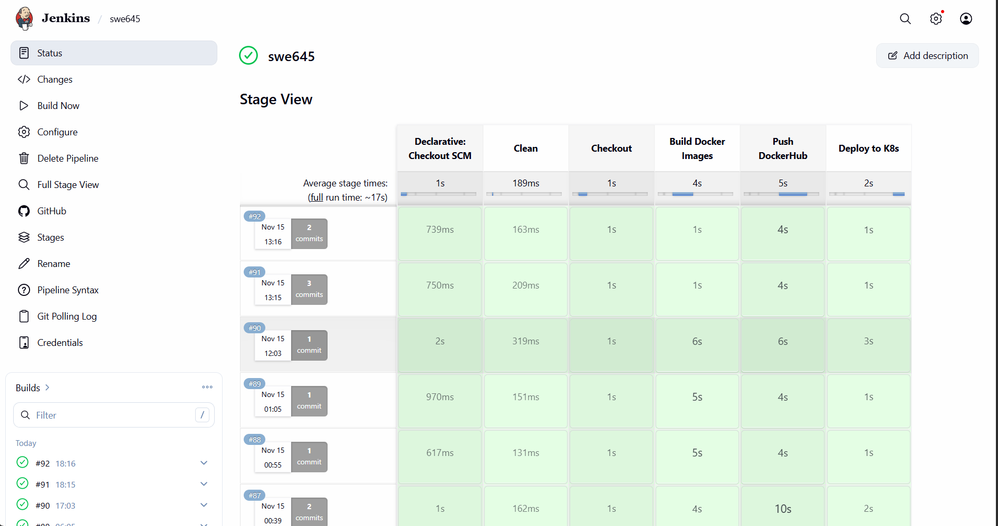
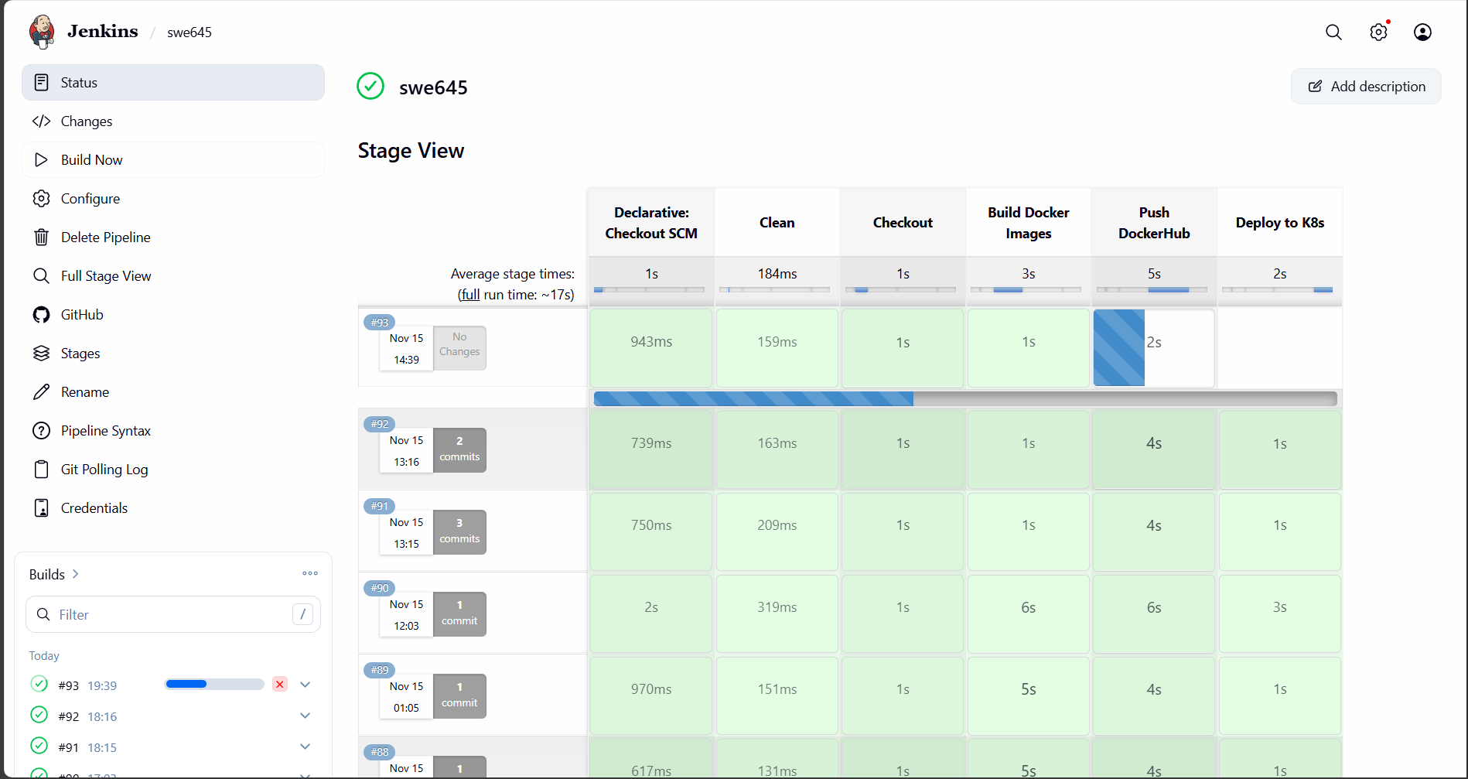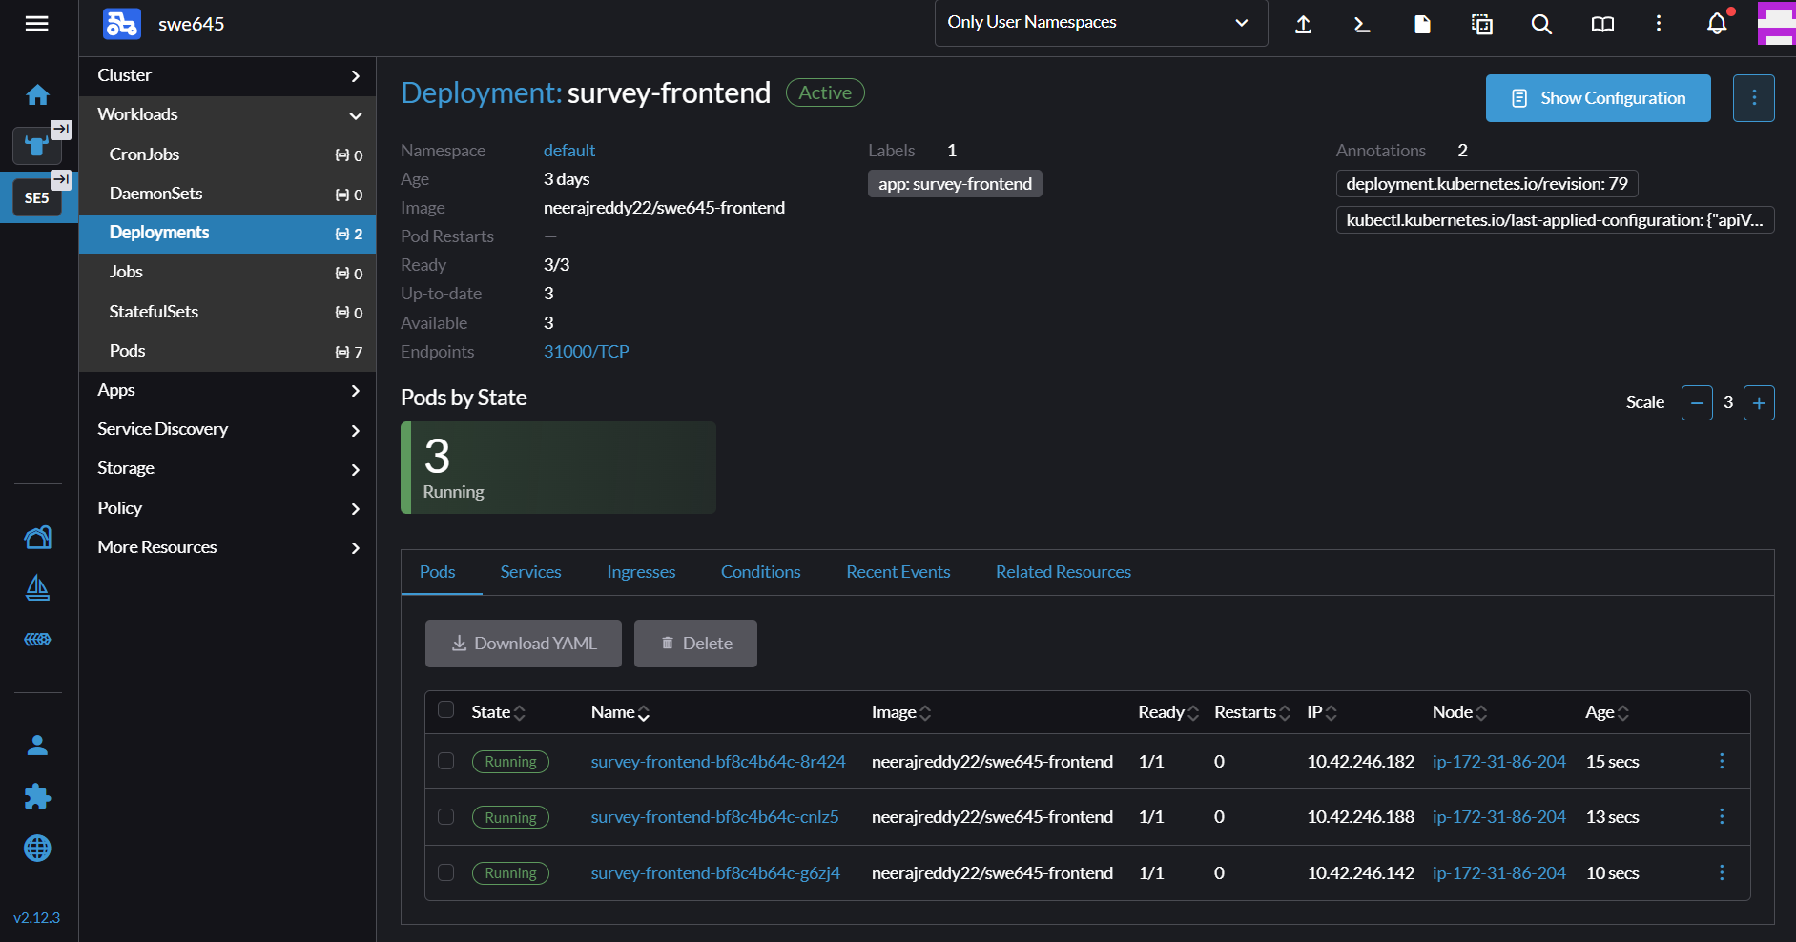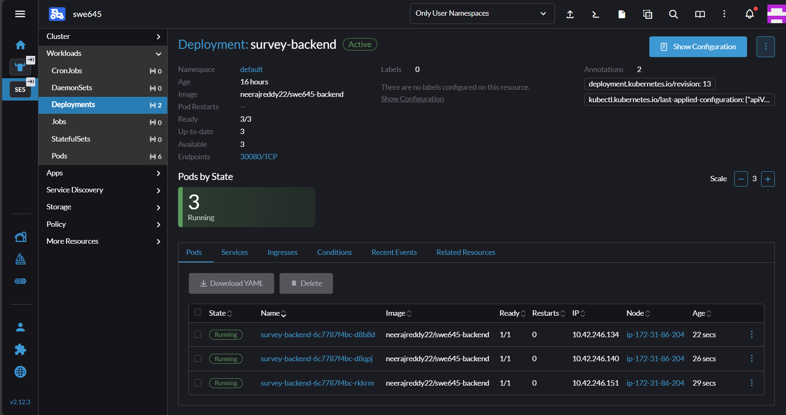

4.8 CI/CD Result:
Once configured, the system achieves:
- Fully automated builds
- Automatic containerization
- Automatic DockerHub pushes
- Zero-downtime rolling deployments
- Full integration of GitHub → Jenkins → Kubernetes
When code is updated:
- Developer commits & pushes to GitHub
- Jenkins detects change
- Jenkins builds new Docker images
- Jenkins pushes new images to DockerHub
- Jenkins deploys updated images to Kubernetes
- Rancher rolls out pods seamlessly
Within seconds, the updated application is live.

4.9 Demonstrating Database Change via CI/CD
To illustrate CRUD operations and show persistence:
Before Submitting Form
Retrieve the DB file:
kubectl cp <backend-pod>:/data/survey.db survey.db
My command:
sqlite3 survey.db
SELECT * FROM survey;
Expected result:
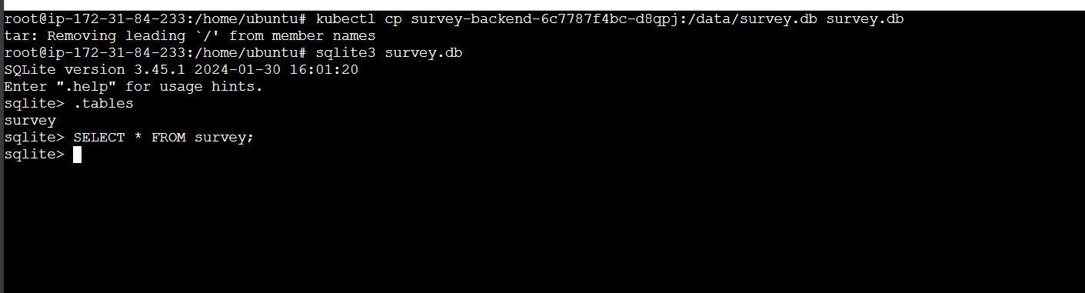
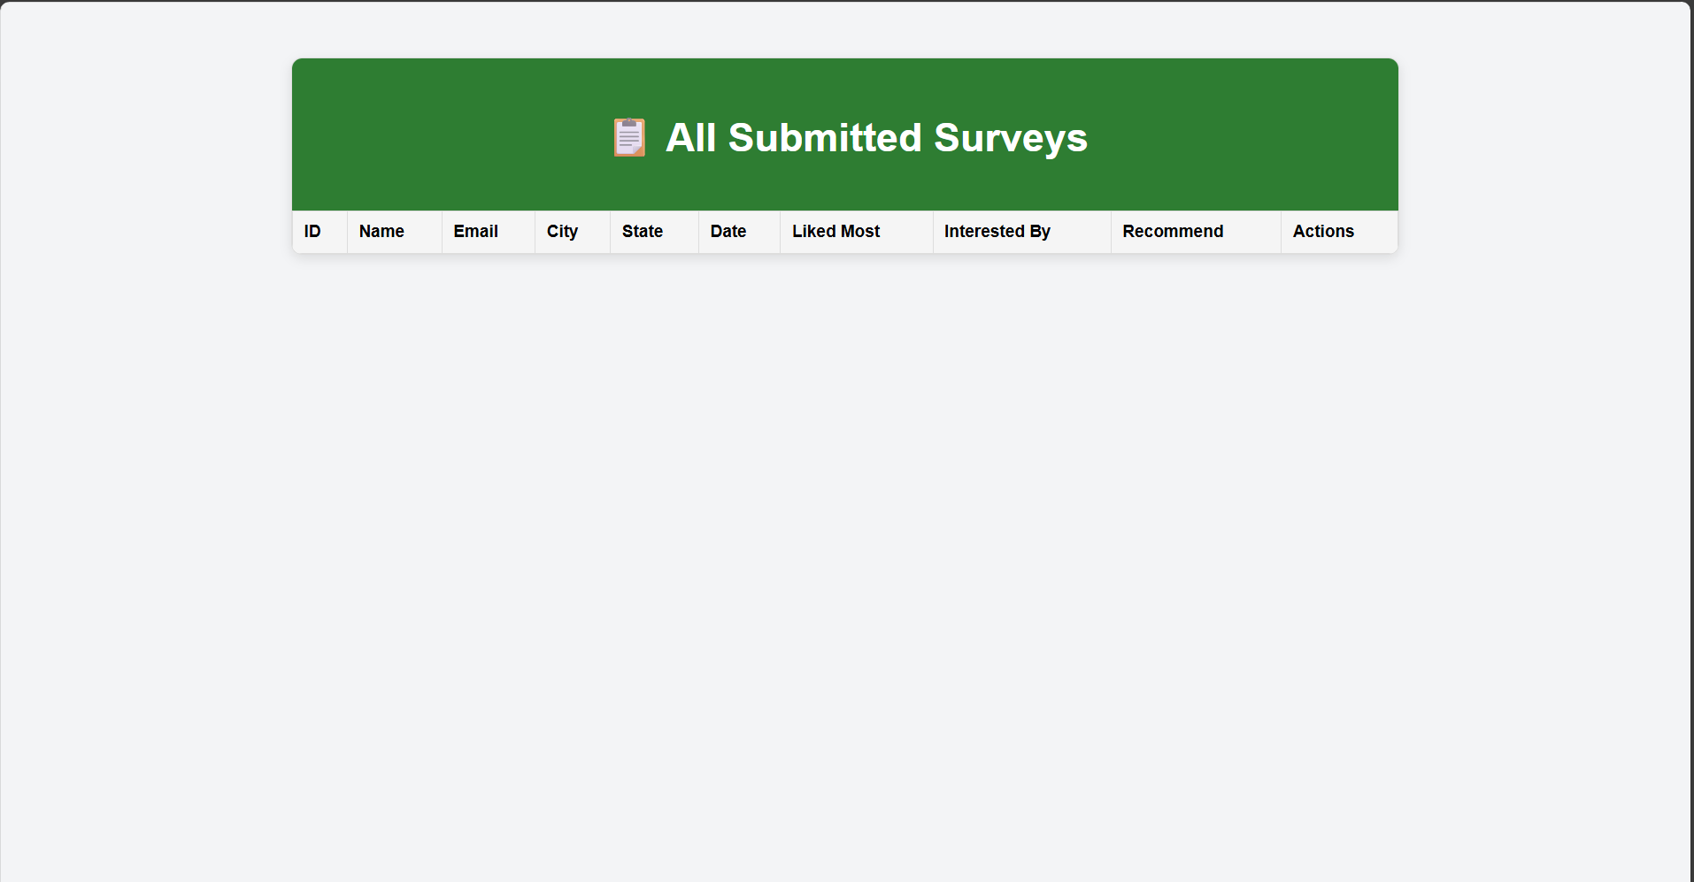
From the screen short we can see that the database is empty because I haven’t submitted a form yet.
Submit Survey Through Website
Use:
http://<EC2-IP>:31000
my ip: http://100.30.1.131:31000/
Fill out and submit a new Student Survey.
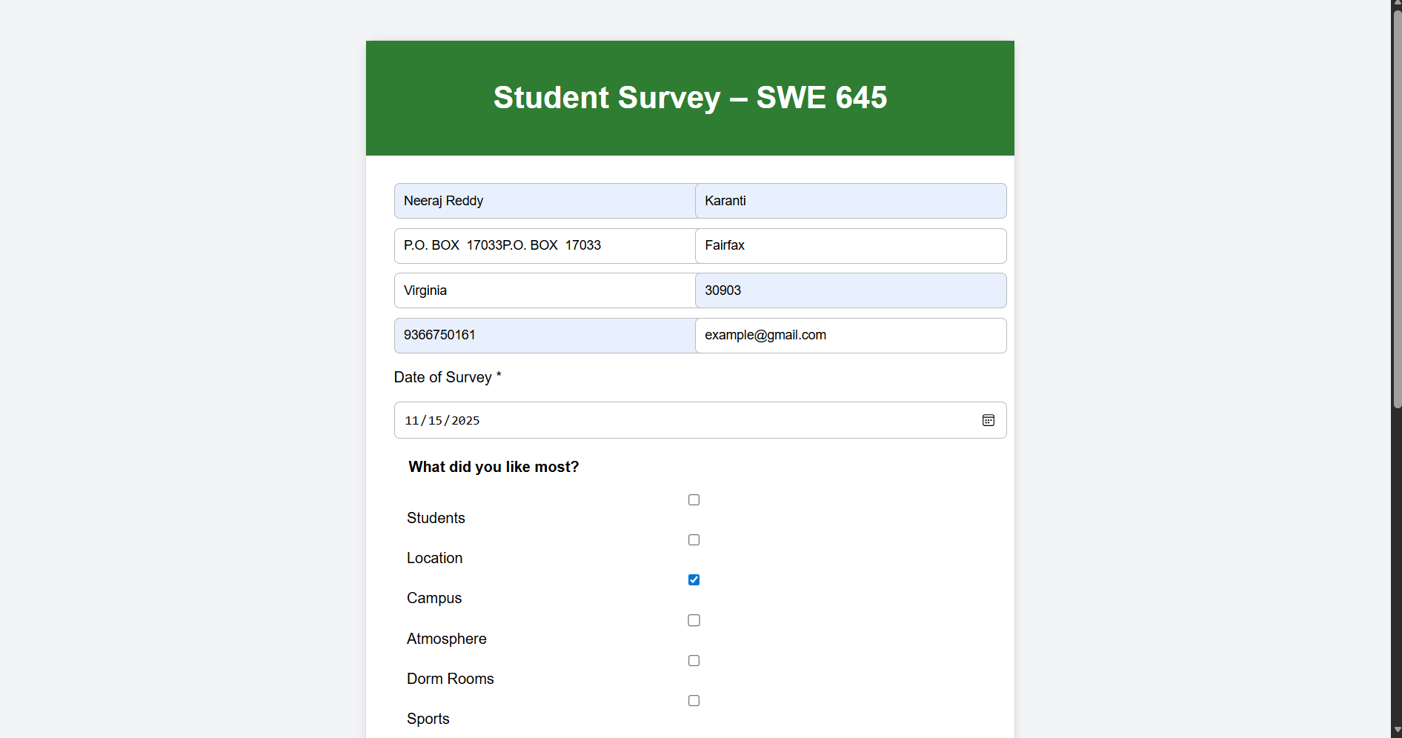
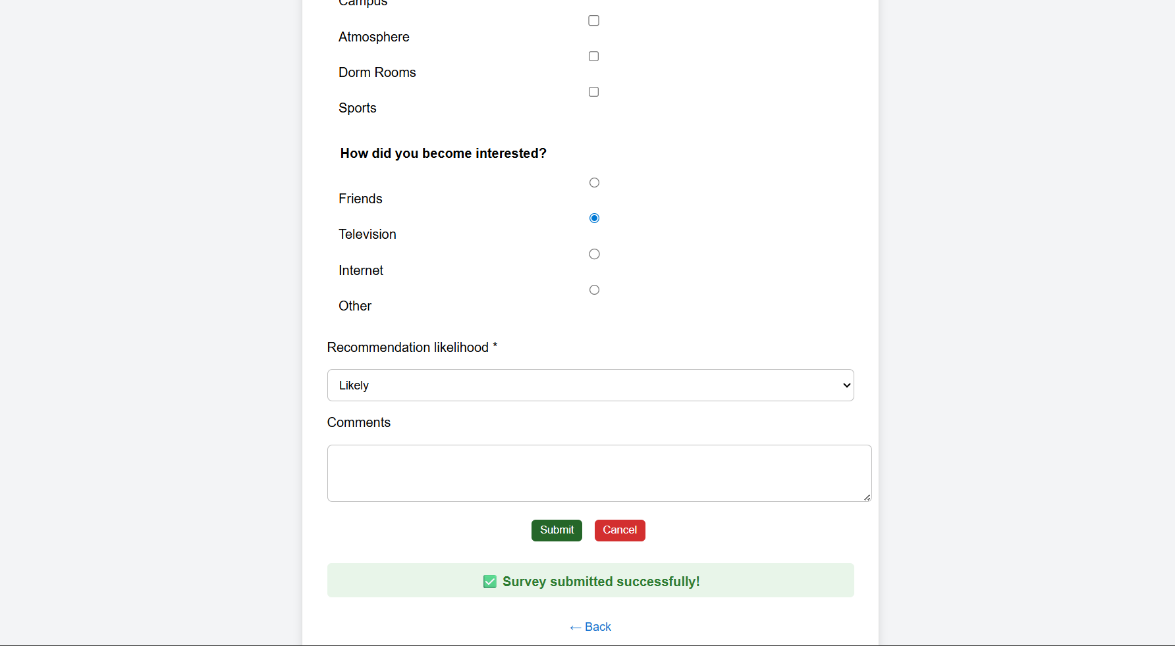
After Submitting the Form
Recheck database:
sqlite3 survey.db
SELECT * FROM survey;
Now you will see the new entry reflected.
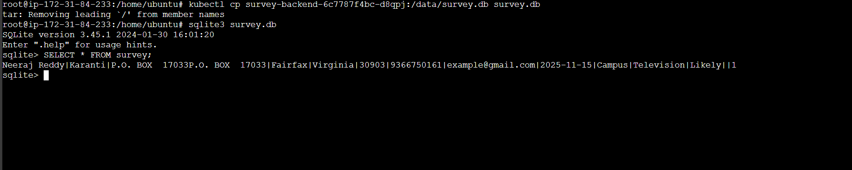
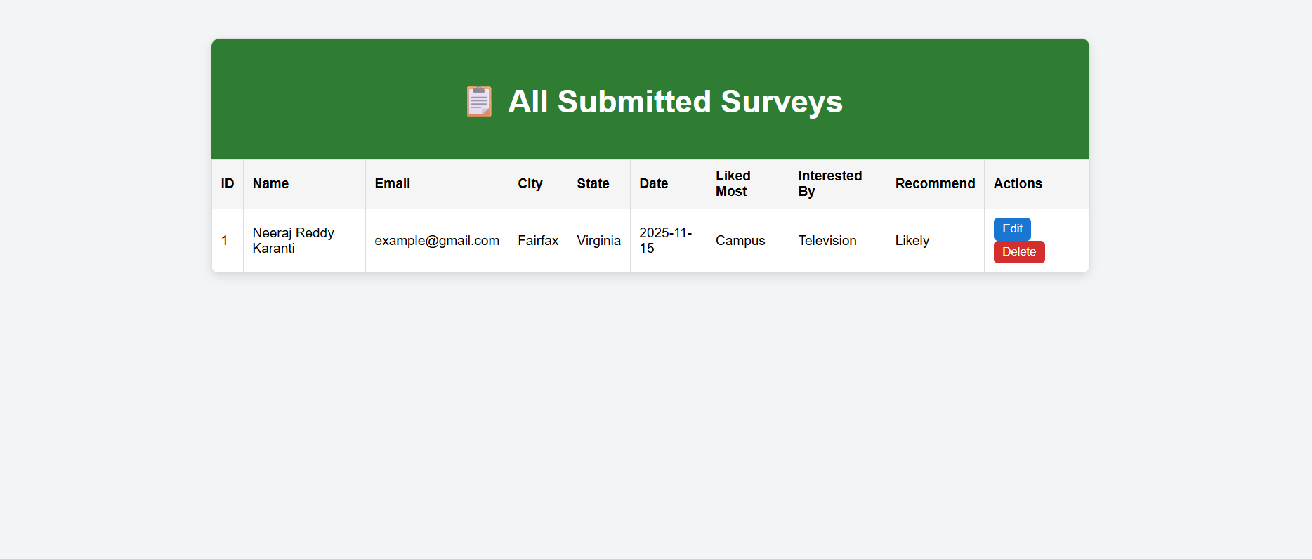
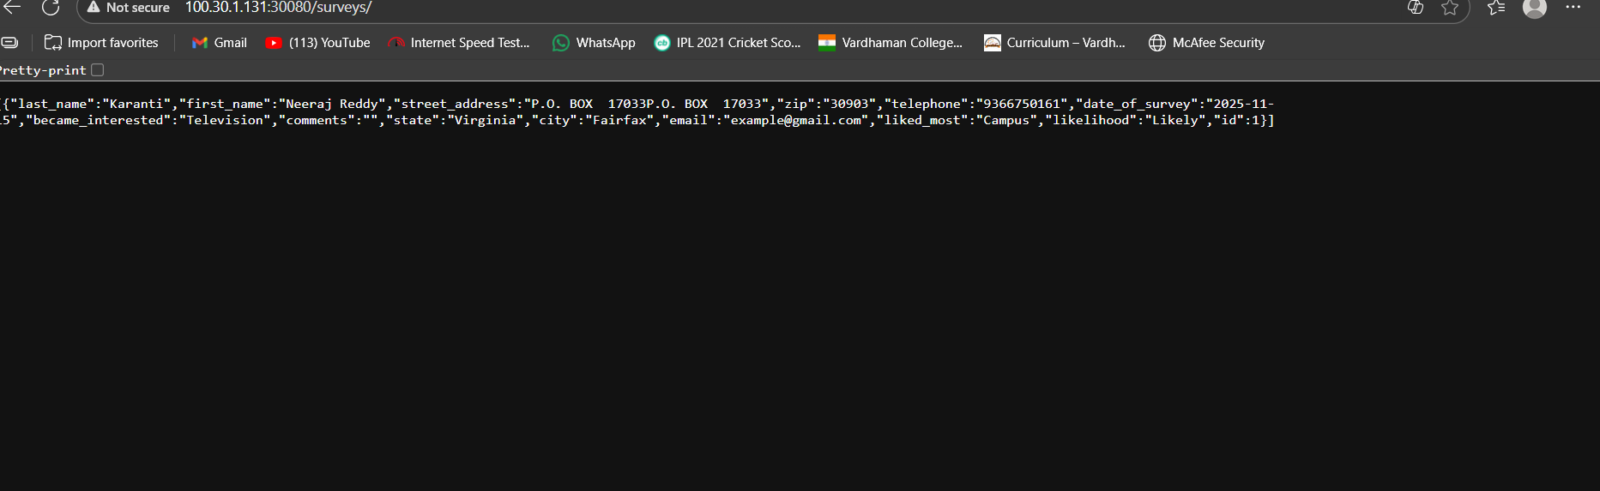

4.10 Demonstrating All CRUD Operations
1. Create – Submit a form
2.Retrieve – View all surveys

3. Update – Edit survey page
Now, I am updating my name from Neeraj Reddy Karanti to Neeraj Karnati
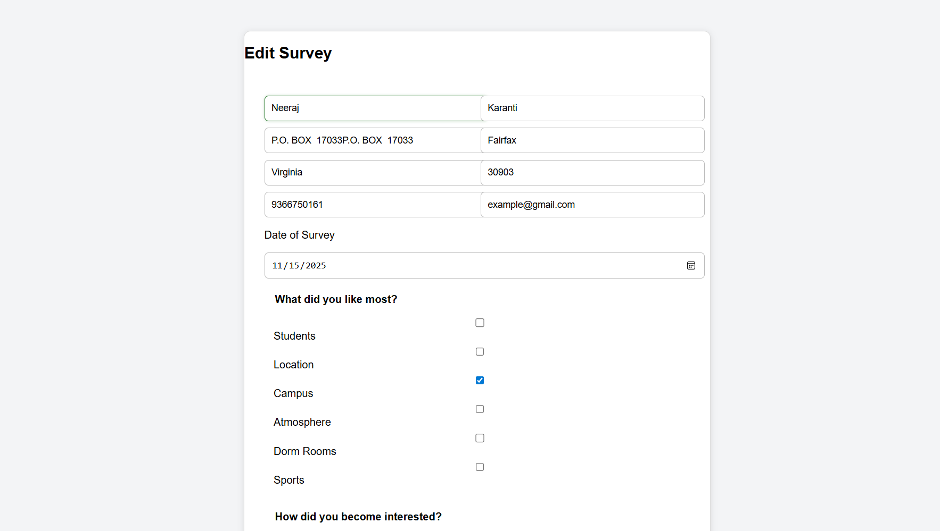
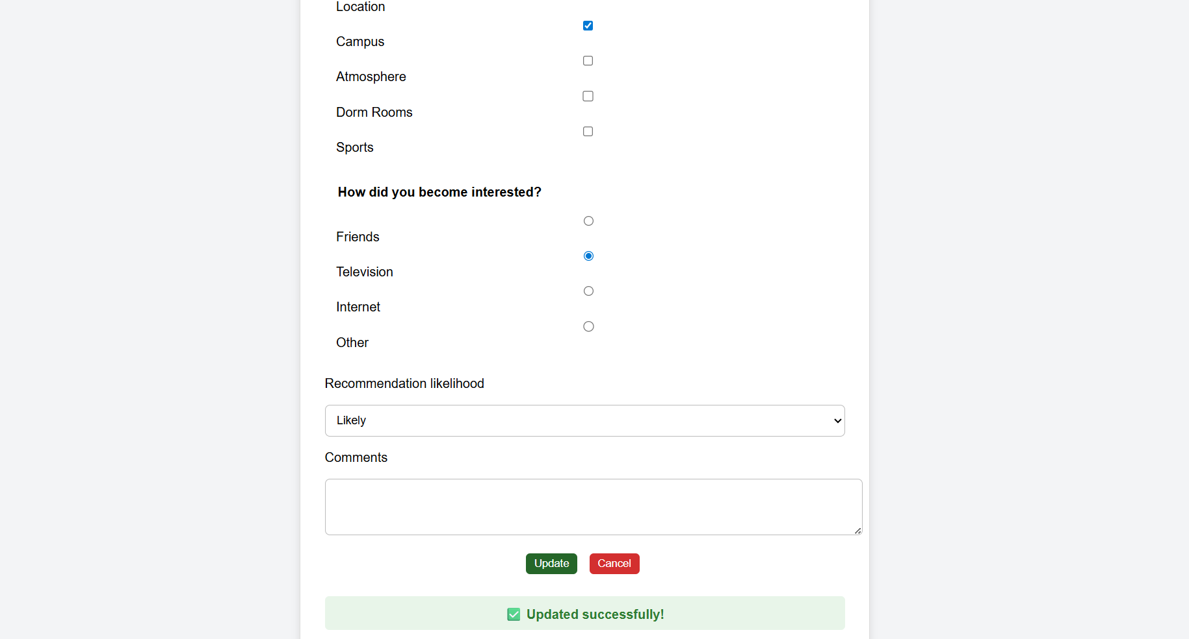
As you can see First name has been updated from Neeraj reddy to Neeraj
From Database:
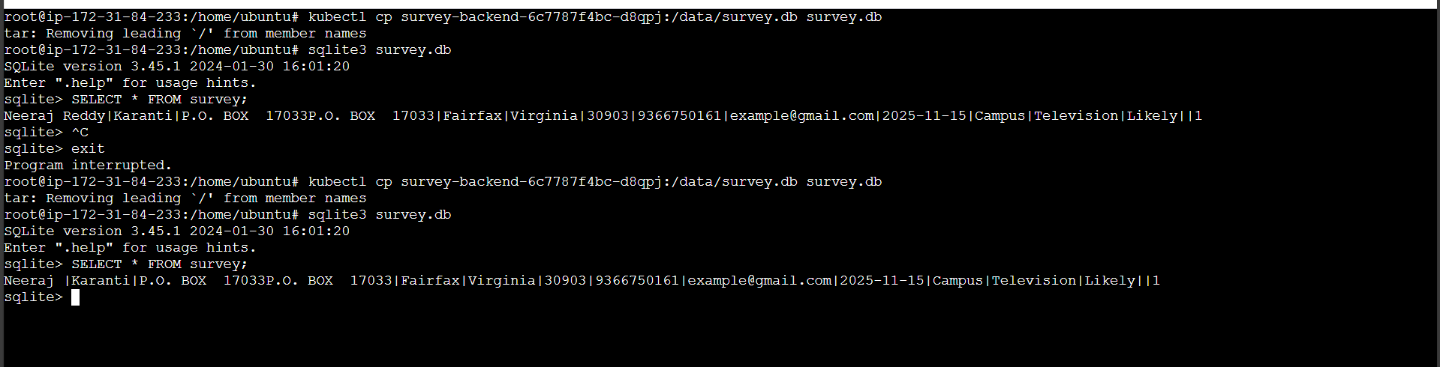

4. Delete – Remove survey
Now I will perform Delete operation. After clicking on delete, a pop up come on the screen for confirmation. On clicking ‘ok’ the form is deleted permanently.
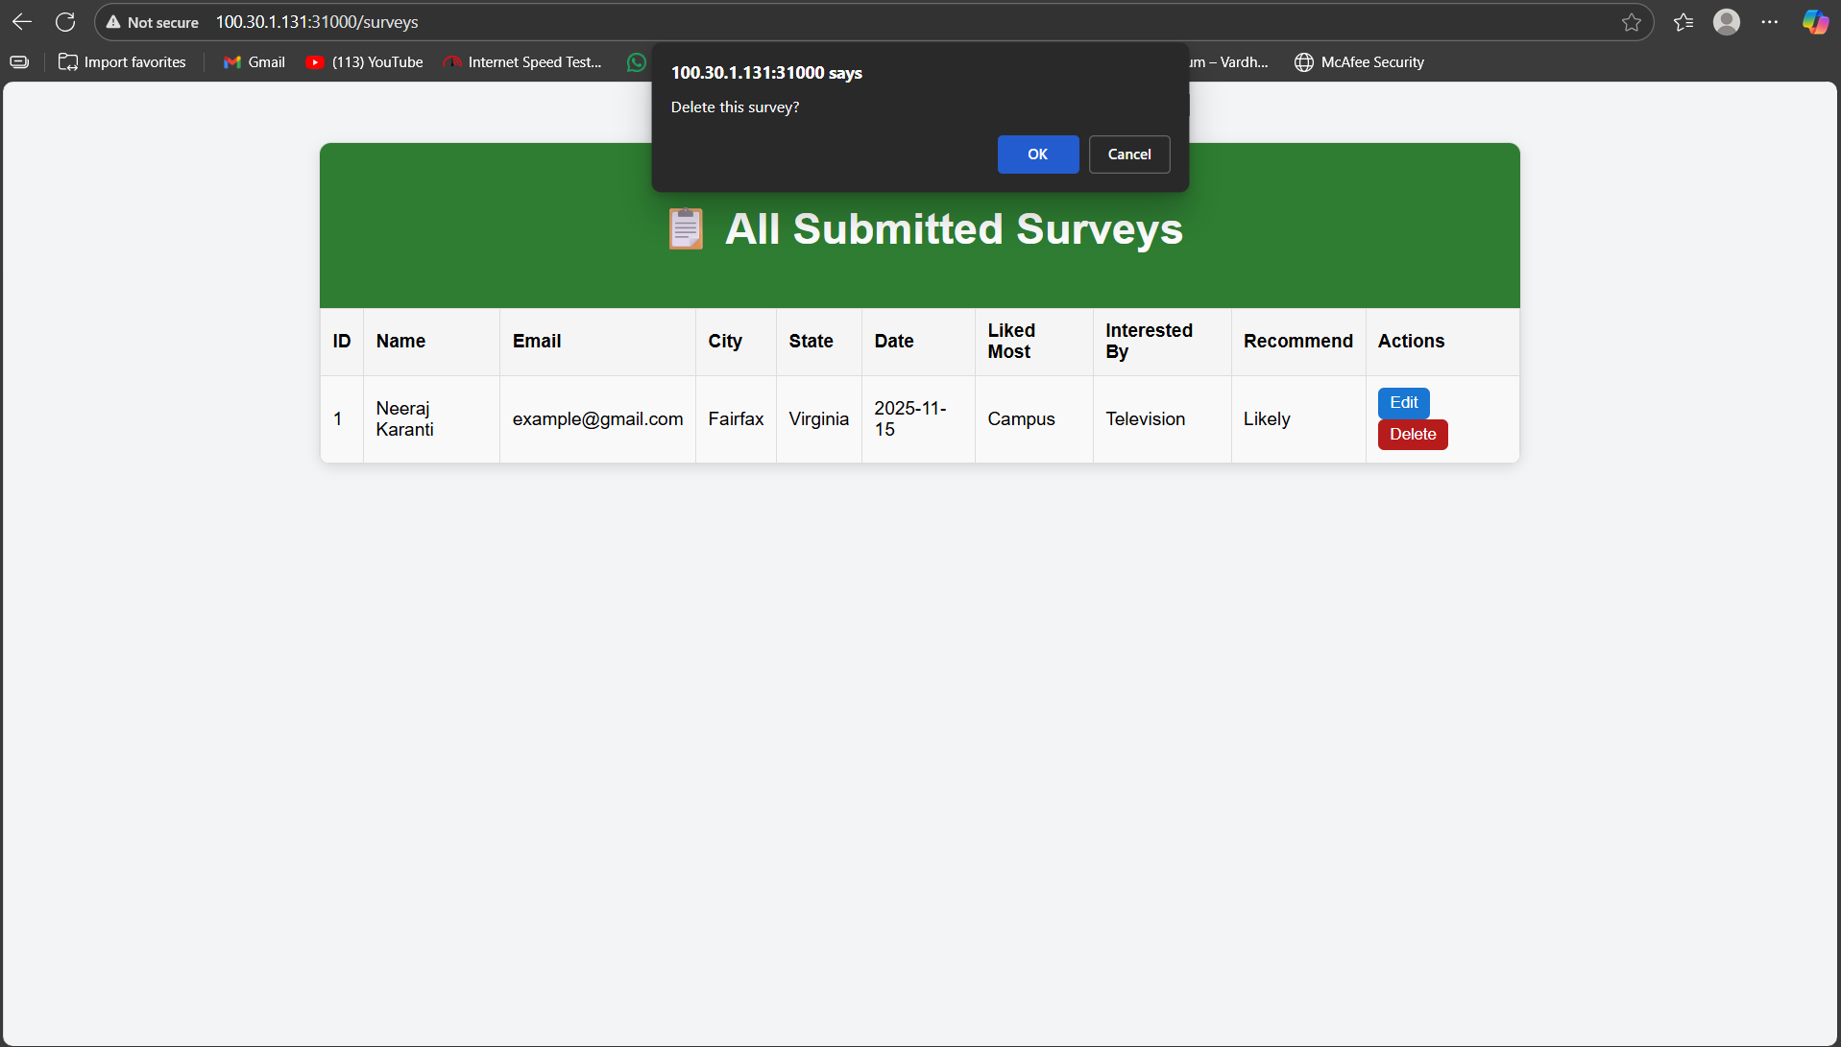
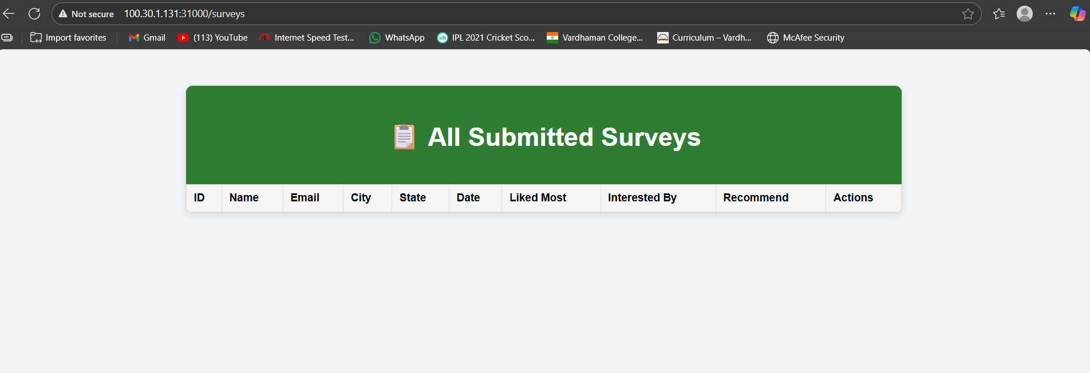
Database is empty because there was only one form submission.
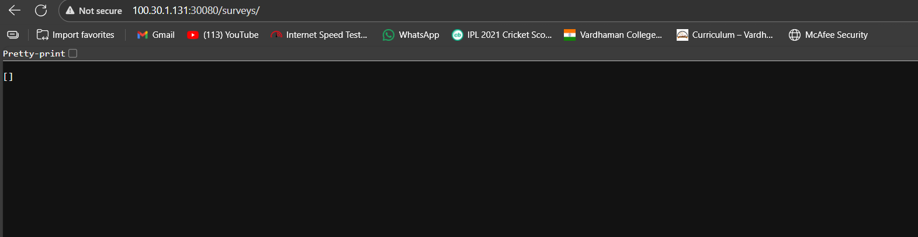
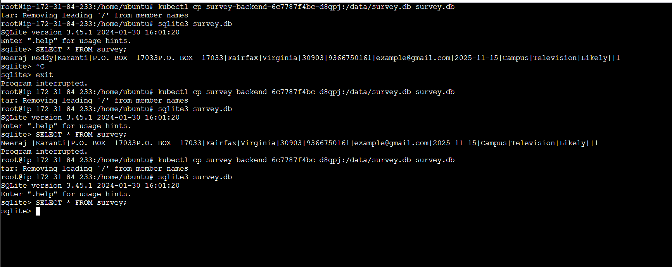

All operations hit the FastAPI backend and update the SQLite DB stored in the PVC.

Conclusion:
This project effectively illustrates how to use cloud-native technologies for the design, implementation, containerization, and automated deployment of a contemporary full-stack web application. We created a scalable, robust, and production-ready system that complies with industry best practices by integrating a React frontend, FastAPI backend, SQLite with persistent storage, Docker containerization, Rancher-managed Kubernetes cluster, and a fully automated Jenkins CI/CD pipeline.
The ability to create, view, update, and remove survey records was among the functional requirements of the Student Survey application that were fulfilled. Jenkins offered smooth continuous delivery with no manual involvement, PV/PVC supplied permanent data storage, and Kubernetes used multi-replica deployments to provide high availability. True DevOps integration was demonstrated by the automated rebuild, container push, and cluster redeployment that followed each change uploaded to GitHub.
This job gave us hands-on experience with workload orchestration, microservice containerization, infrastructure automation, full-stack development, and CI/CD pipelines. The final system satisfies all requirements of SWE 645 Assignment 3 and is secure, scalable, stable, and completely replicable using the supplied documentation.

URL’s:
- Website Page link:
Frontend: http://100.30.1.131:31000/
Backend: http://100.30.1.131:30080/
- Rancher link: https://3.89.94.15/ (Username: admin, Password: Surajneeraj@1)
- Jenkins Link: http://35.174.79.122:8080/(Username: abhinav18, Password: Abhinav@18)
- Github Link: https://github.com/Karnatineerajreddy/SWE645-assignment3-Student-Survey-From-FullStack-Web
- DockerHub repo:
Frontend: neerajreddy22/swe645-frontend
Backend: neerajreddy22/swe645-backend

