Business Template

POLITICAL CAMPAIGN
by Veronika Karnaukh

Contents
1 Business Description 3
1.1 Business Background 3
1.2 Problems. Current Situation 3
1.3 The Benefits of Implementing a Database. Project Vision 3
2 Model description 3
2.1 Definitions & Acronyms 3
2.2 Logical Scheme 4
2.3 Objects 4
2.3.1 Table Person 4
2.3.2 Table Voter 5
2.3.3 Table Candidate 5
2.3.4 Table Faction 6
2.3.5 Table Donor 6
2.3.6 Table Volunteer 7
2.3.7 Table EventType 7
2.3.8 Table Event 8
2.3.9 Table SurveyResult 8
2.3.10 Table Finance 9
2.3.11 Table Volunteer_Event 10

Business Description

Business Background
An independent commission is interested in storing and organizing data about a variety of elections.

Problems. Current Situation
Considering a massive amount of political campaigns happening all over the world, it is not an easy task to work with all necessary information. Existing methods of dealing with it are not intuitive and sufficient enough for a popularized usage.

The Benefits of Implementing a Database. Project Vision
The ability to collect and analyze data in a stable, understandable and automatic form significantly lessens time and resources needed and also improves the quality of related studies on the matter.
The goal of the project is to create a system which allows to easily manipulate required data by creating and using a relative database.

Model description

Definitions & Acronyms
ID – identifier, automatically incremented.
FK – Foreign Key.
PK – Primary Key.

datetime – format for date and time.
decimal – format for money.
int – format for identifiers.
null – indicator of the absence of value.
varchar(n) – format for strings, where n – maximum size.

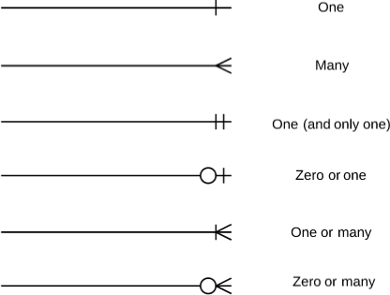
- a database relationship “one to …”.
- a database relationship “one or zero to …”.
- a database relationship “… to many”.

Logical Scheme
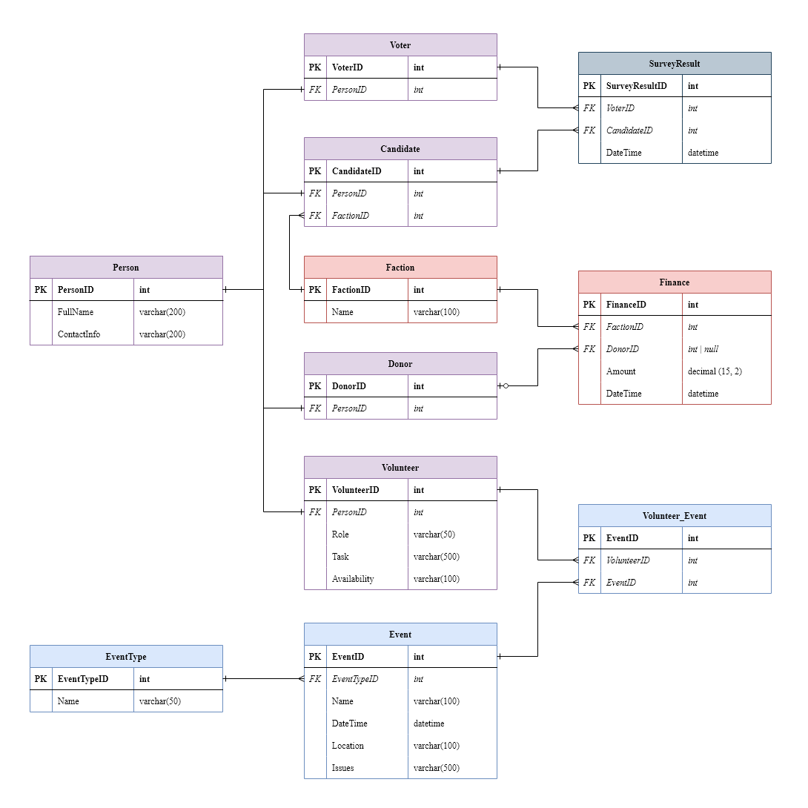

Objects

Table Person
Table Description
Person – a table which includes data about real people.

Table Name | Field name | Field Description | Data Type
Person | ID | Identifier, PK, unique, not null | Int
Person | FullName | Full name (first, last, patronymic), not null | Text
Person | ContactInfo | Contact info (phone, e-mail etc.), not null | Text
Table Relationships
Person has one-to-one connections to Donor, Candidate, Volunteer and Voter.
Donor can be also Volunteer etc., so general data about real people is excluded to a separate table.

Data Example
ID | FullName | ContactInfo
1 | Karnaukh Veronika | smartnica@gmail.com, +380682770768
2 | Harry James Potter | via owls

Table Voter
Table Description
Voter – a table which includes data about real people (based on table Person), who are allowed to vote.

Table Name | Field name | Field Description | Data Type
Voter | ID | Identifier, PK, unique, not null | Int
Voter | PersonID | Identifier, FK, unique, not null | Int

Table Relationships
Voter has one-to-one connection to Person and one-to-many connection to SurveyResult.
Voter can vote for different candidates on different occasions.

Data Example
ID | PersonID
1 | 1
2 | 4

Table Candidate
Table Description
Candidate – a table which includes data about real people (based on table Person), who belong to a certain faction (connected to table Faction) and are trying to be elected on some position.

Table Name | Field name | Field Description | Data Type
Candidate | ID | Identifier, PK, unique, not null | Int
Candidate | PersonID | Identifier, FK, not null | Int
Candidate | FactionID | Identifier, FK, not null | Int

Table Relationships
Candidate has one-to-one connection to Person, many-to-one connection to Faction and one-to-many connection to SurveyResult.
Candidate can be voted for by different Voters.

Data Example
ID | PersonID | FactionID
1 | 1 | 1
2 | 1 | 3

Table Faction
Table Description
Faction – a table which includes data about real political parties.

Table Name | Field name | Field Description | Data Type
Faction | ID | Identifier, PK, unique, not null | Int
Faction | Name | Name of the faction, unique, not null | Text

Table Relationships
Faction has one-to-many connections to Candidate and Finance.
Faction can include several Candidates. Faction can have several Finance operations.

Data Example
ID | Name
1 | Liberty Party
2 | National Party

Table Donor
Table Description
Donor – a table which includes data about real people (based on table Person), who are giving money to some factions (connected to table Finance).

Table Name | Field name | Field Description | Data Type
Donor | ID | Identifier, PK, unique, not null | Int
Donor | PersonID | Identifier, FK, unique, not null | Int

Table Relationships
Donor has one-to-one connection to Person and one-or-zero-to-many connection to Finance.
Donor can sponsor different Factions several times.

Data Example
ID | PersonID
1 | 1
2 | 4

Table Volunteer
Table Description
Volunteer – a table which includes data about real people (based on table Person), who are volunteering on some events (connected to table Event via table Volunteer_Event).

Table Name | Field name | Field Description | Data Type
Volunteer | ID | Identifier, PK, unique, not null | Int
Volunteer | PersonID | Identifier, FK, not null | Int
Volunteer | Role | Role name, not null | Text
Volunteer | Task | Description of tasks, not null | Text
Volunteer | Availability | Description of availability, not null, default=”Always” | Text

Table Relationships
Volunteer has one-to-one connection to Person and one-to-many connection to Volunteer_Event.
Volunteer can participate in several Events.

Data Example
ID | PersonID | Role | Task | Availability
1 | 1 | CEO Manager | Organize other volunteers and submit data to Manager | 8am-4pm
2 | 4 | Secretary | Help manager to collect data | Weekends

Table EventType
Table Description
EventType – a table which includes data about types of events.

Table Name | Field name | Field Description | Data Type
EventType | ID | Identifier, PK, unique, not null | Int
EventType | Name | Type name, unique, not null | Text
Table Relationships
EventType has one-to-many connection to Event.
EventType is a repeating information about Event, so it was excluded in a separated table.

Data Example
ID | Name
1 | Rally
2 | Town Hall
3 | Opposition Research

Table Event
Table Description
Event – a table which includes data about real events (connected to table EventType), where volunteers can participate (connected to table Volunteer via Volunteer_Event).

Table Name | Field name | Field Description | Data Type
Event | ID | Identifier, PK, unique, not null | Int
Event | EventTypeID | Identifier, FK, not null, default=1 | Int
Event | Name | Event name, not null | Text
Event | DateTime | Start of event time, not null, default=NOW() | DateTime
Event | Location | Event location, not null | Text
Event | Issues | Problems arose during event, nullable | Text

Table Relationships
Event has many-to-one connection to EventType and one-to-many connection to Volunteer_Event.
Event can have several Volunteers.

Data Example
ID | EventTypeID | Name | DateTime | Location | Issues
1 | 1 | Rally #1 | 2021-05-14 14:00:00 | Ukraine, Kyiv | Not enough stuff
2 | 4 | Social Media Interaction for Liberty Party | 2024-08-01 09:00:00 | USA, Ohio | null

Table SurveyResult
Table Description
SurveyResult – a table which includes data about voting for candidates (connected to tables Candidate and Voter).
Table Name | Field name | Field Description | Data Type
SurveyResult | ID | Identifier, PK, unique, not null | Int
SurveyResult | VoterID | Identifier, FK, not null | Int
SurveyResult | CandidateID | Identifier, FK, not null | Int
SurveyResult | DateTime | Time of voting, not null, default=NOW() | DateTime

Table Relationships
SurveyResult has many-to-one connections to Voter and Candidate.
Several Voters vote for several Candidates.

Data Example
ID | VoterID | CandidateID | DateTime
1 | 1 | 1 | 2021-05-14 14:00:00
2 | 4 | 3 | 2024-08-01 09:00:00

Table Finance
Table Description
Finance – a table which includes data about factions’ money movements (income, expenses), whether it comes from a donor or not (connected to tables Donor and Faction).

Table Name | Field name | Field Description | Data Type
Finance | ID | Identifier, PK, unique, not null | Int
Finance | FactionID | Identifier, FK, not null | Int
Finance | DonorID | Identifier, FK, nullable | Int
Finance | Amount | Amount of money, not null | Decimal
Finance | DateTime | Time of operation, not null, default=NOW() | DateTime

Table Relationships
Finance has many-to-one connections to Faction and Donor.
Several Factions have several Finance operations (with Donors or not).

Data Example
ID | FactionID | DonorID | Amount | DateTime
1 | 1 | null | -1000.00 | 2021-05-14 14:00:00
2 | 4 | 3 | 1574.65 | 2024-08-01 09:00:00

Table Volunteer_Event
Table Description
Volunteer_Event – a table which includes data about which of volunteers were assigned to which events (connected to tables Volunteer and Event).

Table Name | Field name | Field Description | Data Type
Volunteer_Event | ID | Identifier, PK, unique, not null | Int
Volunteer_Event | VolunteerID | Identifier, FK, not null | Int
Volunteer_Event | EventID | Identifier, FK, not null | Int

Table Relationships
Volunteer_Event has many-to-one connections to Volunteer and Event.
Several Volunteers can participate in several Events.

Data Example
ID | VolunteerID | EventID
1 | 1 | 1
2 | 4 | 3

