Project Name:

School Management system

HCL

HCLT Confidential Page 1 of

School Management System

Date:27/12/2022

Copyright Notice

This document contains proprietary information of HCL Technologies Ltd. No part of this document may be reproduced, stored, copied, or transmitted in any form or by means of electronic, mechanical, photocopying or otherwise, without the express consent of HCL Technologies. This document is intended for internal circulation only and not meant for external distribution.

HCLT Confidential Page 1 of 11 Page 1 of 9

Request for proposal

HCL

### Revision History

| Version No | Date | Prepared by / Modified by | Significant Changes |
| --- | --- | --- | --- |
| 1 | 27/12/2022 | Rakshitha Swaroop Kumar Asfa Khanam Pardeep Nantha Kumar | ___ |

**Table of Contents**

1.1 Project Overview 3

1.2 Scope 3

1.3 Out of Scope 4

1.4 Intended Audience 4

1.5 High Level Use Cases 5

1.6 Use Cases detailed 6

1.7 User Interface Modules 7

1.8 Technical Architecture 8

1.9 Technical Detailed Description 8

1.10 Sequence Diagram 9

1.11 Database Entity Relationship Diagram 10

1.12 Standards 11

1.13 Non Functional Requirements 11

Project Overview: - The title of the project is “School Management system”. This project will handle the activities of the school. School Management system has most of the facilities that a modern school requires to computerize its day-to-day jobs. It provides facilities to keep the records of student, teacher and parents with all their required details. It has facilities to generate various types of reports, which are required by the management during normal business operations to operate the business effectively.

HCLT Confidential Page 2 of 11

Request for proposal

HCL

This document describes approaches and methodologies that will be used in the lifecycle of coding.

Scope: -

|  |  |  |
| --- | --- | --- |
| **Modules** | **Roles and application** | **Description** |
| Admin Registration | Admin/ User | If the Admin(Head master) changes, they can register themselves by providing first name, last name, email, username and password. |
| Admin | Admin | If the admin who has already registered logins, they will be able to create student account, create teacher account, create parent account, add Classes and add Subject. And will be able to log out or may stay in the page. |
| Teachers | User(Teacher) | If the teacher logged in with valid credentials, they will be able to add student’s marks per subject, post any update or related to anything and will be able to view the complaints or recommendations. And can logout or stay in the page. |
| Students | User(Student) | If the student enters the valid details to login, they can view their grades and will be able to post a complaint or recommendation. And will be able to log out or stay in the page. |
| Parents | User(Parent) | If the parent log in, they will be able to view their children grades per subject and will be able to post complaint or recommendation. And will be able to log out or stay if they need. |

HCLT Confidential Page 3 of 11

Request for proposal

HCL

Out of Scope: -

These features are not to be tested because they are not included in the Software Requirement Specification.

* User interface
* Hardware Interface
* Software Interface

Intended Audience: -

* Admin
* User

The document is intended for all the stakeholders customer and the developer (designers, testers,

maintainers). The reader is assumed to have basic knowledge of banking accounts and account

services. Knowledge and understanding of UML diagrams is also require

The document is intended for all the stakeholders customer and the developer (designers, testers,

maintainers). The reader is assumed to have basic knowledge of banking accounts and account

services. Knowledge and understanding of UML diagrams is also require

In this School management system, it is used to all users irrespective of their age but they need to have valid credentials. The aim is to store and view the records of the school by the help of computerized equipment’s and full-fledged computer software, fulfilling the requirements, so that the valuable information can be stored for a longer period with easy accessing and manipulation of the same. Basically, the project describes how to manage for good performance and better services.

HCLT Confidential Page 4 of 11

Request for proposal

HCL

High Level Use Cases: -

UML use case diagram of School Management System

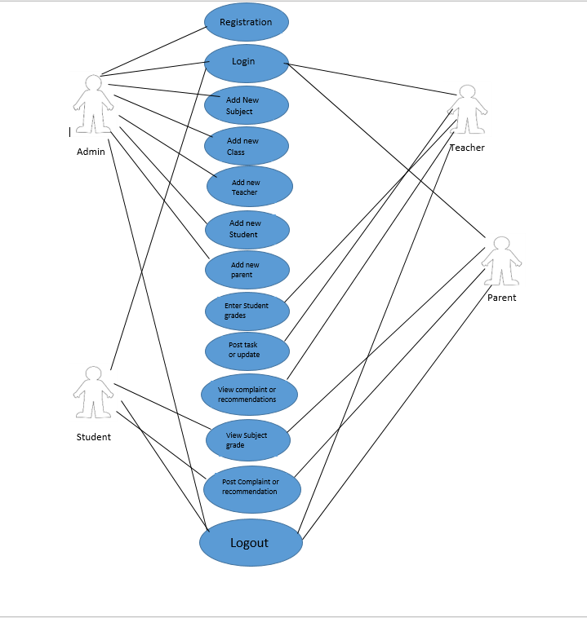

HCLT Confidential Page 5 of 11

Use Cases detailed: -

Request for proposal

HCL

* **Registration:** Registration is a functionality which allows to register a admin by providing first name, last name, email, username and password
* **Login**: This use case describes that the login is a function on the system that authenticates user. Therefore, the actor Admin, Teacher, Student and Parent can log in by providing correct credentials prior to the interacting.
* **Add new subject**: This use case describes that the user(Admin) will be able to add a new subject by giving the subject name and teacher name.
* **Add new class**: This use case describes that the user(Admin) will be able to add a new class by giving the class name, class strength and class teacher and they will be stored in database.
* **Add new teacher**: This use case describes that the user(Admin) will be able to add a new teacher by providing the teacher name, qualification and their experience.
* **Add new student**: This use case describes that the user(Admin) can add new student by providing the student name, parent name, student age and student class.
* **Add new parent**: This use case describes that the user(Admin) can add a new parent by giving the parent name and the student name respectively.
* **Enter student grades**: This use case describes that the user(Teacher) will be able enter the student grades per each subject separately by giving the student id, subject and the marks secured by student in that particular subject.
* **Post task or update**: This use case describes that the user(Teacher) will be able to post a task or update about anything by entering their id.
* **View complaint or recommendation**: This use case describes that the user(Teacher) will be able to view the complaint or recommendation provided by the students or their parents by entering their id initially.
* **View subject grade**: This use case describes that the user (Student or Parent) will be able to view the grades per subject by entering the student id.
* **Post complaint or recommendation**: This use case describes that the user (Student or Parent) will be able to post a complaint or recommendation by providing their id.
* **Logout**: This use case describes that the logout is a function that allow the user to sign out

HCLT Confidential Page 6 of 11

Request for proposal

HCL

User Interface Modules:

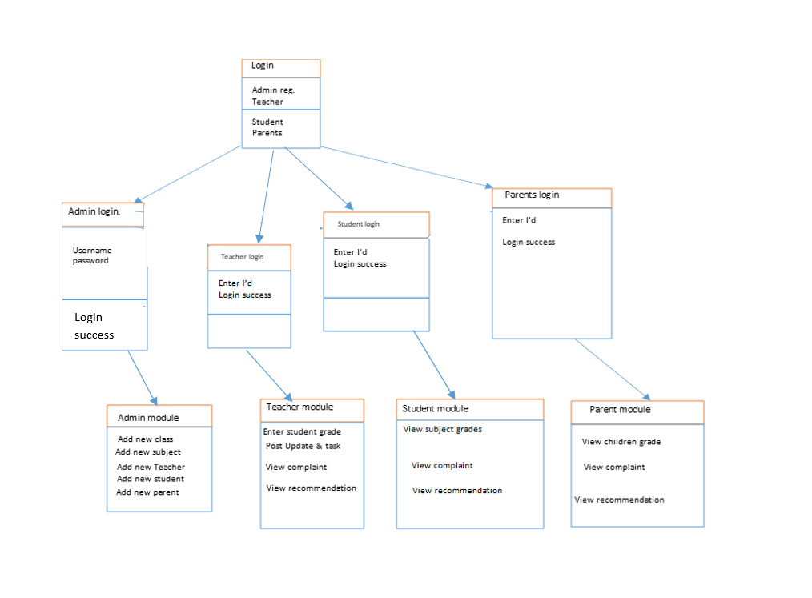

HCLT Confidential Page 7 of 11

Technical Architecture: -

Request for proposal

HCL

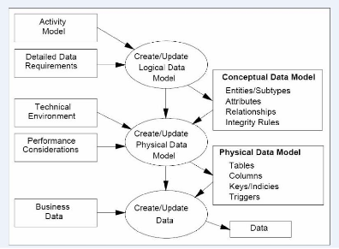

Technical Detailed Description: -

In School Management System console application, we have included Registration, Admin, Student, Teacher and Parent modules.

Registration:

If the Admin (Head master) changes, they can register themselves by providing first name, last name, email, username and password.

Admin:

If the admin who has already registered logins, they will be able to create student account, create teacher account, create parent account, add Classes and add Subject. And will be able to log out or may stay in the page.

Student:

If the student enters the valid details to login, they can view their grades and will be able to post a complaint or recommendation. And will be able to log out or stay in the page.

Teacher:

If the teacher logged in with valid credentials, they will be able to add student’s marks per subject, post any update or related to anything and will be able to view the complaints or recommendations. And can logout or stay in the page.

Parent:

If the parent log in, they will be able to view their children grades per subject and will be able to post complaint or recommendation. And will be able to log out or stay if they need.

HCLT Confidential Page 8 of 11

Sequence Diagram:

Request for proposal

HCL

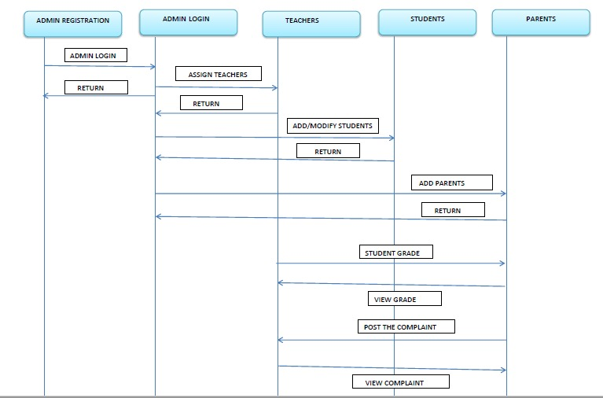

HCLT Confidential Page 9 of 11

**Database Entity Relationship Diagram:** -This School Management System ER Diagram example depicts the relationship between elements such as admin, teacher, parent and student information, as well as how they are related.

Request for proposal

HCL

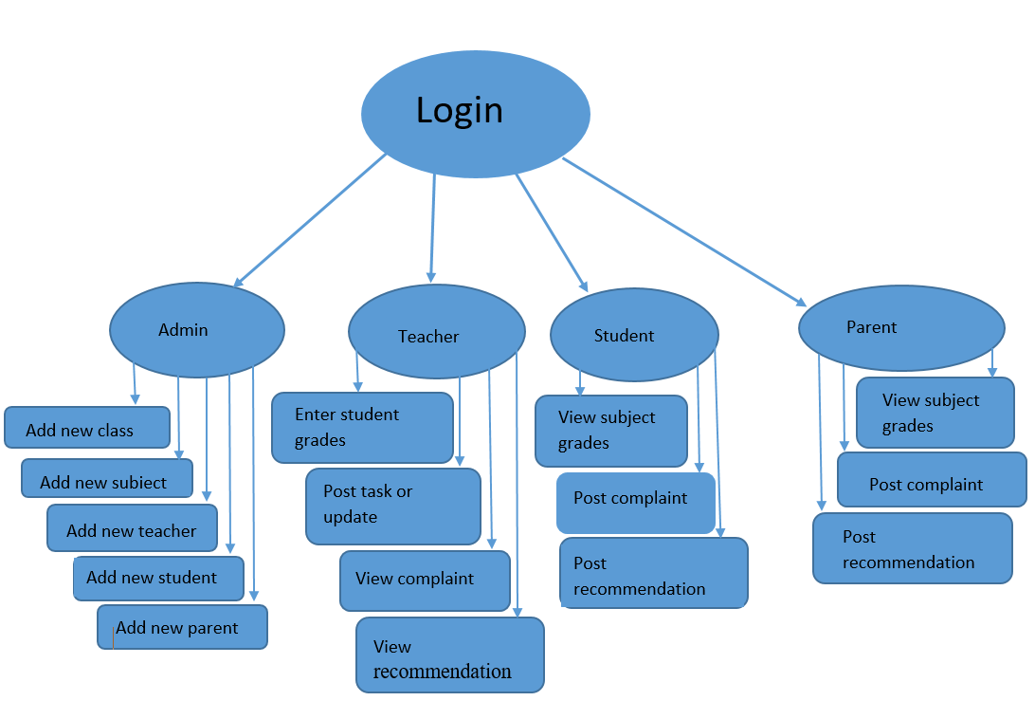

HCLT Confidential Page 10 of 11

**Standards: -**

Request for proposal

HCL

1. Use descriptive and appropriate names for all identifiers (variables, method names, class names, constants, etc.).
2. Class names start with an upper case letter. Variable names start with a lower case letter.
3. Put a single space before every "{".
4. Open braces (i.e. "{") do not start a new line. Close braces (i.e. "}") do start a new line, and are indented with the code they close.
5. Avoid the use of the default package.

**NON-FUNCTIONAL REQUIRMENTS**

HCLT Confidential Page 11 of 11