CASE STUDY
EXPLORATORY DATA ANALYSIS AND
VISUALIZATION OF AI ADOPTION AND
WORKFORCE PRODUCTIVITY
U21CSG05
Exploratory Data Analysis and Visualization
Assignment
Submitted by:
Name: Karnika N.
Register Number: __________________
Department: Computer Science and Engineering
Semester: V
KPR Institute of Engineering and Technology
Academic Year 2026–2027

1. ABSTRACT
Artificial Intelligence adoption is increasingly influencing activities across different industries. This case study explores industry-level AI adoption and its association with workforce productivity using a dataset containing 402 monthly industry records from January 2021 to July 2026. The original dataset includes six attributes covering month, industry, primary use case, active users, token usage and productivity gain. Data preprocessing, feature engineering, statistical analysis and exploratory visualization were performed using Python. Multiple visualizations were developed with Matplotlib and Seaborn to examine distributions, industry comparisons, trends and relationships. A Multi-Layer Perceptron (MLP) regression model was implemented to predict productivity gain. The model was evaluated using MAE, MSE, RMSE and R². The obtained test R² was negative, indicating that the current model did not generalize well and requires further improvement.

2. INTRODUCTION

2.1 Introduction
Artificial Intelligence has become an important technology in modern workplaces. Organizations use AI systems to support content creation, software development, customer support, healthcare, education, finance and other activities. AI adoption can influence work processes by assisting with information generation, task automation and decision support.
The level of adoption and productivity gain may vary across industries and use cases. Exploratory Data Analysis (EDA) helps understand these differences through statistical summaries and visual representations. In this project, Python-based analysis and visualization techniques are applied to an industry-level AI adoption dataset. An MLP neural network is also implemented as a regression model to estimate productivity gain.

2.2 Problem Statement
AI adoption is growing across industries, but the scale of adoption, daily usage intensity and associated productivity gain are not identical across sectors. A systematic analysis is required to examine the distribution of adoption indicators, compare industries, identify relationships and assess whether the available variables can support productivity prediction.

2.3 Objectives
- To explore a dataset related to AI adoption and workforce productivity.
- To perform data cleaning, preprocessing and feature engineering.
- To analyze numerical and categorical variables using statistical techniques.
- To create meaningful visualizations to identify distributions, trends and relationships.
- To investigate productivity patterns across industries and primary AI use cases.
- To develop an MLP-based deep learning regression model for productivity prediction.
- To evaluate model performance using MAE, MSE, RMSE and R² score.
- To derive meaningful insights and suggest possible improvements.

2.4 Scope of the Project
This study focuses on monthly, industry-level AI adoption patterns and their association with productivity gain. It covers exploratory analysis, statistical visualization, feature engineering and deep learning-based regression. The dataset contains aggregated industry observations rather than individual employee records. The observed associations do not establish that AI adoption directly causes productivity improvement.

3. DATASET DESCRIPTION

3.1 Dataset Overview
The dataset used in this case study is named ai_adoption_productivity_2021_2026.csv. It contains monthly information related to AI adoption, usage intensity and productivity gain across six industries.
Dataset Property | Description
Dataset Name | ai_adoption_productivity_2021_2026.csv
File Format | CSV
Number of Records | 402
Original Attributes | 6
Date Coverage | January 2021 to July 2026
Industries | 6
Primary Use Cases | 6
Data Types | Numerical, categorical and date-like

3.2 Description of Original Attributes
S.No. | Attribute | Data Type | Description
1 | YearMonth | Date-like | Month and year of observation
2 | Industry | Categorical | Industry represented by the record
3 | Primary Use Case | Categorical | Main AI application/use case
4 | Global Active Users (Millions) | Numerical | Global active users, in millions
5 | Average Tokens/User/Day | Numerical | Average daily token usage per user
6 | Productivity Gain (%) | Numerical | Reported productivity gain percentage

3.3 Dataset Characteristics
The dataset includes:
- Categorical variables: Industry and Primary Use Case.
- Numerical variables: Global Active Users (Millions), Average Tokens/User/Day and Productivity Gain (%).
- Date-like variable: YearMonth, converted into a datetime field named Date during preprocessing.
The dataset contains 6 industries and 6 primary use cases. Each industry contributes 67 to 67 monthly observations.

3.4 Target Variable – Productivity Prediction
The numerical attribute Productivity Gain (%) is used directly as the target variable for the MLP regression model. Unlike classification, regression predicts a continuous numerical value. Therefore, the model output is a single linear neuron and evaluation uses regression metrics rather than confusion matrix or ROC-AUC.
Target Variable | Type | Description
Productivity Gain (%) | Continuous numerical | Productivity gain percentage predicted by the model

4. DATA UNDERSTANDING AND PREPROCESSING

4.1 Introduction
Data preprocessing is an essential stage in EDA. It ensures that the dataset is suitable for statistical analysis, visualization and deep learning model development. In this project, the AI adoption dataset was examined for missing values, duplicate records, outliers and data inconsistencies. Date-based, interaction, logarithmic and historical features were generated. Categorical encoding and numerical standardization were performed for the MLP model.

4.2 Dataset Loading and Inspection
The dataset was loaded using the Pandas library in Python. The shape, data types, first records and descriptive statistics were examined.
Property | Observed Result
Total records | 402
Original attributes | 6
Columns after feature engineering | 23
Missing values | 0
Duplicate records | 0
The dataset contains numerical and categorical information together with a month field, making it suitable for different EDA techniques.

4.3 Missing Value Analysis
Missing values were examined to determine the completeness of the dataset. The uploaded CSV contains no missing values. Therefore, no imputation was required for the observed records. The model preprocessing pipeline nevertheless includes median imputation for numerical inputs and most-frequent imputation for categorical inputs as a safeguard.
Result: 0 missing values were identified in the original dataset.

4.4 Duplicate Record Analysis
Duplicate records can affect statistical results and introduce bias during model training. Duplicate observations were checked and removed as a precaution.
Result: 0 duplicate records were detected in the original dataset.

4.5 Outlier Analysis
Outliers are observations that differ considerably from the majority of values in a dataset. The Interquartile Range (IQR) method was applied to active users, average tokens per user per day and productivity gain.
Numerical Attribute | IQR Outlier Count
Global Active Users (Millions) | 29
Average Tokens/User/Day | 40
Productivity Gain (%) | 0
Potentially extreme values were visualized rather than automatically deleted, because unusually high adoption or token usage may represent valid observations.
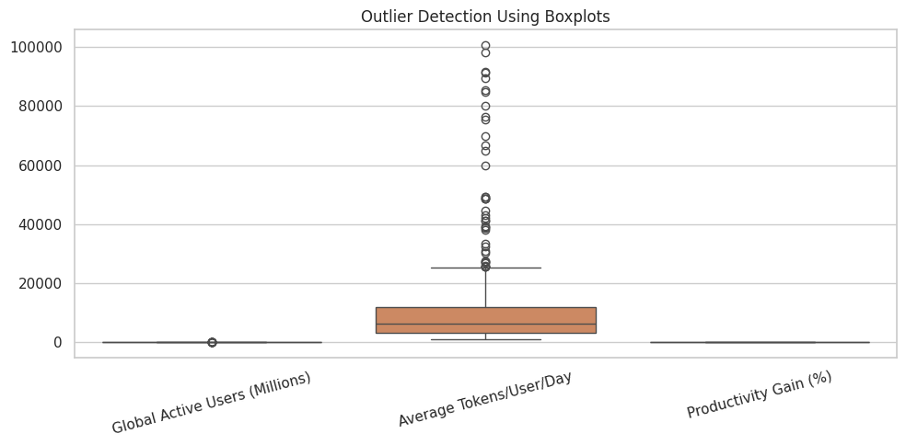
Figure 4.1: Outlier Detection Using Boxplots

4.6 Data Transformation and Feature Engineering
Feature engineering was performed to derive additional information from the six original attributes. The Date field was used to extract Year, Month, Quarter and Half_Year. Time_Index was created to represent the chronological position of each record.
Seasonal encoding was performed using Month_Sin and Month_Cos. Log_Active_Users and Log_Tokens were generated using logarithmic transformations. Users_Tokens_Interaction represents the product of active users and average tokens per user per day.
Historical features were calculated separately within each industry: Previous_Productivity, Previous_Users, Previous_Tokens, Productivity_Rolling_Mean, Users_Rolling_Mean and Tokens_Rolling_Mean. Lagged and rolling values use previous observations.
Feature Group | Derived Features
Date-based | Year, Month, Quarter, Half_Year, Time_Index
Seasonal | Month_Sin, Month_Cos
Log transformation | Log_Active_Users, Log_Tokens
Interaction | Users_Tokens_Interaction
Historical | Previous_Productivity, Previous_Users, Previous_Tokens
Rolling means | Productivity_Rolling_Mean, Users_Rolling_Mean, Tokens_Rolling_Mean
The processed DataFrame contains 23 columns including original and engineered fields.

4.7 Categorical Encoding
Categorical variables such as Industry and Primary Use Case cannot be directly processed as numerical input by the MLP model. One-Hot Encoding was applied using Scikit-learn's OneHotEncoder with handle_unknown='ignore'.

4.8 Numerical Standardization
Numerical predictor variables were standardized using StandardScaler. Standardization transforms features to a comparable scale using the mean and standard deviation.
z = (x − μ) / σ
Where x is the original feature value, μ is the training-set mean and σ is the training-set standard deviation. The preprocessing pipeline was fitted only on the training data to reduce information leakage.

4.9 Dataset Splitting
Dataset | Percentage | Records
Training | Approximately 70% | 276
Validation | Approximately 15% | 60
Testing | Remaining observations | 66
Total | 100% | 402
The split was chronological rather than stratified: earlier dates were used for training, the following period for validation and the latest period for testing. This preserves temporal order.

4.10 Preprocessing Summary
The preprocessing stage prepared the AI adoption dataset for statistical analysis and deep learning.

Key Findings
- The dataset contains 402 records and six original attributes.
- No missing values or duplicate records were identified.
- Outliers were examined using the IQR method and boxplots.
- Date, seasonal, interaction, logarithmic and historical features were generated.
- Categorical predictors were encoded using One-Hot Encoding.
- Numerical predictors were standardized using StandardScaler.
- The data was divided chronologically into training, validation and testing subsets.
These preprocessing steps provide a foundation for subsequent visualization and MLP regression.
Figure 4.2: Outlier analysis used during preprocessing

5. STATISTICAL ANALYSIS AND EXPLORATORY DATA ANALYSIS

5.1 Introduction
Exploratory Data Analysis is performed to understand the structure, characteristics and patterns present in the dataset. Statistical measures and visualization techniques are used to identify distributions, relationships and trends among different variables. Univariate, bivariate and multivariate analyses are performed using Pandas, NumPy, Matplotlib and Seaborn.

5.2 Descriptive Statistical Analysis
Descriptive statistics summarize the important characteristics of numerical variables.
- Mean: Average value of a variable.
- Median: Middle value of the observations.
- Mode: Most frequently occurring value.
- Standard Deviation: Measures the spread of data.
- Variance: Measures the variability of observations.
- Skewness: Indicates the asymmetry of a distribution.
- Kurtosis: Describes the tail characteristics of a distribution.
The describe() function and additional statistical methods in Pandas were used to generate the summaries.

5.2 Descriptive Statistical Analysis – Summary
Variable | Mean | Median | Std. Deviation | Minimum | Maximum
Active users (Millions) | 18.09 | 5.24 | 26.14 | 0.10 | 103.97
Tokens/User/Day | 11732.10 | 6456.00 | 16189.76 | 935.00 | 100750.00
Productivity gain (%) | 41.01 | 41.30 | 15.47 | 1.90 | 71.10

5.3 Univariate Analysis
Univariate analysis examines one variable at a time to understand its distribution and characteristics. The analysis includes active users, average token usage, productivity gain, industry and primary use case. Histograms, bar charts and distribution plots were used to understand numerical and categorical variables.
Observations: active user counts and token usage vary substantially across observations. Productivity gain also has a broad range. Industry and primary use case categories are evenly represented in the dataset.

5.3 Univariate Analysis – Observations
- Global active user counts show a wide spread across monthly industry observations.
- Average daily token usage varies considerably between industries and over time.
- Productivity gain ranges from 1.9% to 71.1%.
- The dataset contains six industry categories with 67 records each.

5.4 Bivariate and Multivariate Analysis
Bivariate analysis examines relationships between two variables, while multivariate analysis considers several variables together. Scatterplots and correlation heatmaps were used to examine associations among active users, token usage, productivity gain and time-related features.

6. DATA VISUALIZATION

6.1 Introduction
Data visualization represents data graphically, making it easier to identify patterns, distributions and relationships. Matplotlib and Seaborn were used to create visualizations for analyzing AI adoption and productivity. The following charts examine productivity distribution, industry adoption, correlations, relationships, industry variation, time trends, empirical category probabilities and token usage.

6.2 Productivity Gain Distribution
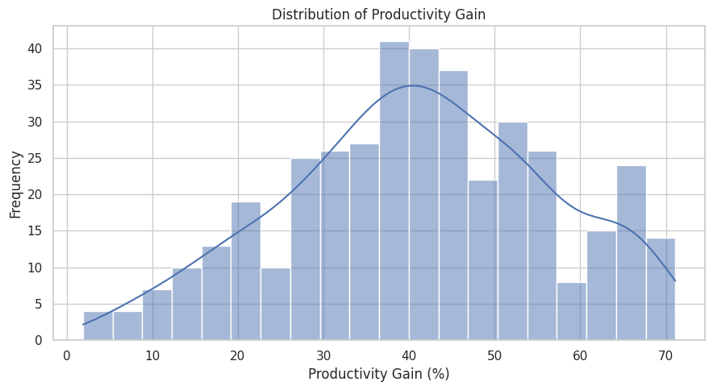
Figure 6.1: Distribution of Productivity Gain
What it shows: This histogram represents the distribution of productivity gain percentages across all industry-month observations.
Why it was created: To understand the frequency, concentration and spread of productivity improvement values.
Insights obtained: The mean productivity gain is 41.01% and the median is 41.30%. The values indicate the central tendency of productivity gain in the dataset.

6.3 AI Adoption Across Industries
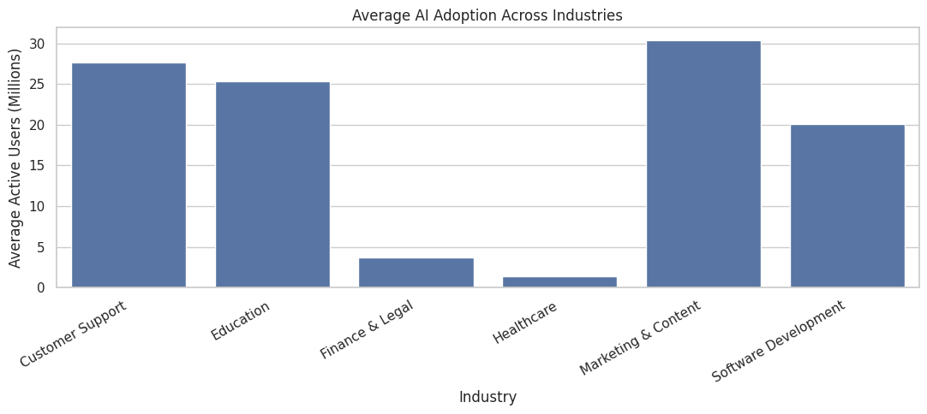
Figure 6.2: Average AI Adoption Across Industries
What it shows: The bar chart compares average active AI users across industries.
Why it was created: To identify differences in the scale of AI adoption across the six industries.
Insights obtained: Marketing & Content has the highest mean active users (30.39 million), while Healthcare has the lowest (1.36 million).

6.4 Correlation Heatmap
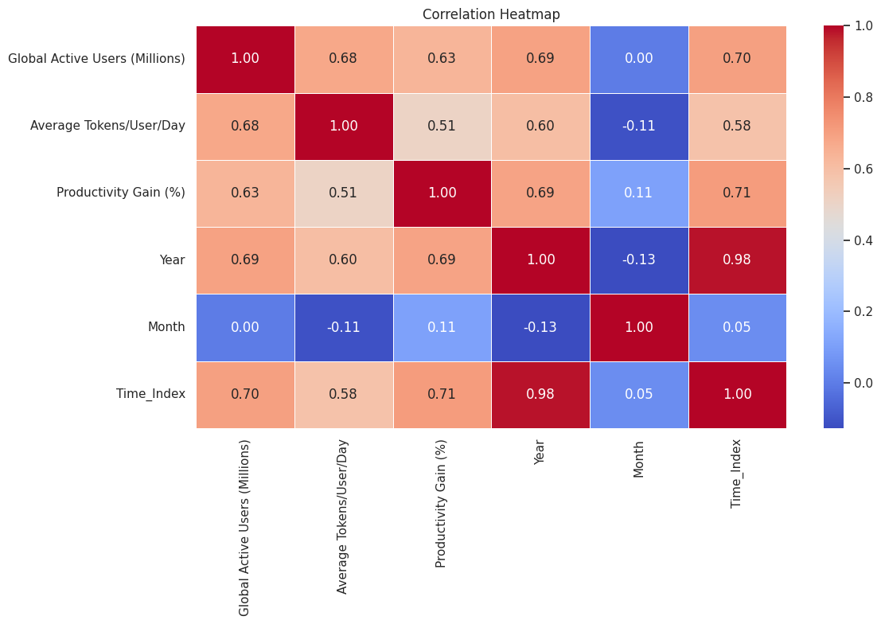
Figure 6.3: Correlation Heatmap of Numerical Features
What it shows: The heatmap represents correlation coefficients between selected numerical variables.
Why it was created: To identify positive and negative linear relationships among numerical attributes.
Insights obtained: Active users and productivity gain have a Pearson correlation of 0.633. Average tokens per user per day and productivity gain have a correlation of 0.508. Correlation does not establish causation.

6.5 AI Usage vs Productivity
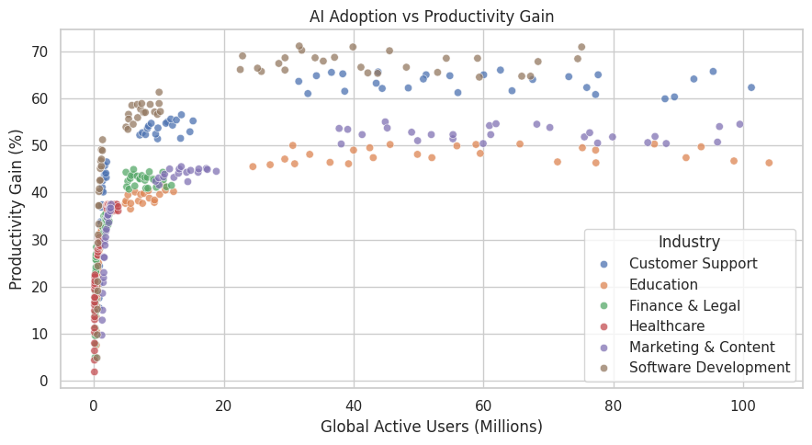
Figure 6.4: AI Adoption vs Productivity Gain
What it shows: The scatterplot displays active AI users against productivity gain, with industry categories distinguished by color.
Why it was created: To examine whether higher active user levels are associated with productivity gain.
Insights obtained: The plot provides a visual view of the association and industry-level spread. Differences between industries and time periods should be considered when interpreting the relationship.

6.6 Productivity Gain Across Industries
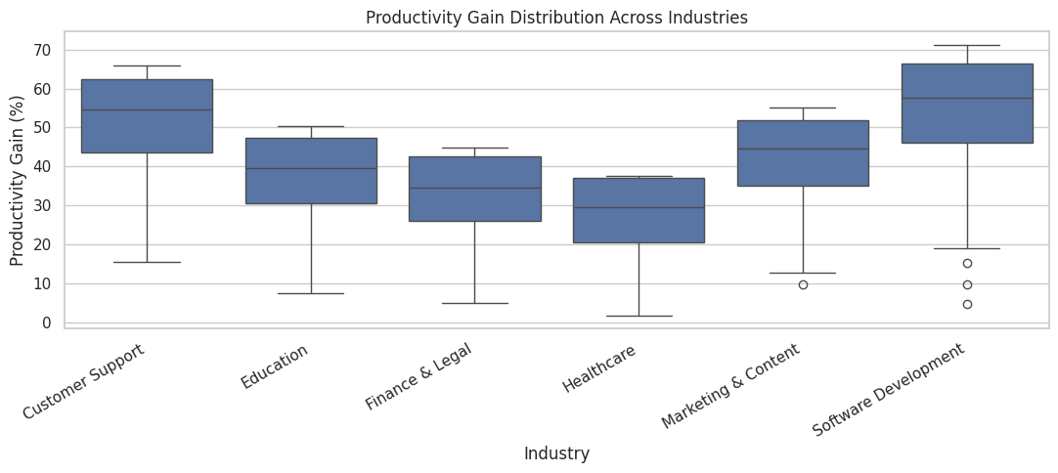
Figure 6.5: Productivity Gain Distribution Across Industries
What it shows: Boxplots compare the median, quartiles, spread and potential outliers of productivity gain for each industry.
Why it was created: To compare productivity variation between different industries.
Insights obtained: Software Development has the highest mean productivity gain (53.94%), followed by Customer Support (51.72%).

6.7 Year-wise AI Adoption Trend
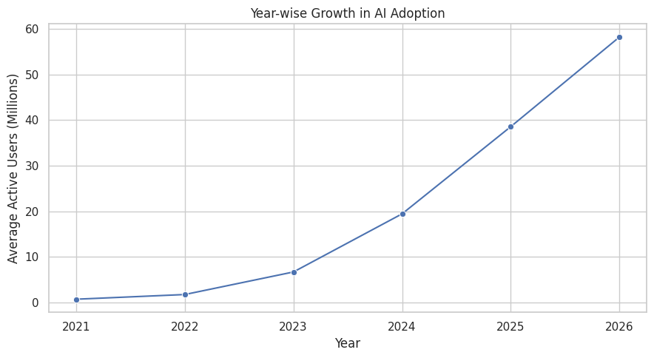
Figure 6.6: Year-wise Growth in AI Adoption
What it shows: The line chart displays average active users by year.
Why it was created: To examine changes in AI adoption over the observation period.
Insights obtained: The chart shows an upward pattern in average active users over the years. The 2026 observation period is partial and ends in July 2026.

6.8 Empirical Probability Distribution of Industries
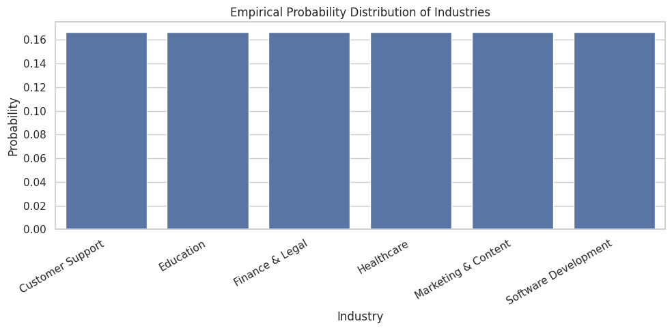
Figure 6.7: Empirical Probability Distribution of Industries
What it shows: The chart displays the relative frequency of each industry category.
Why it was created: To understand the proportion of records belonging to each industry.
Insights obtained: Each industry has 67 observations out of 402, so the empirical probability is approximately 0.167 for each category.

6.9 Average Token Usage Across Industries
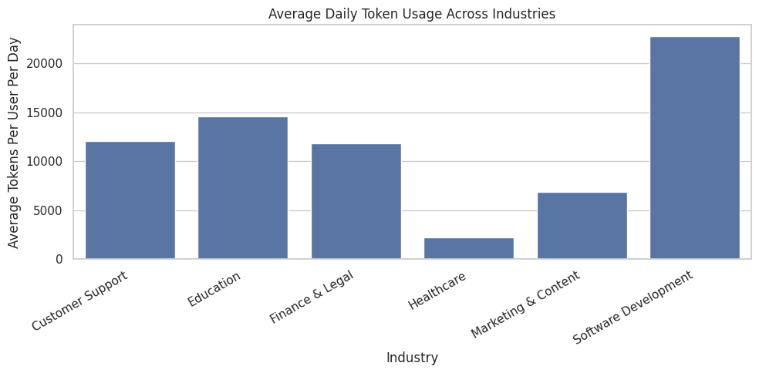
Figure 6.8: Average Daily Token Usage Across Industries
What it shows: This bar chart compares average daily token usage per user across industries.
Why it was created: To identify differences in AI usage intensity between industries.
Insights obtained: Software Development has the highest mean token usage (22794.31 tokens per user per day).

6.10 Summary of Visualizations
The visualizations provide different perspectives on the AI adoption dataset. Histograms help understand individual numerical distributions, boxplots highlight spread and potential outliers, bar charts compare industries, the line chart explores time trends, the scatterplot examines bivariate association and the heatmap summarizes correlations.

6.11 Seven Stages of Visualization
Stage | Description | Application in this project
1. Acquire | Collect data | Load the CSV dataset
2. Parse | Organize data | Read columns and convert YearMonth to Date
3. Filter | Select relevant data | Inspect records and prepare analysis fields
4. Mine | Analyze patterns | Statistical summaries, IQR and correlation
5. Represent | Choose visual forms | Histogram, bar chart, boxplot, scatterplot and heatmap
6. Refine | Improve readability | Titles, labels, legends and layout
7. Interact | Explore data dynamically | Interactive dashboard is a possible future extension

7. DEEP LEARNING MODEL – MULTI-LAYER PERCEPTRON

7.1 Introduction
Deep Learning is a subset of Machine Learning that uses artificial neural networks to learn patterns from data. In this project, a Multi-Layer Perceptron (MLP) model is implemented to predict the continuous Productivity Gain (%) value. The model uses numerical and categorical features obtained after preprocessing and feature engineering.

7.2 Model Architecture
The MLP model consists of an input layer, three hidden dense layers with dropout regularization, and a single-neuron linear output layer.
Layer | Configuration | Function
Input Layer | 30 processed input features | Receives transformed data
Hidden Layer 1 | 64 neurons, ReLU | Learns patterns
Dropout Layer 1 | 0.20 | Reduces overfitting
Hidden Layer 2 | 32 neurons, ReLU | Learns deeper patterns
Dropout Layer 2 | 0.20 | Reduces overfitting
Hidden Layer 3 | 16 neurons, ReLU | Learns additional representations
Output Layer | 1 neuron, Linear | Predicts productivity percentage
The 30 input dimensions are the result of numerical preprocessing and One-Hot Encoding. The input dimension is determined by the transformed training data.

7.3 Activation Functions
ReLU (Rectified Linear Unit) is used in the hidden layers to introduce non-linearity.
f(x) = max(0, x)
The output layer uses a linear activation because the target is a continuous numerical value.

7.4 Model Training Parameters
Parameter | Value
Model | Multi-Layer Perceptron
Optimizer | Adam
Loss Function | Mean Squared Error
Metric during training | Mean Absolute Error
Batch Size | 32
Maximum Epochs | 150
Early Stopping Patience | 15
Output Type | Regression
Early stopping monitors validation loss and restores the best model weights when validation performance stops improving.

7.5 Model Workflow
- Receive the preprocessed input features.
- Pass the data through the first dense layer.
- Apply dropout regularization.
- Process the output through the second and third dense layers.
- Generate a continuous prediction through the linear output neuron.
- Compare predictions with actual productivity gain using regression metrics.

7.6 Model Implementation
The MLP model was implemented using TensorFlow and Keras. The model contains Dense layers with ReLU activation, Dropout layers and a single linear output neuron. The model was compiled using the Adam optimizer, Mean Squared Error loss and Mean Absolute Error as a training metric.

7.7 Training and Validation
The model was trained using the training subset and evaluated on the validation subset during training. EarlyStopping was configured with a patience value of 15 and restoration of the best model weights. The test dataset was kept separate for final evaluation.

7.8 Summary
The MLP model was developed to estimate productivity gain from industry, use case, adoption, token usage, date-derived and historical features. Dropout and early stopping were incorporated to support training regularization.

8. MODEL EVALUATION AND RESULT VISUALIZATION

8.1 Introduction
Model evaluation measures the effectiveness of the trained MLP regression model. The model is evaluated using the chronologically held-out testing dataset. Regression metrics and visualizations are used to understand prediction errors and generalization.

8.2 Evaluation Metrics
- MAE: Mean Absolute Error; average absolute difference between actual and predicted values.
- MSE: Mean Squared Error; average squared prediction error.
- RMSE: Root Mean Squared Error; square root of MSE, expressed in the target's units.
- R² Score: Measures the proportion of target variance explained relative to a mean baseline.
Evaluation Metric | Obtained Value
MAE | 53.6856
MSE | 5925.9347
RMSE | 76.9801
R² Score | -49.6398

8.3 Training Loss vs Validation Loss
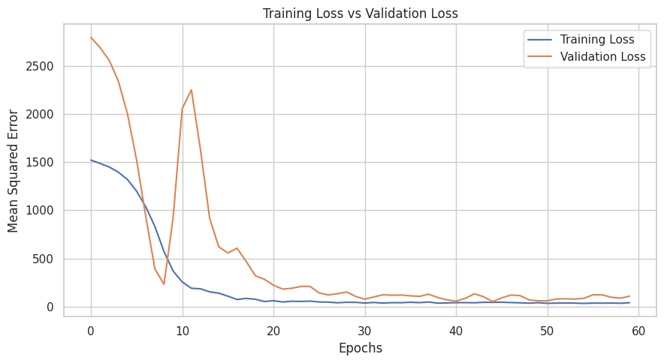
Figure 8.1: Training Loss vs Validation Loss
The loss curve represents changes in training and validation Mean Squared Error during model training. Comparing the curves helps assess convergence and possible overfitting.

8.4 Actual vs Predicted Productivity Gain
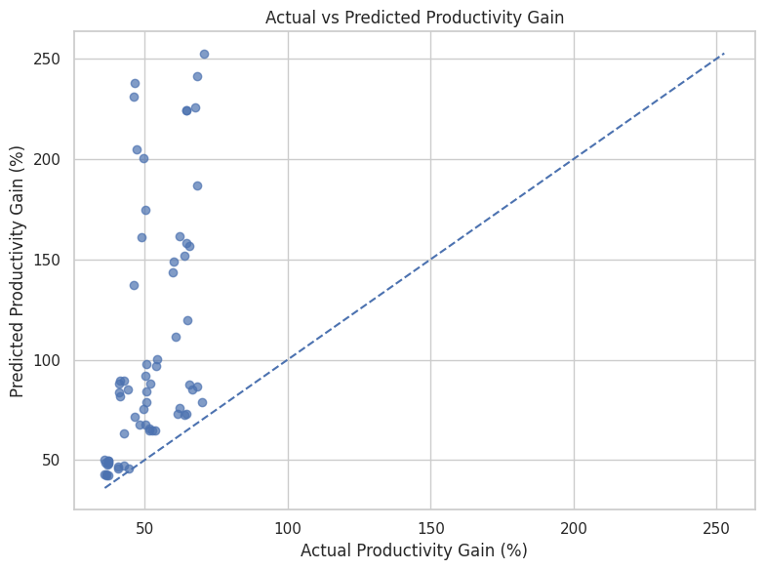
Figure 8.2: Actual vs Predicted Productivity Gain
The scatterplot compares actual productivity values with the model's predictions. Points closer to the diagonal reference line indicate more accurate predictions.

8.5 Model Performance Summary
The test MAE is 53.6856, the MSE is 5925.9347, the RMSE is 76.9801, and the R² score is -49.6398.

8.6 Interpretation
The negative R² score indicates that the model's test predictions are substantially worse than a baseline that predicts the mean of the test target. The MAE and RMSE are also large relative to the observed productivity-gain range. Therefore, the current MLP implementation has not achieved satisfactory predictive performance. The result should be reported transparently rather than described as a successful high-accuracy model.
Potential reasons include the small number of industry-month observations, strong time trends, feature correlations, the chronological test period and the limited information available in the original six attributes. Additional validation and model comparison are needed.

9. CONCLUSION AND FUTURE SCOPE

9.1 Conclusion
This case study focused on performing Exploratory Data Analysis and visualization on the AI Adoption and Productivity dataset. The dataset contains 402 industry-month observations and six original attributes. Data preprocessing was performed to inspect missing values, duplicates and outliers, and to create date-based, seasonal, interaction, logarithmic and historical features. Statistical methods and visualizations were used to understand productivity patterns, AI adoption, token usage, industry-wise differences and relationships among numerical variables.
An MLP regression model was implemented to predict productivity gain. The model was evaluated using MAE, MSE, RMSE and R². The negative test R² indicates that the current model requires improvement and should not be used as a reliable productivity predictor in its present form.

9.2 Key Findings
- The dataset contains 402 records and six original attributes.
- No missing values or duplicate records were identified.
- Six industries and six primary use cases are represented.
- Feature engineering expanded the DataFrame to 23 columns.
- Active users and productivity gain show a positive correlation in the dataset.
- Software Development has the highest mean productivity gain among the six industries.
- The MLP regression model produced a negative test R² and requires further improvement.

9.3 Learning Outcomes
- Understanding and analyzing a structured dataset.
- Handling missing values, duplicates and outliers.
- Performing feature engineering and data transformation.
- Creating statistical visualizations.
- Building and evaluating a deep learning regression model.

9.4 Challenges Faced
- Understanding the dataset and selecting suitable predictors.
- Engineering date and historical features.
- Handling categorical and numerical inputs.
- Maintaining chronological separation of training, validation and testing data.
- Improving model generalization on a relatively small dataset.

9.5 Future Scope
- Include additional records and original attributes.
- Compare MLP with simpler regression models and tree-based models.
- Apply systematic hyperparameter optimization.
- Evaluate feature importance and temporal validation strategies.
- Develop an interactive dashboard to explore industry trends.
- Build a prediction application only after improving and validating model performance.

10. LITERATURE REVIEW AND REFERENCES

10.1 Literature Review
Exploratory Data Analysis: EDA uses statistical summaries and visual representations to understand distributions, unusual values and relationships between variables.
Data Analysis Using Python: Pandas and NumPy provide data loading, cleaning, transformation and statistical analysis capabilities.
Data Visualization: Matplotlib and Seaborn support histograms, bar charts, boxplots, scatterplots and correlation heatmaps.
Data Preprocessing and Machine Learning: Scikit-learn provides encoding, standardization, splitting and preprocessing pipelines.
Deep Learning: Multi-Layer Perceptrons use interconnected neural layers to learn patterns for regression and classification tasks.

10.2 References
- W. McKinney, Python for Data Analysis, 3rd ed. Sebastopol, CA, USA: O'Reilly Media, 2022.
- F. Chollet, Deep Learning with Python, 2nd ed. Shelter Island, NY, USA: Manning Publications, 2021.
- F. Pedregosa et al., “Scikit-learn: Machine Learning in Python,” Journal of Machine Learning Research, vol. 12, pp. 2825–2830, 2011.
- TensorFlow, “TensorFlow Documentation.” [Online]. Available: https://www.tensorflow.org/
- Matplotlib Development Team, “Matplotlib Documentation.” [Online]. Available: https://matplotlib.org/stable/

