Task 1

I've created three entities: Books, Users, and Loans, to model a library system. Books and Users represent the library's offerings and its patrons respectively, while Loans link the two, tracking book lending and returns. Foreign keys, shown as blue lines in the diagram, bind these entities together. To speed up history searches, I've also set up indexes on the user_id, book_id, and loanedAt columns in the Loans entity.

Diagram:

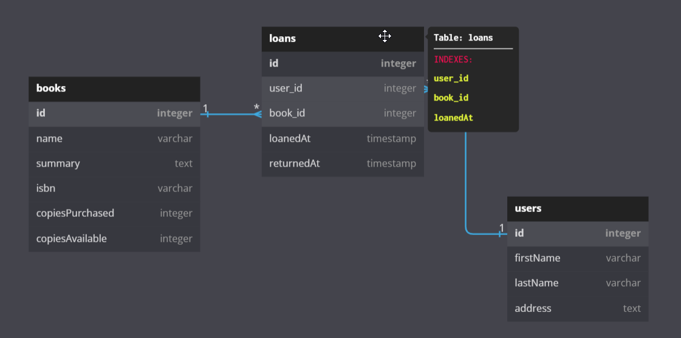  
DBML code:

Table books {

id integer [primary key]

name varchar [not null]

summary text

isbn varchar [not null]

copiesPurchased integer

copiesAvailable integer

}

Table users {

id integer [primary key]

firstName varchar [not null]

lastName varchar [not null]

address text

}

Table loans {

id integer [primary key]

user_id integer [ref: > users.id]

book_id integer [ref: > books.id]

loanedAt timestamp [not null]

returnedAt timestamp

Indexes {

user_id

book_id

loanedAt

}

}