NAME Karol Wadolowski

# Problem 1

Discuss how you determined the reference frequency and all scale / chord frequencies for this project.

I started out by using a reference frequency corresponding to A4 = 440Hz. For the equal intonation I just multiplied the frequency of this reference by (2)^(n/12) where n is how many intervals away the note of interest was from A4. For example for A# n = 1 and for C, n=3.

For just intonation I created a series of fractions going from ½ to 2 (2 octaves). I used the complete scale of intonation from the powerpoint to get the 25 fractions (check spreadsheet for the values). I then found out how many intervals away a certain Key was from A4. So in the key of C, C is 3 intervals above A. So I start with the 3rd largest fraction < 1 to reference A4. This makes C align with the fraction 1. I then take all the fractions and renormalize them by whatever the fraction for A4 was. This puts all the notes in the Key of interest. Sort of like a sliding scale where you put the key of interest at 1 and the rescale everything by whatever fraction A4 corresponds to.

# Problem 4

Insert plots and describe.

From the plots it is easy to see that over one wavelength just and equal temperament are very similar with only a small difference between them. However over a larger time frame (more wavelengths) this difference compounds and becomes larger. This results from the fact that the ratios between intervals are spaced differently in just and equal temperament. 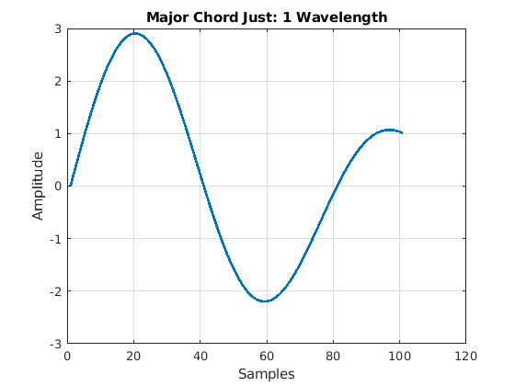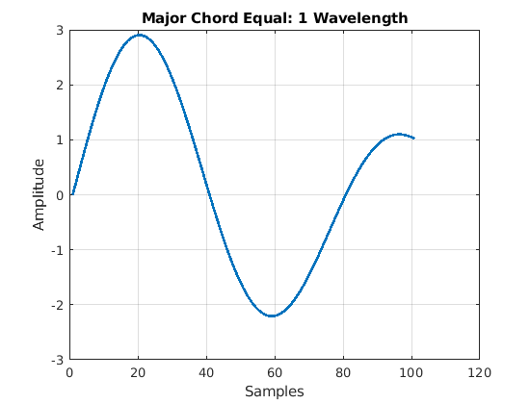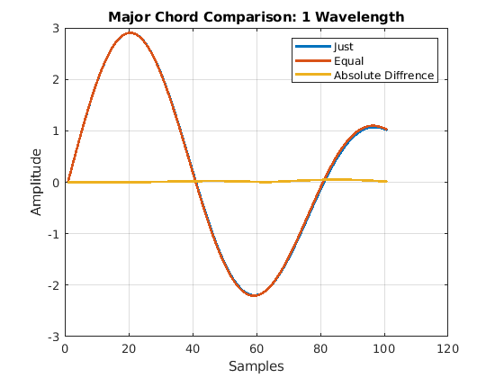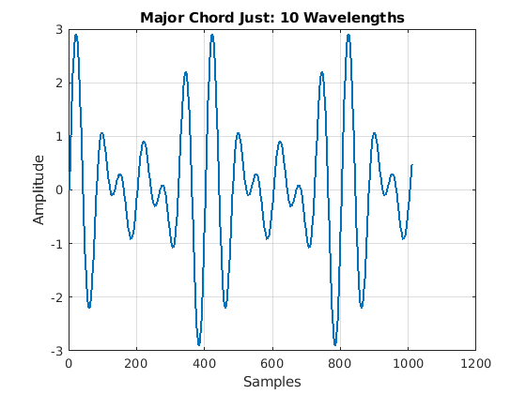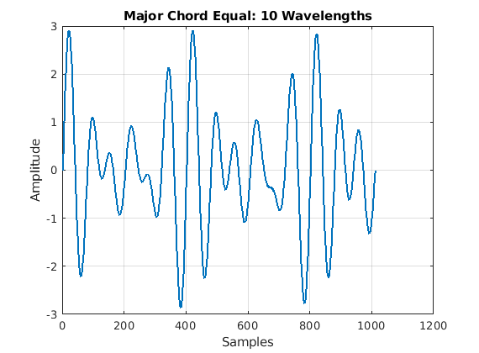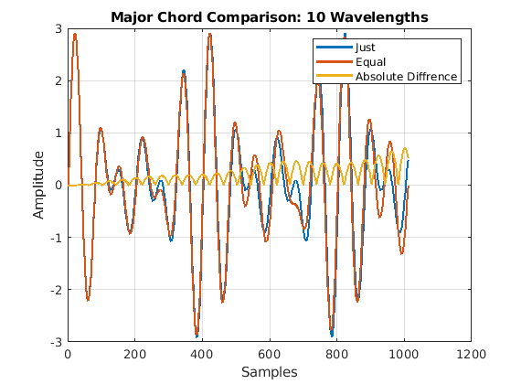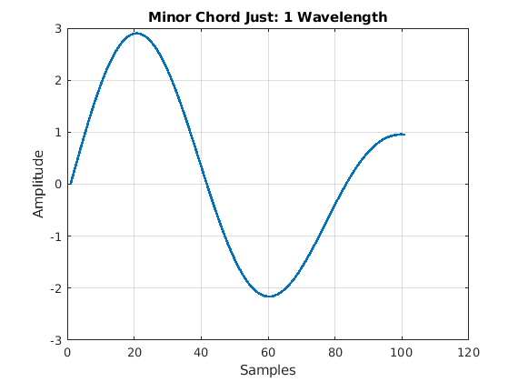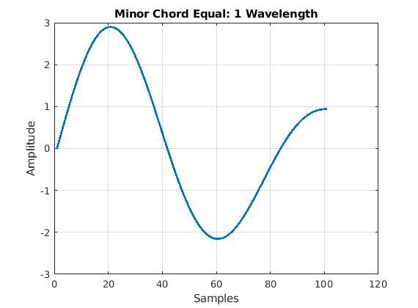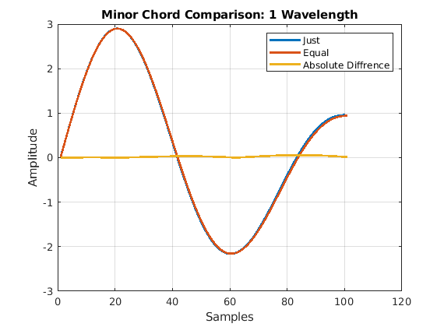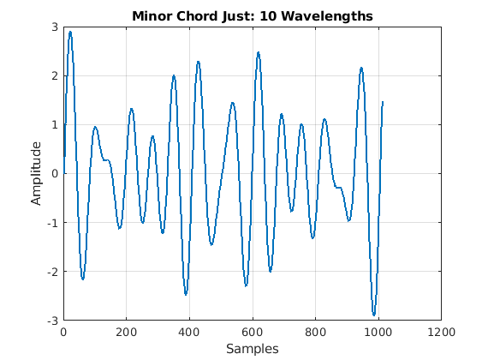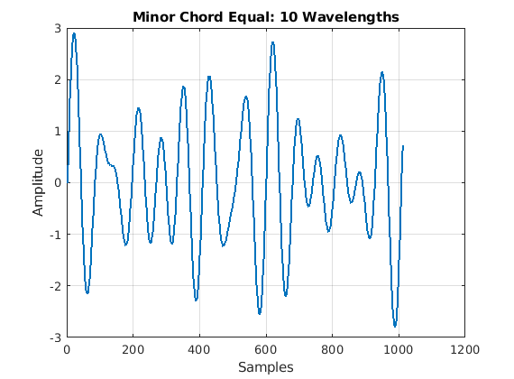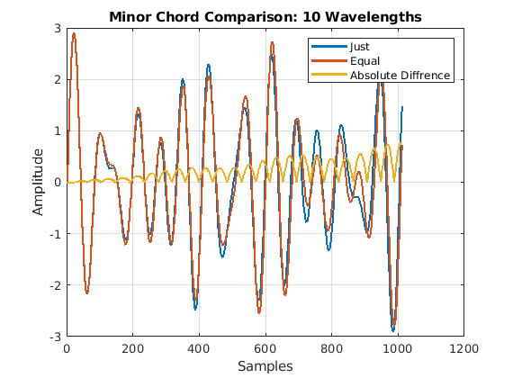

# Problem 5

1. Can you hear the difference between the just tempered Major scale and the equal tempered Major scale?

It is hard for me to hear any difference between the Major scales. The only difference that I can hear is the sudden change between frequencies is more prevalent in the equal tempered scale.

1. Which one sounds better? - Why (explain)

Since the just tempered scale seems to have less audible frequency jumps it sounds better to me. Otherwise mid note I can’t hear a difference.

1. Can you hear the difference between the just tempered Minor scale and the equal tempered Minor scale?

Again as with the Major scale the difference between these two seems to be that the equal tempered has more audible jumps between notes than its just tempered counterpart.

1. Which one sounds better? - Why (explain)

The just tempered has 2 of theses frequency jumps compared to the equal tempered’s 5 jumps. This makes the just tempered flow better and have a more pleasing sound.

1. Can you hear the difference between the just tempered Major chord and the equal tempered Major chord?

After listening to them ten times each back to back I can’t hear a difference. They actually sound the same to me.

1. Which one sounds better? - Why (explain)

Neither sounds better. They both sound the same to me.

1. Can you hear the difference between the just tempered Minor chord and the equal tempered Minor chord?

There seems to be a dip in the sound towards the end of the equal tempered Minor chord that isn’t present in the just version. Other than that they are very hard to distinguish.

1. Which one sounds better? - Why (explain)

I prefer the just tempered version as the dip does not occur. Hearing the dip just through me off.

# Other Comments

Am I actually supposed to hear the difference for all of them? Does the ability to do so come with a better knowledge of music and what to listen for?