Mathematics – list of basic terms and subject matter to be taught in 2(3) x 90min sessions

* **Elements of algebra:**

**numbers**: numerals, odd/even, natural, ordinal numbers, positive/negative numbers, etc.

three hundred (~~hundreds~~) soldiers, but hundreds of soldiers, tens of thousands of protesters

writing/reading dates, years, etc. (20 January 1993, 1st June, June 1st, 7/4/2000, etc.)

**four basic calculations**

addition, subtraction, multiplication, division

**common/vulgar fractions** (½, **¾** – three quarters/three fourths, ⅝ – five eighths, etc.)

**decimal fractions** (0.45, 0.005, etc.)

**roots** ( n√a the n-th root of a, √a - the square root of a, 3√a the cubic root of a, etc.)

**powers** (x2 - x squared, x to the power of two,x3- x cubed, x to the power of three, xn- x to the n-th power, x to the power of n, etc. )

**logarithms** logbc = n - the logarithm of c to the base b is equal to n, lnc - natural logarithm of c, etc.

**trigonometry (trigonometric functions)**

y = sin x, cos45 (the sine of x, the cosine of 45 degrees, etc.), tan, ctn (the tangent, cotangent), y = sin-1 (the arc sine, etc.)

**selected symbols**

**<** less than , ≤ less than or equal to, **>** greater than , ≥ greater than or equal to

**«** much less than, **»** much greater than, {...} in braces, (...) in (round) brackets/parentheses, [...] in square brackets, ≡ identical to, ≈ approximately, ∞ - infinity, → tends to, ≠ not equal to, │b │ absolute value of, ∑ the sum of, ∫ the integral

* **Two and three dimensional geometry**

**lines** (solid, broken, dotted, diagonal, wavy, straight, curved, parallel, perpendicular, intersecting)

**angles**

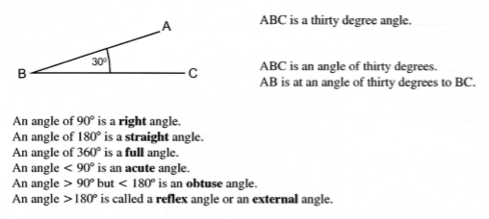

**triangles**

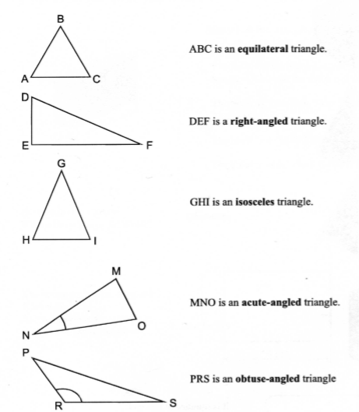

**two-dimensional geometrical shapes (nouns and adjectives)** rectangle - rectangular, triangle - triangular, circle - circular (radius, diameter, circumference, π) , rounded/pointed, convex/concave, etc.

**three-dimensional shapes - a cube, cone, pyramid, cylinder, etc.**

**describing dimensions**

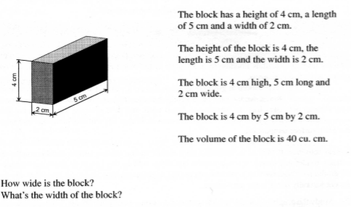

**Sources:** Grzegożek, Małgorzata. Starmach, Iwona. 2004. *English For Environmental Engineering*. Kraków: PK.

Hanf, Bodo. 2001. *Angielski w technice*. Poznań: LektorKlett (PONs)

More material and exercises can be found in: Kubot, Aleksander. Maćków, Weronika. 2015. *Mathematics and Graphs Vocabulary Practice for Academic English Studies.* Poznan: PHPUT