NOTE: Use of internet is not permitted (apart from committing submission to Github, GitLab or BitBucket), calculators are permitted, and your answers must include worked solutions. Please enter your name and student number at the top of each sheet. All work should be stored in source control.

**Objective**

**Part A**   
Complete questions d, e, and f below

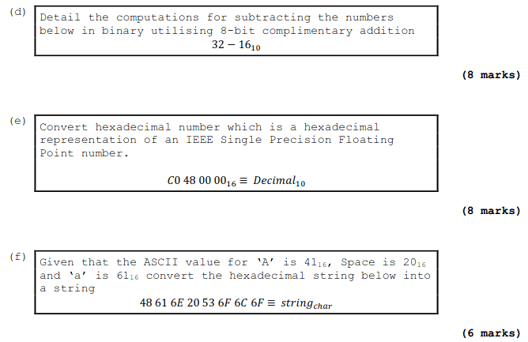**Part B**

Convert today's temperature to an IEEE 32-bit floating-point number and represent as IEEE3216. Assume today's temperature is 16.5 degrees (very warm for this time of year!). Follow method as show in lectures

Commit this practical report at the end of session and ensure it has been checked

|  |  |  |  |
| --- | --- | --- | --- |
| **Student Name** | **Karolis Grigaliunas** | **Student Number** | **C00287940** |
| **Date** | **04/10/23** | **Checked** |  |
| **Group** | **A / B** |  |  |

