**Part A**

**Objective**

Understand various logic gates

|  |
| --- |
| 1. Complete questions below |
| |  |  | | --- | --- | | A  B |  | | C |  | | D |  | | E | Draw a logic Gate diagram for De Morgan’s Law. | | F | Draw a Transistor Gate diagram for De Morgan’s Law. Why is this an important law. | |

A

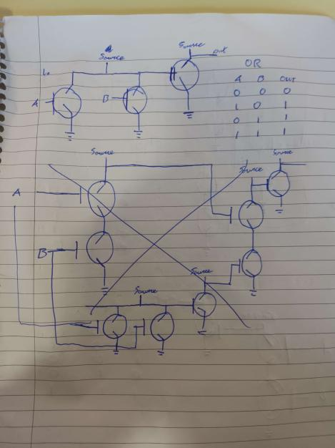

B

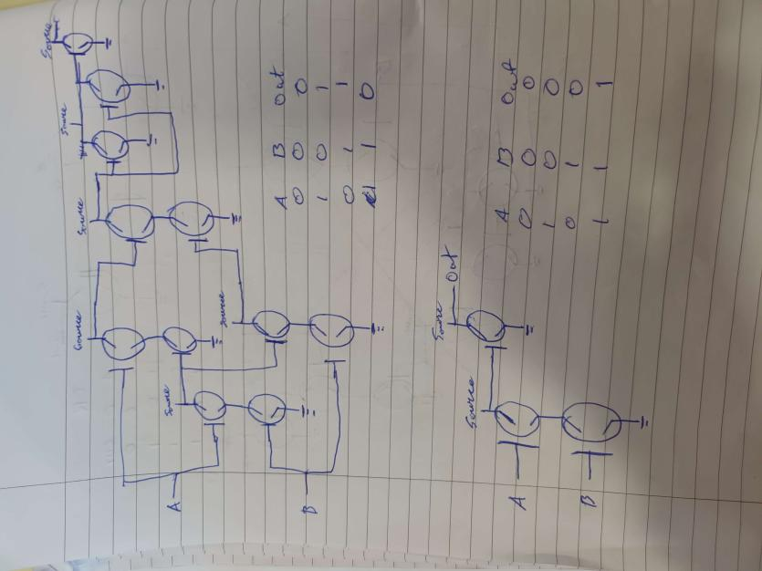

C



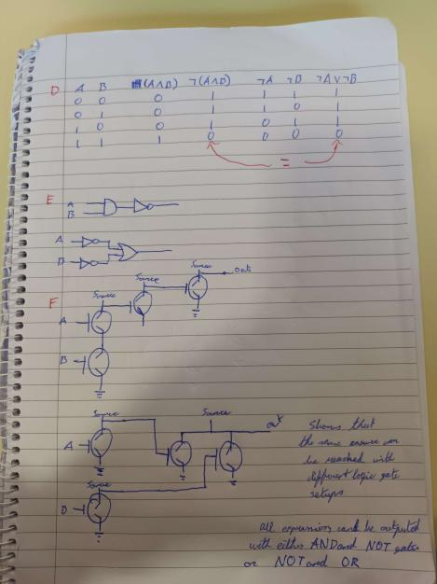

|  |
| --- |
| 1. Complete questions below |
| Using logic.ly construct the following Circuit using NAND and NOT Gates (With a Light at Output) and complete Truth Tables  https://adamwsonu.files.wordpress.com/2010/03/quizcircuit.png  Y is always 1 |

**Hand up this practical report at the end of session and ensure it has been checked**

|  |  |  |  |
| --- | --- | --- | --- |
| **Student Name** | **Karolis Grigaliunas** | **Student Number** | **C00287940** |
| **Date** | **25/10/23** | **Checked** |  |
| **Group** | **A / B** |  |  |