**Part A**

**Objective**

Understand various logic Adder circuits

|  |
| --- |
| 1. Complete questions below |
| |  |  | | --- | --- | | A |  | | B |  | |

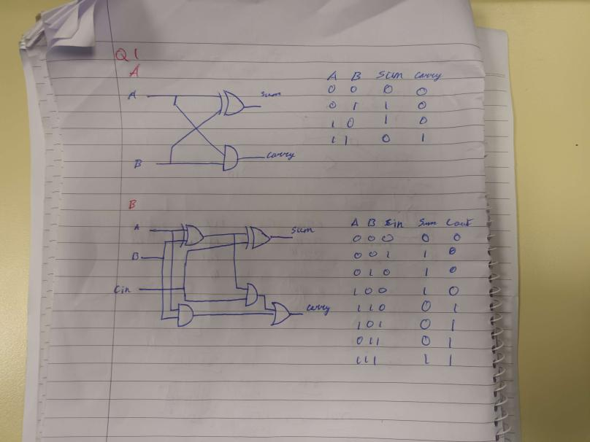

|  |
| --- |
| 1. Complete the circuits below |
| |  |  | | --- | --- | | A | Using logic.ly construct an 8 Bit Rippler Adder and attach to an appropriate number of 7 segment displays.  Add the following numbers  1111 1001  0000 0110  The output should be 255 in Based10  Upload the completed circuit file to GitHub | | B | Using logic.ly modify the 8 Bit Rippler Adder circuit above to be a subtraction circuit and attach to an appropriate number of 7 segment displays.  Subtract the following numbers  1111 1111  0000 1111  The output should be 235 in Based10  Upload the completed circuit file to GitHub | | C | Construct the logic gate circuit for a DM74LS83A  4-Bit Binary Adder with Fast Carry Manufactured by Fairchild Semi-conductors. See Logic Diagram Page 2  <https://www.futurlec.com/74LS/74LS83.shtml>  Upload the completed circuit file to GitHub | |

**Hand up this practical report at the end of session and ensure it has been checked**

|  |  |  |  |
| --- | --- | --- | --- |
| **Student Name** | **Karolis Grigaliunas** | **Student Number** | **C00287940** |
| **Date** | **08/11/23** | **Checked** |  |
| **Group** | **A / B** |  |  |