**Part A**

**Objective**

Understand Encoders Decoders and Block Circuit Diagrams

|  |
| --- |
| 1. Complete block diagram below |
| |  |  | | --- | --- | | A |  | |

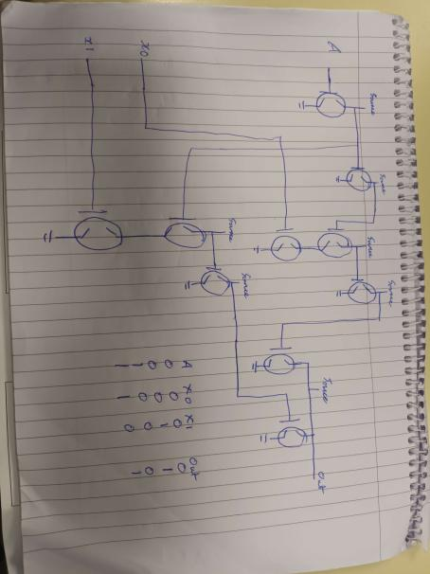

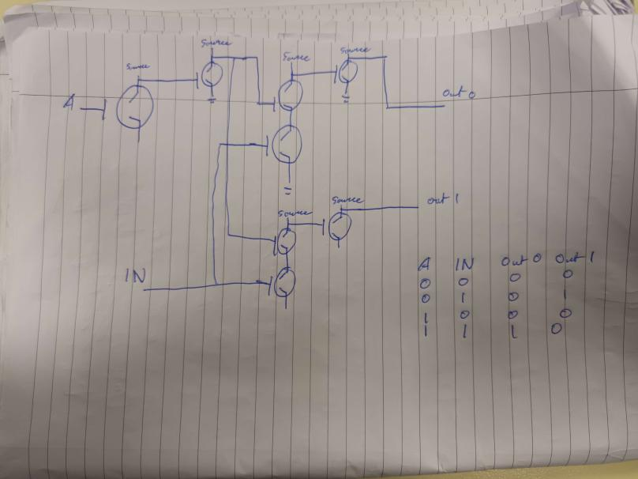

|  |
| --- |
| 1. Using logic.ly complete logic gate level circuit for the block circuit diagram below |
|  |

**Hand up this practical report at the end of session and ensure it has been checked**

|  |  |  |  |
| --- | --- | --- | --- |
| **Student Name** | **Karolis Grigaliunas** | **Student Number** | **C00287940** |
| **Date** | **15/11/23** | **Checked** |  |
| **Group** | **A / B** |  |  |