**Open-Book Marked Practical Logic Circuits and Number Systems**

**3.00 pm** to **5.00 pm 29th November 2023** Total time 2 Hours.

Committed files should be timestamped no later than **5.00 pm 29th November 2023**.

Work must be submitted to GitHub.

Save and commit your progress to GitHub regularly during mark practical.

**Step 1**

Download and install [logic.ly](https://logic.ly/) if not already installed.

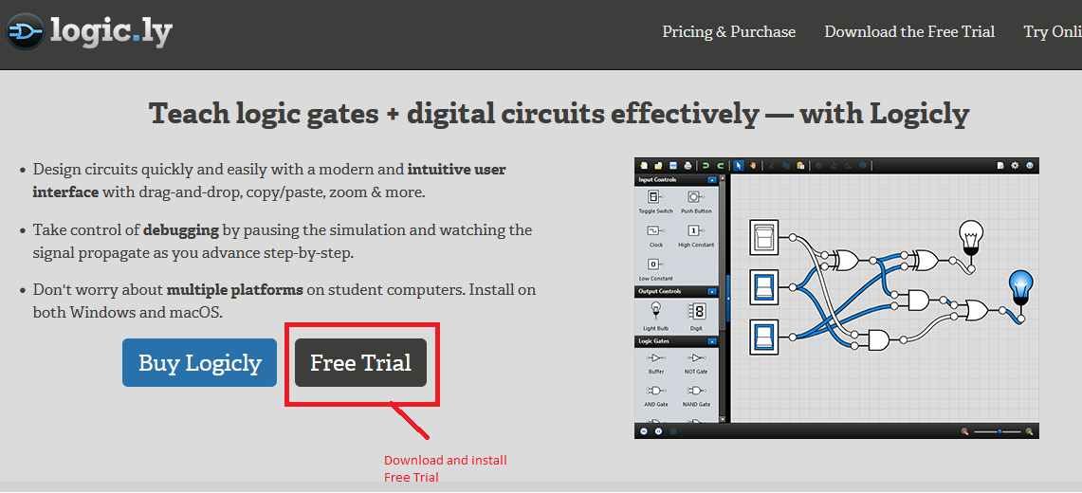

**Step 2**

Create a GitHub or Bitbucket Repository Directory named:

*SystemCircuitDesign*

**Step 3**

Add lab supervisors as collaborators for this repository, if not already added.

**Step 4**

***Share your screen via Discord*** so that your work can be invigilated. You will be assigned a Discord Room. Remain in that Discord Room until 5.00 pm, or your work has been checked.

Add Link to repository to CA Spreadsheet, this must be done before proceeding to Step 5.

***See next Page....***

**Step 5**

Read preamble

You have been asked to prototype a circuit for an Elevator System. The circuit controls the Elevator Floor displays. The building has 8 floors with 7 floors served by elevator and basement serviced by a staff only stairway.

The Elevator starts at floor **1** and stops at floor **7**. Your circuit needs to include an addition and subtraction mechanism to raise and lower elevator.

The Elevator floor display circuit is separate from the UP/Down controller. Wiring has been put in place which can transfer current floor and UP/Down settings.

See circuit block diagram **Figure 1**

***See next Page....***

**Step 6**

Create a 4 Bit Ripple Adder (with Two Complement enabled). The A and B bits should be input to a 7 segment displays. The **bits** display and represent the Current Floor. The **bits** display and represent the new Elevator floor request. The **bits and second 7 Segment Display** should be set to ***0111.*** This circuit will be used to increase and reduce elevator requested floor.

See circuit block diagram **Figure 1**

When this circuit is complete, **Save** your work and Upload to GitHub or BitBucket Repository

**Step 7**

Reduce Floor Requested by 1. Take a screenshot of the circuit including 7 segment display(s) output.

See circuit block diagram **Figure 1**

When this screenshot is complete, **Save** your work and Upload to GitHub or BitBucket Repository

**Step 8**

Create a 4-bit Encoder Circuit to send floor request data over a data line. Use switches for the address lines and Label them A and B.

See circuit block diagram **Figure 1**

When this circuit is complete, **Save** your work and Upload to GitHub or BitBucket Repository

**Step 9**

Create a 4-bit Decoder Circuit to receive floor request over a data line.

See circuit block diagram **Figure 1**

When this circuit is complete, **Save** your work and Upload to GitHub or BitBucket Repository

**Step 10**

Attach a 7-segment display to the decoder data lines.

See circuit block diagram **Figure 1**

When this circuit is complete, **Save** your work and Upload to GitHub or BitBucket Repository

***See next Page....***

**Step 11**

Increase and Reduce floor request by 1 or more floors. Take a screenshot of circuit including 7 segment display output. The remote 7 segment display should display the correct data line output.

When these screenshots are complete, **Save** your work and Upload to GitHub or BitBucket Repository

**Step 12**

Using a D-Latch Circuits (4 D-Latch Circuits) combine the outputs from the decoder circuit such that the Display in the Elevator matches the 7-segment display at the Elevator Controller.

**Figure 1 Block diagram of completed Circuit**

|  |  |  |  |
| --- | --- | --- | --- |
| **Floor**  **Display** | **Elevator Management System** | **Data**  **Comms** | **Elevator**  **Display** |
|  | | | |

**: ENDS**