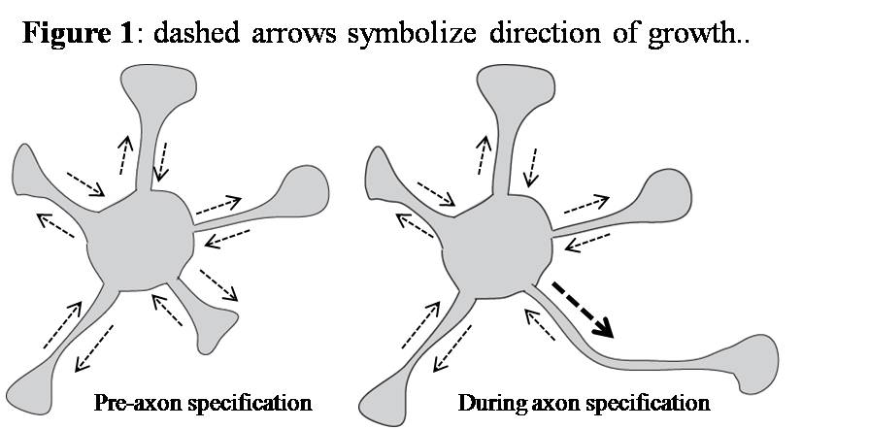
Summary: Hippocampal neurons polarize to form one axon and several dendrites during central nervous system development. Previous studies have shown that kinesin 1 accumulates in axon post specification [1,2], however the mechanism by which kinesin 1 partitions and contributes to axon formation is unknown. Here, I propose to investigate using live cell dynamics and in vitro single molecule imaging experiments the hypothesis that microtubule modification (e.g., acetylation and detyrosination) are responsible for kinesin 1 partitioning and contribute to axon specification.
Hypothesis: Neuronal polarization is initiated by the stabilization and modification of microtubules, which leads to partitioning of active transport into the future axon.
Aim 1: Establish the effect of MT modification, specifically tubulin detyrosination and acetylation, on kinesin binding and processivity using single molecule imaging using reconstituted component in an in vitro system.
Aim 2: With time-lapse live cell imaging, correlate kinesin transport and MT quantity and growth with neurite extension and retraction using primary hippocampal neurons transfected with YFP-kinesin and CFP-tubulin. The addition of drugs and siRNA will be used to test the role of microtubule modification in axon specification.
Introduction: Hippocampal neurons (HNs), which are responsible for long-term memory and spatial awareness, serve as a popular model for in vitro neuron polarization studies. In vitro, HNs sprout four to five neurites that stochastically retract and elongate (Figure 1). Within several days, one neurite “wins”, growing faster than its companions, leading to its eventual specification as the axon [3]. Growing evidence supports the hypothesis that MT modification may be responsible for the partitioning of certain kinesins into a single neurite. Separate studies have shown the selective affinity of kinesin 1 for both acetylated (Acet-tub) [4] and detyrosinated (Glu-tub) [5] tubulin, although the effect of the modifications together has yet to be reconciled. The motor domain of kinesin 1, which lacks the inhibitory tail region, is found to localize in a single neurite then switch between neurites during differentiation, finally residing in the axon post-specification, while kinesin 3 distributes uniformly in all neurites [2]. Furthermore, overexpression and knock-down of many microtubule associated proteins (MAPs) lead to multi-axon or un-differentiated phenotypes [6]. The following experiments are designed to uniquely examine the role of modified MT’s in kinesin partitioning at both the biophysical, in vitro level and on the level of cell dynamics.
Single molecule measurement of the effect of microtubule modification on kinesin motility
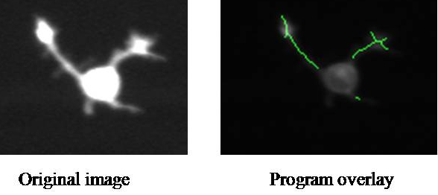
The following assays will be used to probe the claim in my hypothesis that MT modifications can cause the partitioning of kinesins. Motor domains of kinesin 1 and kinesin 3 tagged with YFP or quantum dots will be used in a single molecule imaging assay to measure motor processivity on MT that underwent different modification regimes. Truncation is necessary since kinesins lacking cargo will fold into inert structures. Acet-tub will be harvested from HNs treated with the histone deacetylase (HDAC) inhibitor trichostatin A. Purified HDAC will be added after isolation to produce un-modified MTs, followed by addition of carboxy-terminal peptidase A to produce Glu-tub. After each step, MTs will be re-polymerized if necessary, conjugated to streptavidin, and attached to a biotin-coated glass coverslip. A small amount of rhodamine labeled tubulin will be added to enable imaging of the polymerized microtubules. I will verify the presence of tubulin modifications using in vitro immunostaining using Acet-tub and Glu-tub specific antibodies. Total internal reflection fluorescence (TIRF) will be used to track the signal from labeled kinesins. By fitting a single Gaussian to the imaged point-spread function, I can then extract velocity and processivity parameters. Based on my hypothesis, I expect kinesin 1 to have higher processivity along both Glu-tub and Acet-tub over unmodified MT’s, whereas kinesin 3 will display no favoritism.
Figure 2
Correlation of neurite growth rates with microtubule behavior using live cell imaging
To test my global hypothesis in live cell studies, a robust time-lapse microscopy protocol will be established that allows transfection of multiple fluorescent biosensors in primary hippocampal neurons followed by 12-24 hours of imaging. A new electroporation method developed in the lab will be used to electroporate adherent cells with small volumes of concentrated mRNA to increase cell viability and induce even protein expression of multiple biosensors [7]. An automated epifluorescent microscope will be used to image 100+ cells during a single time-lapse experiment. Neurite growth rates will be obtained through software I wrote to extract neurite length through a RFP-CAAX membrane marker (Figure 2). Kinesin partitioning will be assessed using the previously-described constitutively active YFP tagged kinesin 1 and 3 constructs. CFP-tubulin and CFP-EB1, a MT plus-end binding protein, will be used to measure MT quantity and MT polymerization and collapse rates. This live cell imaging will establish the temporal correlation between kinesin partitioning and axon specification as well as establish the basal level of partitioning in an unperturbed system.
Perturbation of microtubule modification in live cell imaging
Trichostatin A will be added during an imaging run to increase Acet-tub levels. Through the quantitative imaging analysis described above, the effect of acetylation on MT and neurite dynamics will be definitively established. Co-transfection with truncated kinesins will also reveal partitioning caused by acetylation and partitioning rates can be determined. Next, Ttl, the enzyme responsible for re-tyrosinating Glu-tub, will be knocked-down to increase the amount of Glu-tub. Although the time-scale of RNAi is several days, information on MT, kinesin and neurite dynamics in the presence of increased Glu-tub can still be extracted. Immunostaining will be used to verify the presence of MT modifications. It is expected that these experiments show the increased transport and selective partitioning of kinesin 1 into the fastest growing neurite upon upregulation of MT modification. Furthermore, the dependence of kinesin transport on total number of MT’s versus MT modifications will be determined.
Conclusion: These experiments will establish a molecular mechanism underlying kinesin 1 partitioning and its role in axon specification. My study highlights the importance of MTs and MAPs as drug targets for promoting neuron growth or regeneration, especially in the context of neurodegenerative disorders such as Parksinson’s and Alzheimer’s Disease. The study will be aided by the exceptional resources provided by the Biophysics program at Stanford. Labs that lead the field in molecular motor research, such as the Spudich and Block Groups, will be valuable for the successful implementation of my in vitro work. Furthermore, the microscopy systems in Meyer lab, including automatic epifluorescence imaging and TIRF, have allowed my experimental design to better probe my hypothesis.
[1] Nakata T, Hirokawa N. JCB 2003; 162:1045-1055. [2] Jacobson C, Schnapp B, Banker GA. Neuron 2006; 49:797-804. [3] Dotti CG, Sullivan CA, Banker GA. J Neurosci 1988; 8:1454-1468. [4] Reed NA et al. Curr Biol 2006; 16:2166-2172. [5] Konishi Y, Matsutoshi S. Nat Neuro 2009; 12:559:567. [6] Barnes AP, Polleux F. Annu Rev Neurosci 2009; 32:347-8. [7] Teruel MN et al. J Neuro Meth 1999; 93:37-48.

