- Major comments
  - Need 1 sentence introducing some aspect of biology that is unknown. this should appear immediately before your bolded hypothesis in paragraph 2
  - Need 1-2 sentence introduction to specific aims
  - Need conclusion to specific aims, possibly could be part of "broader impacts" section
- Minor comments
  - Broader impacts at end of paragraph 2 could be more concrete. give a couple examples.
  - More discussion of alternative plan if experiments don't work out
- Figure
  - TusA fill color should match line color in plot below
  - center figure, caption in box
  - add horizontal space between figure and text
  - reduce caption font size
- Style
  - The whole document would look more professional in latex
  - The figure would be a vector graphic
  - use wrapfigure environment to wrap figure (wrapfig package)
  - justify the text
  - two-column references
  - replaced ":" after section headings with the smaller ".", you could even remove "." if you wanted an even more minimal style
  - Didn't place aim titles on separate lines
  - Add" Δ" to knockout strains
  - Be more concise. I tried to shorten up the text in a few places
A Systems Biology Approach To Lambda Phage Infection
Keywords. bacteriophage lambda, E. coli, ribosomal frameshifting, systems biology
Background and Motivation. Viruses use surprisingly sophisticated techniques to exploit host resources for their own replication. Programmed ribosomal frameshifting (PRF) is one such technique in which lambda phage controls the expression of its tail protein GT by instructing the host ribosome via a "slippery sequence" to translate forward or backward one nucleotide along the mRNA transcript, thereby altering the reading frame, avoiding a stop codon, and producing both proteins G and T [1]. Lambda phage uses PRF to regulate the ratio of G:GT proteins required for tail formation. Similarly, HIV and SARS employ PRF to produce proper amounts of Gag-Pol and RNA-dependent RNA polymerase [2,3].
Urbonavicius and colleagues have shown that tRNA modifications are critical to reading-frame maintenance (RFM) in Escherichia coli (E. coli) [5]. Last year, my lab screened the Keio E. coli single gene deletion strain library for altered lambda phage infectivity and identified two divergent tRNA modification pathways critical for lambda phage proliferation (Fig. 1) – TusA and IscU, both of which require the upstream cysteine desulfurase IscS [4]. Furthermore, Shi and colleagues have demonstrated that TusA displaces IscU bound to IscS [6]. I hypothesize that IscU/TusA competition for sulfur independently controls PRF and therefore phage infection. Thoroughly understanding PRF is critical to developing a novel, effective anti-viral strategy against human pathogens such as HIV and SARS and those that plague industrial processes.
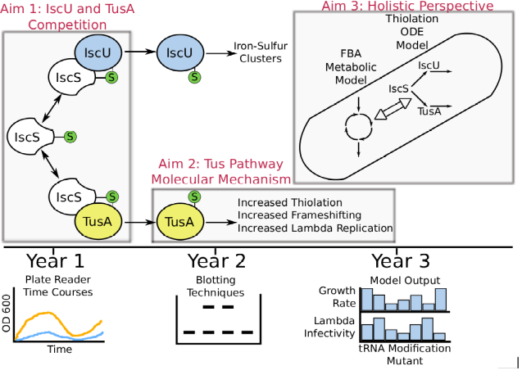 Figure : Experimental plan to study sulfur-transfer pathways and their relationship to lambda infection.
Specific Aim 1. Elucidate the competition between IscU and TusA.
Recently my lab has shown that ΔiscU is more susceptible to infection than wild-type, whereas ΔtusA is more resistant [4]. Additionally, knockouts of genes whose products act downstream of TusA exhibit dynamics similar to ΔtusA. From these observations, I hypothesize either that (1) IscU competes with TusA for sulfur and exerts a protective effect against lambda phage infection by diverting sulfur away from the Tus pathway, or that (2) IscU and TusA act independently.
To discern between the two hypotheses, I propose to use a plate reader to examine population-level lambda phage infection dynamics of the ΔiscU-ΔtusA double knockout strain. I will use a Euclidean distance metric to compare the ΔtusA, ΔiscU, and ΔiscU-ΔtusA infection time courses to wild-type. If the double knockout time course is similar to ΔtusA, and different from both ΔiscU and wild-type, the results would support the competitive inhibition hypothesis. Additionally, I will apply the same Euclidean distance metric to analogous time courses of deletion strains of genes downstream of IscU – HscA, HscB, IscA, Fdx, MiaB, and TtcA. If the deletion strains cluster with wild-type, the results would support the competitive inhibition hypothesis. If instead they cluster with ΔiscU strain, the results would suggest that the Isc pathway exerts a protective effect.
Specific Aim 2. Determine the molecular mechanism of TusA-mediated infection. Recently my lab has shown that E. coli is less susceptible to lambda infection in the absence of tusA, suggesting
the Tus pathway is essential for infection [4]. I hypothesize that this is due to the increased presence of unmodified tRNA^{Lys}, which decreases GT production via RFM perturbations, and inhibits tail formation. I will test this hypothesis by comparing GT production, RFM, and tRNA modification in wild-type and ΔtusA, ΔtusE, and ΔmnmA strains.
To quantitate GT production I will place lambda's G/GT region under the control of the arabinose-inducible portion of a pBAD plasmid, induce expression in wild-type, ΔtusA, ΔtusE, and ΔmnmA strains, and perform a Western blot for proteins G and GT. Altered ratios of G:GT in Tus pathway deletants would demonstrate that the Tus pathway modulates G:GT ratios.
Next, to quantitate RFM I will replace the pBAD plasmid slippery sequence downstream region with lacZ, transform the same strains, and measure β-galactosidase activity [5].
Third, I will asssess the contribution of the Tus pathway to tRNA^{Lys} hypermodification by quantitating the level of hypomodified tRNA wild-type and Tus pathway deletant strains using (N-acryloylamino)phenyl-4-mercuric chloride (APM) electrophoresis [7]. Decreased tRNA^{Lys} modification in Tus pathway deletants would confirm the pathway's role in tRNA modification.
Specific Aim 3. Develop a computational model of the systemic effects of RFM.
To serve as an effective anti-viral strategy, targeting PRF would ideally have a minimal effect on the host. To assess this, first I will identify all E. coli genes containing the lambda slippery sequence GGGAAAG. Second, I will construct a hybrid model of E. coli metabolism, translation, protein decay, and lambda infection. I will use flux-balance analysis (FBA) to model metabolism and predict cellular growth. I will model lambda infection using ordinary differential equations (ODE), and inform this model with the growth rate predicted by the metabolic model. I will model translation using the Ponnala displacement model [8]. The number of proteins produced by the translation module will limit the fluxes of the metabolic model. Protein decay will be modeled as an enzyme- and energy-dependent stochastic process. The entire model will enable a quantitative and holistic view of the effects of PRF in both wild-type and Tus pathway deletant strains. Specifically, it will enable me to explore the relationship between RFM and growth rate.

Broader impacts. The proposed work is critically important and broadly relevant to the field of virology since many viruses utilize PRF [9]. The proposed model will provide a framework to rigorously assess targeting PRF as a viable anti-viral strategy. Furthermore, I will publish my results in peer-reviewed journals, present my findings at conferences, and publicly release the source code for my model. Additionally, I plan to work with and mentor undergraduate students in experimental biology and computational modeling to complete the proposed projects.
Resources. My advisor Markus Covert and my coworkers have extensive experience with E. coli and lambda phage experimental biology and hybrid computational modeling techniques involving FBA and ODE's.
Statement of Originality. I affirm that this proposal is my own work.

References.

[1]. Gesteland (1996). Ann Rev Biochem.
[2]. Dulude et al. (2006). Virology.
[3]. Plant et al. (2010). J. Virol.
[4]. Maynard et al. (2010). PLoS Genetics.
[5]. Urbonavicius et al. (2001). EMBO J.
[6]. Shi et al. (2010). PLoS Biol.
[7]. Behm-Ansmant et al. (2011). J. Nuc. Acid.
[8]. Ponnala et al. (2006). IEEE EMBS.
[9]. Xu et al. (2004). Mol. Cell.

