AGILE TRACKING SYSTEM  
  
LEVEL 1 DFD:  
  
This diagram shows the main processes and how data flows between Users, the Agile Tracking System, and the Database.

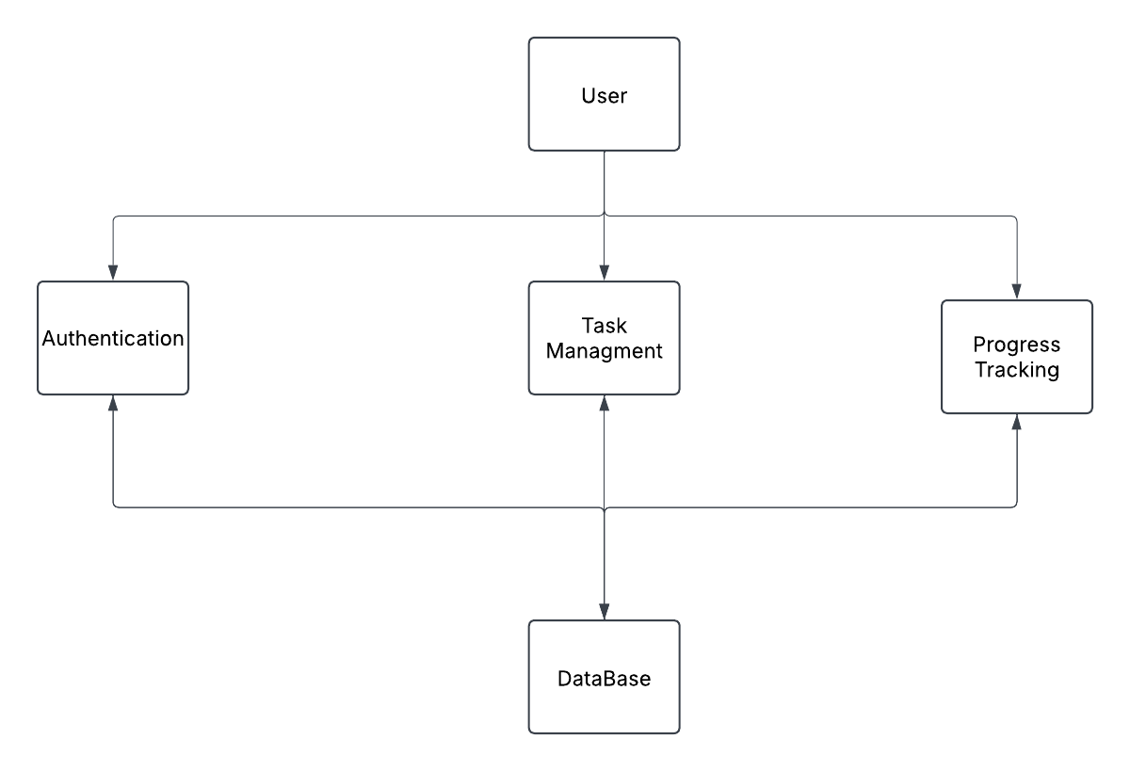

Flow:

1. Users log in → System verifies credentials with the database.
2. Users create/update tasks → System stores them in the database.
3. Users view project progress → System retrieves data and displays reports.

DFD LEVEL 2:

This level breaks down each process into more detailed steps.

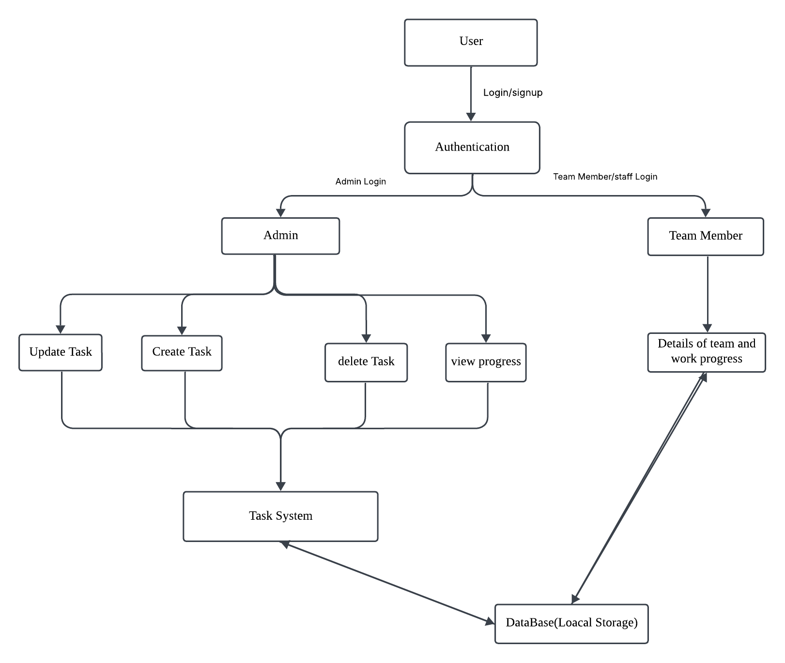

Flow :

**User** → Authentication

* Login/signup credentials verified
* Role-based access (Admin or Team Member)

**Admin** → Task Management System

* Creates new tasks
* Updates task details
* Deletes tasks
* Views task progress

**Team Member** → Task System

* Views assigned tasks
* Updates work progress
* Progress data is saved in Database (Local Storage)

**Database** (Local Storage) → Provides stored task data

* Stores tasks, user details, and progress reports
* Admin & Team Members fetch data from it