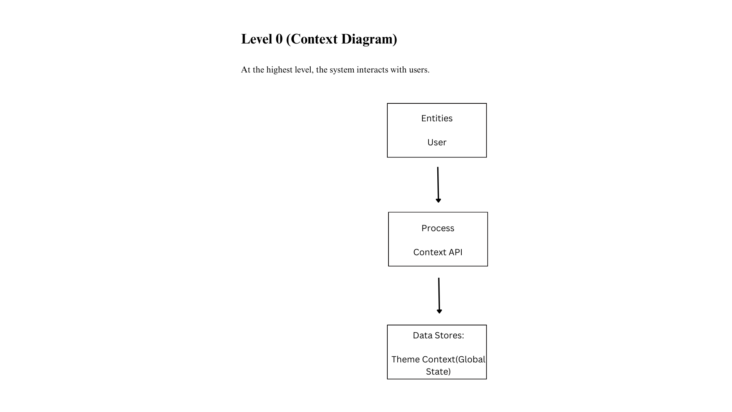

**Flow:**

1. User → Context management: Requests theme change.
2. Context Management → ThemeContext: Updates state.
3. ThemeContext → UI Components: Renders new theme.

**Level 1 DFD (Context API**)

reaking down the system into smaller processes

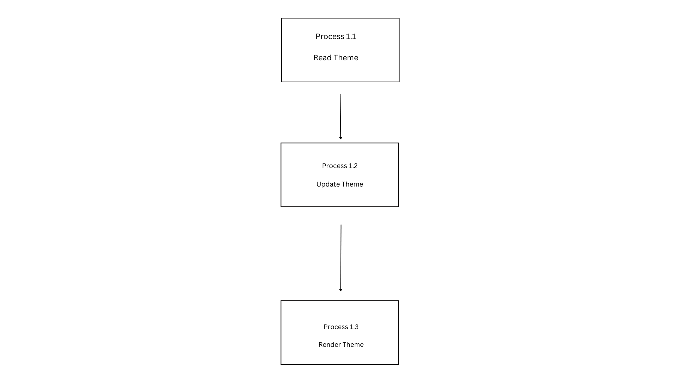

**Data Flow Details:**

* User → ThemeSwitcher: Clicks "Toggle Theme".
* ThemeSwitcher → ThemeContext: Calls setTheme().
* ThemeContext → UI: Re-renders components with the new theme.

