**Level 0 (Context Diagram)**

At the highest level, the system interacts with the user.

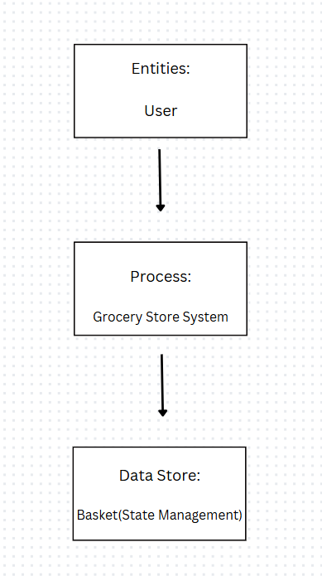

**Flow:**

1. User → Grocery Store System: Requests grocery list.
2. Grocery Store System → User: Displays available items.
3. User → Grocery Store System: Adds or removes items from the basket.
4. Grocery Store System → Basket: Updates the selected items.
5. Basket → Grocery Store System: Sends updated basket data.
6. Grocery Store System → User: Displays basket and total amount.

**Level 1 DFD (Decomposition of Grocery Store System):**

This breaks down the system into smaller processes.

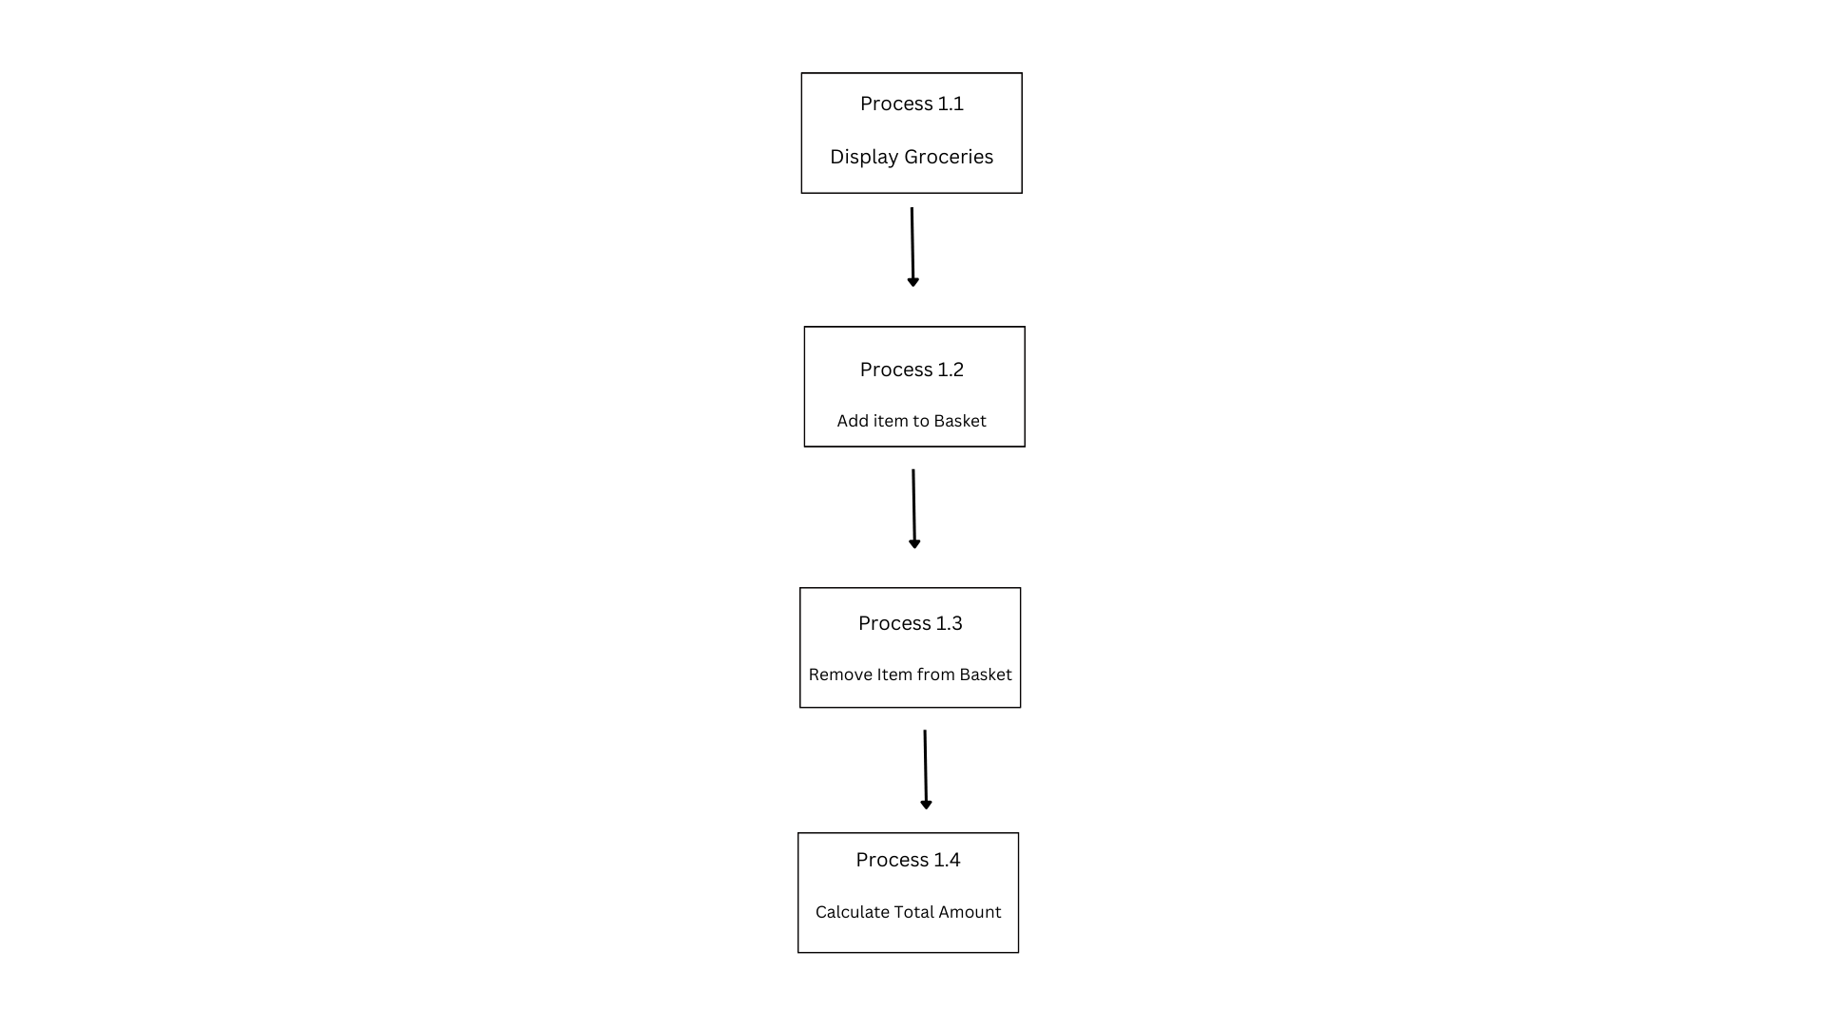

**Data Flow Details:**

* User → Process 1.2: Selects an item to add.
* Process 1.2 → Basket: Updates the basket state.
* User → Process 1.3: Clicks "Remove" to delete an item.
* Process 1.3 → Basket: Updates the basket state.
* Basket → Process 1.4: Sends items for total calculation.
* Process 1.4 → User: Displays the total amount.

