**0. Introduction.** **(1) 企业组织形式:** *Sole proprietorship 独资企业/个体户:* A business owned by a single person (No formal charter required, very few government regulations; Unlimited liability for business debt since no distinction between personal and business assets; Profit taxed as individual income (single taxation); Equity is limited to the proprietor’s personal wealth; Duration is limited to the life of the sole proprietor); *Partnership 普通/有限合伙人:* A business with two or more owners. (General partnership: All partners provide work and cash; All partners share the profit and losses; Each partner is liable for all the business debt. Limited partnership: At least one general partner, others are limited partners; Limited partners are liable for business debt up to the contributed equity; General partner(s) manage the business and have unlimited liabilities for business debt; Limited partners do not participate in daily management. Features: Partnerships are inexpensive to form, subject to very few regulations; General partners have unlimited liabilities for all debts; Limited partners enjoy limited liabilities; Difficulty in raising large amount of equity, limited to partners’ capacity and desire to contribute; Duration of business is limited to life of partners; Difficult to transfer ownership). *Corporation 公司:* A corporation is a distinct legal entity, separated from its owners; Ownership in a corporation is represented by shares of stock; Ownership is readily transferrable, no impact on existence of business; Unlimited life, not subject to owners’ life or exit/change; Limited liabilities: Owners are liable up to the equity contribution; Double taxation: corporate + individual income tax. **(2) 企业决策者:** *Shareholder => Board of directors(directors can be non-shareholders) => Management team.* (Board chair: voted by the directors; Inside directors, who work day-to-day at the company; CEO, CFO, manager, or any other person who works for the company daily). *Shareholder votes for.* (The makeup of the board of directors; Issuing new securities; Initiating corporate actions like mergers or acquisitions; Approving dividends; Substantial changes in the corporation's operations or policies). **(3) 企业目标:** *Maximize Shareholders’ Value*. (Why not market share, profit, growth, survival, risk management? “Value” encompasses all above; Why not creditors’, employees’, customers’, community’s?: Chief decision makers (executives) are hired by shareholders!) *True or False.* (The goal of financial management for a public firm is to maximize the current value per share of the existing stocks: True; The goal of financial management is to maximize the value of existing owners’ equity: True; We evaluate financial managers’ decisions on the basis of whether they add value to the business owners: True; Maximizing shareholders’ value is equivalent with maximizing firm value: False; Maximizing shareholders’ value is equivalent with maximizing the value of all the stakeholders: False). *ESG affect firm value.* (ESG affects long term cash flow: Government intervention and Emission allowances and carbon allowances auctions; Customer preferences; Brand value; Employee disruption of business (such as OpenAI’s mass exodus); ESG affects discount rate: Non-ESG imposes risk factors (climate change and resource scarcity); Investor preferences: green equity (firm based), green bond (project-based)); **(4) 决策内容:** *Capital Budgeting.* (What long-term investments and projects should be taken? M&A); *Capital Structure.* (How should we raise finance for our investments? Should we use debt or equity? What percent?) Working *Capital/Liquidity Management.* (How do we manage the day-to-day finances of the company?) *Related People.* (Corporate managers: Capital budgeting (long-term asset investment decisions); Financing decisions (debt vs. equity); Acquisition, Going Public, Going Private, etc. The basic rules of making good decisions. Investors/ fund managers/ investment bankers: Offer cash in exchange for future cash flows; As investor at buy side, how to judge a good deal; As underwriter at sell side, how to sell a deal.)

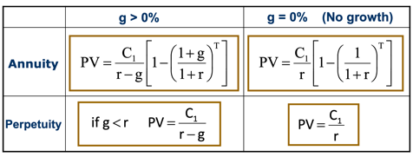**1. NPV and Basic Concepts of Corporate Finance.** **(1) The definition of value.** An asset creates value for its owner if it generates a positive value of cash flows. *Cash Flows:* Cash Flows occur in the future; Unless contractually fixed, cash flows need to be forecasted; For non-financial assets (e.g., cash flows from investment projects), cash flows can be conceptually challenging. *Value-related Decision:* Acquire an asset in exchange for future cash flows; Corporate Manager: Invest in real assets which generates future cash flows; Investors: Invest in financial assets which entitle the owner to future payments (Bond/Loan: Principal & Interest Stock: Dividend and Capital Gain); Value of a single unit of asset is its fair market price. *The value of Money:* Opportunity Cost: the forgone benefit that would have been derived from an option other than the one that was chosen. Annuity 定期年金: Cash flows are constant for T periods: C1=C2=…=CT (debt coupon payment); Perpetuity 永续年金: Infinite series of equal payments: C1=C2=..=CT=CT+1=.. (perpetuity debt 永续债, preferred stock 优先股); Growing Annuity 增长年金: Ct+1=(1+g)Ct, Cash flows that are growing at a constant rate (wage, bonds with “Step-Up” Coupon); Growing Perpetuity 永续增长年金: Infinite series of cash flows that are growing at a constant rate (firm valuation, government sustainability analysis). *Risky Cash Flow:* Investment A generates cash flow of $105 with certainty next year (Risk-free). Investment B’s cash flows are risky (50%=>110, 50%=100). How much are you willing to pay for Investment A? Suppose the risk-free rate is 10%, PVA =105/(1+10%)=95.45, the price will be $95.45. How much are you willing to pay for B? If you are risk averse, **it would be less**. If you are willing to pay $90, what is your discount rate? 𝑃𝑉 =90 =105/(1+ 𝑟 ), 𝑟 =16.67%. The risk-premium for Investment B is 16.67% -10% = 6.67%. Investors require a higher return for riskier financial assets. **(2) NPV.** Net present value: the present value of all future cash inflow & outflows, calculated at the appropriate risk adjusted discount rate. . NPV measures how much an investment adds value to the investors. The NPV rule is simple: *If an investment/project has positive NPV, then it should be accepted, otherwise not.* **(3) Value of a Firm.** PV of the cash flows the firms is expected to generate now and in the future. PV of firm’s cash flows = PV of cash flows to stockholders + PV of cash flows to debtholders. Value of a Firm (V) = Market Value of Equity (E) + Market Value of Debt (D) (E = # of shares * Price per share, D = # of bonds * Bond Price or market value of private debt) **(4) WACC.** Cost of capital of a company is the discount rate for cash flows of a company. One of the main ingredients of any valuation or capital budgeting exercise is to determine the appropriate cost of capital for the firm’s cash flows or that of its projects. For firms with both equity and debt, the cost of capital is the weighted average of *cost of debt* and *cost of equity*. This is called the weighted average cost of capital (WACC). If the company pays corporate tax at rate of 𝜏: . **(5) Example.** A company holds $80 cash today, and has access to one project that requires an initial investment of $80 tomorrow and yields either $100 or $110 with 50%-50% probability in one year. Another financial asset that pays either $100 or $110 with 50%-50% probability is traded in the market at $90. *Will the project be taken tomorrow?* Discount rate , NPV of project , YES! *What’s the expected value of the firm one year later?* $105. *What’s the value of the firm by the end of tomorrow?* . *What’s the value of the firm today?* (Assuming the market has known that the project will be taken tomorrow) $80+$10 = $90 (Firm value = Value of assets in place + NPV of future projects). *What if the market doesn’t know about the project today, and the manager announces it after it’s taken tomorrow?* The price today is $80. The price will jump up to $90 after tomorrow’s announcement. If you somehow knows about the project before other investors do, you will want to buy the stock today at $80 and sell it at $90 tomorrow. Of course, if your purchase order is big, the other investors may infer that some good news is on the way and charge you higher than $80. **(6) Summary.** An asset creates value for its owner (investors) if it generates a positive value of cash flows; NPV measures how much an investment adds value to the investors; For a risky cash flow, the discount rate is the expected return on a financial asset of comparable risk; In an efficient market, investing in financial assets earns zero NPV; The capital budgeting rule of corporate finance (for real assets) is to take positive NPV projects; Firm value incorporates the NPV of ongoing and potential projects; The cost of capital or discount rate for cash flows of a firm is the a weighted average of the cost of equity and debt.

**2. Capital Budgeting Method. (1) IRR.** IRR is that discount rate for which the NPV of the investment is exactly zero. *Basic:*In particular, **NPV(IRR) = -C0+PV(IRR) = 0**. The PV of the future Cash Flows from the investment, discounted at the IRR rate, exactly equal the initial investment. If the initial investment is invested at a rate equal to the IRR, then it can exactly replicate the future cash flows of that investment. *IRR Project Accept/Reject Rule:* **Accept if IRR > actual discount rate; Reject if IRR < actual discount rate**.*IRR&NPV:*If cash flows are conventional, (i.e. first negative and then always positive), the IRR criterion accepts a project if and only if its NPV is positive. Yet, in some situations, decision making within an organization may be easier if IRR rule is followed. *Why IRR?* Return-based evaluations are easier for investors (Example: evaluating the performances of wealth management assets); The same mindset might be used when negotiating deals, especially when the real discount rate is hard to estimate (Example: VC investments in startup companies). *Two major Drawback:* If cash flows are not conventional, there may be multiple IRRs. If projects are mutually exclusive, IRR may not be sufficiently informative. Suppose cash flows are -60, 155 and -100 (Example: a mining project: the last expense is the expenditure required to restore the terrain after the project is completed). The solution yields two positive values of IRR, corresponding to the two roots of the equation. In general, the number of positive IRRs is at most equal to the number of sign changes in the cash flows, but could be less. In cases such as these, the IRR rule may lead to negative NPV projects being chosen. Example (cash flows: -252, 1431, -3035, 2850, -1000), if our discount rate is 40%, this project is a negative NPV project. However, the project does have IRRs that are above 40%. The fact that the project has IRRs greater than the required rate of return does not mean that the project is profitable. In other words, the IRR criterion is not very helpful here! Mutually exclusive projects: The IRR is also in trouble when dealing with mutually exclusive projects. In choosing between two projects, should we choose the one with higher IRR? No! The answer depends on our discount rate. How to fix? Crossover rate. Crossover rate: The crossover rate is the one for which the projects have the same NPV. Imagine C is another project, and Cash flows from C = Cash Flow from A – Cash Flow from B. In the example in the graph, Cash Flows from C are: -100, -75, 0, 75, 150. Then the crossover rate between projects A and B is the IRR of project C. There can be multiple crossover rates. If the discount rate is above (below) the crossover rate, the project with higher (lower) IRR is preferred. How desirable is project A depends on your intertemporal elasticity of substitution or how much you value your consumption in the future as compared to your consumption today! **(2) Discount Rate.** A conversion between a cash flow in the future and a cash flow happens today; Determined by supply and demand in the market; Affected by the following factors: Time value of money (Intertemporal elasticity of substitution), Inflation, Level of risk * Price of risk;

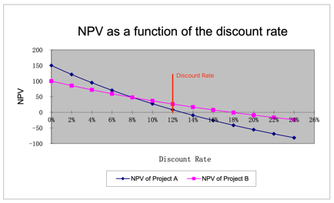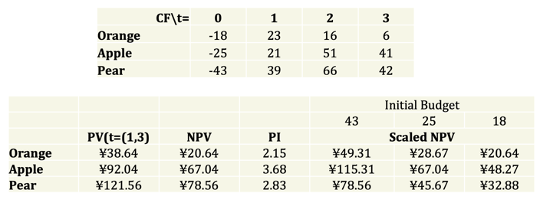

**(3) Profitability Index**. Profitability Index (PI) = PV/ I = (I+ NPV) / I (I denotes the initial investment; PV denotes the present value of cash flows that occur after the initial investment). Independent project: NPV>0, PI>1. Mutually exclusive projects: Do “higher NPV” and “higher PI” rules point to the same choice? **Not always**, PI ignores the size of investment; What if you have a tight budget and each project can be scaled up and down with constant PV per dollar? Then you should choose the project with the highest PI. **(4) Payback Period.** The amount of time required for an investment to generate cash flows to recover its initial cost. An investment is acceptable if its calculated payback period is less than some pre-specified number of years. *Disadvantages:* Ignores time value of money and risk differences; Requires an arbitrary cutoff point with no economic background; Ignores cash flow beyond cutoff date; Biased against long-term investment. *Advantages:* Easy to understand and simple to use; Adjusts for uncertainty of later cash flows by ignoring them; Biased toward liquidity (For firms relying on internal funds for new projects, emphasis on quick payback makes sense).

**3. Accounting Review. (1) Financial Accounting.** *Accrual 应计 accounting:* records revenue and expenses when transactions occur but before money is received or dispensed; *Cash flow calculation:* records revenue and expenses when cash related to those transactions is actually received or dispensed.  **(2) Balance Sheet.** *Features:* A snapshot of a firm’s financial position at one point in time; Assets are listed in order of decreasing liquidity (Ease of conversion to cash without significant loss of value); The balance sheet adheres to an equation that equates assets with the sum of liabilities and shareholder equity; Fundamental analysts use balance sheets to calculate financial ratios. *Assets for Non-Financial Firms:* Current Assets cash and other assets that are expected to be converted to cash within a year (Cash and Cash Equivalents; Accounts Receivable; Inventory); Non-Current Assets (Plant, Property, and Equipment (PP&E); Intangible Assets); Current Liabilities (Accounts Payable; Current Debt/Notes Payable; Current Portion of Long-Term Debt); Non-Current Liabilities (Bonds Payable; Long-Term Debt). Shareholders’ Equity (Share Capital; Retained Earnings). **(3) Net Working Capital.** = Current Assets – Current Liabilities. *Advantages:* An important component for calculating the company’s free cash flow. It measures a company’s liquidity and short-term financial health, indicating the ability to fund operations and respond to financial stress or opportunities. A consecutive of negative NWC is a implication for insolvency 破产. Often a key metrics in M&A 并购重组 deals. High working capital isn’t always a good thing. *Disadvantages:* It might indicate that the business has too much inventory, is not investing its excess cash, or is not taking advantage of low-cost debt opportunities. *NWC in M&A deals:* Why is NWC included in the purchase price? Working capital is necessary to maintain the ongoing operations of a business, so most sophisticated buyers include it in the purchase price when they submit an offer. This ensures they have enough working capital to operate the business post-closure and won’t need to inject extra money. NWC gives a buyer a clear idea of the level of capital required to keep the business running. Why a target? Working capital fluctuates for most businesses and is subject to manipulation. Agreeing on a target reduces friction between the parties by reducing the seller’s ability to manipulate it. The buyer and seller can agree on how much working capital to include in the purchase price without worrying about whether the actual amount will vary between signing the letter of intent (LOI) and closing. **(4) Market vs. Book Value.**

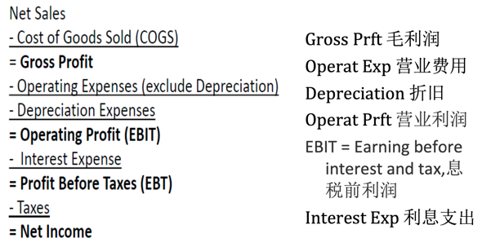 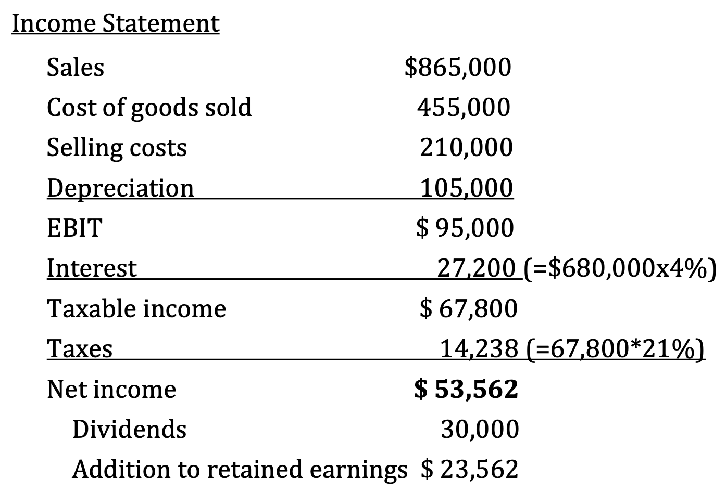 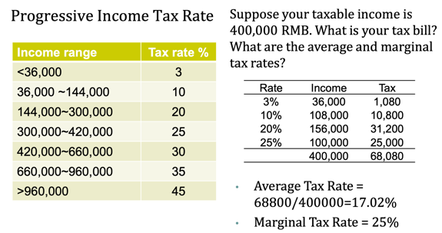

The balance sheet provides the book value of assets, liabilities, and equity. Market value is the price at which the assets, liabilities, or equity can actually be bought or sold. **(5) Income Statement.** A video of the firm’s operations for a specified period of time. Report revenues first, and then deduct any expenses for the period. During the year, the Senbet Discount Tire Company had gross sales of $865,000. The firm’s cost of goods sold and selling expenses were $455,000 and $210,000, respectively. The company also had notes payable of $680,000. These notes carried an interest rate of 4 percent. Depreciation was $105,000. The tax rate was 21 percent. Suppose the company paid out $30,000 in cash dividends. a) What was the company’s net income? b) What is the addition to retained earnings? **(6) Taxes.** Marginal rate: the percentage paid on the next dollar earned; Average rate: the tax bill/taxable income.

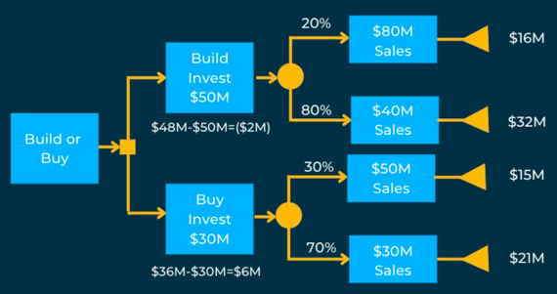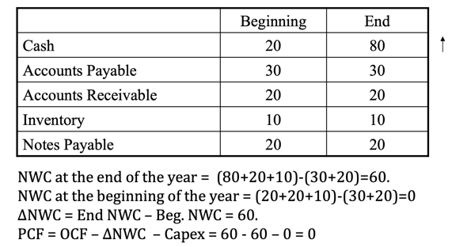**4.1 Project Cash Flow.** Identifying the right cash flows. **(1) Basic.** Think of project and company as separate entities, which were fully financed through equity. If in any year, project returned cash to company, then that is a cash ***inflow***. If in any year, project took away cash to company, then that is a cash ***outflow***. **PCF = OCF – Capex – ΔNWC** (OCF: Operating Cash Flow, Capex: Capital Expenditure, Δ NWC: Change in Net Working Capital (= cash + account receivable + inventory – account payable)) **(2) Three Ways to Compute OCF.** (S: sales, C: operating costs, D: depreciation, t: corporate tax rate). *The Top-Bottom Approach:* OCF = Sales - Costs - Taxes = (S - C) - (S - C - D) * t. *The Bottom-Top Approach:* OCF = Net Income + Depreciation = (S - C - D) * (1 - t) + D. *The Tax-Shield Approach:* OCF = (S - C - D) * (1 - t) + D = (S - C) * (1 - t) + (D * t) = (S - C) * (1 - t) + Depreciation Tax Shield. *Example:* What is OCF? Sales = $150, Cost of Goods Sold = $80, Depreciation = $30, Tax = 25%. The Top-Bottom Approach: OCF = Sales - Cost - Taxes = 150 - 80 - (150 - 80 - 30) * 25% = 60; The Bottom-Top Approach: OCF = Net Income + Depreciation = (150 - 80 - 30) * (1 - 25%) + 30 = 60; The Tax-Shield Approach: OCF = (150 - 80) * (1 - 25%) + 30 * 25% = 60. *Attention!* Depreciation is not a true cash flow. Interest is omitted due to separation of financing & investment considerations (has been in WACC. We do NOT subtract interest payment. Capital expenditures should exclude sunk costs that cannot be recovered). Taxes are calculated based on ACCOUNTING profit. **(3) Capex.** *Direct Method:* Amount spent on asset #1 + Amount spent on asset #2 + Amount spent on asset #3 - Value received for assets that were sold = Net Capex. (初期买为正，末期卖为负，卖的时候别忘了减税). *Indirect Method:* PP&E Balance in the current period - PP&E balance in the previous period + Depreciation in the current period = Net Capex. **(4) ΔNWC.** Changes in current assets and liabilities need to be considered to reflect true cash flow implications of sales or cost of production figures (Accrual Accounting: profits and expenses are recognized to match the business activity, instead of reflecting the cash flow.). ΔNWC = Current Assets - Current Liabilities, increase in NWC will lead to a drop in PCF to the firm. Cash is kept in the project as a buffer against unexpected expenditures. **(5) PCF to FCF.** The free cash flow has the same equation as PCF, only difference: ΔNWC does not consider **change in cash** as a part of ΔNWC. (PCF: cash is locked in the project, FCF: cash is part of the company’s valuation. The equity/debtholder could obtain this part of the value by selling their equity/debt). **(6) Key Issues of Capital Budgeting.** *Relevant cash flows* - the incremental cash flows associated with the decision to invest in a project. The incremental cash flows for project evaluation consist of any and all changes in the firm’s future cash flows that are a direct consequence of taking the project. Make the decision at the margin. *Decision tree analysis:* Nods (a decision/a probability event); Branches (different decisions (which decision you took)/different outcomes (what’s the probability of the event)); Solving the decision tree by backward induction (work from the end). **(7) Sunk Costs and Opportunity Costs.** *Sunk costs* are costs that have been incurred, and cannot be changed regardless of whether or not the project is undertaken; *Opportunity costs* are potential revenues that the firm missed out by taking the project (Assets in place to be used in the proposed project can be sold, leased, or used elsewhere). *Side Effects.* A project can have positive or negative side effects on other parts of the firm. (Negative) Erosion 腐蚀: A new product reduces the sales (cash flows) of the existing products. (Positive) Synergy 协同: A new project increases the sales (cash flows) of the existing products). *Treatment for different pitfalls.* Exclude: sunk costs (market studying cost); Include: opportunity costs of assets in place; Include: side effects (erosion, synergy, etc.); Include: investm ent in new net working capital; Exclude: financing items (WACC already). **(8) Example.** Suppose a project requires an investment of 1000, and will generate perpetual cash flow of 200. The discount rate appropriate for the cash flow is assumed to be 10%. The project is partially financed by perpetual debt. Risk-free rate is 5%. Debt raised is 200, and the interest rate is 5%. *Questions:* Should we deduct the interest payment of 10 to calculate the project cash flow? What is the NPV? *Answers:* An immediate problem of doing so is that the cash flow of 200 and the cash (out)flow of 10 do not have the same risk. The discount rate for the former is 10%, but that for the latter should be 5%. Thus, even if we subtract interest payment, it should be discounted at 5%. Thus, the NPV of the project is: NPV = (200/10%) - (10/5%) - (1000-200). This is the NPV calculated ignoring the financial items. NPV of financial transaction is zero in a frictionless world. This is the foundation of designing “project cash flow” as the



additional cash flow assuming the project was completely equity financed. **(9) Special Cases of Capital Budgeting.** Test Marketing; Termination Option; Externalities and Preemption; Equivalent Cash Flows; Equivalent Annual Cost (tax & depreciation). *Valuing projects with uncertainty (Real Option 实物期权).* When facing uncertainty, the flexibility to adjust investment decision when uncertainty is resolved is important. We need to value the flexibility inherent in a project. For example, option to expand — invest more in successful projects; option to abandon — cancel unsuccessful projects; timing options — when to invest in a particular project. When these options are valuable, a standard NPV analysis will **understate** the value of the firm, since it does not account for the options. Analyzing options: decision tree. Represent firm’s problem as a decision tree; Branches represent actions or outcomes; Nodes are points of time where either decisions are taken or different outcomes are possible; Solve the tree via backward induction: work back from the ends. Example. Suppose a company is considering a project whose cash flows could be either 100 with 50% chance, or 20 with 50% chance. The capital investment required is 50. If the company does the test marketing, it knows exactly what the cash flows will be. If it does not do the test marketing, it learns nothing new (that is, it does not revise the prior probabilities regarding cash flows). If test marketing costs $x, what is the highest possible value of x for which test marketing is worthwhile? Assume there is no discounting. Just like the decision tree, if the cost of test marketing is less than 15 (25 - 10), test marketing is a positive NPV project. Otherwise, it is a negative NPV project. *Termination Option.* A company is planning to introduce a new product in division A. The management thinks this is attractive because part of the machines of division B, which are idle, can be used. The current market price of equivalent machinery is 30 million. Other initial capital expenditure is 50 million. There are two scenarios possible. In the "good" scenario, which will occur with probability 0.5, the present value of remaining cash flows from this new project is 135 million. In the "bad" scenario, which will occur with probability 0.5, the present value of remaining cash flows is 20 million. *Which scenario prevails will be learnt shortly after the initial investment is made. The machines "on loan" from division B can be returned to division B at this time without any loss of their market value*. In the bad state, the project will be terminated, since the present value of the cash flows (20) is less than what the company would get by selling the machines from division B (30). Thus, the only "cost" to the company if the project is terminated is the 50m sunk investment. Therefore, NPV = 0.5 * (135 - 80) + 0.5 * (-50) = 2.5 > 0. **So the project should be taken!** *Externalities and Preemption.* A car manufacturer has determined that to prevent a competitor from introducing a new model that will lower its profits by $1000 per year for the next 10 years, it needs to introduce its own new model next year. This will require an investment today of $14,000, and the new model will generate sales of $3,000 per year for the next 10 years (and nothing thereafter). Cost of production will be $1000 per year. Of course, introducing its own new model will also lower the profits of its existing models. The company estimates that this reduction will be $500 per year for the next 10 years. Should the company introduce the new model if the discount rate is 10%? (Ignore depreciation, taxes, and working capital). Annual OCF for yrs. 1 to 10: = Sales - COGS - **Erosion + Profits Saved** =3,000 - 1,000 - 500 + 1,000 = 2,500. NPV = 2500(1-1/(1.1)10)/(0.1) - 14,000 = 15,361-14,000 = 1,361 > 0. Thus, the company should make the investment. *Equivalent Cash Flows.* Your company has to choose between two components 组件, A and B, which will reduce the operating costs. Component A costs $6m, lasts 5 years, and reduces operating costs by $1.5m per year. Component B costs $11m, lasts 7 years, and reduces operating costs by $2m per year. If a component wears out, you can replace it with a new one, with the same impact on cash flows. Which one will you 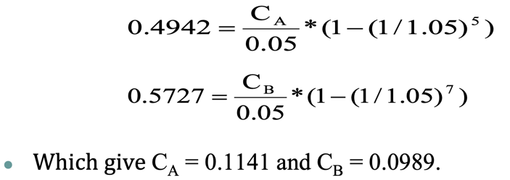choose, if the cost reductions are assumed "not risky" and the return on 5-year government bonds is 5%? Ignore depreciation and taxes. First, we find the NPV of each investment: NPVA = 0.49, NPVB = 0.57. **Should we choose B? NO!** Because the components have different lifetimes and can be replaced by the same model, we should compute the cash flow gain per year.This is the concept of ***equivalent annual cash flow***. We ask the question: for each component, ***how much annual cash flow per year does it add***? This annual cash flow is such that its present value over the life of the component is the same as the NPV of the component. Let CA denote this annual additional cash flow attributable to component A, and CB denote the corresponding number for component B, 这个地方就是将Cash Flow平分到各年份中, 做了一步反向计算. Based on the equation, we can get CA = 0.1141 and CB = 0.0989. Thus, component A gives the higher additional cash flow on a per-year basis, and should be chosen.

**4.2 Free Cash Flow.** **(1) Value a Firm.** The holders of the company’s stock and debt will get the cash flow of firm. *Way 1.* Value of a Firm (V) = Market Value of Equity (E) + Market Value of Debt (D). (E = NPV (cash flow to shareholders, cost of equity), D = NPV (cash flow to debtholders, cost of debt)), Issue: hard to separate the cash flows to equity and debt holder. *Way 2.* Consider the company as a whole. Value of a Firm = PV of the cash flows the firms is expected to generate now and in the future. Value of a company = NPV(CF, WACC). *Details.* Regarding the Company as a Project, free cash flow is the relevant cash flow. Free cash flow is generated from the firm’s continuing operations and is available for distribution (i.e., “free”) to the suppliers of capital (i.e., creditors, shareholders, etc.). Free cash flow is related to the firm’s business activities. It is unrelated to how the firm finances its operations. Free cash flow is the incremental *after-tax cash flows* the firm would generate *if it had no debt*. Source: financial statements. Complication: NI has deducted interest expense payment. **(2) Calculation of FCF.** *Direct method:* Starts with Cash Sales and restates the Income Statement to include only cash charges and operating cash flows. *Indirect method:* Starts with Net Income and adjusts for non-cash charges and non-operating cash flows included in Net Income; Same logic as the Bottom-Top Approach for OCF. We focus on the indirect method. **(3) NI to FCF.** Sales include: Sales on credit (account receivable), revenue earned but no cash received; Cost of goods sold: Include trade credit (account payable): expenses owed but no cash paid; Interest expense: A financing term, not an operating term; Taxes: Affected by tax deduction of financing term (e.g., interest) and non-cash terms (e.g., depreciation); *Questions.* Why are depreciation and interest treated differently? In a equity-funded company, depreciation has two effects on cash flow: Tax shield & Non-cash adjustment. Interest payment has only one: Non-cash adjustment. Why non-cash change in NWC? PCF: cash is locked in the project FCF: cash is part of the company’s valuation. The equity/debtholder could obtain this part of

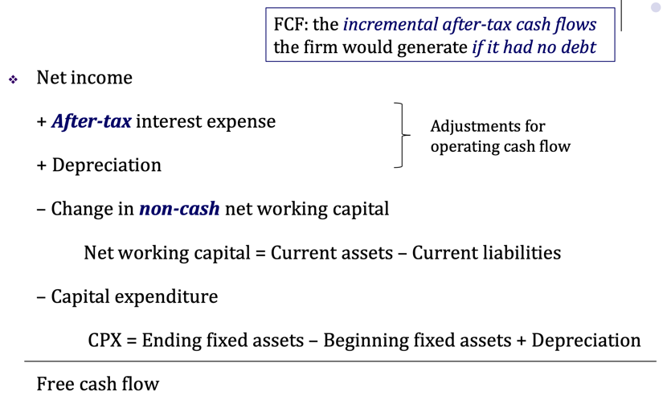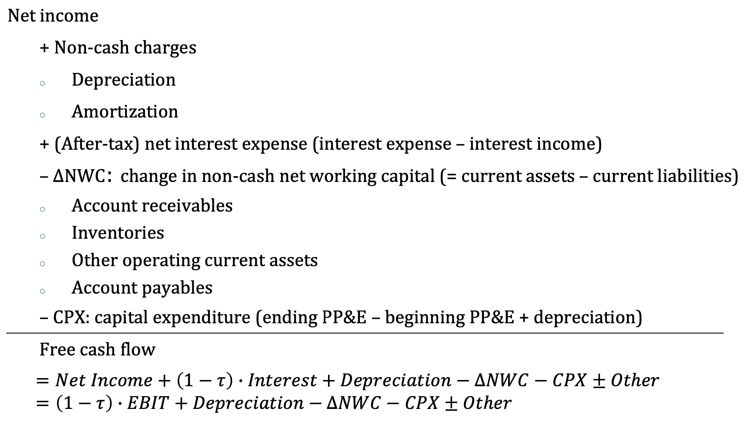

the value by selling their equity/debt. (**4) Example: NI to FCF.** The financial statements of a firm at the end of 2017 are given in the table on the next page. The effective tax rate of this firm is 40%. Compute *Net Income and Free Cash Flow* of this firm for 2017.

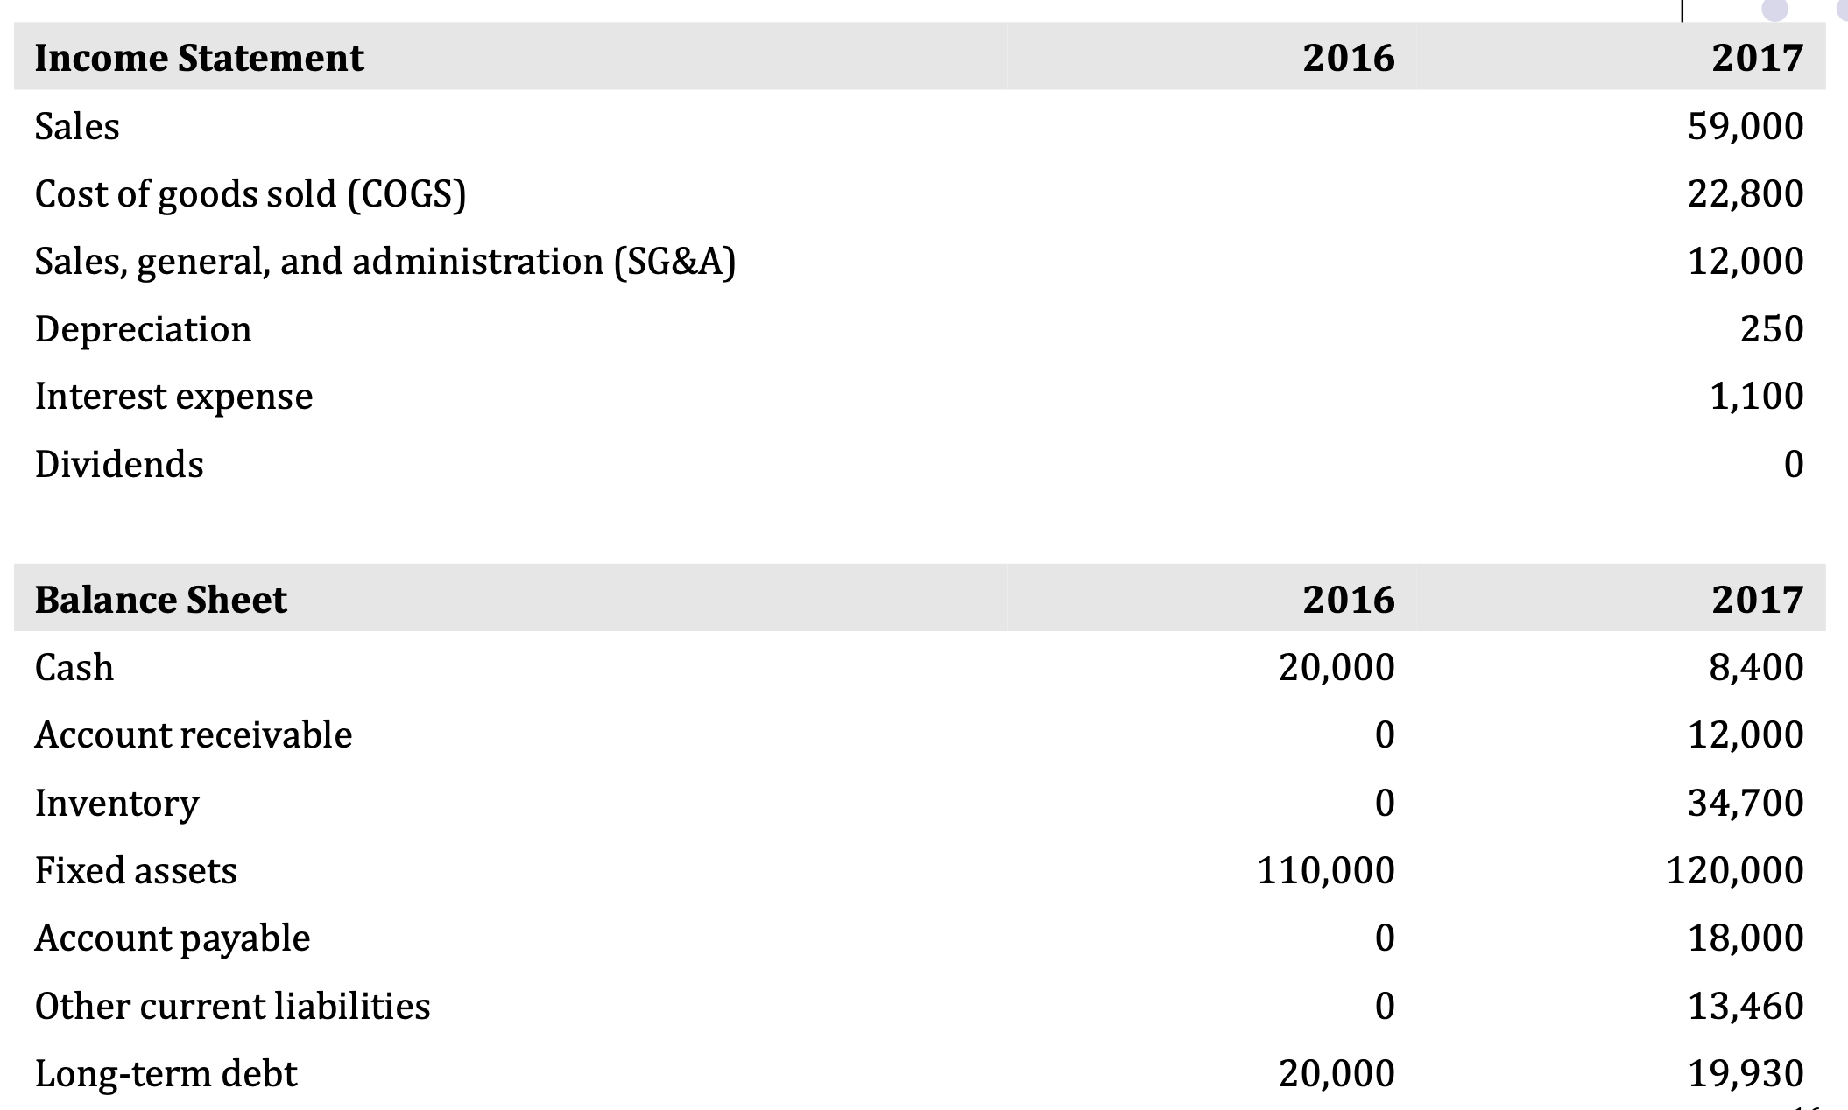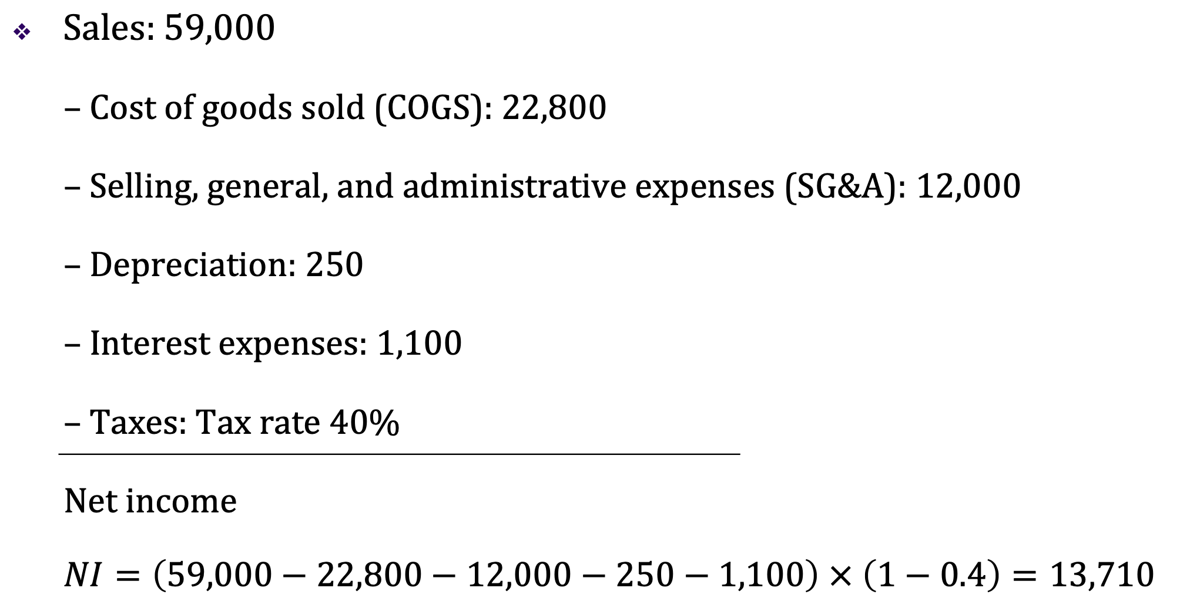

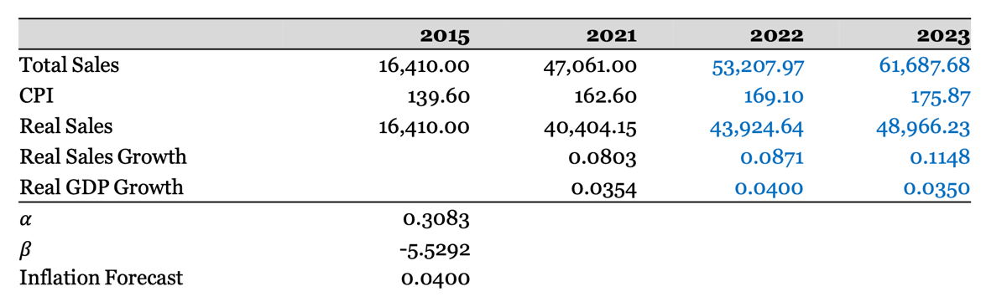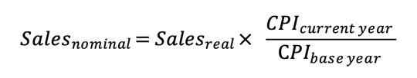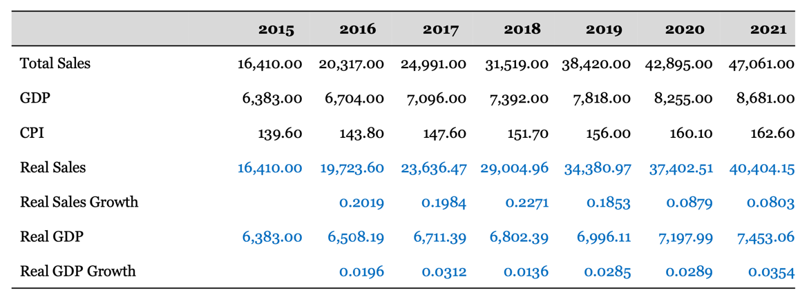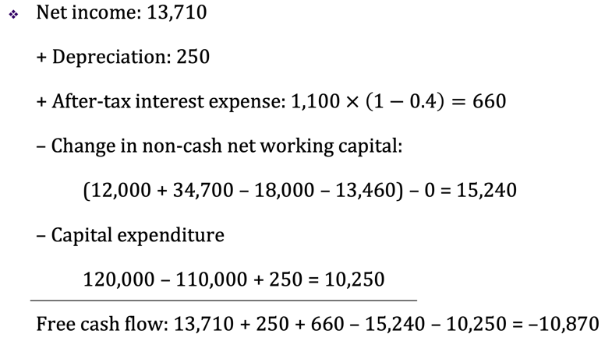**(5) Note: Statement of Cash Flows**. Companies report the accounting statement of cash flow. It records the sources and uses of funds, and reconciles cash balances. One item in the statement is called “Cash flow from operating activities”: It is NOT the same as FCF; It omits cash flows related to investment (Capex); It includes non-operating expenses and income (e.g., interest). **(6) The connections.** Free cash flows are the funds generated by the firm’s business (assets) and *are available* to pay the capital providers. Financial cash (out)flows are the funds *distributed* to the security holders of the firm. The difference between the two funds is the change in cash holdings over the period: Free cash flows = Financial cash (out)flows + ΔCash. *FCF<0:* Cash generated by operation is not enough to fund the new investment=>Financial CF<0 (raise new funds); Financial CF=0 (no external financing), ΔCash<0 (use up the existing cash holdings). *FCF>0:* Firm’s operation generates more cash than the required amount for investment=>Financial CF=0 & ΔCash>0 (retains more cash); Financial CF>0 (distribute to security holders). **(7) Conclusion of FCF.** We’re separating the investing and financing decisions and value the project/company as if fully equity financed => Simplicity, if not, multiple discount rates might be involved. Separation of the financing decision and the investment decision. **(8) Forecasting PCF.** *Pro forma (形式上的) financial statements.* Normally, we cannot directly forecast a project’s future cash flows, a common practice is to forecast the project’s pro forma financial statements. Pro forma financial statements are the project’s Balance sheet, Income statement, Statement of cash flow based on the forecast of the project’s future cash flows. *Sales forecast.* Many items in the pro-forma statements are closely related to sales. Sales forecast is the first step in the discounted cash flow (DCF) valuation and capital budgeting. Inflation adjustment. It is important to distinguish between nominal sales growth and real sales growth. Method 1: Regression forecasting. **Sale Growtht = 𝛼 + 𝛽 * GDP Growtht + 𝜀t**. Run a regression of real sales growth on real GDP growth. Eliminates the effect of inflation + Improves comparability across time + Better economic interpretation + Prices are not controlled by the managers. Method 2: Time series analysis. Sometimes, we examine past sales to identify trends that we expect to continue in the future. Linear growth cycle: **Real Salest = 𝛼 + 𝛽 * t + 𝜀t**. Exponential growth cycle: **Real Salest = e𝛼 + 𝛽 * t + 𝜀**.Method 3: Theoretical analysis. A firm’s **growth rate g** depends on: the percentage of reinvested earnings; the return earned on the firm’s reinvestments, e.g., return on assets (ROA). High growth firms typically have low payout ratio (high investment ratios) (Payout ratio, b = Dividends/Net Income; Reinvestment (retention) ratio = 1 - payout ratio = 1 - b). Low payout ratio allows these firms to reinvest in new projects, and grow faster. Example: In year 2017, a company has ROE of 9.76% and ROA of 4.18%. It paid out 46.38% of its earnings as a dividend. Suppose that ROA, ROE, and payout ratio stay constant: What is the growth rate that this company can achieve without issuing equity, but maintaining its current debt to equity ratio? g=ROE(1-b). What is the growth rate that this company can achieve without additional external financing? g=ROA(1-b). Forecast the firm’s sales by multiplying industry sales forecast to the projected market share. *Projecting operating costs.* We focus on cost of goods sold (COGS) and selling, general, and administrative expenses (SG&A). We can combine them in the forecast. If the company report depreciation as a component of these costs, we need to remove depreciation first from them. Different costs. It is important to distinguish between fixed and variable operating costs: variable costs (VC) are proportional to level of sales, fixed costs (FC) do not change with sales. It is not advisable to project operating costs (OC) as a fixed percentage of sales. Instead, OC = FC + (%VC) × Sales (%VC is the percentage of VC to Sales). Regression way. Consider a regression method: OC = FC + (%VC) × Sales. Set up the analog regression: **OCt = 𝛼 + 𝛽 × Salest + 𝜀**. Use past data to estimate coefficients 𝛼 and 𝛽: They will be the estimates of FC (𝛼) and %VC (𝛽), respectively. Attention. Using the regression analysis to project costs, we assume that firm’s cost structure will remain the same. What if firm was operating inefficiently in the past, but is planning improvements? One alternative is to use industry average estimates (analyze competitors). *Percentage of sales approach.* Many items in the income statement and balance sheet often vary depending on a firm’s (project’s) sales. If the ratios of these items to sales remain stable over time, then we can predict them once sales forecast is available. Use the past ratios to project future ratios and NWC items. We need to assume that these ratios are stationary over time. Projecting fixed assets. Fixed assets are difficult to project because although they depend on sales, the relation is not always linear. 1) Suppose the firm is currently operating its plant and machinery at 70% capacity, it can increase production and sales without adding fixed assets; 2) On the other hand, if it is operating at (close to) 100% capacity, it will need to buy fixed assets. Unfortunately, we do not observe utilization rates. ***Two types of capital expenditures***. Expansion of productivity capacity is undertaken when: Current capacity utilization is close to 100%, and/or Management is buying PP&E in anticipation of future sales growth. Maintenance of current productive capacity (replacement needs), it is not equal to depreciation, which is an accounting concept. Projecting expansion of capacity. 1) GFA turnover = Sales/Gross fixed assets. (examine how this ratio varies over time, compare firm’s GFA turnover with that of its competitors); 2) Useful clues on firm’s capacity utilization. 3) Suppose capacity utilization is almost 100%. (firm needs new assets to generate new sales, projected GFA = Projected Sales/GFA Turnover). 4) Note: A firm can add new capacity even when it is operating less than 100% capacity. Why? In anticipation of future growth. Therefore, always read firm’s “Annual Report” to find out the firm’s capital expenditure plans. 5) Example. A firm had sales of $1 million. The GFA turnover for the firm is 1.35, while comparable firms in the industry have a GFA-turnover of 1.70. Compute the maximum sales the firm can achieve without expanding capacity? Assume that comparable firms are operating at 100% capacity utilization. **$1 million/1.35*1.7**. Projecting replacement of capacity. This information may be found from the “Notes to Financial Statements”. Simple (crude) method: 1) For all past years, find out how much CPX was for replacement of productive capacity; 2) Compute past growth rate of the replacement CPX; then its average. 3) Assume that, in the future, CPX needed for replacement will grow at this average growth rate. *Other aspects of forecasting.* To be able to make accurate forecasts, we must understand the operating and financial characteristics of the firm. Ratio analysis helps understand these characteristics (Liquidity, Leverage, Asset use or efficiency, Profitability).