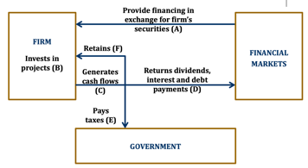 **0. Introduction.** **(1) 企业组织形式:** *Sole proprietorship 独资企业/个体户:* A business owned by a single person (No formal charter required, very few government regulations; Unlimited liability for business debt since no distinction between personal and business assets; Profit taxed as individual income (single taxation); Equity is limited to the proprietor’s personal wealth; Duration is limited to the life of the sole proprietor); *Partnership 普通/有限合伙人:* A business with two or more owners. (General partnership: All partners provide work and cash; All partners share the profit and losses; Each partner is liable for all the business debt. Limited partnership: At least one general partner, others are limited partners; Limited partners are liable for business debt up to the contributed equity; General partner(s) manage the business and have unlimited liabilities for business debt; Limited partners do not participate in daily management. Features: Partnerships are inexpensive to form, subject to very few regulations; General partners have unlimited liabilities for all debts; Limited partners enjoy limited liabilities; Difficulty in raising large amount of equity, limited to partners’ capacity and desire to contribute; Duration of business is limited to life of partners; Difficult to transfer ownership). *Corporation 公司:* A corporation is a distinct legal entity, separated from its owners; Ownership in a corporation is represented by shares of stock; Ownership is readily transferrable, no impact on existence of business; Unlimited life, not subject to owners’ life or exit/change; Limited liabilities: Owners are liable up to the equity contribution; Double taxation: Corporate + individual income tax. **(2) 企业决策者:** *Shareholder => Board of directors(directors can be non-shareholders) => Management team.* (Board chair: voted by the directors; Inside directors, who work day-to-day at the company; CEO, CFO, manager, or any other person who works for the company daily). *Shareholder votes for.* (The makeup of the board of directors; Issuing new securities; Initiating corporate actions like mergers or acquisitions; Approving dividends; Substantial changes in the corporation's operations or policies). **(3) 企业目标:** *Maximize Shareholders’ Value*. (Why not market share, profit, growth, survival, risk management?: “Value” encompasses all above; Why not creditors’, employees’, customers’, community’s?: Chief decision makers (executives) are hired by shareholders!) *True or False.* (The goal of financial management for a public firm is to maximize the current value per share of the existing stocks: True; The goal of financial management is to maximize the value of existing owners’ equity: True; We evaluate financial managers’ decisions on the basis of whether they add value to the business owners: True; Maximizing shareholders’ value is equivalent with maximizing firm value: False; Maximizing shareholders’ value is equivalent with maximizing the value of all the stakeholders: False). *ESG affect firm value.* (ESG affects long term cash flow: Government intervention and Emission allowances and carbon allowances auctions; Customer preferences; Brand value; Employee disruption of business (such as OpenAI’s mass exodus); ESG affects discount rate: Non-ESG imposes risk factors (climate change and resource scarcity); Investor preferences: green equity (firm based), green bond (project-based)); **(4) 决策内容:** *Capital Budgeting.* (What long-term investments and projects should be taken? M&A); *Capital Structure.* (How should we raise finance for our investments? Should we use debt or equity? What percent?) Working *Capital/Liquidity Management.* (How do we manage the day-to-day finances of the company?) *Related People.* (Corporate managers: Capital budgeting (long-term asset investment decisions); Financing decisions (debt vs. equity); Acquisition, Going Public, Going Private, etc. The basic rules of making good decisions. Investors/ fund managers/ investment bankers: Offer cash in exchange for future cash flows; As investor at buy side, how to judge a good deal; As underwriter at sell side, how to sell a deal.)

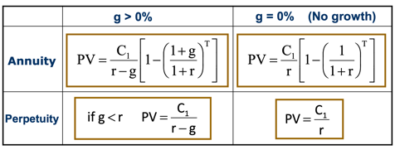**1. NPV and Basic Concepts of Corporate Finance.** **(1) The definition of value.** An asset creates value for its owner if it generates a positive value of cash flows. *Cash Flows:* Cash Flows occur in the future; Unless contractually fixed, cash flows need to be forecasted; For non-financial assets (e.g., cash flows from investment projects), cash flows can be conceptually challenging. *Value-related Decision:* Acquire an asset in exchange for future cash flows; Corporate Manager: Invest in real assets which generates future cash flows; Investors: Invest in financial assets which entitle the owner to future payments (Bond/Loan: Principal & Interest Stock: Dividend and Capital Gain); Value of a single unit of asset is its fair market price. *The value of Money:* Opportunity Cost: the forgone benefit that would have been derived from an option other than the one that was chosen. Annuity 定期年金: Cash flows are constant for T periods: C1=C2=…=CT (debt coupon payment); Perpetuity 永续年金: Infinite series of equal payments: C1=C2=..=CT=CT+1=.. (perpetuity debt 永续债, preferred stock 优先股); Growing Annuity 增长年金: Ct+1=(1+g)Ct, Cash flows that are growing at a constant rate (wage, bonds with “Step-Up” Coupon); Growing Perpetuity 永续增长年金: Infinite series of cash flows that are growing at a constant rate (firm valuation, government sustainability analysis). *Risky Cash Flow:* Investment A generates cash flow of $105 with certainty next year (Risk-free). Investment B’s cash flows are risky (50%=>110, 50%=100). How much are you willing to pay for Investment A? Suppose the risk-free rate is 10%, PVA =105/(1+10%)=95.45, the price will be $95.45. How much are you willing to pay for B? If you are risk averse, **it would be less**. If you are willing to pay $90, what is your discount rate? 𝑃𝑉 =90 =105/(1+ 𝑟 ), 𝑟 =16.67%. The risk-premium for Investment B is 16.67%-10% = 6.67%. Investors require a higher return for riskier financial assets. **(2) NPV.** Net present value: the present value of all future cash inflow & outflows, calculated at the appropriate risk adjusted discount rate. $NPV=-C_{0}+\sum_{t=1}^{T}{\frac{C_{t}}{{\left(1+r\right)}^{t}}}$. NPV measures how much an investment adds value to the investors. The NPV rule is simple: If an investment/project has positive NPV, then it should be accepted, otherwise not. **(3) Value of a Firm.** PV of the cash flows the firms is expected to generate now and in the future. PV of firm’s cash flows = PV of cash flows to stockholders + PV of cash flows to debtholders. Value of a Firm (V) = Market Value of Equity (E) + Market Value of Debt (D) (E = # of shares x Price per share, D = # of bonds x Bond Price or market value of private debt) **(4) WACC.** Cost of capital of a company is the discount rate for cash flows of a company. One of the main ingredients of any valuation or capital budgeting exercise is to determine the appropriate cost of capital for the firm’s cash flows or that of its projects. For firms with both equity and debt, the cost of capital is the weighted average of *cost of debt* and *cost of equity*. This is called the weighted average cost of capital (WACC). If the company pays corporate tax at rate of 𝜏: $WACC=\frac{E}{V}E\left(R_{E}\right)+\frac{D}{V}E\left(R_{D}\right)\left(1-τ\right)$. **(5) Example.** A company holds $80 cash today, and has access to one project that requires an initial investment of $80 tomorrow and yields either $100 or $110 with 50%-50% probability in one year. Another financial asset that pays either $100 or $110 with 50%-50% probability is traded in the market at $90. *Will the project be taken tomorrow?* Discount rate $r=E\left(R_{Fin}\right)=\frac{105-90}{90}=16.67\%$, NPV of project $=\frac{105}{16.67\%}-80=10>0$, YES! *What’s the expected value of the firm one year later?* $105. *What’s the value of the firm by the end of tomorrow? $\frac{105}{16.67\%}=90$* . *What’s the value of the firm today?* (Assuming the market has known that the project will be taken tomorrow) $80+$10 = $90 (Firm value = Value of assets in place + NPV of future projects). *What if the market doesn’t know about the project today, and the manager announces it after it’s taken tomorrow?* The price today is $80. The price will jump up to $90 after tomorrow’s announcement. If you somehow knows about the project before other investors do, you will want to buy the stock today at $80 and sell it at $90 tomorrow. Of course, if your purchase order is big, the other investors may infer that some good news is on the way and charge you higher than $80. **(6) Summary.** An asset creates value for its owner (investors) if it generates a positive value of cash flows; NPV measures how much an investment adds value to the investors; For a risky cash flow, the discount rate is the expected return on a financial asset of comparable risk; In an efficient market, investing in financial assets earns zero NPV; The capital budgeting rule of corporate finance (for real assets) is to take positive NPV projects; Firm value incorporates the NPV of ongoing and potential projects; The cost of capital or discount rate for cash flows of a firm is the a weighted average of the cost of equity and debt.

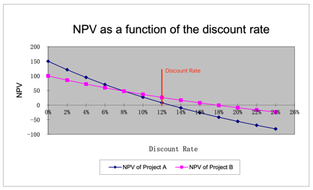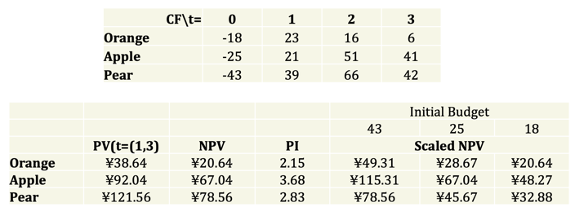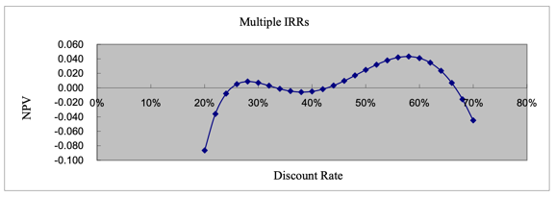**2. Capital Budgeting Method. (1) IRR.** IRR is that discount rate for which the NPV of the investment is exactly zero. *Basic:*In particular, **NPV(IRR) = -C0+PV(IRR) = 0**. The PV of the future Cash Flows from the investment, discounted at the IRR rate, exactly equal the initial investment. If the initial investment is invested at a rate equal to the IRR, then it can exactly replicate the future cash flows of that investment. *IRR Project Accept/Reject Rule:* **Accept if IRR > actual discount rate; Reject if IRR < actual discount rate**.*IRR&NPV:*If cash flows are conventional, (i.e. first negative and then always positive), the IRR criterion accepts a project if and only if its NPV is positive. Yet, in some situations, decision making within an organization may be easier if IRR rule is followed. *Why IRR?* Return-based evaluations are easier for investors (Example: evaluating the performances of wealth management assets); The same mindset might be used when negotiating deals, especially when the real discount rate is hard to estimate (Example: VC investments in startup companies). *Two major Drawback:* If cash flows are not conventional, there may be multiple IRRs. If projects are mutually exclusive, IRR may not be sufficiently informative. Suppose cash flows are -60, 155 and -100 (Example: a mining project: the last expense is the expenditure required to restore the terrain after the project is completed). The solution yields two positive values of IRR, corresponding to the two roots of the equation. In general, the number of positive IRRs is at most equal to the number of sign changes in the cash flows, but could be less. In cases such as these, the IRR rule may lead to negative NPV projects being chosen. As the right figure (cash flows: -252, 1431, -3035, 2850, -1000), if our discount rate is 40%, this project is a negative NPV project. However, the project does have IRRs that are above 40%. The fact that the project has IRRs greater than the required rate of return does not mean that the project is profitable. In other words, the IRR criterion is not very helpful here! Mutually exclusive projects: The IRR is also in trouble when dealing with mutually exclusive projects. In choosing between two projects, should we choose the one with higher IRR? No! The answer depends on our discount rate. How to fix? Crossover rate. Crossover rate: The crossover rate is the one for which the projects have the same NPV. Imagine C is another project, and Cash flows from C = Cash Flow from A – Cash Flow from B. In the example in the graph, Cash Flows from C are: -100, -75, 0, 75, 150. Then the crossover rate between projects A and B is the IRR of project C. There can be multiple crossover rates. If the discount rate is above (below) the crossover rate, the project with higher (lower) IRR is preferred. How desirable is project A depends on your intertemporal elasticity of substitution or how much you value your consumption in the future as compared to your consumption today! **(2) Discount Rate.** A conversion between a cash flow in the future and a cash flow happens today; Determined by supply and demand in the market; Affected by the following factors: Time value of money (Intertemporal elasticity of substitution), Inflation, Level of risk * Price of risk; **(3) Profitability Index**. Profitability Index (PI) = PV/ I = (I+ NPV) / I (I denotes the initial investment; PV denotes the present value of cash flows that occur after the initial investment). Independent project: NPV>0, PI >1. Mutually exclusive projects: Do “higher NPV” and “higher PI” rules point to the same choice? Not always, PI ignores the size of investment; What if you have a tight budget and each project can be scaled up and down with constant PV per dollar? Then you should choose the project with the highest PI. **(4) Payback Period.** The amount of time required for an investment to generate cash flows to recover its initial cost. An investment is acceptable if its calculated payback period is less than some pre-specified number of years. *Disadvantages:* Ignores time value of money and risk differences; Requires an arbitrary cutoff point with no economic background; Ignores cash flow beyond cutoff date; Biased against long-term investment. *Advantages:* Easy to understand and simple to use; Adjusts for uncertainty of later cash flows by ignoring them; Biased toward liquidity (For firms relying on internal funds for new projects, emphasis on quick payback makes sense).

**3. Accounting Review. (1) Financial Accounting.** *Accrual 应计 accounting:* records revenue and expenses when transactions occur but before money is received or dispensed; *Cash flow calculation:* records revenue and expenses when cash related to those transactions is actually received or dispensed.  **(2) Balance Sheet.** *Features:* A snapshot of a firm’s financial position at one point in time; Assets are listed in order of decreasing liquidity (Ease of conversion to cash without significant loss of value); The balance sheet adheres to an equation that equates assets with the sum of liabilities and shareholder equity; Fundamental analysts use balance sheets to calculate financial ratios. *Assets for Non-Financial Firms:* Current Assets cash and other assets that are expected to be converted to cash within a year (Cash and Cash Equivalents; Accounts Receivable; Inventory); Non-Current Assets (Plant, Property, and Equipment (PP&E); Intangible Assets); Current Liabilities (Accounts Payable; Current Debt/Notes Payable; Current Portion of Long-Term Debt); Non-Current Liabilities (Bonds Payable; Long-Term Debt). Shareholders’ Equity (Share Capital; Retained Earnings). **(3) Net Working Capital.** = Current Assets – Current Liabilities. *Advantages:* An important component for calculating the company’s free cash flow. It measures a company’s liquidity and short-term financial health, indicating the ability to fund operations and respond to financial stress or opportunities. A consecutive of negative NWC is a implication for insolvency 破产. Often a key metrics in M&A 并购重组 deals. High working capital isn’t always a good thing. *Disadvantages:* It might indicate that the business has too much inventory, is not investing its excess cash, or is not taking advantage of low-cost debt opportunities. *NWC in M&A deals:* Why is NWC included in the purchase price? Working capital is necessary to maintain the ongoing operations of a business, so most sophisticated buyers include it in the purchase price when they submit an offer. This ensures they have enough working capital to operate the business post-closure and won’t need to inject extra money. NWC gives a buyer a clear idea of the level of capital required to keep the business running. Why a target? Working capital fluctuates for most businesses and is subject to manipulation. Agreeing on a target reduces friction between the parties by reducing the seller’s ability to manipulate it. The buyer and seller can agree on how much working capital to include in the purchase price without worrying about whether the actual amount will vary between signing the letter of intent (LOI) and closing. **(4) Market vs. Book Value.** The balance sheet provides the book value of assets, liabilities, and equity. Market value is the price at which the assets, liabilities, or equity can actually be bought or sold. **(5) Income Statement.** A video of the firm’s operations for a specified period of time. Report revenues first, and then deduct any expenses for the period. During the year, the Senbet Discount Tire Company had gross sales of $865,000. The firm’s cost of goods sold and selling expenses were $455,000 and $210,000, respectively. The company also had notes payable of $680,000. These notes carried an interest rate of 4 percent. Depreciation was $105,000. The tax rate was 21 percent. Suppose the company paid out $30,000 in cash dividends. a) What was the company’s net income? b) What is the addition to retained earnings? **(6) Taxes.** Marginal rate: the percentage paid on the next dollar earned; Average rate: the tax bill/taxable income.

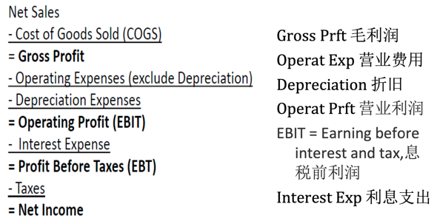 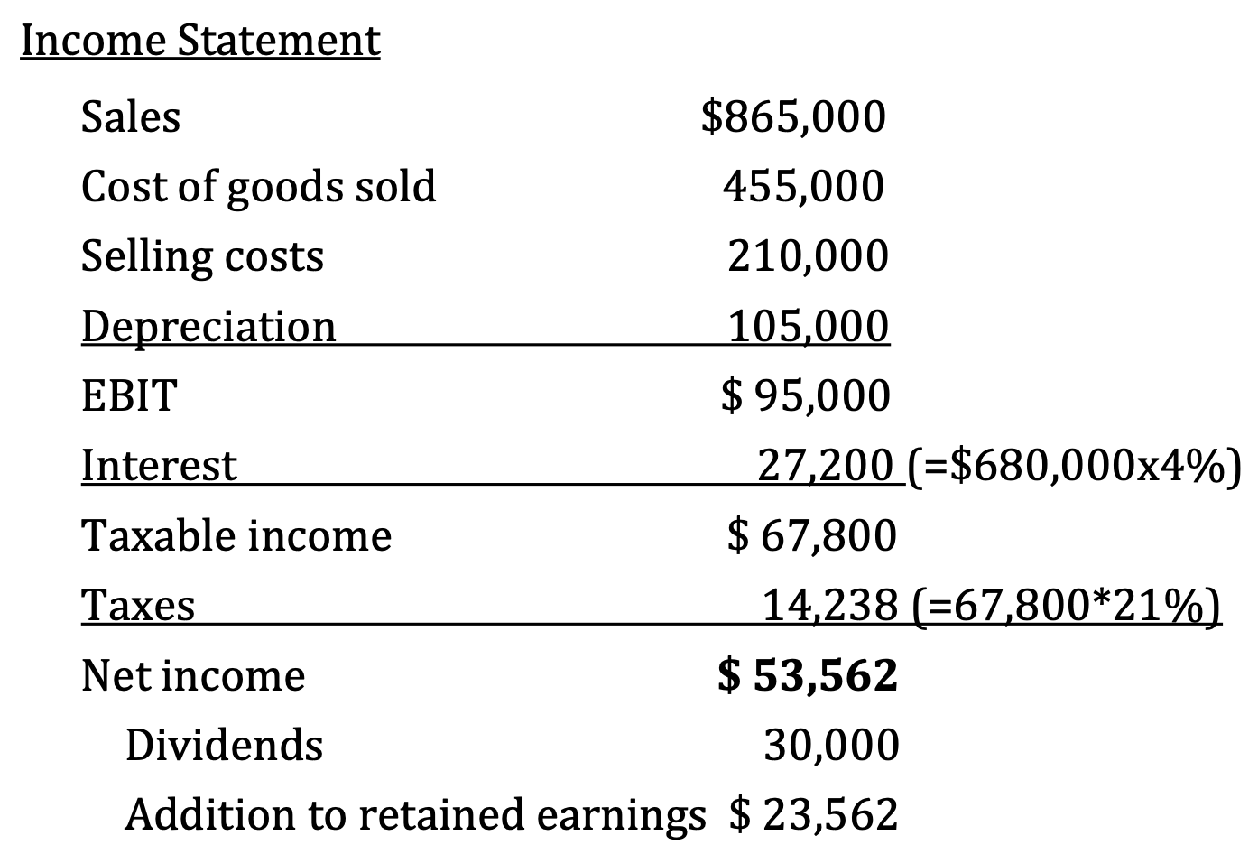 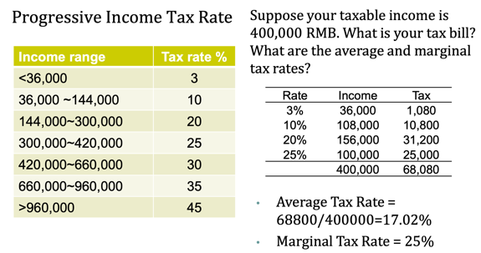

**4. Project Cash Flow.**