**1. New VC.** Public firms’ financing decision: Debt vs. Equity (tax, cost, bankruptcy risk). Startup firm financing decision: 投资者类别, 信息披露方式以及具体的融资形式. **(1) Venture Life Cycle.** *Pre-Seed Funding:* typically refers to when a company’s founders get their operations off the ground: founders, close friends, supporters, and family. *Seed Financing:* funds needed to determine whether the idea can be converted into a viable business opportunity. *Startup Financing:* funds needed to take the venture from having established a viable business opportunity to initial production and sales. *First/A Round Financing:* equity funds provided during the survival stage to cover the cash shortfall when expenses and investments exceed revenues. *Second/B Round Financing:* financing for ventures in their rapid-growth stage to support investments in working capital (用于市场扩张). *Mezzanine Financing:* funds for plant expansion, marketing expenditures, working capital, and product or service improvements (用于公司扩张). *Bridge Financing:* temporary financing needed to keep the venture afloat until the next offering. *Initial Public Offering:* a corporation’s first sale of common stock to the investing public. *Seasoned Securities Offering:* the offering of securities by a firm that has previously offered the same or substantially similar securities. **(2) Sources of New Venture Financing.** *Self, Friends, and Family.* Bootstrap financing: Does not depend on investor assessment of the merits of the opportunity or asserts of the venture. *Angel Investors.* High-net worth individuals. 高风险高回报. Better deal flow; Better information; Syndicate partner/follow-up. *Venture Capital.* 10 Years. LP: provides capitals. GP: investment decisions. Simple consideration of VC funding: Timing; VC’s expertise; Geographic areas; Investment horizon and objectives (VC funds seek equity or equity-like returns, and the finite life of the fund). *Asset-Based Lenders.* Secured lenders (担保贷款人). *Venture Leasing.* Leasing assets that are key to the operation of the venture (减少初始投资). *Corporate Venturing.* Seek to identify and exploit synergies between firm and the new venture. 可能是公司内部也可能是外部VC子公司的形式, 内可实现创新外可获得收益. *Trade Credit.* 供货商和销售之间应付账款和应收帐款的差. *Factoring.* A factor is a specialist who buys account receivable and manages the collection activities. 保理商帮助收款. *Franchising.* 通过加盟许可收取加盟费是融资方式的一种. *Mezzanine Capital.* VC and PE offer this financing. 在净收入转正后的融资. 混合结构, 有股债还有次级债. *Debt.* 适用性强. *Private Placement.* 私人配售, 成本低. Any sale of equity or debt to a small number of investors by means other than a public offering. *IPO.* Why do firms go public & trade-offs. Good: Expansion with massive financing; Better accessibility to financial market; Increase of stock liquidity; Bad: Losing private benefit; M&A Threat. *SSO.*

**2. VC. (1) Organization of venture capital firms.** *Limited Partnership Structure.* GP Responsible for 1) raising investment capital from LP (销售, 定期报告); 2) deploying the capital by investing in portfolio; 3) harvesting investments (GP 投入 1%, 获利集中于 LP 70%); 4) screening opportunities, commits human capital to ongoing involvement in monitoring and advising. *Distribution waterfalls.* 先给 GP 管理费, 再还 LP 本金, 再给 LP 约定的最低收益, 然后给 GP 约定的最低收益, 最后按约定分配剩余的超额收益. Recovery Phase: Payment of management fee; Return of LPs’ principal; Hurdle Phase: Preferential return to LP; Catchup Phase: A carried interest portion to the GP corresponding to LPs’ preferential return; Carried Interest Phase: Remaining portion of capital gain due to LPs (80%); The GP’s remaining carried interest (20%). 注意 Catchup 机制让 GP 更有动力. *Clawbacks(回拨机制).* LP 收益没有满足的情况下, GP 需要让渡一部分收益. *The Investment Process.* Fundraising stage; Fund closing; Investments (Value creation and monitoring); Harvesting. **(2) How Venture Capitalists Add Value?** *Selecting* invest-ment and negotiating deals with screen criteria (这个地方有许多的参考标准). *Changing* the management team. *Monitoring and advising* portfolio companies (如果 VC 选择派股而不是发现金, 说明其不自信, 对价值有负面影响). *Luck vs. Skill:* What accounts for VC Success? 运气发挥重要作用, 风格坚持以及及时转向很重要. *Syndication:* VC 联合投资互补创造价值. **(3) VC Compensation and Selection.** GP 和 LP 的组成影响 VC 投资项目的选择. *Adverse Selection in VC investment.* VCs 选择项目时有信息不对称, 倾向于选择估值过高的项目. Ways: Syndication, Staging, Financial Contracting (用可转股而非 Cash), Due Diligence. **(4) VC Contracts with Ventures.** VCs can use convertible preferred stock put options, demand registration rights, and others to protect themselves and ensure to harvest. **(5) VC Contracts with Investors.** Excessive risk taking (限制 GP 加杠杆). Favoring existing funds over new funds (防止用新 funds 给老的充钱). Manipulation of management fees. Self-dealing and dilution of effort (限制 GP 投资). **(6) Role of VC Reputation.** IPOs with VC backing are less underpriced and raise more capital.

**3. CVC.** Corporate venture deal sizes becoming **significantly larger** than VC overall. **(1) Objectives of CVC.** 1) It can be a rich source of technological advantage and information about potential transformations in companies’ core businesses. 2) Venturing enables corporations to keep on new developments and potential new markets in adjacent industries. 3) Venturing gives a means to learn about emerging trends in more-distant industries. 4) Venturing yields important information that companies can use to prepare for or facilitate their entry into new businesses. **(2) Comparison of CVC and IVC.** *Hypothesis 1:* CVCs may be superior to IVCs in nurturing innovation. 1) Longer investment horizons. 没有 IVCs 10年的固定限制. 2) Strategic purpose. IVCs 的核心目标是赚钱. CVCs 的核心目的则还有公司发展. 3) Lack of purely performance-driven compensation schemes. CVC 管理者薪资和 funds 表现弱绑定, 固定薪资 + 母公司情况. 4) Unique knowledge from parent firm. CVC 的母公司可以提供特有知识. *Hypothesis 2:* IVCs may be superior to CVCs in nurturing innovation. 1) Efficient resource allocation. CVC 可能有路径依赖, 无法合理分配资源. 2) Higher powered compensation schemes. IVC 薪资激励性强, 创新动力高. 3) Specialized industry expertise. IVC可以帮助公司专业化. *Empirical Findings.* CVC-backed firms创新性更强. **(3) Choice of Corporate Innovation Activities.** 逐渐转向外部VC以加速创新速度, 并获得竞争优势.

**4. Valuation 1. (1) VC Method.** Estimates the venture’s value by projecting **only a terminal flow** to investors at the exit event. 只考虑项目退出收益, 且只初期一个投资. *题目比较固定:* 给定1) Founder 有固定初始股数; 2) 投资者投资金, 有其目标收益. 3) 项目的退出价值 (有时需要 P/E 自己算); 4) 时间跨度. *主要考察:* 1) 新来的投资者占多少股份; 2) 需要增发多少股, 股价是多少; 3) 融资前后项目的估值; *解决思路:* 起点是将初期投入资金贴到最后, 与最终值比较得到占比; 进而得到需要增发的新股数以及股价; 增发前后股价不变, 股数增加带来估值增加. **(2) Multiple Rounds.** *Expected.* 第一轮投资的时候预料到后续还会有投, 最终估值不变, 只需要将每一轮投资贴到最后一轮计算占比即可, 都减去得到初创者部分, 这种在预期内的多轮投资估值计算方式和上述相同. *Unexpected.* 第一轮投资的时候没有预料到后续还会有投, 最终估值不变, 未预期到的投资占比直接计算, 初始投资和初创者则在剩余的部分按原比例瓜分, 会稀释第一轮投资占比. **(3) Anti-Dilution Provision.** Investors are concerned about “Down Round” (could be at a lower price per share than what he is paying this round). *Full Ratchet Provision.* 如果新发行价格较低, 原始投资者有权以低价购入. 也就是说 B 轮后 A 轮投资者如果被稀释, 应该通过增发保证 A 轮投资者占比不变. 计算核心在于 Founder 的占比是确定的, 进而算出总股本, 用 B 轮后的总估值除以总股本得到股价. 另一种情况是 B 轮发行价格降低后, 通过转化 (Conversion) 增股的方式保证 A 轮投资者资金不变 (Common Stock 转化为 Preferred Stock). *Weighted Average Provision.* 加权转化, 和之前直接通过价格进行转化, 现在考虑进原有股数加权. New Conversion Price = Old Conversion Price * (CSO+CSP)/(CSO+CSAP). 其中 CSO 表示原有 Common Stock 数量, CSP 表示按照价格转化新发行股得到的 Common Stock 数量, CSAP 表示新发行的 Common Stock 数量. *Example.* A 轮 $1, 25 shares. B 轮 $0.5, 20 shares. 那么如果不考虑加权需要多给 A 转化 25 shares. 如果考虑加权 CSO=25, CSP=10, CSAP=20, New Conversion Price=0.78, 25/0.78 为结果.

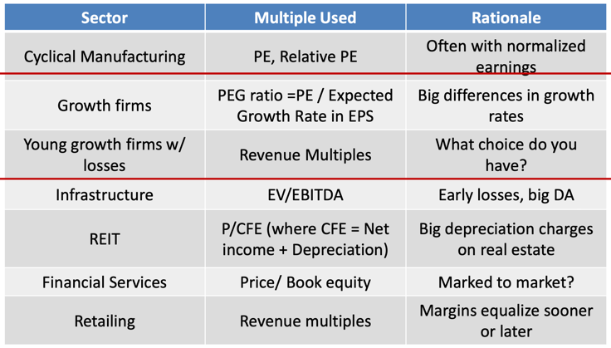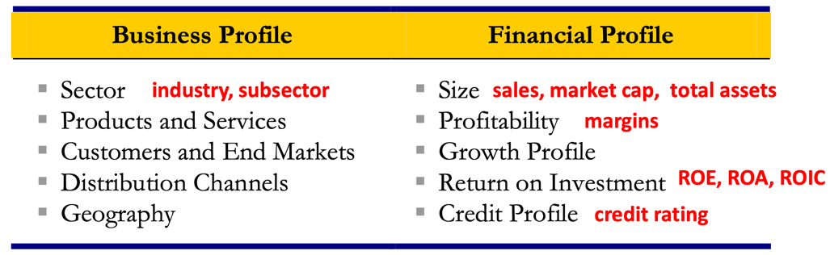**5. Valuation 2. (1) Relative Valuation.** *Why Relative Valuation?* Relative Valuation is pervasive. Pros: Market-based (数据全部来自真实市场); Relativity (相对性强, 容易直接比较); Quick and convenient (计算所需条件很少); Current (实时性强, 甚至可以做到日内更新). Cons: Market-based (非理性繁荣或熊市中估计不准确); Absence of relevant comparables (找不到可对比公司); Potential disconnect from cash flow; Company-specific issues. **(2) Five Steps to Relative Valuation.** *1) Select the Universe of Comparable Companies.* Identify Key Characteristics of the Target for Comparison Purposes (Business & Financial). *2) Locate the Necessary Financial Information.* Valuation is driven on basis of both historical performance (Financial Statement) and expected future performance (Research Report). *3) Spread Key Statistics, Ratios, and Trading Multiples.* Market Valuation. Equity Value = Share Price * Full Diluted Sharing Outstanding (Basic Shares Outstanding + “In-the-Money” Options and Warrants + “In-the-Money” Convertible Securities). Number of shares repurchased is less than additional shares outstanding from exercised options. 股价 20, 期权行权价 18, 股数 100, 期权数 5, 实际股票数=100.5. Convertible and Equity-Linked Securities. Incremental Share = Amount Outstanding / Conversion Price. Enterprise Value. = Equity Value + Total Debt + Preferred Stock + Noncontrolling Interest – Cash and Cash Equivalents (从购买方角度, 现金折价) Independent of capital structure (MM Theory). Key Financial Data. sales, gross profit, EBITDA, EBIT, and net income; Profitability: Sales, Gross profit (Usually expressed as percentage of sales), EBITDA (Earnings Before Interest, Taxes, Depreciation and Amortization), EBIT, Gross Profit Margin (毛利率) and Net Income Margins (净利率). Growth Profile: Historical and estimated growth rates. Compound annual growth rates (CAGRs 复合年增长率). Return on Investment: ROIC (Return on Invested Capital=EBIT/(Average Equity+Debt)), ROE (Return on Equity=Net Income/Average Shareholder’s Equity), ROA (Return on Assets=NI/Average Total Assets), and Dividend Yield (Most Recent Quarterly Dividend Per Share*4/Current Share Price). Credit Profile: Leverage ratios (Debt/EBITDA), Debt-to-Total Capitalization = Debt / (Equity+Debt+Preferred Stock+Noncontrolling Interest), Coverage Ratios (EBIT/利息), and credit ratings. Equity Value Multiples. PE=Market Price per Share/Earnings per Share (Negative Earning: Drop, Use Median Ratio, Average PE then reciprocal). Enterprise Value (EV) Multiples. EV/EBITDA & EV/EBIT. EV/EBIT is less commonly used than EV/EBITDA due to differences in D&A among companies. (PE 更好操控, 但对加杠杆的公司不利). *4) Benchmark the Comparable Companies.* Benchmark Financial Statistics and Ratios: 通过财务数据和比率分析多家公司, 选择关键指标较接近的, 分析既需定量又需定性. Benchmark the Trading Multiples: 循环所有公司, 计算多个比率取均值, 中位数, 两端值. 一般选择 median 做为 reliable comparison point. 可能会出现 outliers (可直接剔除, 但如果明显有偏, 需要谨慎考虑). *5) Determine Valuation (两层考虑).* Use means and medians of most relevant multiple for sector (e.g., EV/EBITDA or P/E) to extrapolate range of multiples. Must also determine which period financial data is most relevant for calculating trading multiples. **(3) Why Precedent Transactions Analysis?** Pros: Market-based (数据全部来自真实案例, 相似度高); Relativity (有直接参考); Current (最近的交易有时效性); Simplicity (一些关键特征可以直接做为估值基础); Objectivity (都是现实中存在的例子, 无需做出任何假设). Cons: Market-based (multiples may be skewed depending on capital markets and/or economic environment at the time of the transaction). Time lag (和现实情况差别比较大); Existence of comparable financing round; Investor’s basis for valuation.

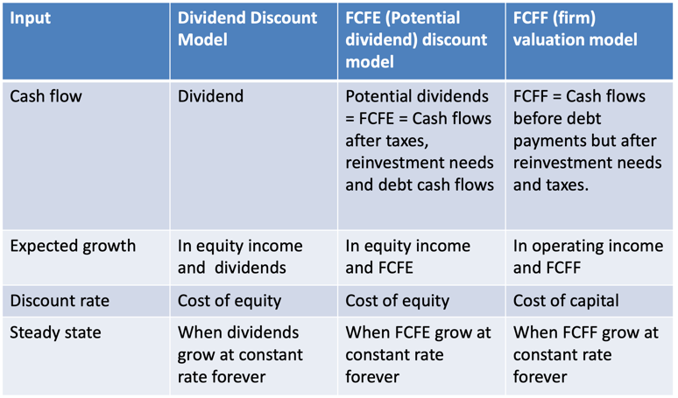**6. Valuation 3. (1) DCF Overview.** Firm Valuation: 现金流是还Debt前的, 贴现率是考虑Debt和Equity综合的. Equity Valuation: 现金流是还Debt后的, 贴现率只考虑Equity. 核心是不要错误匹配现金流和贴现率! *Free Cash Flow:* The cash that a company is able to generate after laying out the money required to maintain or expand its asset base (一般会估计5年, 并估算Terminal Valuation). *Pros&Cons:* Cashflow-based (更fundamental, 展现真实的FCF); Market independent (不受市场aberrations异像的影响); Self-sufficient (不依赖可比公司); Flexibility (可分析更全面的情形) | Dependence on financial projections (需要较为精准的分析预测); Sensitivity to assumptions (小变动导致大差异); Terminal Value; Assumes constant capital structure. *Two standard problems.* No Market Value: Equity & Debt 没有交易记录, 无法估计. Cash Flow Estimation: Shorter history & Different Accounting Standards. **(2) DCF Steps.** *1) Study the Key Performance Drivers.* Determine key drivers (management, brand, customer base, operational focus, product mix, sales/marketing strategy, scale, and technology) of a company’s performance (sales growth, profitability, and FCF generation). *2) Project Free Cash Flow.* FCF=(EBIT*(1-t)+D)-CAPX-dNWC=((S-C-D)*(1-t)+D)-CAPX-dNWC. Considerations. historical perfo, projection period length. Sales Projections. Top-Down Approach: Market size*Market share, Bottom-Up Approach: Capacity size*Unit sales. CAGR=(End V/Start V)^(1/years)-1. 基于研报和行业报告预估销售额增长速度. COGS and SG&A. 基于过往数据估计一个固定的与Sales的比. EBITDA and EBIT. 同上. Tax. 有一个Marginal Rate, 但也需参考公司情况. Net CAPX. (Capital expenditures – Depreciation). 估计其占Sales的比. Funds that a company uses to purchase, improve, expand, or replace physical assets such as buildings, equipment, facilities, machinery, and other assets. Depreciation & Amortization. 非现金折旧, D-PP&E, A-intangible assets. dNWC. NWC=Current Asset-Current Liabilities. 假设流动资产和负债的占比和收回时间, 进行估计. NWC 极少情况下为负, 需要设为 0. Free Cash Flow to Equity. =FCF-(Principal Repayments - New Debt Issues). *3) Calculate WACC.* Discount rate should ref-lect the risk perceived by the marginal investor in the company. Cost of Equity. CAPM, APM(Arbitrage Pricing Model), Multi-Factor(FF 3 fators). Re=Rf+βL(Rm-Rf). 奢侈品, 固定成本高, 杠杆高的β大. 资本结构不同, 先找类似公司算多个无杠杆的βU, 然后均值后得到平均βU, 再加杠杆得到目标公司βL. βU=βL/(1+D/E(1-t)), βL= βU*(1+D/E(1-t)). Cost of Debt. Company’s cost of debt reflects its credit profile at the target capital structure. Based on a multitude of factors including size, sector, outlook, cyclicality, credit ratings, credit statistics, cash flow generation, financial policy, and acquisition strategy. Way:到期收益率;评级, 根据评级得到风险利差,Rd=Rf+利差. WACC=(Rd*(1-t))*D/(D+E) +Re*E/(D+E). *4) Determine Terminal Value.* Use terminal value to capture the value of the company beyond the projection period. Exit Multiple Method (EMM). Calculates the remaining value of a company’s FCF produced after the projection period on the basis of a multiple of its terminal year EBITDA (or EBIT). Terminal Value=EBITDA*Exit Multiple. Perpetuity Growth Method (PGM). Calculates terminal value by treating a company’s terminal year FCF as a perpetuity growing at an assumed rate. Terminal Value=FCF*(1+g)/(r-g). ROE = (Net income-Cash) / (BV Equity-Cash). *5) Calculate Present Value and Determine Valuation.* Perform Sensitivity Analysis (WACC, exit multiple, g 变化分析). Illiquidity 流动性不足很常见.

**3 Cases.**

Question1: payment of management 是第一个返回？