
Peking University HSBC Business School (PHBS)

Conceptualization of Reforms in China's Foreign Exchange Market
Based on the Experience of the 2015 Foreign Exchange Reforms

Instructor: Professor Cen Wei
Topic: Foreign Exchange Market

Group 2 (names in no specific order)
Ren Kai (任凯) | 2401212437
Mads Victor Kristensen | 2402010103
Magnus Raffnsøe-Møller | 2402010111
Andrea Conti | 2402010117
Lucien Leon Frei | 2402010112
Giacomo Brusadelli | 2402010115

Financial Markets and Investments in China
14th January 2025
Contents
List of Figures III
List of Tables III
Preamble 1
1 Details and evaluation of 2015 foreign exchange reforms (Q1) 1
2 Foreign exchange market regulation comparison (Q3) 4
3 Changes for regulatory agencies (Q2) 6
4 Reforms for financial regulation (Q4) 7
5 Reforms for more efficient, safer Chinese capital markets (Q5) 9
References IV
Appendix 1. Overview of project V
Appendix 2. Figures and tables VII
Appendix 3. Detail of difference-in-difference regression XIII

List of Figures
Figure 1: Total and average daily trading volume of China’s foreign exchange market VII
Figure 2: The framework of our project VII
Figure 3: China’s Official Foreign Exchange Reserves from 2000 to 2024 VIII
Figure 4: Daily exchange rates(right) and currency indexes(left) under different regimes VIII
Figure 5: Percentage composition of the CFETS RMB Index IX
Figure 6: Trade balance pre- and post-2015 forex policy reforms IX
Figure 7: Share of allocated foreign exchange reserves, the first quarter of 2023 X
Figure 8: Percentage of allocated reserves X
Figure 9: Value of non-gold reserves by territory, 2022 XI

List of Tables
Table 1: Forex market regulation comparison between China, US, and HK XII
Table 2: Effect of the trade war on currency dependences with USD XIV

Preamble
Before reading the answers to the five questions in the main text, we strongly recommend reading the overview of the project in Appendix 1, which will help in quickly understanding the project framework. This section provides key context and highlights the rationale behind our analysis and proposed recommendations.

Details and evaluation of 2015 foreign exchange reforms (Q1)
Chinese foreign exchange market underwent major reforms reflecting the gradual shift from a centrally planned economy to a market-oriented system. One of the most important reforms is represented by the 2015 foreign exchange reform. The PBOC announced the implementation of a "managed float” exchange rate system based on market supply and demand, with reference to a basket of currencies.
In Figure 3, we see the foreign reserves in China from 2000 to 2024. The reserves grew steadily until late 2014, mainly driven by trade surplus, foreign direct investment and the tightly controlled exchange rate regime at the time (Neely, 2017). A sharp decline happened around the time when the 2015 policy was implemented. The managed float meant that market forces had a greater influence on the CNY and had the consequence of depreciation and an outflow of capital, which forced the reserve down (Neely, 2017). However, after the first decline, the foreign exchange reserve stabilized.
Figure 4 shows the evolution of China’s exchange rate regime from 2014 to 2017, highlighting the shift from being linked to the dollar to a broader basket peg and the “broad depreciation” of the RMB. Before Aug. 2015, the RMB was tightly linked to the USD, as shown by the close alignment of the RMB/USD rate and the DXY Index. In Aug. 2015, as we know, the PBOC announced reforms to the central parity mechanism to increase market flexibility, leading to a 1.9% devaluation and significant market turbulence. This sparked capital outflows and global volatility, forcing the PBOC to intervene by selling reserves (over $300 billion in 2015) and tightening capital controls. In the broad depreciation phase (2015 to 2016), the RMB weakened even further, with the real effective exchange rate depreciating by 6.8% by December 2016. By 2017, the RMB stabilized under a broad basket peg, reducing dependence on the USD while allowing market forces to play a greater role The earlier mentioned figure illustrates the challenges of transitioning to a managed float system, balancing flexibility with stability in the face of market pressures.
To broaden the market focus beyond the RMB/USD exchange rate, the China Foreign Exchange Trade System (CFETS) introduced the CFETS RMB Index in December 2015. Initially consisting of 13 currencies weighted by trade volumes, the index was expanded in 2016 to include 24 currencies, reducing the dominance of the US dollar and reflecting China’s growing trade ties with a wider set of partners. Figure 5 represents the composition of the CFETS RMB Index, introduced by the CFETS in 2016 compared to 2024. The figure presents the weightings of major and smaller currencies in the CFETS RMB Index, illustrating how these weights evolved between 2016 and 2024. The data demonstrates a decline in the weight of major currencies (USD, EUR, JPY) over time, accompanied by a notable increase in the weightings of smaller currencies, which were introduced after the basket’s expansion. This change aligns with China's broader goals of fostering currency stability, trade competitiveness, and regional integration while reducing dependency on the USD. The shift also supports the RMB’s continued path toward internationalization.
Clark (2017) found that although the central parity mechanism became more predictable and market-responsive, its role in guiding intra-day RMB/USD exchange rate changes was inconsistent. Instead, foreign exchange interventions by the PBOC to dampen volatility had a more significant impact on daily exchange rate movements. This highlights a persistent tension between market-driven mechanisms and China’s preference for stability, which remains a core feature of its currency management approach.
Figure 6 shows a box plot illustrating the trade balance of China before and after the policy implementation. The pre-2015 policy plot shows a narrow interquartile, which indicates a lower variability compared to the post-2015 policy plot. In the post-2015 policy plot, we see a larger amount of variability and more extreme outliers. The median surplus is larger which indicates that we see more trade surplus after the policy implementation. This indicates that the 2015 policy introduced more flexibility in relation to the exchange rate however it also introduced more volatility in the trade performance.
The trade war between China and the US, which began in 2018, has significantly altered the dynamics of exchange rate relationships, introducing structural breaks that have amplified dependency shifts among currencies. This conflict increased depreciation pressures on the RMB and heightened exchange rate volatility. As a result, the trade war intensified capital outflow pressures, negatively impacting China's economy. While tensions eased in subsequent years, the situation has re-emerged as a point of concern with Donald Trump's return to office in 2025. His renewed hardline stance against China suggests that China’s foreign exchange market may once again face considerable strain.
To investigate these dependency shifts, we conducted a difference-in-differences analysis. Recognizing China’s efforts to internationalize the CNY, understanding the currency's dependency dynamics with key trading partners becomes crucial. Using an ordinary least squares regression model, we analyzed the relationship between the CNY and the currencies of China’s six largest trade partners: the Australian dollar (AUD), South Korean won (KRW), Hong Kong dollar (HKD), Singapore dollar (SGD), and South African rand (ZAR). Our study examined two distinct periods: the pre-trade war phase (January 4, 2016, to March 22, 2018, the date when President Trump imposed $50 billion worth of tariffs on Chinese imports) and the post-trade war phase (ending on May 1, 2020, to avoid confounding effects from the COVID-19 pandemic and the Biden administration). Detailed information about the regression methodology is available in Appendix 3. Our findings (see Table 2 empirical statistics) reveal no statistically significant evidence of a change in the sensitivity of CNY exchange rates to fluctuations in the USD, underscoring the resilience of the CNY in this regard. However, the most notable result is the consistent significance of the dummy variable for a trade war in all regressions. The positive coefficients in most cases indicate that the CNY depreciated against nearly all its major trading partners’ currencies during the trade war. This depreciation highlights the vulnerability of the RMB to external shocks, such as the trade war, underscoring its relative weakness in international markets.
As China pursues the internationalization of its currency, addressing these vulnerabilities will be essential. The findings emphasize the need for strategic measures to bolster the RMB's stability and resilience in the face of external pressures. This becomes particularly pertinent when viewed alongside the broader context of the 2015 foreign exchange reform in China. While the reform introduced greater flexibility in exchange rates, it also resulted in increased volatility in trade performance. The trade war and its impacts further illuminate the challenges that China must navigate to strengthen the RMB’s position on the global stage.
In summary, we see that the 2015 policy has had a huge impact on the way China managed its currency, with less dependence on the USD. The changes meant that the RMB became more responsive to market dynamics and volatile both in relation to trade performance and exchange rates. It’s clear that the RMB was affected by the trade war with the US and is more sensitive to exogenous pressures. China faces challenges going forward balancing a more internationally responsive currency with economic stability in the home market.

Foreign exchange market regulation comparison (Q3)
Both the US and Hong Kong (HK) have advanced foreign exchange markets. We will systematically compare the relevant policies and draw references from them. The detailed comparison results are shown in Table 1. We have analyzed various dimensions such as Regulatory Structure, Exchange Rate System, etc., and compared the strengths and weaknesses of each region. Specifically, we need to focus on.
One of the major differences lies in the regulatory structure where China has a centralized framework controlled by the PBOC, SAFE and NFRA focusing on economic stability and control. The US on the other hand has a decentralized system with multiple agencies like the FED, SEC and CFTC, ensuring transparency and Innovation. We also included HK as a different reference because it bridges Mainland China and the global markets. HK has adopted a hybrid system under the HKMA and SFC.
One of the major competitive advantages for the US is the power of the US Dollar. The dollar has been the world’s principal reserve currency since the end of World War II and is widely used in international trade. The dominance of the US dollar (“exorbitant privilege” as the former French Finance minister Valery Giscard d’Estaing termed it in the 1960s) is unparalleled and highlights global influence. Major commodities such as oil are bought and sold using US dollars. As can be seen in Figure 7, most of the foreign exchange reserves are in the US dollar as of Q1 2023. The dominance is rooted in trust, transparency and stability. Qualities that China must evaluate if they want the RMB to become the global currency.
China has made incremental gains in the internationalization of the RMB as it now accounts for 3% of the global reserves compared to the overwhelming majority of the USD (See Figure 8). However, as recent data shows, we have seen a recent decline trend in the global share of USD. This is partly due to nations diversifying their reserves due to geopolitical tensions and a desire for alternatives. However, the RMB’s limited convertibility and lack of transparency hindered the potential of becoming a variable competitor to the US dollar.
Another major difference between the US and China is the amount of foreign exchanges each country holds. According to the World Bank (See Figure 9), China has $3.2 Trillion worth of other currencies, on the other hand, the US only holds $232.7 Billion. This factor gives China extreme power which has drawn accusations of currency manipulation, especially during periods when the RMB was undervalued to boost exports.
All in all, by introducing our table, we highlighted the major differences between the US, HK and China. Building on that, we highlighted the powers of the US, having the power of the US dollar and China having the largest reserve. Despite the internationalization of the RMB, the RMB is still very low accounting for 3% of the global forex reserve. Building on some of the issues that the US faces, China can potentially gain more shares of the global share by improving transparency.

Changes for regulatory agencies (Q2)
In the following, we discuss based on the background of arguments found in Q1 and Q3 the recommendations to the regulatory agencies — more specifically, the PBOC, NFRA and the CSRC. As highlighted in Q1, the internationalization of the RMB and the challenges posed by external shocks, such as the trade war, have exposed inefficiencies in the regulatory framework. Addressing these issues is crucial for creating a stable and efficient foreign exchange market. The most significant problem with these regulatory bodies is the fragmentation of responsibilities among them and their lack of coordination, which often leads to overlapping powers. As can be seen in Table 1, many of the strengths of the US system can be adopted into the Chinese foreign exchange market. Based on this we give the following recommendations:
For PBOC, it should be more transparent, as we believe this would enhance the value of the RMB and push the currency to become one of the major currencies in the global reserves. To build trust among global investors and reduce speculation the agency should publish regular updates and provide clear guidance on the actions that are undertaken to manage the exchange rate. Moreover, it should be granted better operational independence from the government. Once the main objective is set, the government shouldn’t intervene in the operation of PBOC. These two changes would enhance RMB credibility, attracting more investors and strengthening the stability of the currency. From Q1 we also highlighted how external factors have increased the vulnerability, thus the PBOC should continue to diversify its reserve with other currencies.
For the NFRA, we see that the overall financial system is underdeveloped compared to the one in the US. The number of products to reduce risk (like options, swaps, futures and forwards) is much less, only reflecting 2% of China’s GDP in total. Thus, if China wants to have a more efficient foreign exchange market, the NFRA needs to issue regulations to stimulate banks’ offering of RMB-denominated assets and foreign exchange trading would increase liquidity and stability in the forex market. At the same time, it should improve risk management systems in the financial sector to guarantee stability and safety.
Regarding CSRC, the approval process for foreign investors requires long waiting times and discourages them from applying. Simplifying this process would reduce bureaucracy and attract more foreign investors, increasing RMB adoption. Moreover, allowing more complex financial products on the forex market would permit investors to manage currency risks more effectively, attracting more capital to the market. Finally, Articles and manipulation have been present in China. This hurts everyone. So, strengthening supervision of financial crimes would make the market safer, building investors’ confidence.
These reforms targeting individual agencies align with broader efforts to address market vulnerabilities and ensure the smooth functioning of the forex market.

Reforms for financial regulation (Q4)
Building on the vulnerabilities identified in Q1, particularly the managed exchange rate system and its limitations, comprehensive reforms to China’s financial regulations are required to bolster the RMB's stability and resilience in the face of external pressures such as trade wars. While the RMB has made strides in independence, as seen in Figure 5, its reduced reliance on the USD, the current managed exchange rate remains a limiting factor. Transitioning to a free-floating exchange rate system would be a bold but necessary reform. This shift would align the RMB with global currencies operating under market-driven systems, setting the stage for it to compete with the USD as a global currency.
However, this reform cannot be rushed. The experiences of other developing nations, such as Argentina and Mexico, underscore the potential dangers of poorly managed transitions. Without adequate safeguards, moving to a free-floating exchange rate could lead to excessive volatility, speculative attacks, and loss of confidence in the currency.
One way could be to focus on strengthening the RMB’s role in global trade. Encouraging more trade settlements in the RMB would reduce dependency on the USD while boosting the currency's visibility and credibility on the international stage. While progress has been made in this area through strategies such as the Belt and Road, such as agreements with key trading partners, the scope of these efforts must expand. Policies that incentivize foreign companies to adopt the RMB for cross-border transactions would accelerate this shift. China is already pushing this agenda through the BRICS alliance but expanding this alliance to include more countries and maybe even some European countries would go a long way to internationalizing the RMB even further.
A crucial component of financial reform involves improving transparency and regulatory alignment. As noted in Q3, the US’s regulatory framework is decentralized and prioritizes transparency and innovation, which has been instrumental in maintaining trust in the US dollar as the world’s dominant reserve currency. Adopting similar principles of transparency and predictability could significantly enhance the RMB's international credibility. China’s regulatory framework needs to be more predictable and aligned with international standards. This would build trust among global market participants, particularly foreign investors and central banks, who are critical to RMB internationalization. For instance, greater clarity around the People’s Bank of China’s intervention policies and monetary goals would reduce uncertainty and encourage wider acceptance of the RMB.
Ultimately, these reforms aim to create a financial environment where the RMB operates with greater autonomy and stability while integrating seamlessly into global markets. Addressing these challenges requires not only structural changes but also a commitment to gradual, coordinated progress. Through careful planning and international cooperation, China can establish a financial regulatory framework that supports its ambitions to make the RMB a leading global currency.

Reforms for more efficient, safer Chinese capital markets (Q5)
As outlined in Q1, the efficiency and safety of China’s capital markets are intrinsically linked to the performance of its forex market and the internationalization of the RMB. Addressing systemic inefficiencies and vulnerabilities in both markets is essential to achieving these goals.
First of all, further opening to foreign investors is needed. China has already taken important steps to open its capital markets to foreign investors by introducing infrastructures that permit them to trade RMB-denominated assets. Nonetheless, the pace of opening up needs to accelerate. One way to do this is to loosen the already-mentioned capital controls:
- Expanding or even eliminating the threshold for currency conversion would allow investors to invest more capital in China increasing liquidity in capital markets.
- Gradually reducing capital flow controls would allow a more fluid flow of capital, creating a more dynamic market, and it would encourage foreign investors to enter the Chinese market.
- Simplifying the process to approve foreign investors would lower waiting time and incentivize foreign investors to access the market.
- Increasing quotas for the RQFII program and expanding its scope to allow investment in a wider range of products would make the Chinese market more appealing to foreign investors.
Furthermore, foreign investors are currently worried about the stability and reliability of the RMB, as China has been repeatedly accused of currency manipulation, especially by the US. The current system limits RMB flexibility and makes foreign investors skeptical. This brings us to the conclusion drawn in the precedent question: changing the exchange rate system from a managed floating exchange rate to a free-floating exchange rate. A FFER would establish more trust and would attract more investors in capital markets.
These two significant reforms, opening up and reforming the exchange rate system, should develop simultaneously, as they are closely related and have a mutual effect on each other. A liberalized RMB would attract more capital, and at the same time, more capital would strengthen RMB stability, attracting even more capital and so on. This vicious cycle would be beneficial both for the internationalization of the currency and the efficiency and safety of capital markets.
These reforms are all aimed at increasing liquidity, strengthening integration with global markets, and supporting RMB internationalization. As emphasized throughout the project, the interdependence between the forex market and capital markets requires a coordinated approach. The reforms proposed here would not only enhance the safety and efficiency of capital markets but also strengthen the RMB's position in the global financial system, as highlighted in Q1.

References
Anshu S. & Noah B. (2023 July 19). The Dollar: The World’s Reserve Currency. https://www.cfr.org/backgrounder/dollar-worlds-reserve-currency

ASIFMA. China’s capital markets: Navigating the road ahead. https://www.asifma.org/research/chinas-capital-markets-navigating-the-road-ahead/

Central Banking Publications. China’s capital controls: Here to stay? https://www.centralbanking.com/central-banks/currency/7860946/chinas-capital-controls-here-to-stay

Clark, J. (2017). China's evolving managed float: an exploration of the roles of the fix and broad dollar movements in explaining daily exchange rate changes. Federal Reserve Bank of New York Staff Report, 828. https://papers.ssrn.com/sol3/papers.cfm?abstract_id=3072925

Council on Foreign Relations. (2023 February 2). China’s massive belt and road initiative. https://www.cfr.org/backgrounder/chinas-massive-belt-and-road-initiative

Das, S. (2019). China’s Evolving Exchange Rate Regime. IMF Working Papers 19: 1. doi:10.5089/9781498302029.001. https://www.elibrary.imf.org/view/journals/001/2019/050/article-A001-en.xml

Deutsche Bank. (2024 November 7). China’s capital markets illuminations. https://flow.db.com/securities-services/chinas-capital-markets-illuminations

Jeffrey F. (2015 December). The Plaza Accord, 30 years later. https://www.nber.org/system/files/working_papers/w21813/w21813.pdf

Neely, C. J. (2017). Chinese foreign exchange reserves, policy choices, and the US economy. Federal Reserve Bank of St. Louis Review, 99(2), 207-231. https://papers.ssrn.com/sol3/papers.cfm?abstract_id=2952262

Serkan A., Barry E. & Chima S. (2024, June 11). Dollar Dominance in the International Reserve System: An Update. https://www.imf.org/en/Blogs/Articles/2024/06/11/dollar-dominance-in-the-international-reserve-system-an-update

Xu, Y., & Lien, D. (2020). Dynamic exchange rate dependences: The effect of the U.S.-China trade war. Journal of International Financial Markets, Institutions and Money, 68(C), 101238. https://doi.org/10.1016/j.intfin.2020.101238

Zhou, S. (2023). China’s currency exchange system: A study and debate.

Zeidan, R. (2024 April 18). The future of the Chinese yuan. Georgetown Journal of International Affairs. https://gjia.georgetown.edu/2024/04/18/de-dollarization-the-belt-and-road-initiative-and-the-future-of-the-chinese-yuan/

Appendix 1. Overview of project
In the last few decades, China’s foreign exchange (forex) market has become one of the largest and most active in the world, playing a crucial role in global trade and investment flows. According to recent data (as shown in Figure 1), in 2023, the total trading volume of the forex market in China reached $35.85 trillion. The average daily trading volume rose from $48.67 billion in 2015 to about $98.21 billion in 2023, after a high of $101.01 billion in 2021.
The RMB’s international presence and influence have continued to expand in recent years as China’s economy grows and its external linkages deepen. A range of reforms in China’s foreign exchange market over the past two decades have also played an important role in increasing the RMB’s role in global markets. The policy of floating the RMB exchange rate has been improving since 2005. In August 2015, the People’s Bank of China (PBOC) announced further adjustments to the RMB exchange rate mechanism, whereby the daily exchange rate would no longer be determined by the central bank, but would instead be referenced to the previous day’s market closing rate. These changes were designed to increase market influence over the currency and make the RMB more attractive to investors, thus supporting its broader adoption for trade settlement.
However, in recent years, the international situation has been complex and volatile, and China's foreign exchange market has faced increased pressure. In particular, the trade war between China and the US, which began in 2018, has increased the depreciation pressure on the RMB and intensified exchange rate volatility, which has led to rising pressure for capital outflows, negatively impacting the economy. Although the current situation has eased, with Trump's second term in office in 2025, he has once again shown a tough stance towards China, meaning that China's foreign exchange market could once again face greater difficulties.
As shown in Figure 2, our project hopes to propose targeted reforms based on the experience of the 2015 exchange reform and the performance of China's foreign exchange market since the reform, and in light of the complex situation we are currently facing, to promote its efficient and smooth development.

Appendix 2. Figures and tables
Figure 1: Total and average daily trading volume of China’s foreign exchange market
Data source: China State Administration of Foreign Exchange

Figure 2: The framework of our project
Figure 3: China’s Official Foreign Exchange Reserves from 2000 to 2024
Data source: Wind

Figure 4: Daily exchange rates(right) and currency indexes(left) under different regimes
Data source: Wind

Figure 5: Percentage composition of the CFETS RMB Index
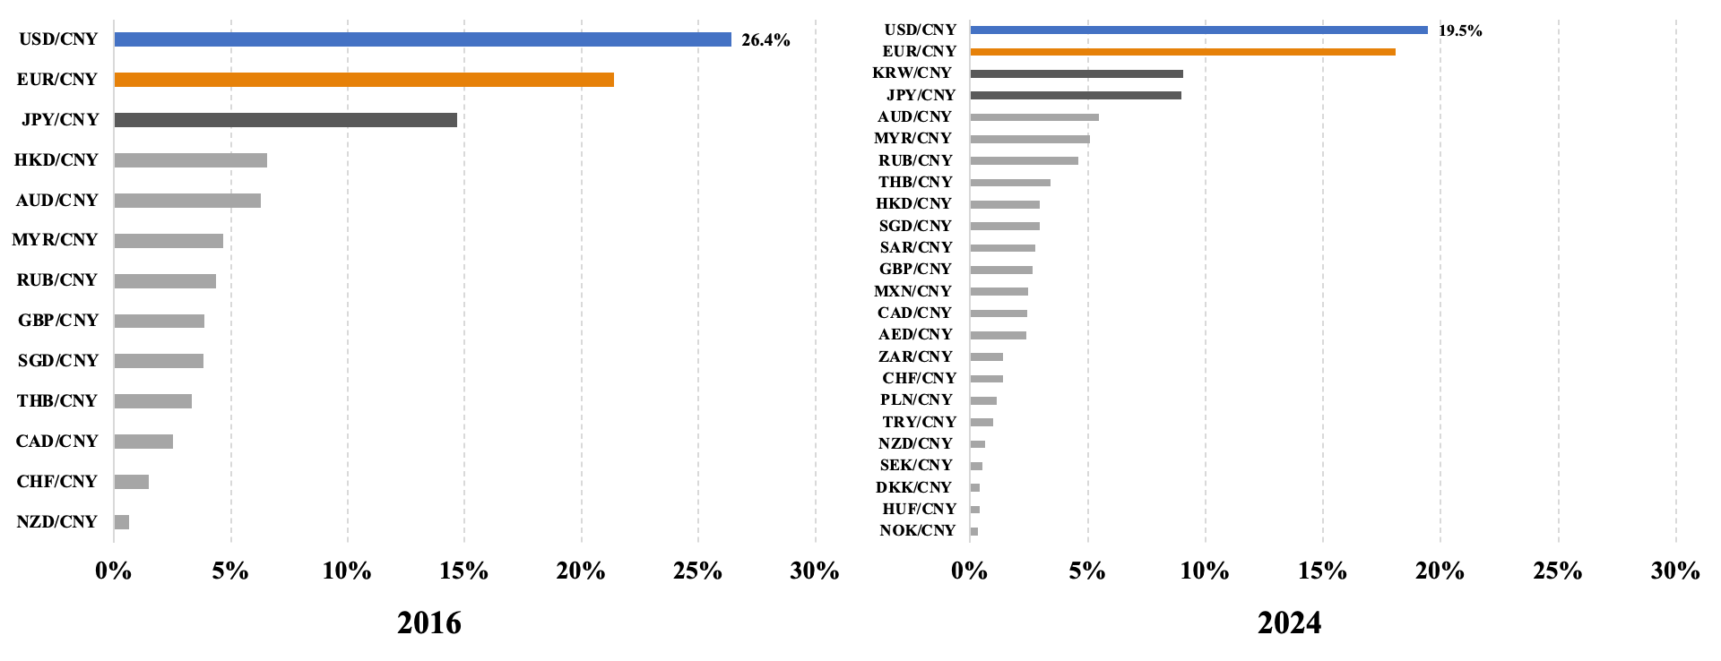
Data source: China foreign exchange trade system

Figure 6: Trade balance pre- and post-2015 forex policy reforms
Data source: Wind

Figure 7: Share of allocated foreign exchange reserves, the first quarter of 2023
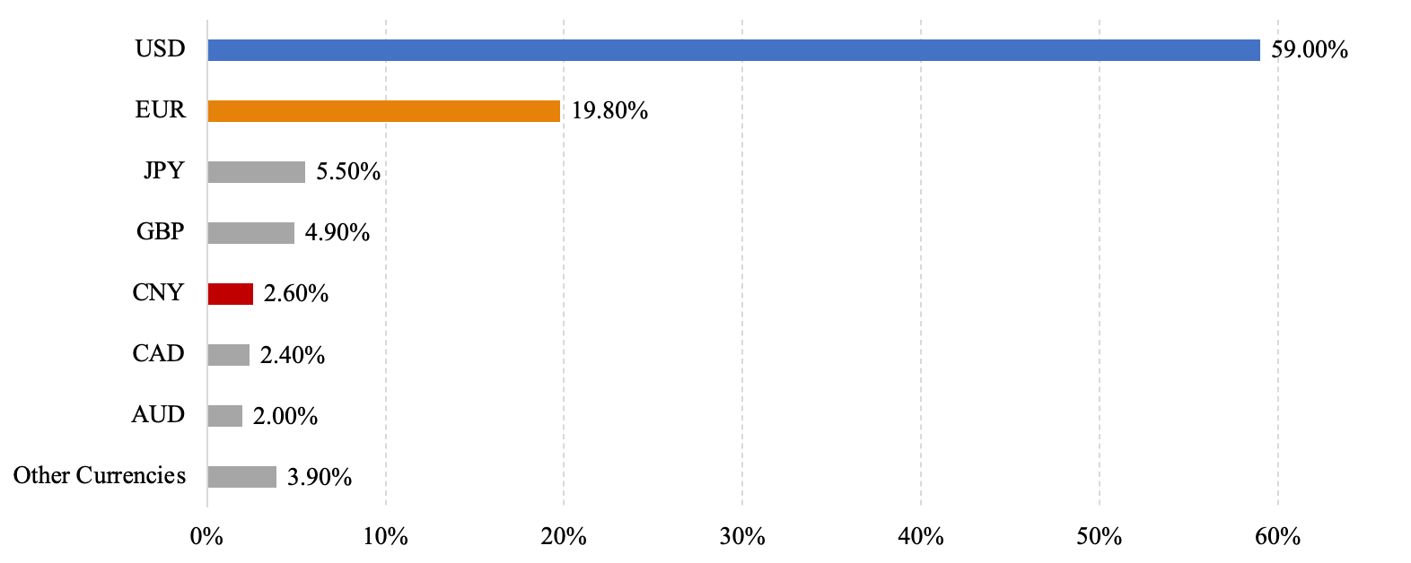
Data source: COFER

Figure 8: Percentage of allocated reserves
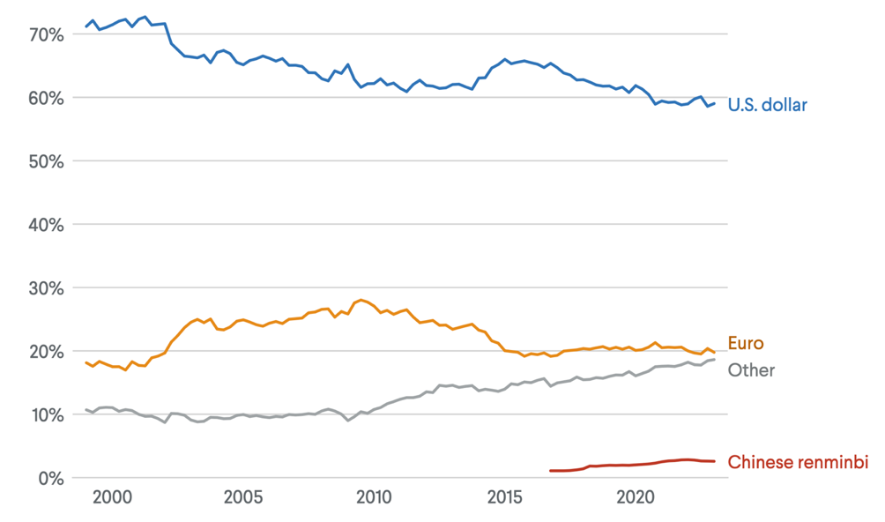
Data source: COFER

Figure 9: Value of non-gold reserves by territory, 2022
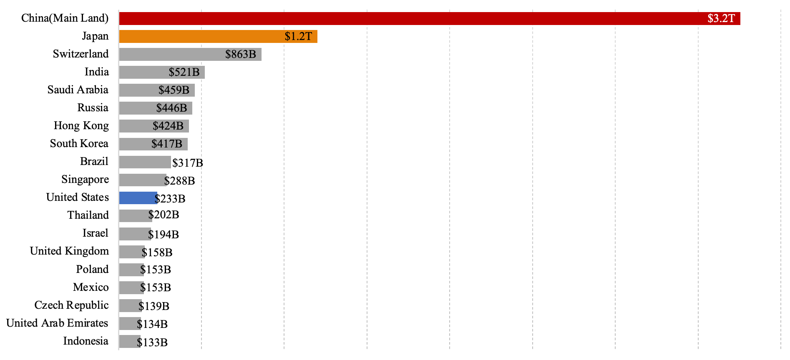
Data source: COFER

Table 1: Forex market regulation comparison between China, US, and HK
Aspects | China | United States of America | Hong Kong
Regulatory Structure | Centralized system dominated by PBOC, CSRC, NFRA and SAFE | Decentralized system with multiple agencies: Federal Reserve, SEC, CFTC. | Hybrid system with HKMA and SFC balancing local and international regulations.
Exchange Rate System | Managed floating exchange rate with PBOC intervention to maintain stability | Free-floating exchange rate, driven by market forces. | Pegged exchange rate under the Linked Exchange Rate System, maintaining a fixed rate to the USD.
Currency Convertibility | CNY is not fully convertible; capital controls limit foreign exchange transactions and outbound investments. | Fully convertible, with no restrictions on cross-border transfers. | Fully convertible, with no restrictions on cross-border capital flows.
Regulatory Focus | Prioritizes economic stability, state control, and alignment with national development goals. | Emphasizes market efficiency, innovation, and transparency. | Focuses on global integration, serving as a bridge between Mainland China and international markets.
Role of Central Bank | BOC implements monetary policy, manages the exchange rate, and enforces macroprudential policies. | Federal Reserve sets monetary policy to achieve price stability, employment, and moderate long-term interest rates. | HKMA manages monetary policy, oversees banking, and maintains the USD peg through foreign reserve management.
Market Transparency | Improving transparency but still faces challenges. Policy interventions and objectives are not always clearly communicated. | High transparency, strict disclosure requirements enforced by the SEC. | High transparency; adheres to international standards to maintain investor confidence.
Investor Protection | Developing framework; investor protection remains an area for improvement. | Strong legal framework, investor protection agencies like SIPC. | Strong legal framework ensures protection for both local and foreign investors.
Policy flexibility | Policies are closely tied to government directives and national priorities. | Flexible policies tailored by independent agencies. | Limited flexibility due to the currency peg but otherwise adaptive to market needs.
Crisis Resilience | Strong central control and capital controls provide stability during global crises. | Vulnerable to systemic risks (e.g., 2008 crisis), reforms strengthen stability. | Proven resilience during crises like the Asian Financial Crisis and 2008 GFC, supported by USD peg.
Strengths | Rapid policy implementation, alignment with national goals, and stability. | Innovation, global financial leadership, and investor confidence. | Serves as an offshore RMB hub, ensuring global connectivity and robust financial systems.
Weaknesses | Heavy state control limits market-driven growth and international integration. | Regulatory fragmentation and systemic risks from high market exposure. Fragmentation in regulation leads to inefficiencies and overlapping jurisdictions. | Dependence on global economic trends and limited monetary policy autonomy due to the USD peg.

Appendix 3. Detail of difference-in-difference regression
This study aims to investigate the impact of the US-China trade war on the exchange rates between China’s currency (CNY) and its six largest trade partners’ currencies (AUD, KRW, HKD, SGD, ZAR) by implementing an Ordinary Least Squares (OLS) model. Specifically, we take into consideration the trade war initiated by President Donald Trump during its first term. We consider as pre-trade war period the time from January 4, 2016, to March 22, 2018, which is the date when President Donald Trump imposed significant trade tariffs on Chinese imports for an estimated value of about $50 billion. Instead, we assume the post-trade war period to end on May 29, 2020, as we cannot isolate the covid-related impacts, and the Biden presidency effects on the exchange rates.
As we want to study the effect of the trade war on the exchange rate of the CNY against multiple currencies, we carry out different regressions for each pair. We decided not to use dependent variables directly from the different exchange rates, as this would lead to different orders of dimension for the coefficients due to the scales of the exchange rates (e.g. EUR/RMB 7.6 vs KRW/RMB 0,005). Using direct exchange rates would also lead to multicollinearity problems. Instead, we create an index for each exchange rate to make them start from the same point and we then use as a dependent variable the percentage change of the indexes.
We use as an independent variable the changes in the USDX, which measures the value of the U.S. dollar relative to a basket of the top 6 currencies: EUR, JPY, GBP, CHF, CAD and SEK. To measure it we use the first difference ($USD_{t+1}-USD_{t})$. Then, we create a dummy variable, which takes the value of 1 in the post-trade war period and 0 otherwise. Finally, we also include as an independent variable the interaction term between the USDX and our dummy. This term explains whether the relationship between the USDX changes and the exchange rates differs during the trade war period and the pre-trade war period. The regressions can be described by the following formula:
$$ExchangeRate_{i,t}=β_{i}+β_{1}USD_{t}+β_{2}TW_{t}+β_{3}USD_{t}×TW_{t}+ε_{i,t}$$
Where:
- $ExchangeRate_{i,t}$ is the exchange rate index between CNY and currency $i$ at time $t$.
- $β_{i}$ is the currency $i$ specific constant.
- $USD_{t}$ is the change in the USDX at time t, calculated as mentioned above.
- $TW_{t}$ is the dummy variable, constructed as previously described.
- $USD_{t}×TW_{t}$ is the interaction term.
- $ε_{i,t}$ denotes the currency $i$ error term.
Beside avoiding heteroskedasticity in the variable $USD_{t}$ by taking the first differences, we also corrected for heteroskedasticity in the error term by implementing robust standard errors. Further testing like checking for multicollinearity or abnormal outliers would be relevant but was not done in this report.

Table 2: Effect of the trade war on currency dependences with USD
 |  | AUD |  | EUR | JPY | KRW | SGD | ZAR
$$β_{i}$$ |  |  | 107.804*** | 105.456*** | 110.311*** | 106.609*** | 105.845*** | 114.961***
 |  |  | (0.153) | (0.118) | (0.198) | (0.133) | (0.399) | (0.399)
$$USD_{t}$$ |  |  | 42.042 | 34.160 | -31.921 | 22.303 | 17.287 | 103.175
 |  |  | (38.790) | (29.991) | (50.219) | (33.703) | (24.711) | (101.298)
$$TW_{t}$$ |  |  | -5.045*** | 4.019*** | 4.358*** | 1.151*** | 3.145*** | -2.964***
 |  |  | (0.203) | (0.157) | (0.263) | (0.177) | (0.130) | (0.531)
$$USD_{t} × TW_{t}$$ |  |  | -23.034 | -28.310 | -18.481 | -54.911 | 0.352 | -143.415*
 |  |  | (49.202) | (38.041) | (63.699) | (42.749) | (31.344) | (128.489)
Observations |  |  | 1230 | 1230 | 1230 | 1230 | 1230 | 1230
R-squared |  |  | 0.335 | 0.348 | 0.183 | 0.035 | 0.325 | 0.026
Note: Standard errors in parentheses.
*** p<0.01, **p<0.05, *p<0.1
Note: March 22nd, 2018, to May 29th, 2020

https://www.safe.gov.cn/safe/zgwhscjygk/index.html
https://www.chinamoney.com.cn/chinese

