**Information Security Homework #1**

**Question I. Please find the vulnerabilities in the following programs and explain their potential security risks (15 points)**

**1. *Answer***

* *Vulnerabilities:* **An array access out-of-bounds vulnerability exists.** The character array **login[][1]** defined in the **main()** function has a space length of 512, and the **fgets()** function is limited to 512 input characters, which means that **login[]** can be up to 512 characters long (including the “\0” character at the end). The character array **user[]** defined in the **verify()** function has a length of 256, but when the length of the **login[]** array is greater than 256, the following core assignment code will have **i>=256**, resulting in out-of-bounds access to the user array. Presenting “passwords” here in **plaintext** also carries a high risk of being attacked.

for (i = 0; name[i] != '\0'; ++i) {

user[i] = tolower(name[i]);

}

user[i] = '\0';

* *Potential Security Risks:* There are several risks associated with this vulnerabi-lity: **(1) Data Corruption**. Data may be inadvertently modified in areas of memory (memory locations above the user array) that should not be modified, during the copying, resulting in data errors; **(2) Program Crash**. The operating system may detect a memory access violation and terminate the program, resulting in a premature termination; **(3) Security Vulnerability**. Hackers may be able to exploit an access violation to execute arbitrary code or read sensitive information to complete a hacking attack.
* *Other Bugs:* The core logic of this code is that when entering “xyzzy”, it can be matched and the **reveal_secret()** function is executed. However, after testing, we found that even if we type “xyzzy”, **strcmp(user,“xyzzy”)** **still has a value of 1**, which means that the **login** character array obtained from typing “xyzzy” is not equal to that of “xyzzy”. The core reason for this is that the **fgets()** function itself has a shortcoming that injects the newline character “**\n**” into the character array, causing the **login** character array to be “xyzzy\n” after typing “xyzzy” and returns. The usual workaround is to remove the newline character after **fgets()**, e.g., using

login[strcspn(login, "\n")] = '\0';

**2. *Answer***

* *Vulnerabilities:* **An array access out-of-bounds vulnerability exists.** In the **loop()** function, the array **a[]** is defined directly by assignment, and its length is **fixed at 10**. However, in the for loop code, since the restriction on **i** is **i<11**, **i** may reach 10, and **a[10]** will obviously cause access to the array a to go out of bounds!
* *Potential Security Risks:* First of all, since **a[10]** corresponds to the variable **above the tenth element** of the array **a[]**, i.e., variable **i**, the assignment of **a[10]=0** means that **i** will go back to 0 and start a new loop, which ultimately results in a **dead loop** that keeps outputting “Hello World”. Second, because of the array out-of-bounds access vulnerability, the potential problem in the previous problem still exists here.

**3. *Answer***

* *Vulnerabilities:* **An array access out-of-bounds vulnerability exists, too.** Similar to question 1.1, since the definition of the length of the **str[]** character array and the length limit of the **fgets()** function are both 256, the length of the **str[]** array could be up to 256, which is much larger than the length of the **buffer[]** character array defined in the **func()** function. Because the **strcpy()** function does not have an array out-of-bounds detection mechanism, if the length of the **str[]** array is greater than 12, it will be out of bounds when it is assigned.
* *Potential Security Risks:* All three problems mentioned above are also present here. Specifically, out-of-bounds accesses to **buffer[]** can cause the value of the variable **canary** to be rewritten to bypass the **canary==secret** check. In addition, since the **getRandomNumber()** function generates a pseudo-random number, an attacker can try repeatedly to guess the value of the secret and break it.
* *Note:*However, the **strcmp()** function should now have some protection, as shown in Figure 1. Even though gcc compiles with array bounds protection turned off, when the **str[]** array is longer than 12, the program still terminates and does not continue to run.

**Question Ⅱ. Read the following code and answer: Except for "** **Ft369BfiA", what can be entered to make the program output "Welcome!\n"? (10 points)**

Tip: you can enter multiple times

***Answer***: For the program to output “Welcome!\n” it needs to make the char array **inputs[]** and **true_password[]** equal. The only way to make them equal without inputting “Ft369BfiA” would be to modify **true_password[]**. Since this code contains the **gets()** function, it is possible to alter the value of **true_password[]** using a vulnerability injection. The stack memory map shown in Figure 2. can be obtained after analysis. As long as more than 32 characters are entered into the **gets()** function, the **true_password[]** string can be modified entirely. Based on this idea, there can be two ways to achieve the goal:

* *Input twice:* The first time, the value in **true_password[]** is modified by **gets()** injection, and the second time, the same **inputs[]** are inputted to realize the output of “Welcome!\n”, which is shown in Figure 3. Specifically, the first time, the modification of **true_password[]** is accomplished by typing a string containing **34 A**, and the second time, the match is accomplished by typing the modified value “**AA**” directly.
* *Input once:* Modify **true_password[]** while making the value in the **inputs[]** equal to it. In this case, the **inputs[]** need to be explicitly “**\0**” terminated, so the following pattern of strings will accomplish this goal:

**“XXXX**(<=16)**[NULL]**(*N length be 32)**XXXX**(Same as the front)”

It should be noted that the **input method** of “**[NULL]**” is related to the operating system, but you cannot input “**\0**” or “**[NULL]**” directly. Figure 4 presents one solution.

**Question ⅡI.Read the following code and draw the stack structure of the program when the 4th line of code is executed. (10 points)**

***Answer***: The stack structure of the program is shown below. To show it clearly, I split all of the things into **three** columns:

* the left column represents the functions;
* the middle column represents values in the stack;
* the right column provides explanations for the corresponding values.



**Appendix Figures:**

**Figure 1.** Schematic diagram of the operation of question 1.3[2].

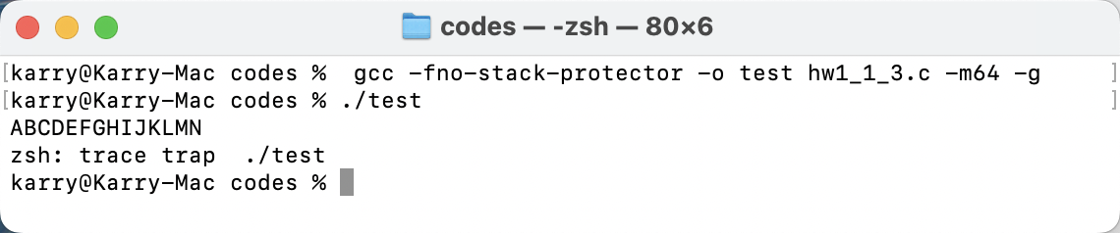

**Figure 2.** The stack memory map of question Ⅱ.



**Figure 3. “***Input twice*” solution for question Ⅱ[3].

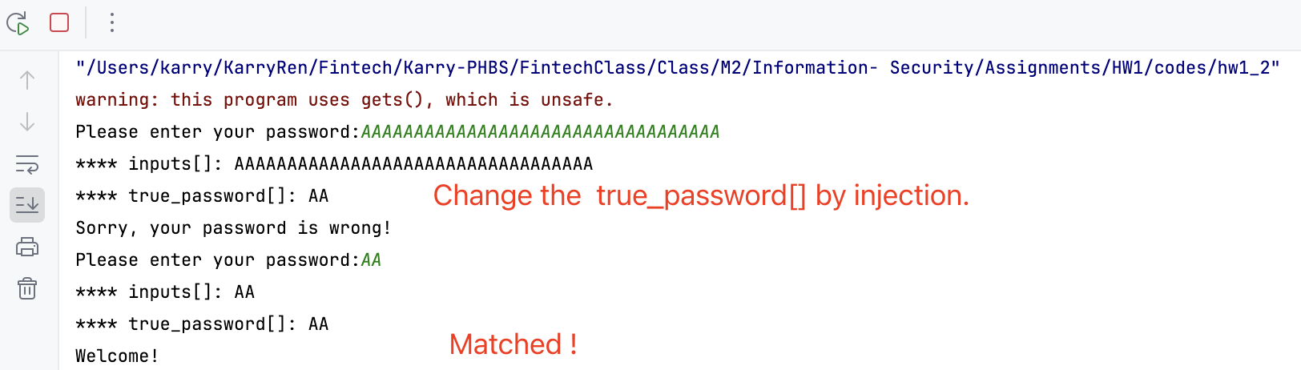

**Figure 4. “***Input once*” solution for question Ⅱ.

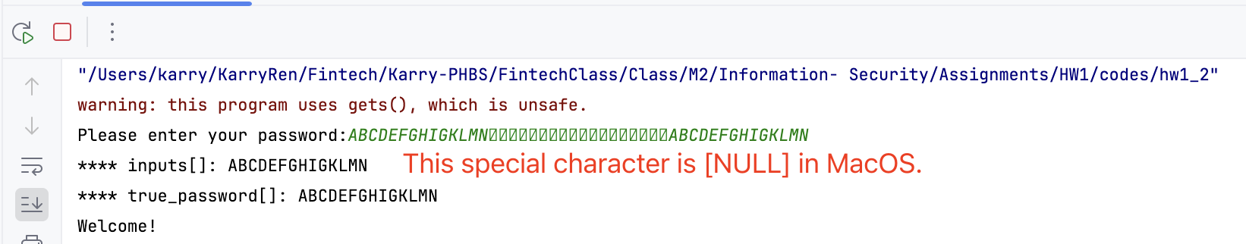

1. To present the elements in the code snippet more visibly, code content such as variables and functions are font-emphasized.
2. All of the runnable codes are released in <https://github.com/KarryRen/Information-Security-Project/tree/main/HW_Code/codes_hw1>
3. To make it easier to see, “**** XXXX” is printed as a comment. Figure 4 is the same.