**Fintech’s next decade will look radically different (Reading Article 7)**

*Ren Kai 2401212437*

**READING NOTES**

For the **Second Reading Assignment**, I select the **reading-article-7[1]** from the reading list to read. After completing the reading, I **summarize** this article and record **reading notes** as required by the assignment.

***SUMMARY.***

This article focuses on predicting the development of financial technology (fintech) in the next decade. Having seen the creation and evolution of fintech over the last decade, the author believes that fintech will look radically different in the next ten years. Although fintech was (and still is) heavily verticalized and recreating the offline branches of financial services by bringing them online and introducing efficiencies, the early signs have suggested that fintech will produce significant changes in four aspects: 1. Be portable and interoperable; 2. Become more ubiquitous and accessible; 3. Move to the background; 4. Centralize into a few places and steer on ‘autopilot’.

Specifically, the following **four** more nuanced predictions can be made. **The first is** for the open-source data level, where data will be openly portable and will no longer be a competitive moat for fintechs. With the change of legislation, the walls around siloed customer data in financial services are coming down, which is opening the playing field for upstart fintech innovators to compete with billion-dollar banks. **The second is** for the open protocol, where basic financial services will become simple open-source protocols, lowering the barrier for any company to offer financial products to its customers. Thanks to many “finance as a service” platforms and a number of open-source financial solutions, fintech companies no longer need to struggle to become their own experts at building financial protocols ancillary to their core services, but instead, they can get the licensing process, regulatory work and all the different payment-type networks directly. **The third prediction is** that fintech will become part of the basic functionality of non-finance products rather than standalone products. Just like the Apple Card, Amazon Pay, and Facebook Pay, consumers can get fintech services from the platforms with which they already have a direct relationship and unlock more value in them without managing finances separately. **The last prediction is** that consumers will access financial services from one central hub, such as a smartphone, QuickBooks, or Gmail. Having to interface with multiple fintechs separately is ultimately value subtractive, not additive, and the future products will be designed around customer-centric intuition while becoming ‘autonomous finance’ services.

All in all, there is no doubt that over the next decade, fintechs will fundamentally reshape the way we manage our finances and the extent to which we think about them. (388 words)

In order to understand the article summary more clearly, I have drawn a framework figure of the article as shown in **Figure 1**.



**Figure 1.** Framework of Reading Article 7.

***NOTE.***

In the last two weeks of class, we have been learning in-depth about some of the many areas in which fintech products are being used. As this article mentioned, in the decade between 2010 and 2019, fintech made the leap from 0 to 1, with numerous related innovations rushing out. Five years on from the article, many of the predictions mentioned in the article have indeed come true, with fintech becoming more portable, protocols more harmonized, and developments more standardized. At the same time, the development of embedded fintechs has also become more mature. However, the open-source data with high quality is still precious. While much of it is publicly available, as predicted in the article, some of the larger, more comprehensive data is still a moat for fintech companies and an important part of what makes some of their products great.

The rapid development of AI in recent years may not have been anticipated by the author of the article, and I believe that with the support of AI, the development and innovation of financial technology will be faster and faster, and the application forms will be more diversified. Financial data will still be the moat of each company in the short term, and the characteristics of the data might determine the effectiveness of service products.

**QUIZ QUESTIONS AND ANSWERS**

***Q1.*** *What did Fintech look like in the past?*

***Answer:***

As Figure 2 illustrates, the term “fintech” was not widely recognized before 2014. Just like the author said: “When I started working in fintech in 2012, I had trouble tracking competitive search terms because no one knew what our sector was called”.

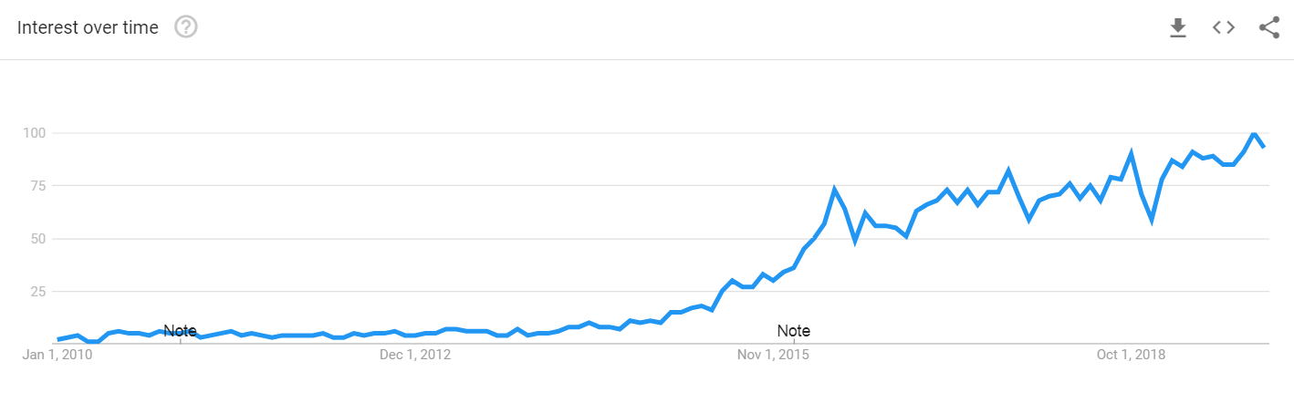

**Figure 2.** Google search volume for “fintech”, 2000-2019.

Fintech has since become a household name, a shift that came with prodigious growth in investment: from $2 billion in 2010 to over $50 billion in venture capital in 2018 (and on-pace for $30 billion+ in 2019). During this time of rapid growth, fintech was (and still is) **heavily verticalized**, recreating the offline branches of financial services by bringing them online and introducing efficiencies.

***Q2.*** *What are some of the general directions in which services enabled by fintech may change in the next decade?*

***Answer:***

In this article, the author argues, based on some early signs, that the fintech services will move in the following four directions:

1. *Be portable and interoperable*: Like mobile phones, customers will be able to easily transition between ‘carriers’.
2. *Become more ubiquitous and accessible*: Basic financial products will become a commodity and bring unbanked participants ‘online’.
3. *Move to the background*: The users of financial tools won’t have to develop 1:1 relationships with the providers of those tools.
4. *Centralize into a few places and steer on ‘autopilot’*: Consumers will access financial services from one central hub, and the fintech will know the consumers’ financial position better than them.

***Q3.*** *What are the author’s specific predictions for fintech in the next decade?*

***Answer:***

The author of this article gives four specific predictions at four levels.

1. *For the open data layer*: Data will be openly portable and will no longer be a competitive moat for fintechs.
2. *For the open protocol layer*: Basic financial services will become simple open-source protocols, lowering the barrier for any company to offer financial products to its customers.
3. *More embedded fintechs*: Fintech will become part of the basic functionality of non-finance products.
4. *Bring fintech all together*: Consumers will access financial services from one central hub.

***Q4.*** *Why does the author predict that the data will be openly portable?*

***Answer:***

As the author mentioned in the article, the walls around siloed customer data in financial services are coming down, which is opening the playing field for upstart fintech innovators to compete with billion-dollar banks, and it’s happening today.

The main reason for this phenomenon is the relatively obscure piece of legislation in Europe, PSD2. The policy requires all large banks to make consumer data available to any fintech which the consumer permissions. This greatly expands the volume of open-source data.

(Although the author of this article is very optimistic about the development of open-source policies for financial data, the actual situation in recent years has shown that the large-scale open-source of financial data still faces lots of difficulties, such as privacy protection.)

***Q5.*** *What is embedded fintech and how will it evolve in the future?*

***Answer:***

The concept of embedded fintech is that financial services, rather than being offered as a standalone product, will become part of the native user interface of other products, becoming embedded.

The embedded fintech will be the next layer of the ‘stack’ to build on top of the internet, cloud, and mobile, which allow consumers to unlock more value in the applications without managing their finances separately. Technology companies and large consumer brands will become gatekeepers for financial products, which themselves will move to the background of the user experiences.

1. https://techcrunch.com/2019/12/22/fintechs-next-decade-will-look-radically-different/