**1. Intro.** **(1) Introduction and Historical Trends.** *Non-organic Growth and M&A.*Inorganic growth occurs when a company grows by merging with or acquiring other businesses. (M&As are a much faster way of growing a company than organic growth). M&A is one of the most important means by which companies **r**espond to changing conditions. *Merger Waves.* Mergers have typically occurred in cyclical patterns. 1965-69: Known as the conglomerate (联合体) wave, 经济形势好, 收购大批不相关公司. 1981-89: Known for the hostile takeovers. 出现了一些恶意收购, LBO债务融资很常见. 1992-99: Known for the “strategic” mega-merger, 重视长期利益, 债务融资很少见. 2003-08: Shareholder Activism and Rebirth of Leverage, Highly leveraged buyouts and complex securities, Syndicated (银团) loan and excessive lending. Why Waves? Neoclassical Hypothesis: Economic disturbance leads to industry reorganization; Q (the ratio of market to book value) Theory of Mergers (高 Q 并购低 Q). Behavior Hypothesis: Stock Market Misvaluations drive waves; Bidders with overvalued stock to use the stock to buy assets of undervalued targets; Why anticipate? Herding (羊群) Behaviors; Deals completed late in waves tend to show lower acquirer returns. **(2) Why M&As Happen?** *“Better” Reasons Synergies.* Eco-nomies of Scale and Scope: 产生更大规模, This lowers the cost/good since any fixed costs are distributed over more units. Vertical Integration: Vertical integration is the merger of two companies involved in different stages of the production process of the same good (合并后目标一致). Expertise: Purchase “talent" as an already functioning unit by acquiring an existing firm (Acquiring human capital and innovation). Efficiency Gains: Efficiency gains are often achieved through an elimination of duplication (管理团队效率低就可以撤换掉他们, 调整发展逻辑). Tax Savings: 一个部门亏损可以抵消另一个部门的利润. *“Worse” Reasons to Acquire.* Monopoly Gains: 市场上少了一家公司, 竞争少, 利润高 (有搭便车现象, 毕竟只有收购方需要付钱). Diversification: Risk Reduction (分散化降低风险, 但完全可以通过分散投资实现), 公司过大导致效率降低. Earnings Growth: Acquirer can raise its earnings per share by acquiring a company with low growth potential. 收购低估值公司后高估值公司的EPS上升, 但没有任何经济价值. Managerial Motives: Under the conflict of interest explanation, managers know they are destroying shareholder value, but personally gain from doing so. Under the hubris hypothesis (overconfidence), managers believe they are doing the right thing for shareholders.

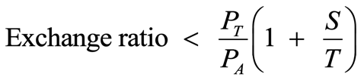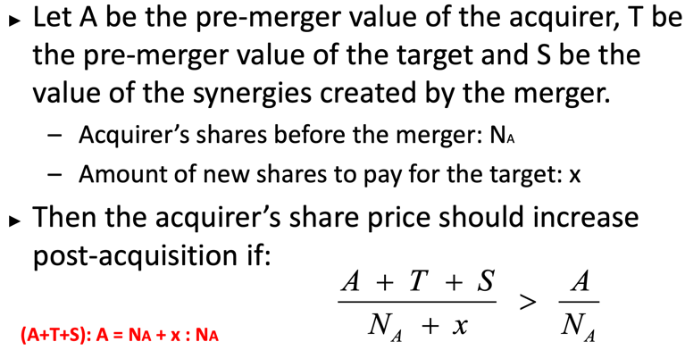**2. Takeover Process and Defense. (1) Takeover Process.** *1) Valuation.*Valuation of Target.市场有自己的判断. It is important to use the un-affected target price: the price before market got wind of the takeover. 价格为公司原价值加溢价. The price paid for a target is equal to the target’s pre-bid market capitalization plus the premium paid in the acquisition. Condition for positive-NPV takeover. 支付的溢价比共生价值少就赚了. Target 的股价波动体现市场观点. *2) The Offer.* Two principal ways. Friendly: over a cocktail with the target's management/board; Hostile: an offer made directly to the share-holders of the target. Two methods to pay. Cash; Stock: In a stock-swap transaction, the bidder pays for the target by issuing new stock and giving it to the target shareholders. 这个地方Exchange Ratio 是必考点, 直接套公式即可. *3) Merger “Arbitrage”.* Average price reaction of the target firm to a takeover is 15%, while the average premium paid is 43% (没有突然跳跃的原因在于交易能否成功的不确定性). Risk-arbitrageurs. 因为不确定性, Target估值可能偏低, 就可以通过做多Target股票, 做空Acquirer股票赚取Merger-Arbitrage Spread. 但如果合并失败, Target估值跌, Acquirer股票涨, 会亏. Appraisal arbitrage. HFs acquire shares of announced target firm with the expectation that the Court determines that the fair value is higher than the merger price. 有些股东对收购价格有异议, 会向法院提起诉讼. 在这之前HFs收购了无异议的股东股票, 期待法院裁定更高价格套利. *4) Tax and Accounting Issues.* Target的股东需缴资本利得税. The difference between the purchase price and the sum of the fair value of the net assets is by definition the value of the "goodwill" of the purchased company. *5) Board and Shareholder Approval.* 就算有溢价, 董事会也可能会反对(自己价格没体现出来, 对方价格被高估). **(2) Takeover Defenses.** 对于恶意收购而言, 收购方和目标方可能有Proxy Fight: Schedule 14A (代理声明); Third-party proxy solicitor; Stock transfer agent (aggregate votes); Forward to target corporate secretary before shareholder’s meeting. Target有如下方法保护自己. *1) Poison Pills (Shareholder rights plan).* It is a right offering that gives the target shareholders the right to buy shares of either the target or an acquirer at a deeply discounted price. Flip-over rights (买Acquirer’s), Flip-in rights (买Target’s), Golden handcuffs (期权), Refund guarantees (退款). Goal. 防止bidder绕过董事会和股东直接交易, 争取时间获得更高估值. *2) Staggered Board (Classified Board).* 按类别将董事会错开, 恶意收购者需连续获得代理权竞争, 才能取得控制. 是一种有力手段, 保护管理层. 但很少被用. *3) White Knight.* 为防止恶意收购, 找一家友好的公司收购, 保全管理层. White Squire. 找大投资者购买大量股份, 享有特殊投票权, 但无控制权. *4) Golden Parachutes.* 公司被收购后保证给管理层一大笔遣散费. 实证表明其能创造价值, 可以减少管理层的固化. *5) Recapitalization.* 改变资本结构降低吸引力, 比如发债回购股票. *6) Greenmail.* 从特定股东手中回购股票, 减少公司价值. *7) Other Way.* 要求超多数票 (80%), 限制大股东投票权, 要求“公平”价格.

**3. Does M&A create value?** **(1) Does M&A pay?** Acquisition premium (Offer Premium). The acquisition premium is the percentage difference between the acquisition price and the pre-merger price of a target firm. *Premium average 23%, Reac-tion: Target 15%; Acquirer 1%.* Difference between Premium and Target price reaction: Run-up & Uncertainty. Difference between Target and Acquirer returns: Size effects & Uncertainty on synergy & Structural problem. 溢价已经基本就是其价值增长了, target公司股东获得了这个收益. *1) The Free Rider Problem.* The problem is that existing shareholders do not have to invest time and effort, but still participate in all the gains from the takeover that the corporate raider generates, hence the term “Free Rider Problem.” *2) Post-takeover Dilution.* 解决搭便车问题的方式. Two-tiered tender offer: The first tier is a bid b while the back end is a minority buyout at a lower value vd<v. If fair price rules prevent the minority buyout to take place at a price below the front-end price, acquirers can use Freeze-out/Squeeze-out merger (获得大多数股份后, 可强制并购). self-dealing (“asset tunneling”) 损害小股东利益. *3) Pre-takeover Toehold.* not announce anything and simply acquire the 50% stake anonymously through the market (正式谈判前悄悄从二级市场购买足够多的筹码). An initial ownership stake in a firm that a corporate raider can use to initiate a takeover attempt. SEC rules 强制过5%要公开信息. Why does toehold disappear? Cost from information leakage. *4) The Leveraged Buyout.* Instead of using his own cash to pay for these shares, he borrows the money and pledges the shares themselves as collateral on the loan. The law allows the corporate raider to attach the loans directly to the corporation (控制后将债务直接加到公司里). LBOs 并非纯债务融资, 只不过大部分是债务. *5) Competition.* The most likely explanation for large premium is the competition that exists in the takeover market.

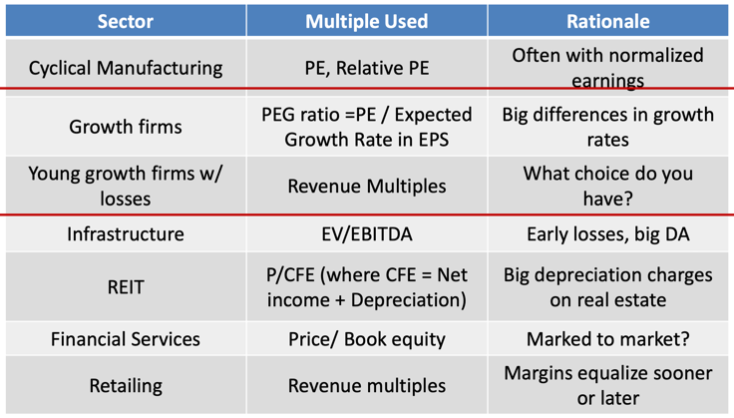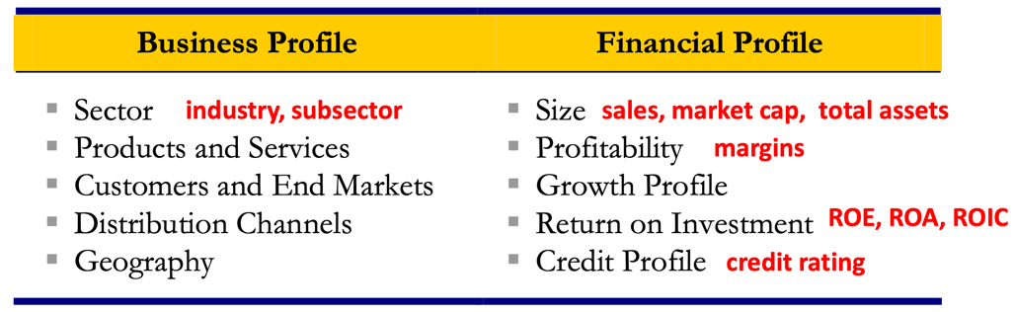**4. Valuation (1).** **(1) Why Relative Valuation?** Relative Valuation is pervasive. Pros: Market-based (数据全部来自真实市场); Relativity (相对性强, 容易直接比较); Quick and convenient (计算所需条件很少); Current (实时性强, 甚至可以做到日内更新). Cons: Market-based (非理性繁荣或熊市中估计不准确); Absence of relevant comparables (找不到可对比公司); Potential disconnect from cash flow; Company-specific issues. **(2) Five Steps to Relative Valuation.** *1) Select the Universe of Comparable Companies.* Identify Key Characteristics of the Target for Comparison Purposes (Business & Financial). *2) Locate the Necessary Financial Information.* Valuation is driven on basis of both historical performance (Financial Statement) and expected future performance (Research Report). *3) Spread Key Statistics, Ratios, and Trading Multiples.* Market Valuation. Equity Value = Share Price * Full Diluted Sharing Outstanding (Basic Shares Outstanding + “In-the-Money” Options and Warrants + “In-the-Money” Convertible Securities). Number of shares repurchased is less than additional shares outstanding from exercised options. 股价 20, 期权行权价 18, 股数 100, 期权数 5, 实际股票数=100.5. Convertible and Equity-Linked Securities. Incremental Share = Amount Outstanding / Conversion Price. Enterprise Value. = Equity Value + Total Debt + Preferred Stock + Noncontrolling Interest – Cash and Cash Equivalents (从购买方角度, 现金折价) Independent of capital structure (MM Theory). Key Financial Data. sales, gross profit, EBITDA, EBIT, and net income; Profitability: Sales, Gross profit (Usually expressed as percentage of sales), EBITDA (Earnings Before Interest, Taxes, Depreciation and Amortization), EBIT, Gross Profit Margin (毛利率) and Net Income Margins (净利率). Growth Profile: Historical and estimated growth rates. Compound annual growth rates (CAGRs 复合年增长率). Return on Invest-ment: ROIC (Return on Invested Capital= EBIT/(Average Equity+Debt)), ROE (Return on Equity=Net Income/ Average Shareholder’s Equity), ROA (Return on Assets=NI/Average Total Assets), and Dividend Yield (Most Recent Quarterly Dividend Per Share*4/Current Share Price). Credit Profile: Leverage ratios (Debt/EBITDA), Debt-to-Total Capitalization = Debt / (Equity+Debt+ Preferred Stock+ Noncontrolling Interest), Coverage Ratios (EBIT/利息), and credit ratings. Equity Value Multiples. PE=Market Price per Share/Earnings per Share (Negative Earning: Drop, Use Median Ratio, Average PE then reciprocal). Enterprise Value (EV) Multiples. EV/EBITDA & EV/EBIT. EV/EBIT is less commonly used than EV/EBITDA due to differences in D&A among companies. (PE 更好操控, 但对加杠杆的公司不利). *Why do we use sector-specific multiples?* More intuitive way of estimating value; Accounting differences across countries; None of the other multiples can be estimated or used *4) Benchmark the Comparable Companies.* Benchmark Financial Statistics and Ratios: 通过财务数据和比率分析多家公司, 选择关键指标较接近的, 分析既需定量又需定性. Benchmark the Trading Multiples: 循环所有公司, 计算多个比率取均值, 中位数, 两端值. 一般选择 median 做为 reliable comparison point. 可能会出现 outliers (可直接剔除, 但如果明显有偏, 需要谨慎考虑). *5) Determine Valuation.* Use means and medians of most relevant multiple for sector to extrapolate range of multiples. Must also determine which period financial data is most relevant for calculating trading multiples.

**5. Valuation (2). (1) Why Precedent Transactions Analysis?** Pros: Market-based (数据全部来自真实案例, 相似度高); Relativity (有直接参考); Current (最近的交易有时效性); Simplicity (一些关键特征可以直接做为估值基础); Objectivity Cons: Market-based (multiples may be skewed depending on capital markets and/or economic environment at the time of the transaction). Time lag; Existence of comparable financing round; Investor’s basis for valuation. **(2) Five Steps to Precedent Transactions Analysis.** *1) Select the Universe of Comparable Acquisitions.* Locate as many potential transactions as possible. Specific circumstances and context for each transaction (识别每一个的特殊性). Market Conditions (业务, 宏观环境和金融市场). 结合交易所在周期来看. Deal Dynamics. Type: Strategic buyers traditionally can pay higher purchase prices than financial sponsors due to potential ability to realize synergies; Motivation; Process: Auctions are designed to maximize competitive dynamics. Consideration: Stock tends to result in lower valuation than all-cash transaction as target shareholders retain equity interest in combined entity. *2) Locate the Necessary Deal-Related Information.* 按照法律披露公开信息可查, 但有的会出于保密无法查找. Sources for Public Target Information: Proxy Statement for One-Step Merger Transaction (发给股东的材料); Schedule TO (Acquire)/Schedule 14D-9 (Target); Registration Statement/Prospectus (S-4, 424B) (增股收购时的声明); Schedule 13E-3; 8-K, 10-K, 10-Q & Research. Sources for Private Target Information: 没有披露要求, 根据情况获取. *3) Spread Key Statistics, Ratios, and Trading Multiples.* 拆分关键指标, 计算股票价值和公司价值, 分析Synergy. Equity value used as multiple of net income (or offer price per share as a multiple of diluted EPS). Enterprise value (or transaction value) is used as multiple of EBITDA, EBIT, and sales. Multiples in precedent transactions are typically higher than those in trading comps (Premium paid for control & Synergies). Closest comparables are generally those most similar to target in terms of business and financial profile. Valuation from Precedent Transactions is likely to be higher than relative valuation due to synergy (premium) consideration.

**6. Valuation (3). 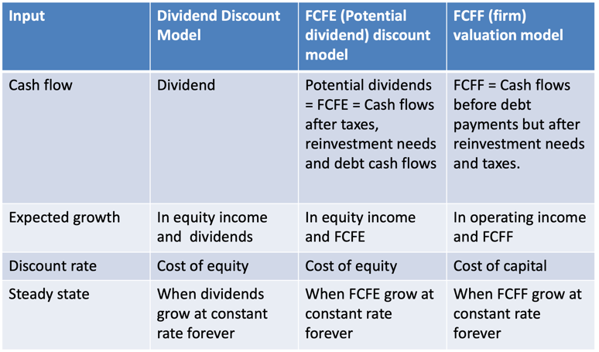(1) DCF Overview.** Firm Valuation: 现金流是还Debt前的, 贴现率是考虑Debt和Equity综合的. Equity Valuation: 现金流是还Debt后的, 贴现率只考虑Equity. 核心是不要错误匹配现金流和贴现率! *Free Cash Flow:* The cash that a company is able to generate after laying out the money required to maintain or expand its asset base (一般会估计5年, 并估算Terminal Valuation). *Pros&Cons:* Cashflow-based (更fundamental, 展现真实的FCF); Market independent (不受市场aberrations异像的影响); Self-sufficient (不依赖可比公司); Flexibility (可分析更全面的情形) | Dependence on financial projections (需要较为精准的分析预测); Sensitivity to assumptions (小变动导致大差异); Terminal Value; Assumes constant capital structure. *Two standard problems.* No Market Value: Equity & Debt 没有交易记录, 无法估计. Cash Flow Estimation: Shorter history & Different Accounting Standards. **(2) DCF Steps.** *1) Study the Key Performance Drivers.* Determine key drivers (management, brand, customer base, operational focus, product mix, sales/marketing strategy, scale, and technology) of a company’s performance (sales growth, profitability, and FCF generation). *2) Project Free Cash Flow.* FCF=(EBIT*(1-t)+D)-CAPX-dNWC=((S-C-D)*(1-t)+D)-CAPX-dNWC. Considerations. historical perfo, projection period length. Sales Projections. Top-Down Approach: Market size*Market share, Bottom-Up Approach: Capacity size*Unit sales. CAGR=(End V/Start V)^(1/years)-1. 基于研报和行业报告预估销售额增长速度. COGS and SG&A. 基于过往数据估计一个固定的与Sales的比. EBITDA and EBIT. 同上. Tax. 采用Marginal Rate, 但也需参考公司情况. Net CAPX. (Capital expenditures – Depreciation). 估计其占Sales的比. Funds that a company uses to purchase, improve, expand, or replace physical assets such as buildings, equipment, facilities, machinery, and other assets. Depreciation & Amortization. 非现金折旧, D-PP&E, A-intangible assets. dNWC. NWC=Current Asset-Current Liabilities. 假设流动资产和负债的占比和收回时间, 进行估计. NWC 极少情况下为负, 需要设为 0. Free Cash Flow to Equity. =FCF-(Principal Repayments - New Debt Issues). *3) Calculate WACC.* Discount rate should ref-lect the risk perceived by the marginal investor in the company. Cost of Equity. CAPM, APM(Arbitrage Pricing Model), Multi-Factor(FF 3 fators). Re=Rf+βL(Rm-Rf). 奢侈品, 固定成本高, 杠杆高的β大. 资本结构不同, 先找类似公司算多个无杠杆的βU, 然后均值后得到平均βU, 再加杠杆得到目标公司βL. βU=βL/(1+D/E(1-t)), βL= βU*(1+D/E(1-t)). Cost of Debt. Company’s cost of debt reflects its credit profile at the target capital structure. Based on a multitude of factors including size, sector, outlook, cyclicality, credit ratings, credit statistics, cash flow generation, financial policy, and acquisition strategy. Way:到期收益率;评级, 根据评级得到风险利差,Rd=Rf+利差. WACC=(Rd*(1-t))*D/(D+E) +Re*E/(D+E). *4) Determine Terminal Value.* Use terminal value to capture the value of the company beyond the projection period. Exit Multiple Method (EMM). Calculates the remaining value of a company’s FCF produced after the projection period on the basis of a multiple of its terminal year EBITDA (or EBIT). Terminal Value=EBITDA*Exit Multiple. Perpetuity Growth Method (PGM). Calculates terminal value by treating a company’s terminal year FCF as a perpetuity growing at an assumed rate. Terminal Value=FCF*(1+g)/(r-g). Expected Growth in NI = Eq. reinvestment rate X non-cash ROE; Eq. reinvestment rate = (Net Capex + Change in WC – Net Debt) / NI; ROE = (Net income - Cash) / (BV Equity- Cash). *5) Calculate Present Value and Determine Valuation.* Perform Sensitivity Analysis (WACC, exit multiple, g 变化分析). *6) Valuing Synergy.* The firms involved in the merger are valued independently, by discounting expected cash flows to each firm at the weighted average cost of capital for that firm. The effects of synergy are built into expected growth rates (增加增长速度), cash flows (FCF各个部分都改善), cost saving (WACC 各个环节优化), and the combined firm is revalued with synergy. 如果 Synergy 需要很久后才展现, 那就需要考虑时间因素贴现.

**7. Cross-Border Acquisition. (1) Motivations for international expansion.** *1) Geographic and Industrial Diversification.* 在和现有产品关联性不大的国家或企业投资, 减少收入波动性和成本. *2) Accelerating Growth.* *3) Industry Consolidation.* 产业融合带来规模经济. *4) Utilization of Lower Raw Material and Labor Costs.* *5) Leveraging Intangible Assets.* *5) Minimizing Tax Liabilities.* *6) Avoiding Entry Barriers:* 绕过国内保护, 直接经营. *7) Fluctuating Exchange Rates. 8)* *Following Customers.* 适应顾客的需求. **(2) International Market Entry.** *1) M&A.* 比较快速, 但受限于监管文化等问题, 成本高昂. 发生条件: 财产受法院保护; 目标公司市场占有大, 知识丰富; 进入门槛高, 文化差异小; 目标规模小, 收购方进入市场时间晚. *2) Solo Ventures.* 直接跨国开新公司, 风险高但是掌控力强. 发生条件: 进入门槛低, 文化差异大; 创业者经验丰富. *3) Joint ventures.* 共担风险和成本, 容易因冲突失败. 发生条件: M&A 难拆分资产问题多; 创业者经验资源少, 希望有更大的灵活性; 文化差异大. *4) Exporting.* 无需当地经营, 必须建立开拓市场和分销方法, 运输成本高, 汇率波动. 发生条件: 本地运营成本高, 创业者经验少, 风险厌恶. *5) Licensing.* It allows a firm to purchase the right to manufacture and sell another firm’s products within a specific country or set of countries. 获得代理权分销. . **(3) Structuring Cross-Border Deals.** *1) Acquisition Vehicles.* Common-law countries (UK, Canada, Australia,

India etc.): use corporation-like structure; Civil-law countries (Western Europe, South America, Japan, Korea): use share company or LLC; EU: smaller firms often use LLC (flexible law) while larger firms use share companies (more restrictions but freely traded shares). *2) Form of Payment.* cash rather than shares. Shares 流动性差, 收购双方信息不对称. 资产销售有时是困难的, 比如强制要求聘用员工. *3) Tax Strategies.* 至少持有US目标公司80%股份才能按照US纳税. Forward triangular merger. 将目标公司合并到US的子公司中, 实现Cash和Share的分类发放; Reverse triangular merger. 分离出目标公司债务将在US的子公司合并到其中. Hybrid transactions. 购买优先股的免税, 销售股票换现金需纳税. *4) Financing.* Debt: 最常用; Equity: American Depository Receipt (ADR), 向美银行发股融资. *5) Planning and Imple-menting.* 有一系列风险. 汇率波动, 自由程度. Using Options and Contract Language to Manage Risk.

**8. M&A and Corporate Restructuring. (1) Corporate Financial Distress and Bankruptcy.** Financial Distress: When a firm has difficulty meeting its debt obligation. Bankruptcy: A firm is technically insolvent if it is unable to pay its liabilities as they come due. *Financial distress cost.* 完美的无摩擦市场破产无损失, 但实际不会. Direct cost of bankruptcy: process is complex, time-consuming, and costly (experts, creditors). Indirect cost of bankruptcy: Customers, Suppliers, Employees, Receivables, Fire Sale of Assets, Delayed Liquidation, Costs to Creditors. 成本太高, 需要协商, 不破产, 少损失. *Resolu-tion.* Out-of court procedures: Reorganization-Extension(延期), Composition(重组), Debt for equity swap. Liquidation. Merger into another firm; Formal legal proceedings: Bankruptcy is designed to **Protect** failing firms from lawsuits by its creditors until decision made to shut-down or continue to operate the firm; Provide creditors with an **efficient** way of recovering what they are owed. *Procedure.* Chapter 7: deals with liquidation and defines priority in which creditors will be paid; Chapter 11: deals with reorganization and provides for the debtor to remain in possession, unless court rules otherwise. Priority: Secured creditors, Unsecured creditors, Preferred, Common. *Chapter 11 Target.* Asset restructuring. 无偿获取, 促进出售(Section 363通过法律的方式保证资产合理出售). Acquisitions (恶意收购很难, 并合双方都有收益). Swe-den’s mandatory auction system (拍卖按出价决定). *Determinants.* Going concern | Sale | Liquidation value. Informa-tion asymmetries; Holdout problems (拒绝支付); Various conflicts of multiple layers of creditors; Direct/Indirect cost; 信息差少, 冲突小, IP多就更偏向于庭外restructuring而不是破产. **(2) Distressed Acquisitions and Restructuring.** *1) FireSale Acquisitions.* What is fire-sale? 清仓甩卖. An urgent sale in an illiquid market; Financially constrained seller combining with industry-wide distress causes a fire-sale. Effects. 更高的回报, 竞争对手损失. *2) Distressed debt investment.* a hedge fund acquires the debt of a distressed borrower with the intention of converting the acquired position into a controlling equity stake upon the firm’s emergence from Chapter 11. Hedge funds prefer companies in which secured debt is more likely to be overcollateralized. 对冲基金增加重组成功的可能性. *3) Alternative Restructuring Strategies.* Divestiture, spin-off, split-up, equity carve-out, split-off, and tracking stock strategies. Motives: deconglomeration/increase corporate focus; Moving away from the core business; Assets are worth more to the buyer than to the seller; Satisfying government requirements; Correcting past mistakes; Assets have been interfering with profitable operation of other businesses. Divestiture: 出售资产, 带来现金. Spin-Off: 将状况好的业务拆出来, 股东直接获子公司股份. Equity carve-out: 销售子公司股票筹集资金. Split-off: 成立子公司, 拿母公司股份换子公司股份. **9. M&A and stakeholder.** (1) Breach of Trust in Takeover. 欺诈后财务上没区别但social consequences区别很大. *Implicit Contracts.* 隐性的承诺(保证工作), 无约束, 收购后现任mgt没有动力维护. *The role of long-term employment relationships.* Risk-sharing, Loyalty. **(2) Labor-unfriendly side.** Acquirers improve targets’ TFP by cutting back on wages, employment, and capital expenditures and by increasing investment efficiency. *Private Equity’s LOB.* 通过发债收购, 完成后削减工资还债, 就业率下降. (3) Managers, Workers, and Corporate Control. 当Manager和Workers利益一致时, 管理者会更加重视工人利益, 共同抵抗并购者. *Employee Stock Option Plan (ESOP).* Create a worker-management alliance. 联合反对, 组织并购. *Employees’ Lobbying.* 即使员工没有股票也可以通过游说维护不被并购. **(4) CSR and Stakeholder Value Maximization.** Corporate social responsibility (CSR) has become an important part of U.S. firms’ operation over the past decade. Mixed evidence on the relations between CSR and firm performance (但这可能是reverse causality). 合并时CSR影响股东价值的一个维度. CSR 越高, 股票回报越高, 经营业绩和长期回报, 并购完成时间短, 成功率高, 受益者多, 解雇人员少,