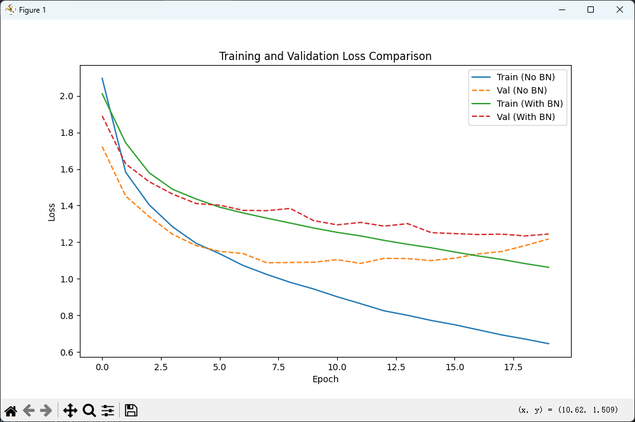

Test Accuracy (No BN): 61.67%

Test Accuracy (With BN): 56.16%