##### 一、单项选择题（本大题共20小题，每小题1分，共20分）

##### 提示：在每小题列出的四个备选项中只有一个是符合题目要求的，请将其代码填写在下表中。错选、多选或未选均无分。

|  |  |  |  |  |  |  |  |  |  |
| --- | --- | --- | --- | --- | --- | --- | --- | --- | --- |
| **1** | **2** | **3** | **4** | **5** | **6** | **7** | **8** | **9** | **10** |
|  |  |  |  |  |  |  |  |  |  |
| **11** | **12** | **13** | **14** | **15** | **16** | **17** | **18** | **19** | **20** |
|  |  |  |  |  |  |  |  |  |  |

1. Software is . (c)  
   a) set of programs  
   b) documentation and configuration of data  
   c) set of programs, documentation & configuration of data  
   d) None of above
2. Which one of the following is a functional requirement? (d)  
   a) Maintainability  
   b) Portability  
   c) Robustness  
   d) None of above
3. Which of the following is the best type of module coupling? （c）  
   a) Control Coupling  
   b) Stamp Coupling  
   c) Data Coupling  
   d) Content Coupling
4. Which is the first step in the software development life cycle ?（c）  
   a) Analysis  
   b) Design  
   c) Problem Identification  
   d) Development and Documentation
5. In Design phase, which is the primary area of concern ?(d)  
   a) Architecture  
   b) Data  
   c) Interface  
   d) All of above
6. Which model in system modeling depicts the dynamic behavior of the system ? (b)  
   a) Context Model  
   b) Behavioral Model  
   c) Data Model  
   d) Object Model
7. What is the first step of requirement elicitation? (a)  
   a) Identifying Stakeholder  
   b) Listing out Requirements  
   c) Requirements Gathering  
   d) All of above
8. What are the types of requirement in Quality Function Deployment(QFD) ? (d)  
   a) Known, Unknown, Functional  
   b) User, Customer ,Developer  
   c) Functional, Non-Functional  
   d) Normal, Expected, Exciting
9. Which of the following is not included in software requirement specifications?(c)  
   a) Performance  
   b) Functionality  
   c) Design solutions  
   d) External Interfaces
10. Which of the following does not apply to agility to a software process? (c)  
    a) Uses incremental product delivery strategy  
    b) Only essential work products are produced  
    c) Eliminate the use of project planning and testing  
    d) All of above
11. Which of the following activities of a Generic Process Framework provides a feedback report? (d)  
    a) Communication  
    b) Planning  
    c) Modeling & Construction  
    d) Deployment
12. Which of the following is a mechanism that allows several objects in a class hierarchy to have different methods with the same name? (b)  
    a) Aggregation  
    b) Polymorphism  
    c) Inheritance  
    d) All of above
13. Which of the following describes “is a kind of” relationship? (b)   
    a) Aggregation  
    b) Inheritance  
    c) Dependency  
    d) All of above
14. Which of the following interface design principles does not allow the user to remain in control of the interaction with a computer (d)   
    a) allow interaction to interruptible   
    b) allow interaction to be undoable   
    c) hide technical internals from casual users   
    d) only provide one defined method for accomplishing a task
15. White Box testing is also classified as （b）  
    a) Design based testing  
    b) Structural testing  
    c) Error guessing technique  
    d) None of above
16. Exhaustive testing is (c)  
    a) always possible  
    b) practically possible  
    c) impractical but possible  
    d) impractical and impossible
17. Boundary value analysis belongs to? (b)  
    a) White Box Testing  
    b) Black Box Testing  
    c) White Box & Black Box Testing  
    d) None of above
18. Which of the following is one of the steps in the integration testing of OO software? (a)  
    a) cluster testing  
    b) thread-based testing  
    c) use-based testing  
    d) none of above
19. An abstract class is ? （c）  
    a) A class that has direct instances, but whose descendants may have direct instances  
    b) A class that has direct instances, but whose descendants may not have direct instances  
    c) A class that has no direct instances, but whose descendants may have direct instances  
    d) All of above
20. Which diagram in UML emphasizes the time-ordering of messages? （b）  
    a) Activity  
    b) Sequence  
    c) Collaboration  
    d) Class

**二、判断题（本大题共10小题，每小题1分，共10分）**

##### 提示：正确打，错误打✗。

|  |  |  |  |  |  |  |  |  |  |
| --- | --- | --- | --- | --- | --- | --- | --- | --- | --- |
| **1** | **2** | **3** | **4** | **5** | **6** | **7** | **8** | **9** | **10** |
|  |  |  |  |  |  |  |  |  |  |

1. Object diagram captures the behavior of a single use case. (F)
2. A software engineer designs the user interface by applying an iterative process.（T）
3. Software Debugging is a set of activities that can be planned and conducted systematically. （F）
4. Spiral Model has user involvement in all its phases. （F）
5. In XP, the work on a task will be integrated into the whole system as soon as it is completed. （T）
6. A Use-case actor is always a person having a role that different people may play.（F）
7. Functional requirements capture the intended behavior of the system.（T）
8. Requirements elicitation is an iterative process.（T）
9. Activity diagrams are used to model the processing of data.(T)
10. The reason for reducing the user's memory load is make his or her interaction with the computer quicker to complete.(F)

##### 三、名词解释（本大题共5小题，每小题3分，共15分）

##### 提示：解释每小题所给名词的含义，若解释正确则给分，若解释错误则无分，若解释不准确或不全面，则酌情扣分。

|  |  |  |  |  |
| --- | --- | --- | --- | --- |
| **1** | **2** | **3** | **4** | **5** |
|  |  |  |  |  |

1. Regression Testing

Regression Testing is the process of testing the modified parts of the code and the parts that might get affected due to the modifications to ensure that no new errors have been introduced in the software after the modifications have been made. Regression means return of something and in the software field, it refers to the return of a bug.

2. Prototyping Model

The Prototyping Model is one of the Software Development Life Cycle Models. This model is used when the customers do not know the exact project requirements beforehand. In this model, a prototype of the end product is first developed, tested and refined as per customer feedback repeatedly till a final acceptable prototype is achieved which forms the basis for developing the final product.

3. QFD (Quality Function Deployment)

Quality function deployment (QFD) is a quality management technique that translates the needs of the customer into technical requirements for software. QFD concentrates on maximizing customer satisfaction from the software engineering process.

4. Refactoring

Refactoring is the process of changing a software system in such a way that it does not alter the external behavior of the code yet improves its internal structure.

5. Use Case

A use case is a software engineering term that describes how a actor uses a system to accomplish a particular goal. A use case acts as a software modeling technique that defines the features to be implemented and the resolution of any errors that may be encountered.

##### 四、问答题（本大题共2小题，每小题10分，共20分）。

##### 1. What does OCP (Open-Closed Principle) stand for? Please modify the following design model to avoid violation of OCP.

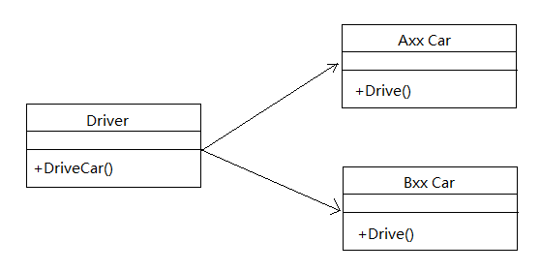

答：

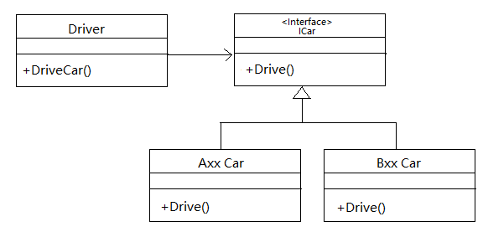

##### 2. What are the contents of user interface analysis ? (4分) Please describe them in detail. (6分)

##### 答：

##### User analysis, task analysis, content analysis , environment analysis.

##### User analysis means understanding the people (end-users) who will interact with the system through the interface ,

##### Task analysis means understanding the tasks that end-users must perform to do their work;

##### Content analysis means understanding the content that is presented as part of the interface;

##### Environment analysis means understanding the environment in which these tasks will be conducted.

**五．分析设计题（本大题共5小题，共35分）。**(无标准答案，根据回答情况酌情给分)

You are supposed to develop a hotel reservation system with following requirements:

**Customers can check available rooms ( rooms that are not booked). Customers can book one or more rooms with their names, phone numbers, check-in time and check-out time. Customers can check the room they reserved by their names. They may withdraw their reservation. System administrators can set up the type and number of rooms for customers to book. Reserved rooms cannot be booked by other customers for same time period.**

Please answer the following questions:

1. Identify your stakeholders.（5分）
2. What elicitation techniques will you to use to elicit the requirements of the system?（5分）
3. Draw a Use Case Diagram for the system.（5分）
4. Write a Use Case Specification for each use case.（10分）
5. Draw a Sequence Diagram to show object interactions when customers withdraw their reservation.（10分）