**编译原理第五次作业**

**任凯 2020141460080**

1. 考虑文法G(E)：



1. （2分）按顺序标注出在对串进行LR分析的过程中，每一步的句柄。

**答：**结果如下表所示：

|  |  |  |
| --- | --- | --- |
| RIGHT SENTENTIAL FORM | HANDLE | REDUCING PRODUCTION |
|  |  |  |
|  |  |  |
|  |  |  |
|  |  |  |
|  |  |  |
|  |  |  |
|  |  |  |
|  |  |  |
|  |  |  |
|  |  |  |
|  |  |  |
|  |  |  |
|  |  |  |

1. （3分）为这个文法构造LR(0)项目的DFA

**答：**对文法进行增广可得，进而根据**CLOSURE and GOTO**函数方法可得到如下图所示的DFA：

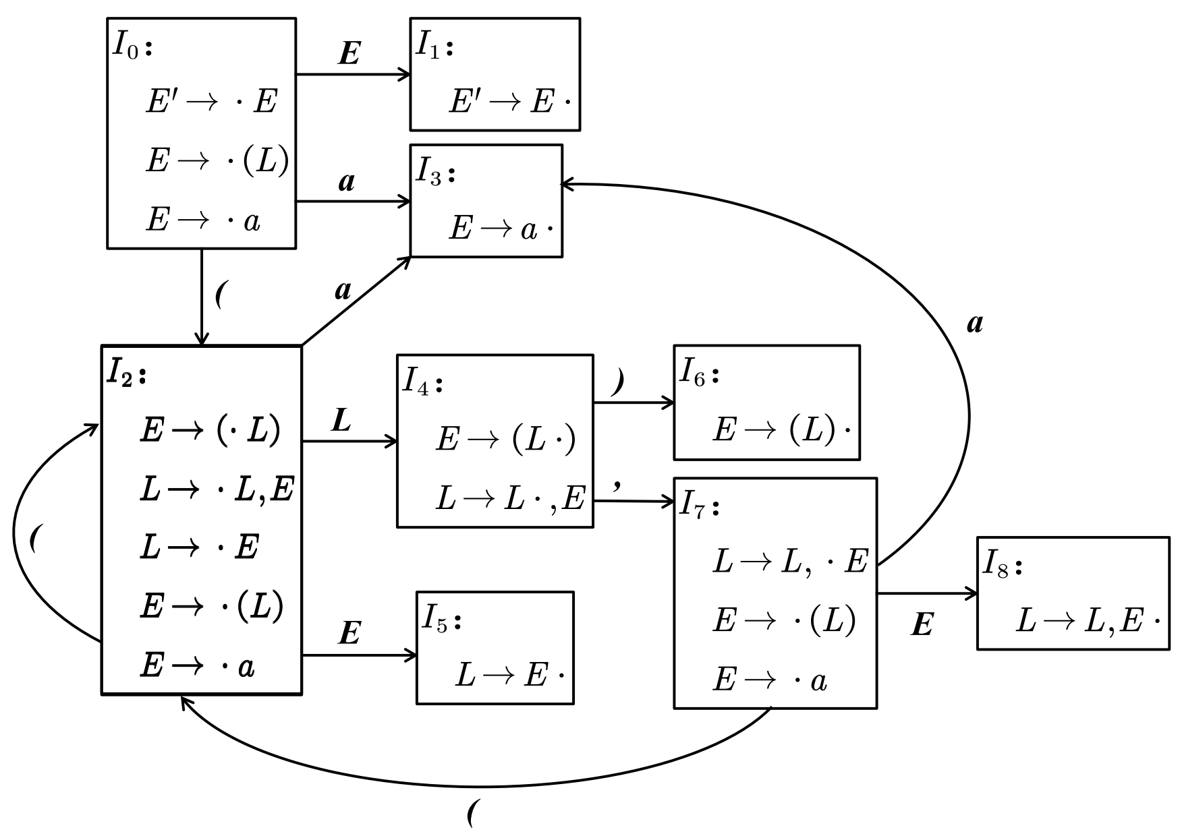

1. （5分）这个文法是不是LR(0)文法？请说明理由，并构造SLR(1)分析表

**答：**该文法是一个LR(0)文法：由上述DFA可知，文法G(E)的LR(0)自动机中的每个状态都不存在“移进-归约冲突”与“归约-归约冲突”。

|  |  |  |  |  |  |  |  |
| --- | --- | --- | --- | --- | --- | --- | --- |
| **STATE** | **ACTION** | | | | | **GOTO** | |
| ***(*** | ***)*** | ***a*** | ***,*** | ***$*** | ***E*** | ***L*** |
| 0 | s2 |  | s3 |  |  | 1 |  |
| 1 |  |  |  |  | acc |  |  |
| 2 | s2 |  | s3 |  |  | 5 | 4 |
| 3 |  |  |  |  |  |  |  |
| 4 |  | s6 |  | s7 |  |  |  |
| 5 |  |  |  |  |  |  |  |
| 6 |  |  |  |  |  |  |  |
| 7 | s2 |  | s3 |  |  | 8 |  |
| 8 |  |  |  |  |  |  |  |

1. （5分）按照（2）中构造的分析表对串进行LR分析，给出栈分析过程。

**答：**栈分析过程如下表：

|  |  |  |  |  |
| --- | --- | --- | --- | --- |
|  | **STACK** | **SYMBOLS** | **INUPT** | **ACTION** |
| (1) | 0 |  | ((a),a,(a,a))$ | shift |
| (2) | 02 | ( | (a),a,(a,a))$ | shift |
| (3) | 022 | (( | a),a,(a,a))$ | shift |
| (4) | 0223 | ((a | ),a,(a,a))$ | reduce by |
| (5) | 0225 | ((E | ),a,(a,a))$ | reduce by |
| (6) | 0224 | ((L | ),a,(a,a))$ | shift |
| (7) | 02246 | ((L) | ,a,(a,a))$ | reduce by |
| (8) | 025 | (E | ,a,(a,a))$ | reduce by |
| (9) | 024 | (L | ,a,(a,a))$ | shift |
| (10) | 0247 | (L, | a,(a,a))$ | shift |
| (11) | 02473 | (L,a | ,(a,a))$ | reduce by |
| (12) | 02478 | (L,E | ,(a,a))$ | reduce by |
| (13) | 024 | (L | ,(a,a))$ | shift |
| (14) | 0247 | (L, | (a,a))$ | shift |
| (15) | 02472 | (L,( | a,a))$ | shift |
| (16) | 024723 | (L,(a | ,a))$ | reduce by |
| (17) | 024725 | (L,(E | ,a))$ | reduce by |
| (18) | 024724 | (L,(L | ,a))$ | shift |
| (19) | 0247247 | (L,(L, | a))$ | shift |
| (20) | 02472473 | (L,(L,a | ))$ | reduce by |
| (21) | 02472475 | (L,(L,E | ))$ | reduce by |
| (22) | 024724 | (L,(L | ))$ | shift |
| (23) | 0247246 | (L,(L) | )$ | reduce by |
| (24) | 02478 | (L,E | )$ | reduce by |
| (25) | 024 | (L | )$ | shift |
| (26) | 0246 | (L) | $ | reduce by |
| (27) | 01 | E | $ | accept |

1. 已知一LR分析表如下所示，根据该表求出与之相匹配的文法G(S)

**答：**由表可知i在不断循环，k是终结符，所以与之匹配的文法应该是

