Homework（课堂练习）

Part 1
- Draw the program chart as following and Compute its cyclomatic complexity
j=0;
for (i=1; i<10; i++)
{
if ( buffer [i]<10000) j=j + buffer [i] * i;
}

2. Draw the program chart as following and Compute its cyclomatic complexity
If ( i>0 && x>1 || y>5) x:=x+y
else x:=y+i;

Part 2

1.Why is regression testing an important part of any integration testing procedure?
2.Describe object-oriented unit testing.
3.List four types of systems tests.
4.What are the key differences between validation testing goals and acceptance testing goals?
5.Why is a highly coupled module difficult to unit test?

Part 3

- What are the attributes of a good software test?
- Describe the differences between black-box testing and white-box testing.
- What is equivalence partitioning as it applies to software testing?
- Describe three control structure testing strategies.
- How does unit testing differ for object-oriented testing as compared to conventional software unit testing?
- Given the decision tree as follows：
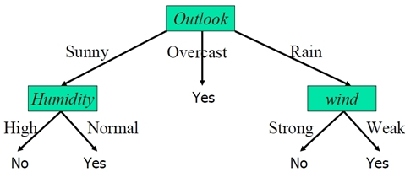
According the three conditions( Outlook, Humidity, Wind) to determine who will do exercise or not.
1) Draw the program chart with simple condition
2) Compute cyclomatic complexity
3) List a set of independent path for conducting basic path testing
4) Design test cases to conducting basic path testing

- Design a software game which is used to determine the edges of triangle is valid or not. The description of this game is as following:
- Startup picture is the ranking list of TOP 10 players. Press “OK” enter the game
- Three edges of triangle are generated randomly by the system. All the value of three edges are greater than 0.
- Press “Correct” button to identify all input is valid, that means the value of three edges can establish the triangle, otherwise press “Fault” button. If the choice is right, the player win 10 scores
- After 10 times operations, the game is over, the final score and runtime are displayed on the screen. If the score is TOP 10, a Pop-up window will be displayed to ask the player to input his/her name.

Please complete all the following designs:

1) Design all the User Interfaces of this game
2) Design the data mode of this game
3) Describe the scenario of playing game, and develop a complete use-case for it.

According to the definition of module ValidateTriangle, complete all the following designs:
Module name: ValidateTriangle(a,b,c)
Input Paramater: three edges of triangle(a>0,b>0,c>0)
Return Value: if Triangle is valid return True, otherwise return false
4) Draw the program flow chart of this module with simple condition (not need to describe the program code of this module)
5) Compute Cyclomatic complexity of this module.
6) In order to test the correctness of this module, List a set of independent path for conducting basic path testing.

