《数字逻辑（双语）》2023年下学期第一次平时测试题及答案
（2023年11月8日）

1. Choose the best answer from the four choices. (20points)
(1) Which one is the negative logic? ( C )
A.H=1,L=1 B.H=1,L=0 C.H=0,L=1 D.H=0,L=0
(2)In a given digital waveform, the period is four times the pulse width, then the duty cycle is ( C ).
A.20% B.50% C.25% D.100%
(3)In the 2’s complement form,the binary number 11010110 is equal to the decimal number ( B ).
A.-41 B.-42 C.-86 D.+214
(4) (5B7A)₁₆，whose the third character B has a bit weight of ( B ).
A.(2816)₁₀ B. (256)₁₀ C. (4)₁₀ D. (100)₁₀
(5) Which method can be used in digital systems to convert subtraction operations to addition operations. ( C )
A. Original code B. ASCII code C.Complement code D. BCD code
(6)As shown in the figure,which logical relationship is reflected.( B )
A.AND B.XOR C.OR D.XNOR
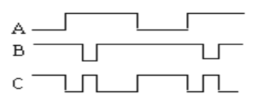
(7)The same is”1”,the difference is “0”,what is its logic relationship?( D )
A.AND B.OR C.XOR D.XNOR
(8) Which is correct about 8421BCD code operation. ( D )
A.00111000 + 10000011 = 10111011 B. 11001001 + 00000001 = 11001010
C. 01001000 + 00100100 = 10000010 D. 01010011 + 00010100 = 01100111
(9) Which is the equivalent form of the logic diagram. ( B )
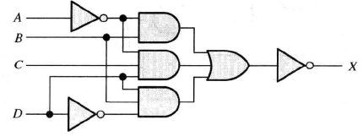
A.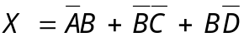 B.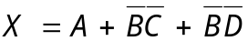
C.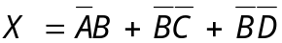 D.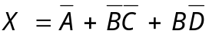
(10) F = f(A,B) = m0+m3, select the right answer for 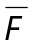( D )
A.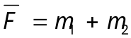 B. 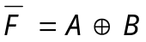 C.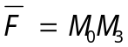 D. All above

2. Fill in the blanks with the correct answer. (20 points)
(1) Convert F=A+BC to the standard POS form：F=ΠM(0,1,2)或者 F=Π(0,1,2)

(2) (46.25)₁₀ = (_101110.01 _)₂=(_ 2E.4 _)₁₆= (01000110.00100101 )_{BCD}.
(3) Apply DeMorgan’s theorems to the expression 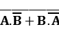.The answer is ____A’B’+AB_ ___,which belongs to XNOR gate.（填中文“异或非”、“同或”均可）
(4) The output of an exclusive-OR is __ 1 _ if the inputs are opposite.
(5) The universal gates are the gates of __NAND_____ and __NOR____.（中文也可以：与非、或非）
(6) A 5-variable Karnaugh map has 32 cells.

3.Fill the T or F.(T represents true,F represents false )(10points)
(1)A anolog had a continous value.( T )
(2) Parity can detect two errors in a set of data.( F )
(3)AND gate has only two inputs.( F )
(4)Any SOP expression can be implemented using only NOR gates.( T )
(5) If the arbitrary input of a OR gate is 1, then its output is 1.( T )

4. Calculation and Analysis (50 points)
(1)Please convert (125.125)₁₀ to binary, octal , hexadecimal, and BCD code.(9 points)

(125.125)₁₀=(01111101.001)₂=(175.1)₈=(7D.2)₁₆=(000100100101.000100100101)_{BCD}

(2)Please answer the function of the following waveform. Write the expression X and draw the diagram.(4+3=7 points)
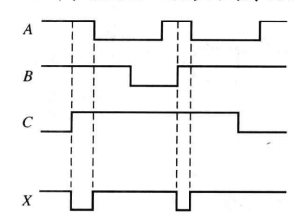
功能：三输入与非门 ；X=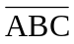。
电路图:
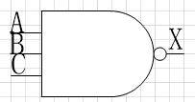

(3) As shown in the following logic diagram, write the expression P and the standard and or expression, then list the corresponding truth table of expression Y. (3+3+4+5=15 points)
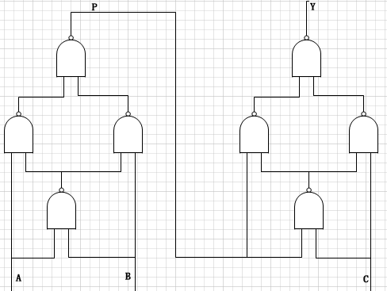

解：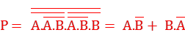 ① （3分）
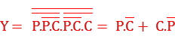 ② （3分）
将①式带入②式得：
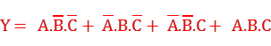 (标准与或表达式) （4分）
Y的真值表：（5分）
A | B | C | Y
0 | 0 | 0 | 0
0 | 0 | 1 | 1
0 | 1 | 0 | 1
0 | 1 | 1 | 0
1 | 0 | 0 | 1
1 | 0 | 1 | 0
1 | 1 | 0 | 0
1 | 1 | 1 | 1

(4) Simplify the following expression using karnaugh maps .(5+6+8=19 points)
a) F(A,B,C) = A’B’C’+A’BC’+AB’C’+AB
b) F(A,B,C,D) = Σ(0,1,2,3,4,5,8,10,11)
c) F(A,B,C,D) = Σm(0,1,2,3,6,8)+ Σd(10,11,12,13,14,15)
解：a) 先化为标准形式：F(A,B,C) = A’B’C’+A’BC’+AB’C’+ABC+ABC’

BC  A | 00 | 01 | 11 | 10
0 | 1 | 0 | 0 | 1
1 | 1 | 0 | 1 | 1

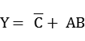
b)

CD  AB | 00 | 01 | 11 | 10
00 | 1 | 1 | 1 | 1
01 | 1 | 1 | 0 | 0
11 | 0 | 0 | 0 | 0
10 | 1 | 0 | 1 | 1

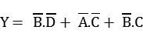
c)

CD  AB | 00 | 01 | 11 | 10
00 | 1 | 1 | 1 | 1
01 | 0 | 0 | 0 | 1
11 | X | X | X | X
10 | 1 | 0 | X | X

F(A,B,C,D) =  

