《数字逻辑（双语）》2023年下学期第一次平时测试题

1. Choose the best answer from the four choices. (20points)
(1) Which one is the negative logic? ( C )
A.H=1,L=1 B.H=1,L=0 C.H=0,L=1 D.H=0,L=0
(2) In a given digital waveform, the period is four times the pulse width, then the duty cycle is ( C ).
A.20% B.50% C.25% D.100%
(3) In the 2’s complement form,the binary number 11010110 is equal to the decimal number ( B ).
A.-41 B.-42 C.-86 D.+214
(4) (5B7A)₁₆，whose the third character B has a bit weight of ( B ).
A.(2816)₁₀ B. (256)₁₀ C. (4)₁₀ D. (100)₁₀
(5) Which method can be used in digital systems to convert subtraction operations to addition operations. ( C )
A. Original code B. ASCII code C.Complement code D. BCD code
(6) As shown in the figure, which logical relationship is reflected.( B )
A.AND B.XOR C. OR D.XNOR
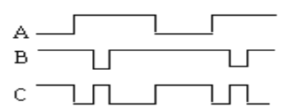
(7) The same is”1”,the difference is “0”,what is its logic relationship?( D )
A.AND B.OR C.XOR D.XNOR
(8) Which is correct about 8421BCD code operation. ( D )
A.00111000 + 10000011 = 10111011 B. 11001001 + 00000001 = 11001010
C. 01001000 + 00100100 = 10000010 D. 01010011 + 00010100 = 01100111
(9) Which is the equivalent form of the logic diagram. ( B )
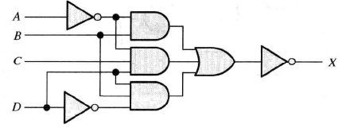
A.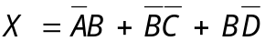 B.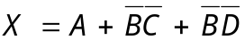
C.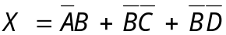 D.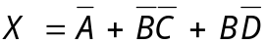
(10) 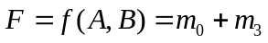, select the right answer for 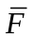 ( D )
A.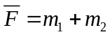 B. 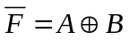 C.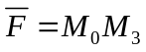 D. All above

2. Fill in the blanks with the correct answer. (20 points)
(1) Convert F=A+BC to the standard POS form： F=Π(0,1,2) .
A+BC=(A+B)(A+C)=(A+B+C)(A+B+C’)(A+B+C)(A+B’+C)
=(A+B+C)(A+B+C’)(A+B’+C)=Π(0,1,2)

(2) (46.25)₁₀ = ( 101110.01 )₂=( 2E.4 )₁₆= ( 01000110.00100101 )_{BCD}.
(3) Apply DeMorgan’s theorems to the expression 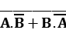.The answer isA’B’+AB,which belongs to XNOR gate.
(4) The output of an exclusive-OR is 1 if the inputs are opposite.
(5) The universal gates are the gates of NAND and NOR .
(6) A 5-variable Karnaugh map has 32 cells.

3.Fill the T or F.(T represents true,F represents false )(10points)
(1)A anolog had a continous value.( T )
(2) Parity can detect two errors in a set of data.( F )
(3)AND gate has only two inputs.( F )
(4)Any SOP expression can be implemented using only NOR gates.( T )
(5) If the arbitrary input of a OR gate is 1, then its output is 1.( T )

4. Calculation and Analysis (50 points)
(1)Please convert (125.125)₁₀ to binary, octal , hexadecimal, and BCD code.(9 points)
(2)Please answer the function of the following waveform. Write the expression X and draw the diagram.(4+3=7 points)
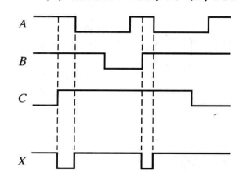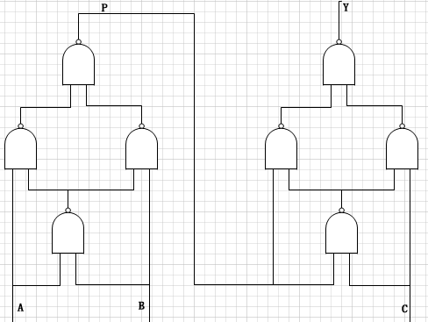
第4（2）题 第4（3）题
(3) As shown in the following logic diagram, write the expression P and the standard and or expression, then list the corresponding truth table of expression Y. (3+3+4+5=15 points)
4(2).波形是实现的功能是X=(ABC)’，切记三输入的时候同或和异或的真值表和
两输入的不相同。
(3) standard and or expression指标准的SOP或POS形式

