数字逻辑（双语）2023年下学期第三次测试题

一. Choose the best answer from the four choices. (21 points)
1.For synchronous RS flip-flops, if 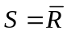, the logic function of the（ ）flip-flop can be completed.
A.JK B. D C.T D.
2.The output of a gated D latch will not change if ( )
A. the output is LOW B. Enable is not active
C. D is LOW D. all of the above
3.To parallel load a byte of data into a shift register with a synchronous load, there must be（ ）.
A .One clock pulse B. One clock pulse for each 1 in the data
C. Eight clock pulses D. One clock pulse for each 0 in the data
4.A modulus-5 ring counter require （ ）.
A. Eight flip-flops B. Three flip-flops
C. Five flip-flops D. Twelve flip-flops
5. The group of bits 01110101 is serially shifted (left-most bit first) into an 8-bit parallel output shift register with an initial state of 11100100. After three clock pulses, the register contains （ ）.
A. 01110101 B. 11011100
C .10111100 D. 01111100
- A 4-bit binary up/down counter is in the state of 1111. The next 4th state in the UP mode is （ ）.
A. 0000 B. 1011 C. 1100. D. 0011
7.Assume the clock for a 4-bit binary counter is 80 kHz. The output frequency of the fourth stage (Q3) is ( )
A. 5 kHz B. 10 kHz C. 20 kHz D. 320 kHz

二．Fill in the blanks with the correct answer. (15 points)
1.A modulus-15 counter has 15 states requiring flip-flops.
2. A 4-bit binary up/down counters is in the binary state of zero. The next state in the DOWN mode is .
3.A J-K flip-flop with J=1 and K=1 has a 10kHz clock input, then the Q is a KHz square wave.
4.A circuit with 5 flip-flops can store bits binary numbers, that is,include states at most.
三. Calculation and Analysis.(64 points)
1. Given the 4-bit ring counter in the figure for this problem, assume that a 1010 input data pattern is loaded into the counter. Sketch the resulting flip-flop Q output waveforms. (9 points)
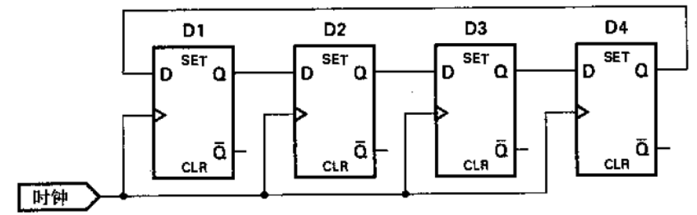

2. Given the timing diagram for Q0 ,Q1.(10points)
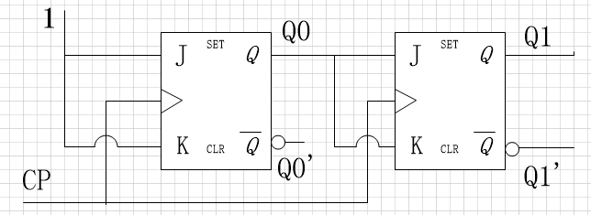
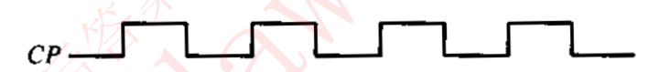
Q0
Q1

3. draw the state table and state diagram, and complete the timing diagram by showing Y output according to the circuit in the following Figure. Assume the initial values are Q=0.(15 points)
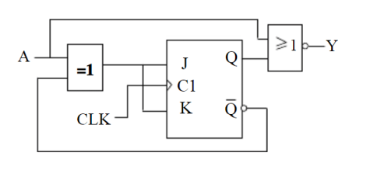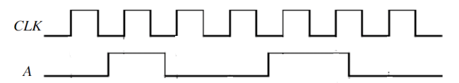
- Please design a synchronous timing diagram with J,K flip-flop triggered by falling edge, the statechart diagram of which is shown as follows.(15points)
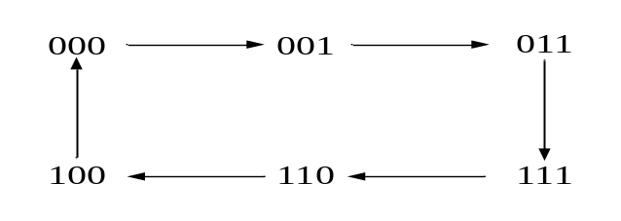
- Design a counter to produce the following sequence: 1, 5, 6, 8, 9, 1, …(open answer) (15points)

