数字逻辑（双语）2020年下学期第一次平时测试题

1. Choose the best answer from the four choices. (20points)
(1) Which one is the negative logic? ( )
A.H=1,L=1 B.H=1,L=0 C.H=0,L=1 D.H=0,L=0
(2)In a given digital waveform, the period is four times the pulse width, then the duty cycle is ( ).
A.20% B.50% C.25% D.100%
(3)In the 2’s complement form,the binary number 11010110 is equal to the decimal number ( ).
A.-41 B.-42 C.-86 D.+214
(4) (5B7A)₁₆，whose the third character B has a bit weight of ( ).
A.(2816)₁₀ B. (256)₁₀ C. (4)₁₀ D. (100)₁₀
(5) Which method can be used in digital systems to convert subtraction operations to addition operations.( )
A. Original code B. ASCII code C.Complement code D. BCD code
(6)As shown in the figure,which logical relationship is reflected.( )
A.AND B.XOR C.OR D.XNOR
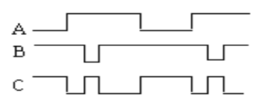
(7)The same is”1”,the difference is “0”,what is its logic relationship?( )
A.AND B.OR C.XOR D.XNOR
(8) Which is correct about 8421BCD code operation. ()
A.00111000 + 10000011 = 10111011 B. 11001001 + 00000001 = 11001010
C. 01001000 + 00100100 = 10000010 D. 01010011 + 00010100 = 01100111
(9) Which is the equivalent form of the logic diagram. ( )
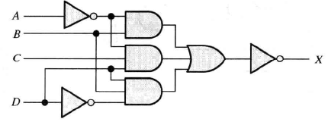
A. B.
C. D.
(10) F = f(A,B) = m0+m3, select the right answer for ( )
A. B. C. D. All above

2. Fill in the blanks with the correct answer. (20 points)
(1) Thetime interval between the amplitude of 10% and 90% at the front of the pulse is_____________; thetime interval between the amplitude of 90% and 10% at the behind of the pulse is_____________.
(2) (46.25)₁₀=(__)₂=(__)₁₆= ()_{BCD}.
(3) Apply DeMorgan’s theorems to the expression $\overline{A.\overline{B}+B\overline{.A}}$.The answer is _____ ___,which belongs to ______ gate.
(4) The output of an exclusive-OR is ___ if the inputs are opposite.
(5)The universal gates are the gates of _______ and ______.

3.Fill the T or F.(T represents true,F represents false )(10points)
(1)A anolog had a continous value.( )
(2) Parity can detect two errors in a set of data.( )
(3)AND gate has only two inputs.( )
(4)BCD represents binary-to-decimal decoder.( )
(5) If the arbitrary input of a OR gate is 1, then its output is 1.( )

4.Calculation and Analysis (40 points)
(1)Please convert (125.125)₁₀ to binary, octal , hexadecimal, and BCD code.(8 points)

(2)Please answer the function of the following waveform. Write the expression X and draw the diagram.(2+2)
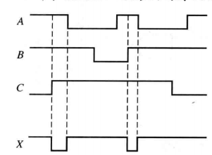
(3) As shown in the following logic diagram, write the expression P and the standard and or expression, then list the corresponding truth table of expression Y. (2+(2+3)+3=10points)
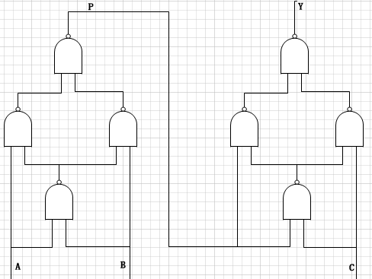

(4)Write down the simplest and or expression of each karnaugh maps.(3+3)
BC  A | 00 | 01 | 11 | 10
0 | 1 | 0 | 0 | 1
1 | 1 | 0 | 1 | 1

CD  AB | 00 | 01 | 11 | 10
00 | 1 | 1 | 1 | 1
01 | 1 | 1 | 0 | 0
11 | 0 | 0 | 0 | 0
10 | 1 | 0 | 1 | 1

(5) Simplify the following expression using karnaugh maps .(6points)
F(A,B,C,D)=Σm(0,1,2,3,6,8)+ Σd(10,11,12,13,14,15)

