数字逻辑（双语）2020年下学期第三次测试题

一. Choose the best answer from the four choices. (30points)
1. 8 channel data selector, of which address input (select control) have（ ）
A.One B.Two C.Three D.Four
2.For synchronous RS flip-flops, if S= $\overline{R}$, the logic function of the（ ）flip-flop can be completed.
A.JK B. D C.T D. $\overline{T}$
3.A register’s function include （ ）.
A.Data storage B. data movement
C.Neither A not B D. Both A and B
4.To parallel load a byte of data into a shift register with a synchronous load, there must be（ ）.
A .One clock pulse B. One clock pulse for each I in the data
C.Eight clock pulses D. One clock pulse for each 0 in the data
5.A modulus-5 ring counter require （ ）.
A. Eight flip-flops B. Three flip-flops
C. Five flip-flops D. Twelve flip-flops
6. The group of bits 01110101 is serially shifted (left-most bit first) into an 8-bit parallel output shift register with an initial state of 11100100. After three clock pulses, the register contains （ ）.
A. 01110101 B. 11011100
C .10111100 D. 01111100

二．Fill in the blanks with the correct answer. (15 points)
1.A modulus-15 counter has 15 states requiring flip-flops.
2. A 4-bit binary up/down counters is in the binary state of zero. The next state in the DOWN mode is .
3.A J-K flip-flop with J=1 and K=1 has a 10KHz clock input,then the Q is a KHz square wave.
4.A circuit with 5 flip-flops can store bits binary numbers, that is,include states at most
二.Calculation and Analysis.(55points)
1.Given the timing diagram for Q0 ,Q1.(10points)
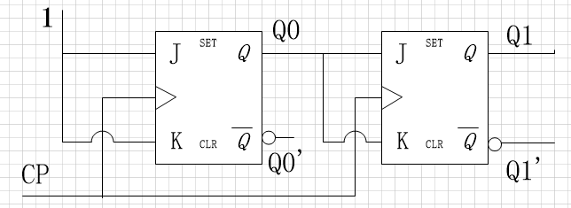
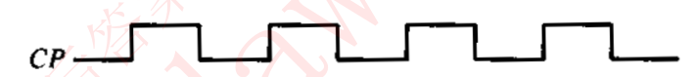
Q0
Q1

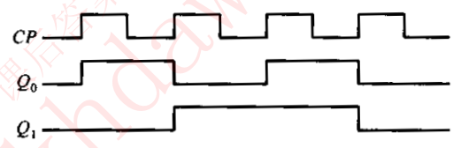
2.draw the state table and state diagram, and complete the timing diagram by showing Y output according to the circuit in the following Figure. Assume the initial values are Q=0.(15 points)
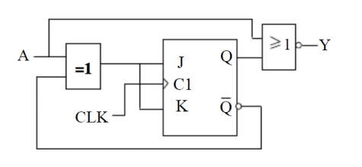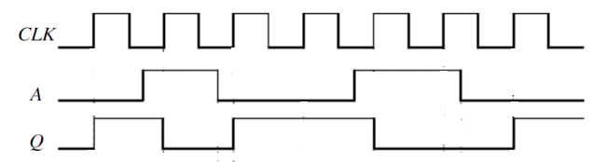
参考答案：(1)
Write the characteristic equation
Write the excitation equation $J=K=A^{'}Q^{'}+AQ=A⊙Q$
Write the next state equation. $Q_{t+1}=\left(A⊙Q\right)\overline{Q}+\overline{A⊙Q}Q=\overline{A}$
Write the output variable equations. （上面每个式子2分，共8分）
State table State diagram（2分）
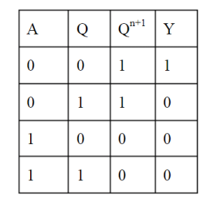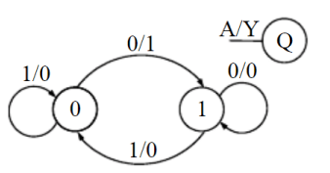
(2)Timing diagram（2分）
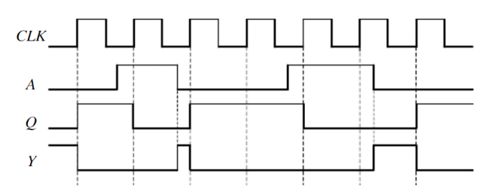（3分）
3.Please design a synchronous timing diagram with J,K flip-flop triggered by falling edge, the statechart diagram of which is shown as follows.(15points)
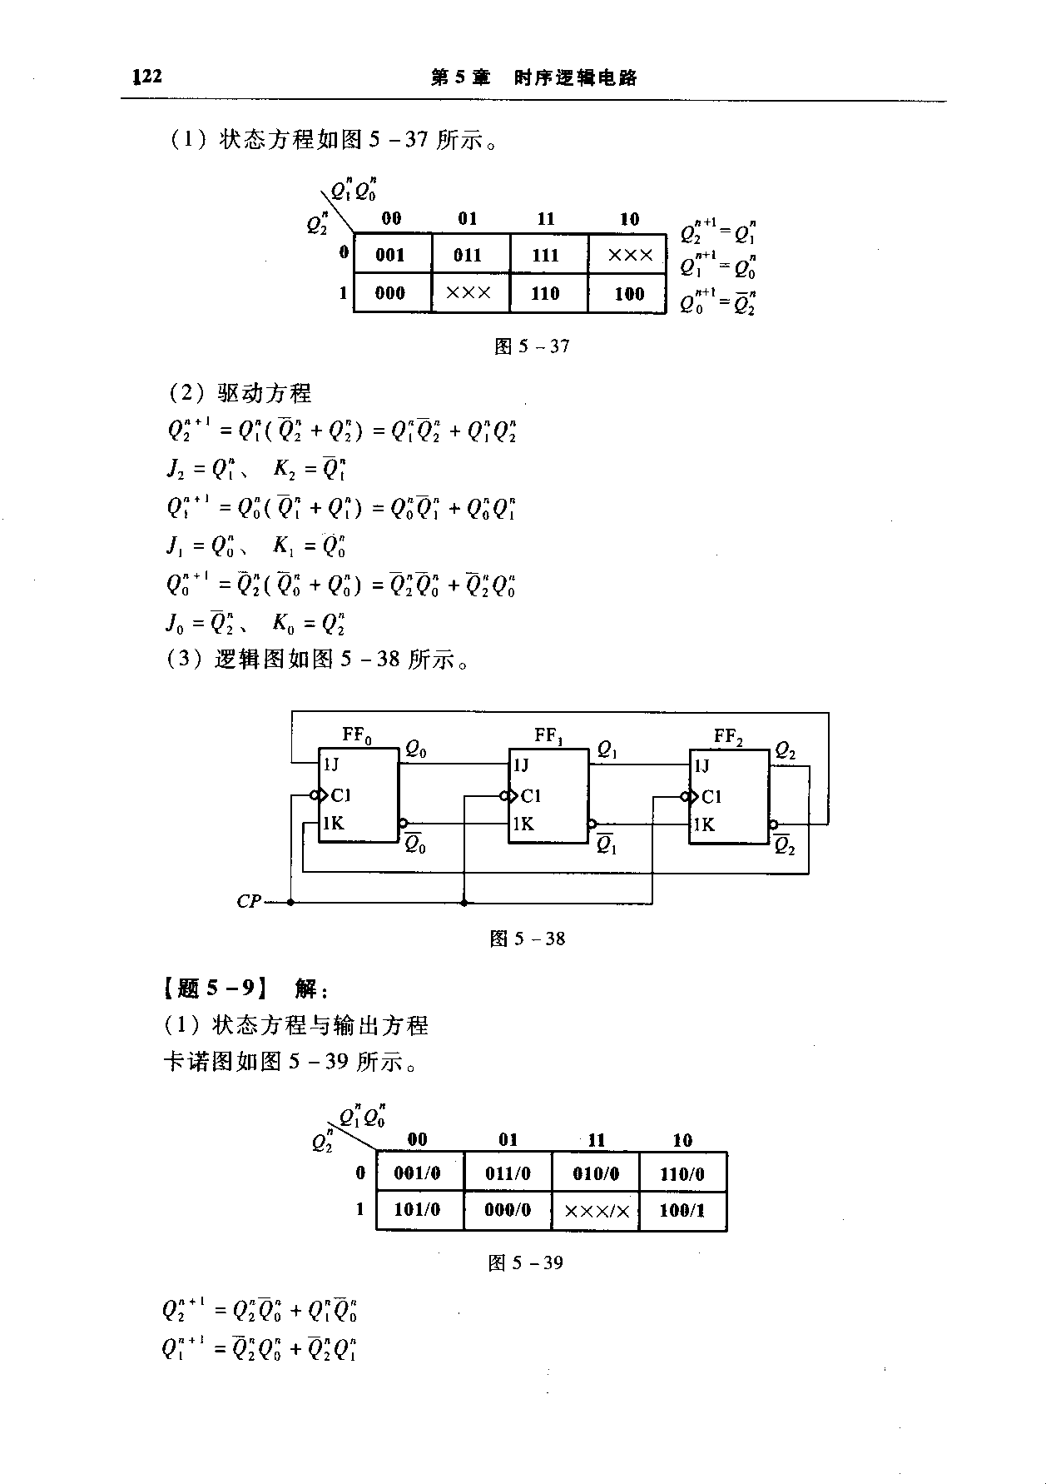
（每项各5分）
4.Design a counter to produce the following sequence: 1, 4, 5, 7, 1, …(open answer) (15points)

